Supplemental Digital Content 2. Overview of study design
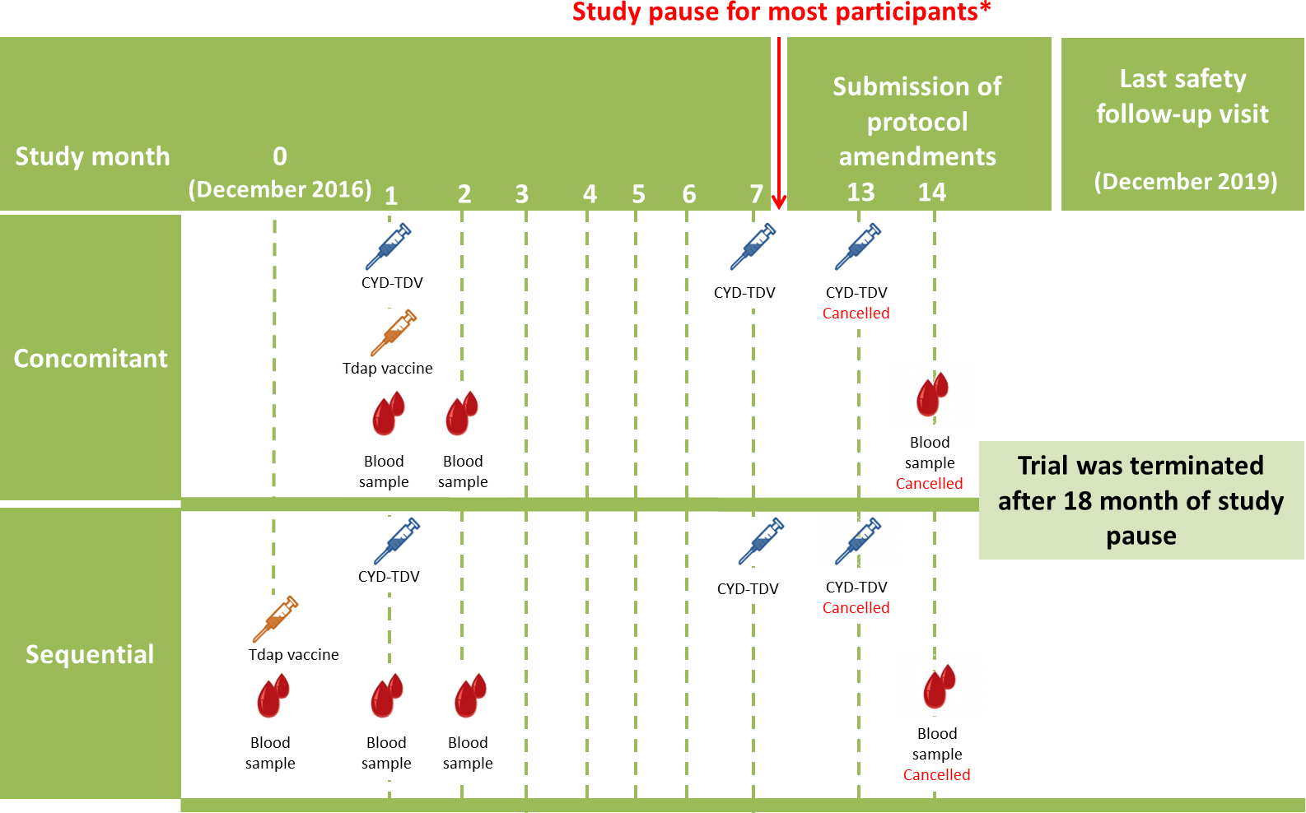
*The study pause occurred after Month 7 for most participants. All but 19 participants received the second dose of CYD-TDV.

