Supplemental Digital Content 11a. Hematoxylin & eosin-stained section of lung showing severe type II pneumocyte proliferation, including cytomegaly, nucleomegaly, prominent eosinophilic nucleoli and syncytia formation (arrows).

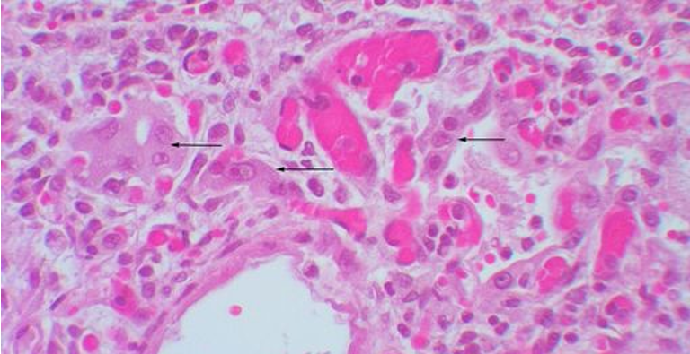

11b. Hematoxylin & eosin-stained section of lung showing early type II pneumocyte proliferation lining alveolar septa
