Supplemental Digital Content 13a. Hematoxylin & eosin-stained section of liver showing a cirrhotic nodule. A fibrous tissue band (*) surrounds hepatic parenchyma which is exhibiting small and large droplet steatosis. Intracanalicular cholestasis is present (long arrow). Bile ductular proliferation is seen at the interface between the fibrous tissue and the parenchyma (short arrows). Note the absence of an original bile duct, suggesting underlying bile duct paucity.

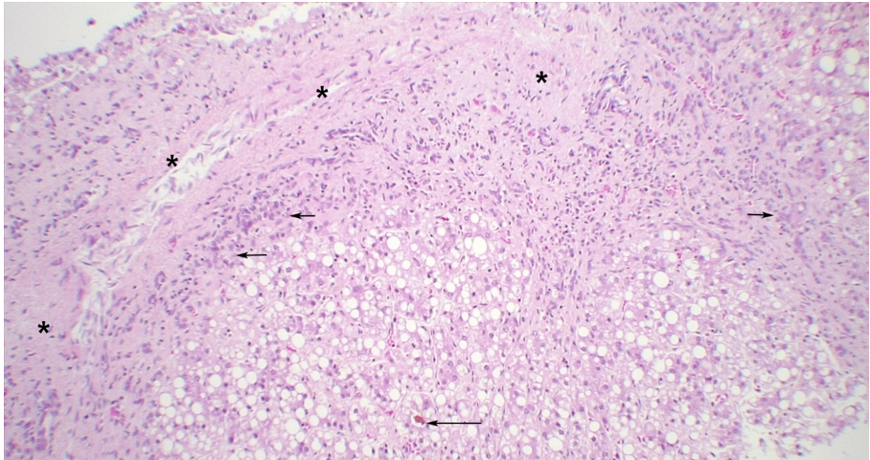
13b. Hematoxylin & eosin-stained section of liver showing higher magnification of small and large droplet steatosis and bile ductular proliferation (short arrows). Intracanalicular cholestasis is present (long arrow).
