Supplemental Digital Content 14a. Hematoxylin & eosin-stained section of liver showing a Kupffer cell exhibiting erythrophagocytosis with an ingested red blood cell in an intracytoplasmic vacuole (arrow).
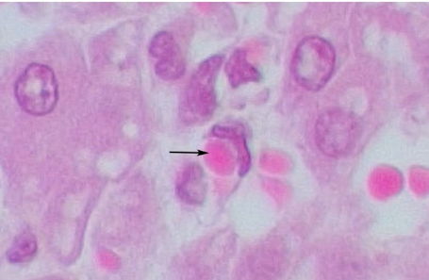
14b. Hematoxylin & eosin-stained section of liver showing a Kupffer cell exhibiting lymphophagocytosis with an ingested lymphocyte in an intracytoplasmic vacuole (arrow).

