Supplemental Digital Content 1. Figure – Age-specific HIV prevalence in children <15 years, estimated in MPHIA and evolution of PMTCT and option B+ in Malawi.

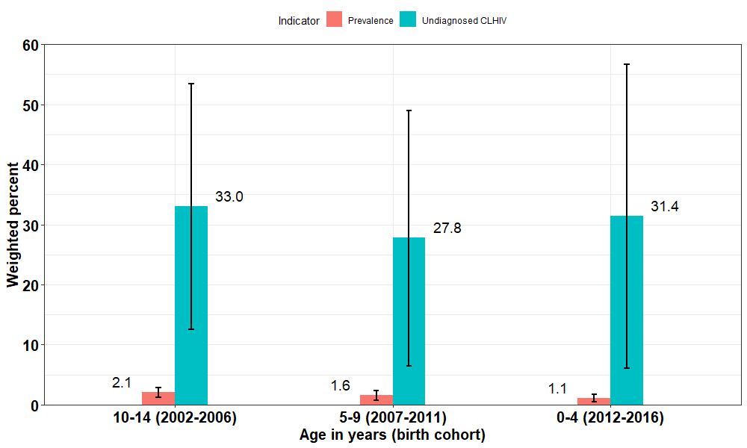
MPHIA field work
(2015 – 16)
Malawi introduces lifelong ART to HIV-positive pregnant women in 2012
Single dose NVP for mother and child at birth introduced in 2004

Supplemental Digital Content 2. Table – Age at initiation of antiretroviral treatment among HIV positive children <15 years, Malawi Population-based HIV Impact Assessment, 2015-16
Variable | Count | Median age at ART initiation (years) | Interquartile range
All, 0-14 y | 39 | 3.0 | 1.9 - 4.6
Age at the time of the survey (year)
0-4 | 8 | 1.2 | 0.0 - 2.0
5-9 | 11 | 3.1 | 2.1 - 4.0
10-14 | 20 | 5.0 | 3.7 - 10.1
Sex
Male | 24 | 2.7 | 1.0 - 4.0
Female | 15 | 4.2 | 2.6 - 7.3
Residence
Urban | 14 | 1.8 | 1.2 - 6.2
Rural | 25 | 3.2 | 1.2 - 4.0

