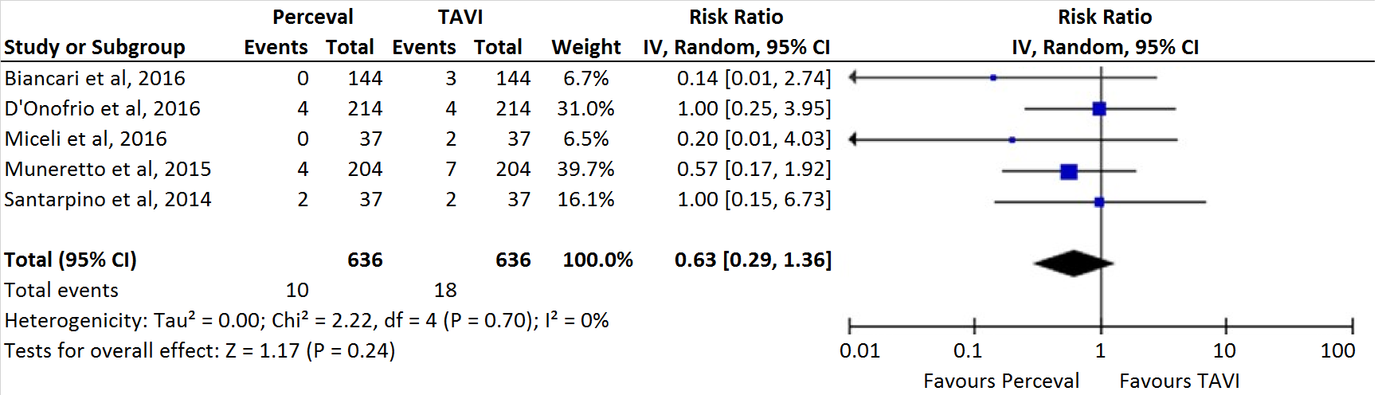
FIGURE 12. Mean difference of ICU stay (day) among patients assigned to sutureless Perceval versus TAVI. CI, confidence interval.

