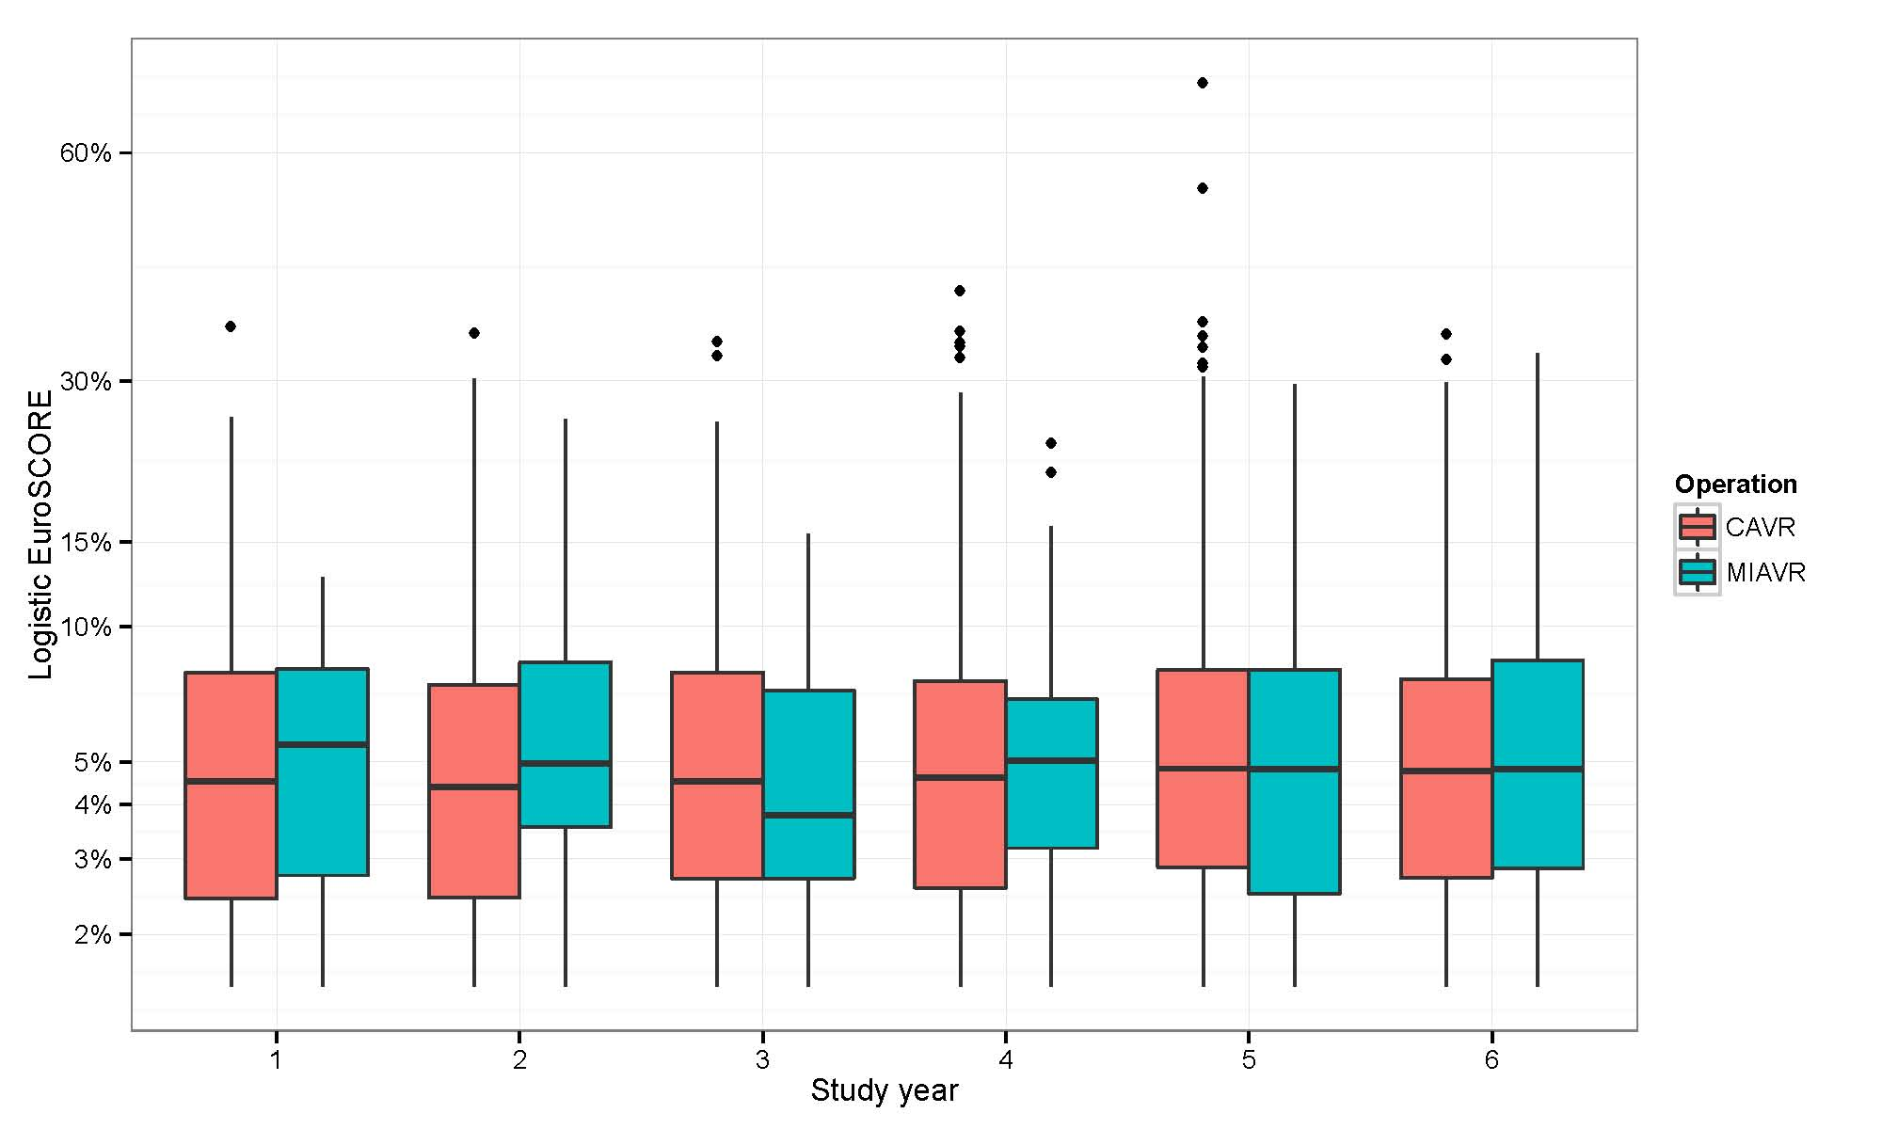Boxplots showing the distribution of logistic EuroSCORE for CAVR and MIAVR by study year in the complete unmatched data. Note the vertical axis is on a logit-transformed scale to aid interpretation.

