Appendix A. Additional Information on the Ready Steady Grow Initiative

Figure A.1 RSG IMH Strategy

A.1 Description of RSG’s components
Strand A: Building the Capacity of Parents
Embedded at the center of RSG’s strategy is a focus on building the capacity of parents to improve child and family outcomes. The centerpiece of this work is the Parent Child Psychological Support Programme (PCPSP), an individually tailored, center-based intervention for parents and their infants up to the age of 18 months. The goals of PCPS are to
- promote the child’s optimum development;
- support parents in the early stages of parenting;
- promote good quality caregiver-baby interaction and attachment;
- cooperate with other services in providing supports to parents and infants, which empower them to fulfil the baby’s basic needs and support their emotional and cognitive development;
- empower parents to look after themselves in this busy phase of their lives and enjoy the parenting experience;
- identify developmental delays/difficulties early and arrange referral to more specialist services where required.

PCPSP is an adaptation of a Spanish program which was developed by Professor M Angeles Cerezo in 1990 (Cerezo, 2003). The PCPSP aims to promote infant wellbeing in the parenting context. It employs physical and mental health screening with a specific emphasis on the caregiver-infant dyad. Through assessment of father/mother-infant interaction, it seeks to sustain and promote attunement and synchrony as a means of cultivating secure infant attachment (Cerezo, 2012). As part of RSG, the program is delivered in partnership with the Health Service Executive and is integrated into the mainstream delivery of child development clinics by Public Health Nurses and Speech and Language Therapists in Ballymun.

The program comprises seven 30-60 minute center-based visits; an introductory/baseline visit and six further visits at approximately 3, 5, 7, 12, 15, and 18 months, with the option of scheduling two additional visits if it is felt that the family needs additional support. Each visit is spread across three stations where the PCPSP facilitator talks with the parent and conducts a number of assessments. The process includes (a) the assessment of the infant’s physical development including their height, weight, and nutrition; (b) motor, cognitive, and socio-emotional development including a brief structured observation of parent-infant interaction; culminating in (c) a station where all of the information relating to the child’s development, the parent-child relationship, and parental wellbeing is examined and discussed with the parent. The parent is also invited to discuss any concerns he or she may have. Families requiring additional support are considered for onward referral to 39 community-based services including medical, social work, and speech and language agencies, in addition to local community groups, outreach workers, and counselling services.

Referral services linked to the RSG initiative include:
- Baby and me: A weekly parent and baby group offering themed advice and guidance for parents of babies up to 12 months.
- Baby Ballymun: A topical workshop series, co-delivered by Public Health Nurses and youngballymun covering topics such as postnatal depression, sleeping, and feeding.
- Baby massage: Classes on baby massage for parents of infants from newborns to toddlers.
- Talk and play everyday: Weekly interactive play-based sessions with parents and toddlers aged 12-24 months. The program is informed by IMH principles, the Hanen: You Make the Difference Program, and High Scope.
- Incredible Years Toddler Program: A parenting program, available to parents of toddlers from 12 to 26 months aimed at building parental capacity to develop children’s socioemotional skills. Delivered by youngballymun and the Community and Family Training Agency.
- Hanen: You Make the Difference: A nine week parent education program which aims to support positive parent-child interaction and attunement, with a particular focus on language. Weekly sessions are delivered by Health Service Executive Speech and Language Therapists or Public Health Nurses.
- Individual IMH interventions: Therapeutic interventions delivered to parents and infants together where more significant vulnerability and risk are identified. Interventions are delivered by a primary care psychologist and the Child and Adolescent Mental Health Team.

Strand B: Building the Capacity of Practitioners
See the Method Section in the main manuscript.

Strand C: Building Local Service Capacity to Facilitate Infant Mental Health Practice
See the Method Section in the main manuscript.

Strand D: Establishing a Favourable Policy Environment
This strand focuses on RSG’s work to integrate the prevention and early intervention work of IMH into the national policy framework. This is principally achieved by the convening of an IMH working group comprised of a nationwide group of practitioners and advocacy organisations. The group has developed a discussion document and a position paper, which have served as the basis of a number of policy submissions. The group has also disseminated its policy and practice perspectives to other interest groups and organisations through various forums and networks.

Strand E: Awareness Raising
Lastly RSG seeks to develop a broad awareness of IMH principles and practices, which is seen as an essential precursor to the development of policy and practice. This was reflected in the design of youngballymun which brought together stakeholders from a variety of backgrounds and disciplines and continued through ongoing dissemination of the IMH agenda to a wider group of statutory and community-based services. This is augmented by efforts to engage senior health service managers, heads of discipline, and governmental and agency level policy makers.

Table A.2 RSG milestones and capacity activities September 2006 to February 2012
2006 | September |  | youngballymun formally launched
2007 | January |  | Literature review to identify proven models of antenatal and parent support for parents of 0 – 2 year olds.  Mapping exercise of existing services
 | September |  | The Antenatal and Parent Support Service Design Teams established  Focus groups to inform service design
 | November |  | Local needs and resource assessment conducted by Dublin City University School of Nursing presented to the Service Design Teams
 | December |  | Infant Mental Health model identified as a possible approach by Service Design Team
2008 | January |  | youngballymun representatives visit Michigan Association for Infant Mental Health (MI-AIMH) Infant Mental Health endorsed Specialists/clinical psychologists (Rochelle Matacz and Dr Catherine Maguire) in Cork Health Service Executive (HSE)
 |  |  | Contact made with MI-AIMH and Dr Deborah Weatherston
2009 | April |  | 16 day training of Ballymun staff in Parent Child Psychological Support Programme (PCPSP) delivered by Professor M. Angeles Cerezo
 | July |  | Ready, Steady, Grow Implementation Team established
 | October |  | Hanen You Make the Difference® 6 week staff training course for Early Childhood Care and Education practitioners
 | November |  | Introduction to Infant Mental Health Workshops by HSE clinical psychologists/IMH specialists
 | December |  | IMH and Child Development Master Classes
2010 | January |  | IMH Classes for practitioners/policy makers and parents by Dr Deborah Weatherston
 | August |  | MI-AIMH seconded IMH Mentor takes up post
 |  |  | Hanen You Make the Difference® 6 week staff training course for three agencies providing home visiting
 | October |  | Hanen You Make the Difference® 9 week parent education program commences
2011 | January |  | IMH Training ‘A Safe harbour from stormy seas: Supporting the Ballymun home support team’ commences (4 sessions) targeting paraprofessionals providing family support and home help
 | February |  | Antenatal course commences (6 sessions)
 |  |  | Hanen You Make the Difference® parent program commences
 | March |  | IMH clinical training: ‘Supporting first relationships’ (6 sessions) targeting multidisciplinary clinicians working across the community
 |  |  | Baby massage (5 week course) commences
 | May |  | Antenatal course commences (6 sessions)
 | June |  | youngballymun convenes IMH Working Group
 | July |  | Baby massage (5 week course) commences
 | September |  | IMH Training: Foster parent training (2 sessions)
 |  |  | Baby massage (5 week course) commences
 |  |  | Antenatal course commences (5 sessions)
 |  |  | Hanen - You Make the Difference® parent program commences
 | October |  | youngballymun hosts national IMH practice and policy forum
 |  |  | Baby massage (5 week course) commences
 |  |  | Hanen - You Make the Difference® parent program commences
 | November |  | Pregnancy yoga commences
 |  |  | Baby massage (5 week course) commences
2012 | January |  | Baby Ballymun (sleep workshop)
 |  |  | Baby massage (5 week course) commences
 |  |  | Hanen - You Make the Difference® parent program commences
 |  |  | Talk & Play (2 sessions)
 |  |  | Infant Mental Health training: Supports for Strengthening Families (4 sessions) targeting paraprofessionals providing family support and home help
 | February |  | Baby Ballymun: Feeding workshop
 |  |  | Talk & Play (4 sessions)
 |  |  | Antenatal course commences (5 sessions)
 |  |  | Hanen - You Make the Difference® parent program commences

A.3 Description of the Introductory and Main IMH Training Programs
Key Topics Covered in the Introductory Workshops
- Definitions of IMH.
- IMH framework of supporting healthy child development and parent-child relationships through emotional and concrete support, advocacy, child development guidance, and parent-infant psychotherapy.
- The intergenerational transmission of parenting influences.
- Key IMH principles such as home visiting, parallel process, secure base, empathetic support, holding environment, and the importance of early intervention.
- Key milestones and transitions in socioemotional development.
- Emotional regulation and caregiver influences.
- Attachment and socioemotional development including the qualities, features, and stages of attachment, the formation of internal working models, Ainsworth’s strange situation and patterns of attachment, and the implications and clinical applications of attachment theory.
- Parents’ representations of parenting including the role and function of parental internal working models and their contribution to the parent-child relationship.

Key Topics Covered in the Main Training Programs
Program 1; Series 1 ‘A Safe Harbour in Stormy Seas: Supporting the Ballymun Home Support Team’ key topics:
- The importance of relationships to healthy socioemotional development.
- Socioemotional developmental milestones and the importance of socioemotional health to lifelong development.
- Strategies for supporting positive parent-infant/toddler relationships.
- Strategies for identifying and discussing infants’ developmental capacities with parents and supporting healthy infant development.
- The impact of addiction on families and strategies for working with families facing addiction in a home visiting context.
- Identifying and setting boundaries in a home visiting context.
- The importance of self-care and maintaining personal safety.

Program 1; Series 2 ‘Supports for Strengthening Families’ key topics:
- Introduction to attachment theory, attachment styles, brain development and their implications for working with families.
- Supporting the Circle of Security.
- Observing parents and young children’s interactions.
- Core IMH principles including the possibility for growth, parents’ positive aspirations for their infant, parents as experts on their infants, parallel process, appraising families’ capacities using a strengths-based approach, first relationships as relationship prototypes, intergenerational transmission of parenting influences, privilege of working in the home-visiting context.
- IMH strategies and practices.
- Listening skills.
- Documenting practice.

Program 2; ‘Supporting First Relationships’ key topics:
- Definitions of IMH
- Core IMH principles including the possibility for growth, parents’ positive aspirations for their infant, parents as experts on their infants, parallel process, appraising families’ capacities using a strengths-based approach, active role of infants in infant-parent relationships, first relationships as relationship prototypes, attachment relationships as a secure base for development, intergenerational transmission of parenting influences, privilege of working in the home-visiting context, therapeutic relationship as a key context and mechanism for change.
- IMH framework of supporting healthy child development and parent-child relationships through emotional and concrete support, advocacy, child development guidance, and parent-infant psychotherapy.
- Parallel process in infant parent work.
- IMH strategies in assessment.
- Observing parents and young children’s interactions.
- Attachment styles and the importance of sensitive and responsive caregiving for healthy child development.
- Supporting secure attachment and parent-infant relationships using IMH strategies.
- Supporting the Circle of Security.

Appendix B. Additional Information on the Interviews and Surveys

B.1 Interview Schedule
- Part 1: Individual Role
  - What is your current role in relation to the IMH aspect of RSG?
  - How long have you been in this role?
  - Can you give a brief overview of your day to day work?
    - What direct services are necessary to do your job?
    - What personal skills are necessary to do your job?
    - Do you work alone or as part of a team? If part of a team how does this typically operate?
- Part 2: RSG
  - Are you aware of RSG having a defined strategy in relation to IMH?
  - Do you feel that you have been give the resources required to carry out your role effectively in relation to IMH?
    - If not what would help you improve?
  - Do you feel that the IMH needs of the end users of your service are being met?
    - How is this being done? Can you give examples?
    - How do you think the service could be improved?
    - Are you aware of any quality control measures monitoring the effectiveness of service delivery re IMH in RSG? What are they?
    - Do you meet many ends users from different cultures within your role? Is there any facility within your role for dealing with issues which may arise as a result of cultural differences among service users?
    - How do you think your role fits within the overall IMH function of RSG?
    - Do you feel you have an influence on the way in which RSG is operated?
    - Do you feel that there is adequate funding in place in order for RSG to build IMH capacity?
- Capacity Building
  - What is your understanding of the term capacity building in reference to IMH?
  - Are you aware of any capacity building function of RSG?
    - Can you tell us about it?
    - How often does it arise in your day to day work?
    - Do you think it’s working? Why/Why not?
  - Do you actively seek to develop IMH capacity in Ballymun within your role?
    - How do you do this?
    - If you don’t, is something preventing you from doing this?
  - How do you interact with other service providers in RSG?
    - At the organisational level (meetings, regular updates, etc)? Do you ever specifically address IMH issues with these organisations? Do you take any steps to work with these providers to build IMH capacity? If not is anything specific preventing you from doing this?
    - On an individual level? Is there much interaction? Do you feel you have an open relationship with them? Are there any difficulties? Do you ever specifically address IMH issues with these individuals? Do you take any steps to work with these individuals? If not is there anything specific preventing you from doing this?
  - Do you feel that RSG have adequate access to the following resources needed for building IMH capacity?
    - Human resourcs, financial resources.
    - What do you feel would improve RSG’s ability in this regard?
  - Do you feel that you have the skills and competencies necessary to carry out the work needed in order to build IMH?
    - Do you feel other people you work with have these skills?
  - Are you aware of any plans in place to assess and address training needs in RSG?
  - To what extent do you get to apply new skills to the work of building IMH capacity?
  - Do you feel that you are encouraged and rewarded to ask why and put forward new improved ways of doing things?
  - Do you feel that suggestions and ideas are implemented when you suggest them?
  - What government/local council policies do you feel impact/inform the work of RSG and IMH capacity building?
- The wider communiy
  - How do you feel local community groups are working together re IMH?
    - Is there a sense of working towards a common goal? If not what’s preventing this from happening?
  - How do you interact with local groups
    - Do you work with local group leaders?
    - Are there clear roles for partnership and community leaders?
    - What is the nature of your inetraction with them?
    - How often do you meet them or talk to them?
    - Do you ever specifically address IMH issues with these leaders?
    - Do you have a role in helping these leaders to develop local IMH capacity. How do you do this? If not is anything specific preventing you from doing this?
    - In your opinion, have RSG involved disadvantaged groups in their capacity building activities?
    - To what extend do you feel cultural differences are taken into account when building capacity?
  - Do you think RSG contirbute to a sense of community in the area?
  - To what extent do you feel the community are changing from passive to active participants in building IMH capacity?
  - To what extent do you feel RSG are addressing the root causes of issues affecting IMH in the community?
- Prior to RSG implementation
  - How were referrals in relation to IMH identified prior to RSG implementation?
    - How were referrals handled?
    - How were referrals recorded?
  - How and to what extent have processes/ways of working changed since RSG implementation?
- Wrapping up
  - Do you think RSG is succeeding in its capacity building function around IMH?
    - What factors could help it to improve?
  - What supports have been put in place in relation to the implementation of IMH principles in the RSG programme?
  - What have been the barriers to IMH principle implementation?
  - Is there anything else you would like to add?

Table B.2 Original Interview Themes relating to Capacity Building by RSG
Theme | Sub-theme | Indicative quote
Confidence in youngballymun | YB have a strong presence in the area | “they’re reaching out to people, they’re trying to inform people, they’re trying to set something up here”
 | YB are well-liked | “they’re very positive and very willing and eager to develop capacity and things”
 | IMH training is well-received | “everyone was really energised by the training and people didn’t want it to end”
 | RSG provide good support and supervision | “I think certainly the supervision makes a big difference and gives you the confidence to try it [IMH] out”
Concern about sustainability | Service delivery groups need to meet RSG halfway | “it’s one thing for RSG to inform other services about it [IMH], it’s another thing for the other services to get involved to develop that I suppose and nurture that more and discuss it and re-discuss it and bring it back within our own services”
 | Concern regarding whether IMH can develop independently of RSG | “they’ve created something that’s working really well, I think, ‘oh god, what’s going to happen when they go?’. That’s the bit that worries me”
 | Concern regarding whether those who received RSG training can build capacity in Ballymun | “I think sustainability is a big barrier. Like how to sustain and really, how to embed it in services I think still needs to be done. I’m one professional here. If I for example leave here and get another job somewhere, well then they’ve lost one of their connection here”
 | Possible over-dependence on key members of RSG staff | “I’m a bit anxious about it, how we’re going to hold it together…that’s what her role is, so she’s the person who holds that and can bring it along kind of whereas the rest of us are learning it and getting to know it”
Frustration about resources | The will is there, but the resources are not | “they approached us to get [in further IMH study] but we don’t have time to do that”
 | Service delivery groups already overloaded | “there is not enough of time going into the children. We get an hour, in some places I get half an hour. A half hour is no use to nobody. For children you need much more”
 | Want to build capacity but busy fire-fighting | “some people need a real longer term outreach where you can go out to them and draw them in…but that is something you can’t show at the end of the year in your statistics…the manager says what were you doing with your time here. There is someone else on the waiting list who is waiting to be seen”
 | Groups who deal largely with older individuals – no resources for infants | “it’s been difficult for us resource-wise as we can’t take on working with babies as well as everything else”

B.3 Survey Instrument
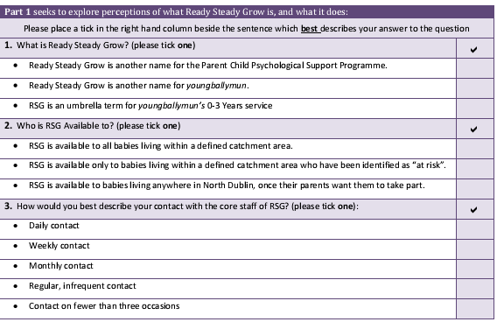

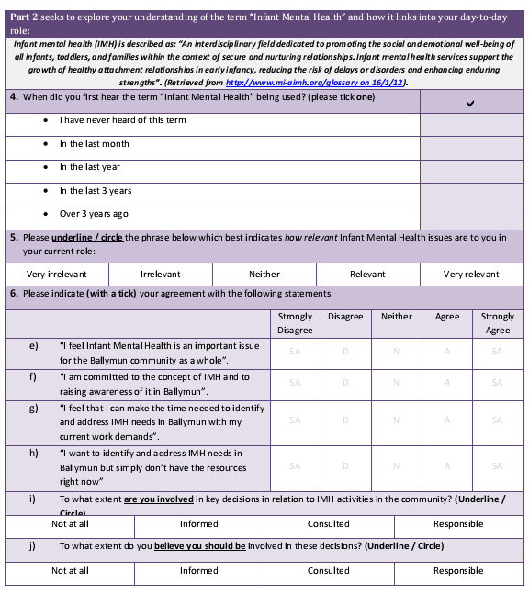

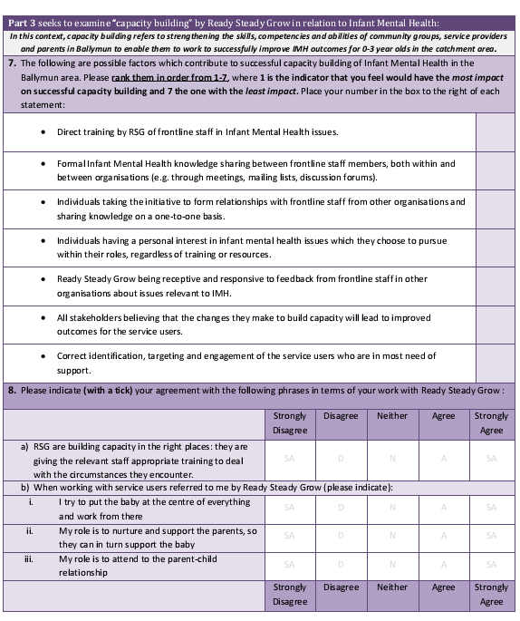

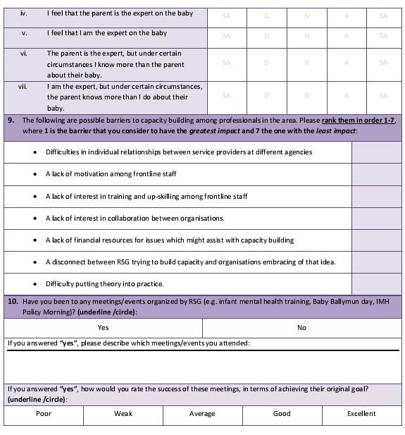

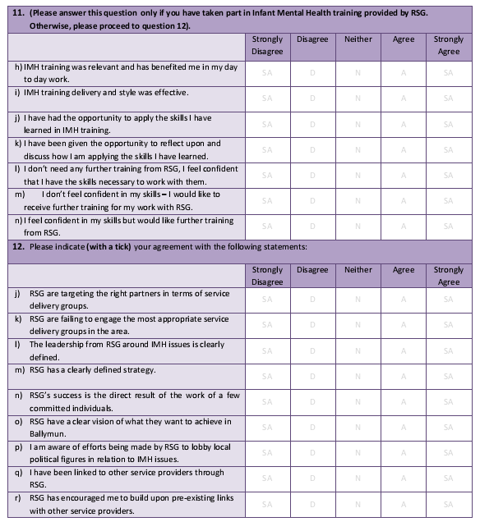

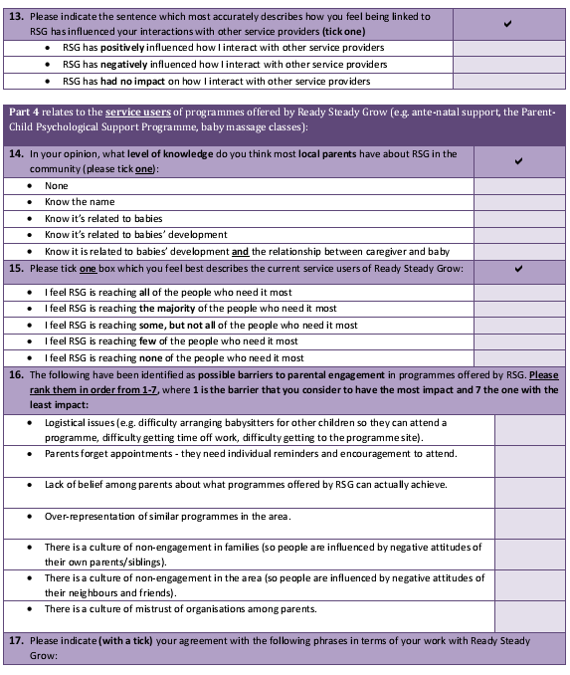

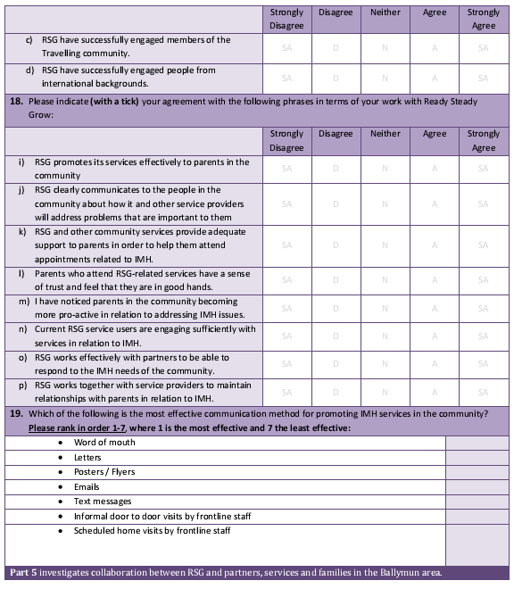

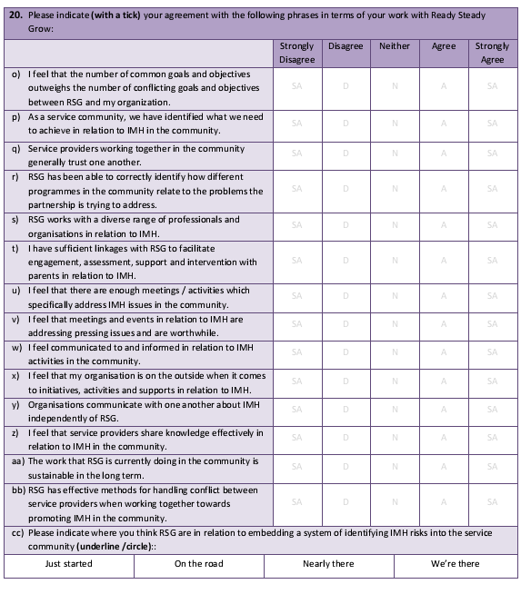

Master classes on ‘Developing reflection on Infant Mental Health Practice’ by Rochelle Matacz and Dr Catherine Maguire (Cork Health Service Executive), ‘Infant Brain Development’ by Professor Stuart Shanker, York University Canada, and ‘Social emotional development’ by Professor Cerezo.
‘Keeping the baby in mind in youngballymun. The importance of the early years: Building a foundation for social and emotional health’ topics covered include principles and practice of Infant Mental Health, and relationships matter to the promotion of Infant Mental Health.
Ballymun Home Support Service, Lifestart, and Community Mothers
Delivered by RSG and Health Service Executive speech and language therapists to parents referred from PCPSP and those on Health Service Executive Speech and Language caseload
Delivered by Primary Care Psychologist and IMH mentor
Monthly themed parent workshops on sleep, feeding, and behavior integrated with with Health Service Executive Psychology and Public Health Nursing
Playgroup for parents with toddlers (12-24 months) supporting healthy parent child interaction and tips to promote language and social-emotional development

