APPENDICES

Appendix A: Menopause Rating Scale (MRS)

Reprinted from International versions of the Menopause Rating Scale (MRS) by Heinemann, L. A., Potthoff, P., & Schneider, H. P., 2004, Health Quality Life Outcomes, 1, 28, pg. 3. Copyright 2003 by Heinemann et al; licensee BioMed Central Ltd. Open Access. Reprinted with permission.
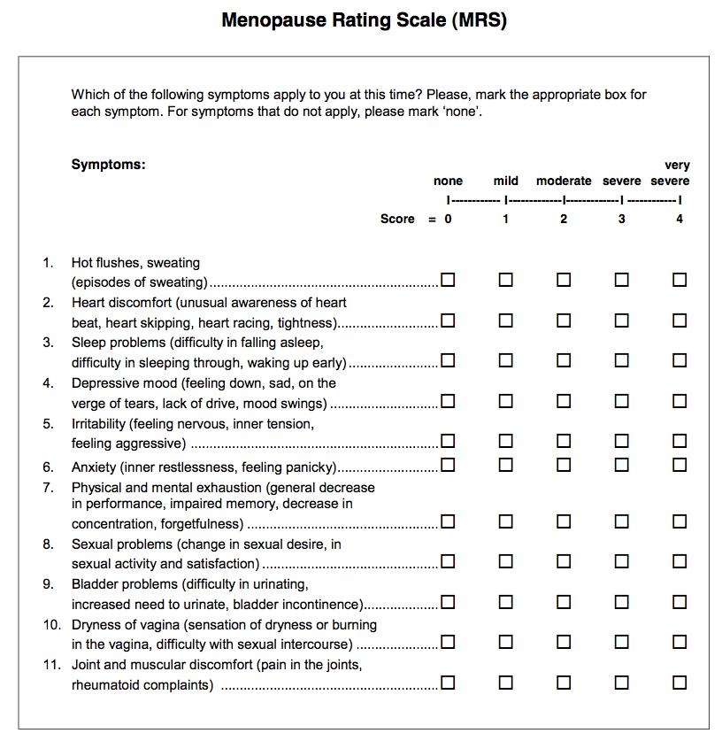

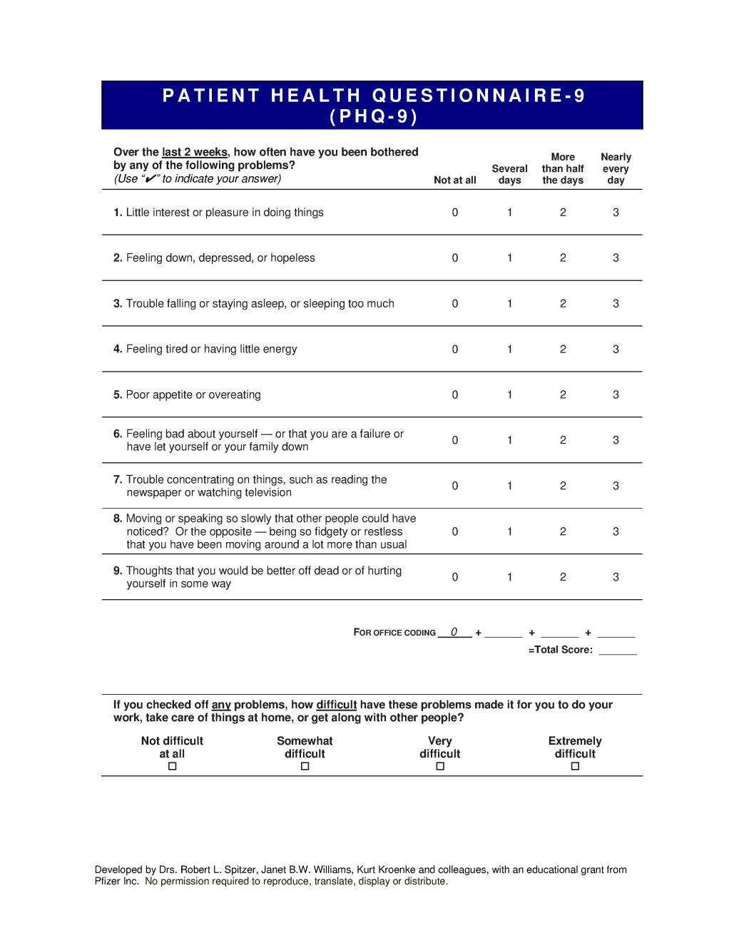
Appendix B: Patient Health Questionnaire (PHQ-9)
Appendix C: International Mean Standard Deviation Reference Values

Reprinted from The Menopause Rating Scale (MRS) scale: A methodological review by Heinemann et al., 2004, Health Quality Life Outcomes, 2, 45, pg. 6. Copyright 2004 by Heinemann et al; licensee BioMed Central Ltd. Open Access. Reprinted with permission.

International Mean Standard Deviation Reference Values

 |  |  |  |  |  |  | Somato-vegetative
 |  | Total score |  |  | Psychological score |  |  | score | Urogenital score
 |  |  | Mean |  |  | Mean |  | Mean |  | Mean
 |  | n | (SD) |  | n | (SD) | n | (SD) | n | (SD)
 | Europe | 4,246 | 8.8 | (7.1) | 4,453 | 3.4 (3.4) | 4,485 | 3.6 (2.9) | 4,465 | 1.9 (2.2)
 | North America | 1,376 | 9.1 | (7.6) | 1,426 | 3.4 (3.5) | 1,440 | 3.8 (3.1) | 1,437 | 2.0 (2.3)
 | (US)
 | Latin America | 3,001 | 10.4 | (8.8) | 3,002 | 4.9 (4.9) | 3,006 | 4.1 (3.6) | 3,005 | 1.4 (2.2)
 | Asia | 1,000 | 7.2 | (6.0) | 1,000 | 2.9 (2.9) | 1,000 | 3.3 (2.7) | 1,000 | 1.0 (1.6)

Appendix D: Chart Audit Form

Levels of Distress Chart Audit Form (page 1 of 6)

Date of Data Collection: ______________ Study ID#: ________

Demographics

- Age: _________

- Gender: Female

- Ethnic Background
  - Caucasian
  - African American
  - Asian/Pacific Islander
  - Eskimo/Native American Indian
  - Mixed (specify)
  - Other (specify)

- Hispanic
  - Yes
  - No

- Marital Status
  - Never Married
  - Married
  - Not married but living with a partner
  - Divorced or separated
  - Widowed

- Lives with _______________

- Employment Status
  - Unemployed: [ ] disabled [ ] retired [ ] supported by other
  - Employed Full-time Hours/week ______
  - Employed Part-time Hours/week ______
  - On leave [ ] with pay [ ] without pay
  - Retired
  - Other (specify)

Appendix D Continued

Levels of Distress Chart Audit Form (Page 2 of 6)

Date of Data Collection: ______________ Study ID#: ________

- Level of Education
  - Less than high school
  - High school graduate/GED
  - Vocational/Technical degree beyond High School
  - Some College
  - Community College Degree (AA/AS)
  - College/University degree (BA/BS)
  - Master’s Degree
  - Doctoral Degree

- Household Income
  - Under $4,999
  - $5,000 – 14,999
  - $15,000 – 24,999
  - $25,000 – 39,999
  - $40,000 – 69,999
  - 70,000+

- Insurance – ALL that apply
  - ____Tricare
  - ____Blue Cross/Shields
  - ____Humana
  - ____Aetna
  - ____Medicaid
  - ____Medicare
  - ____None

Military History

- Branch of Military Service
  - Army
  - Marine Corps
  - Coast Guard
  - Navy
  - Air Force
  - National Guard

- Total Years of Service ________

- Highest Rank Achieved ___________________

Appendix D Continued

Levels of Distress Chart Audit Form (Page 3 of 6)

Date of Data Collection: ______________ Study ID#: ________

- Any Deployments?
  - Yes
  - No

- Any combat zone deployments?
  - Yes
  - No

- Tours of Duty
  - 1
  - 2
  - 3
  - 4 or more

- Location of Deployment all that apply
  - Vietnam
  - Kosovo
  - Persian Gulf
  - Iraq
  - Afghanistan
  - Other

- Principal type(s) of traumatic experiences encountered while in the military

No Yes

Witness death or execution

IED blast or combat explosion

Witness major injuries (nonlethal)

Physical assault

Sexual assault

19.

- Use of Medications

- Categories of any prescription medications taking:

 | Class of
 | Medication | No | Yes | Daily | Weekly | Other
 | Pain | ◻ | ◻ | ◻ | ◻ | ◻
 | Anti-Depression | ◻ | ◻ | ◻ | ◻ | ◻
 | Anti-Anxiety | ◻ | ◻ | ◻ | ◻ | ◻
 | Anti-Seizure | ◻ | ◻ | ◻ | ◻ | ◻
 | Sleep | ◻ | ◻ | ◻ | ◻ | ◻

Appendix D Continued

Levels of Distress Chart Audit Form (Page 4 of 6)

Date of Data Collection: ______________ Study ID#: ________

Social History

- Do they smoke?
  - Yes
  - No

- How much they smoke? ___________

- Any alcohol use?
  - Yes
  - No

- How much alcohol do they drink? __________

- Any recreational drug use?
  - Yes
  - No

- Which recreational drugs? ______________

Gynecological History

- History of abnormal pap smears
  - Yes
  - No

- If yes, when was the last abnormal Pap smear? ________

- History of abnormal mammograms?
  - Yes
  - No

- Surgical procedures on female organs?
  - Yes
  - No

30. Hysterectomy? Date? ________
  - Yes
  - No

- Reason for Hysterectomy ____________

Appendix D Continued

Levels of Distress Chart Audit Form (Page 5 of 6)

Date of Data Collection: ______________ Study ID#: ________

- Abdominal or vaginal hysterectomy? ____________

- Ovaries removed?
  - Yes
  - No

- Frequency of menstrual periods _________

- Length of menstrual periods __________

- Sexually active?
  - Yes
  - No

- If not, how long since last sexual activity? ________

- Is sexual partner
  - Male
  - Female
  - Both

- History of sexually transmitted infections?
  - Yes
  - No

- If yes, which sexually transmitted infection? ___________

- History of sexual trauma not related to military experience
  - Yes
  - No

- Number of pregnancies ________

- Number of deliveries __________

Appendix D Continued

Levels of Distress Chart Audit Form (Page 6 of 6)

Date of Data Collection: ______________ Study ID#: ________

- Full term deliveries?
  - Yes
  - No

- Type of deliveries
  - Vaginal ______
  - Cesarean Section _______

- Weight of largest baby born vaginally _________

- Reason for being at the women’s health specialty clinic _________

- Goals of Therapy in the women’s health specialty clinic _________

- Referred to the clinic by ______________

- Psychological Subscale _______________

- Somatic Subscale ____________________

- Urogenital Subscale __________________

- Total of MRS _______________________

Results of PHQ-9

- Column 1 Several Days _______________

- Column 2 More Than Half the Days __________

- Column 3 Nearly Every Day _______________

- Total of PHQ – 9 _____________

- Question 10 of PHQ – 9 ____Not difficult at all ___ somewhat difficult
____ Very difficult ____ extremely difficult

Appendix E: Approval Letters

Appendix E: Institutional Review Board Approval Letter
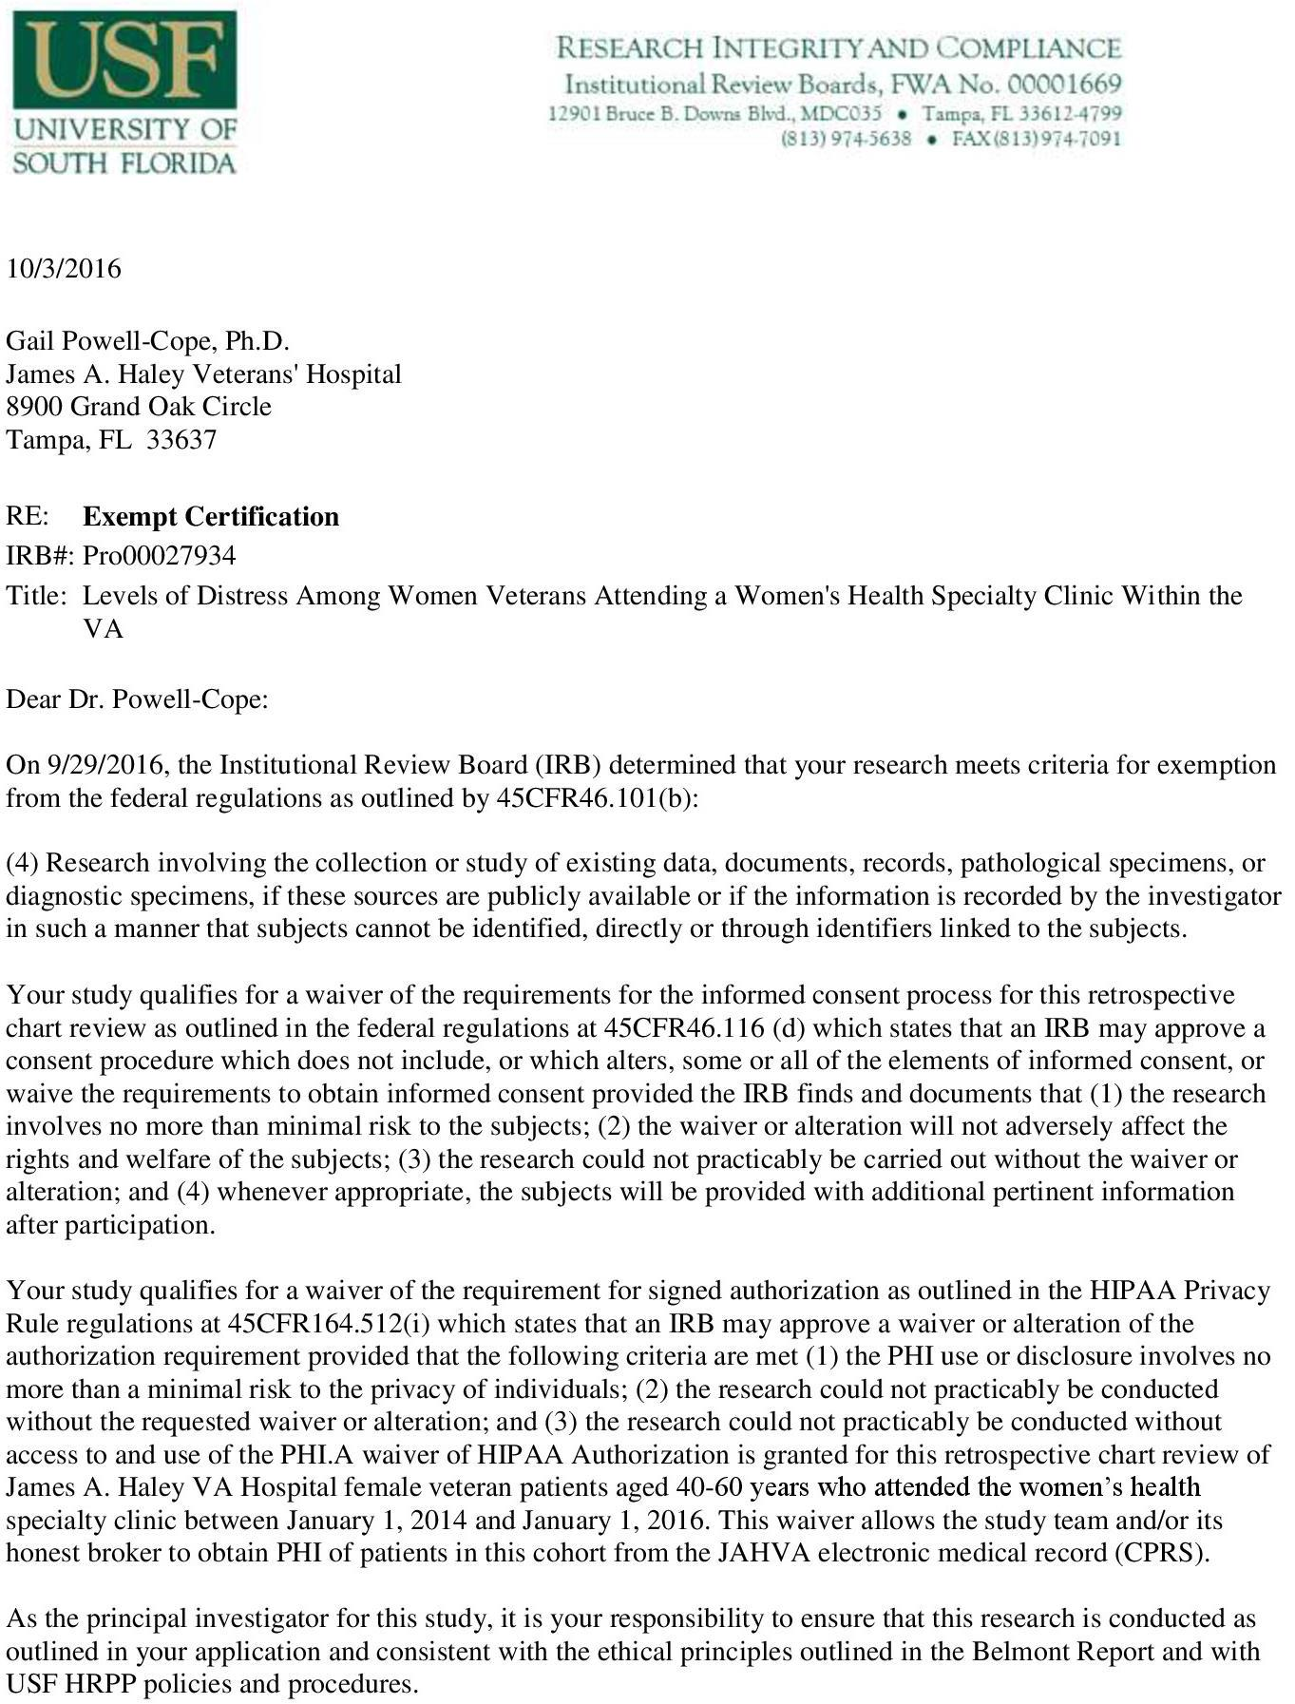

Appendix E: Institutional Review Board Approval Letter (continued)

10/20/2016

Gail Powell-Cope, Ph.D.
James A. Haley Veterans' Hospital
8900 Grand Oak Circle
Tampa, FL 33637

RE: Exempt Certification

IRB#: Pro00028305

Title: Levels of Distress Among Women Veterans Attending a Women's Health Specialty Clinic Within the VA

Dear Dr. Powell-Cope:

On 10/20/2016, the Institutional Review Board (IRB) determined that your research meets criteria for exemption from the federal regulations as outlined by 45CFR46.101 (b):

- Research involving the collection or study of existing data, documents, records, pathological specimens, or diagnostic specimens, if these sources are publicly available or if the information is recorded by the investigator in such a manner that subjects cannot be identified, directly or through identifiers linked to the subjects.

Your study qualifies for a waiver of the requirements for the informed consent process for this retrospective chart review as outlined in the federal regulations at 45CFR46.116 (d) which states that an IRB may approve a consent procedure which does not include, or which alters, some or all of the elements of informed consent, or waive the requirements to obtain informed consent provided the IRB finds and documents that (1) the research involves no more than minimal risk to the subjects; (2) the waiver or alteration will not adversely affect the rights and welfare of the subjects; (3) the research could not practicably be carried out without the waiver or alteration; and (4) whenever appropriate, the subjects will be provided with additional pertinent information after participation.

Your study qualifies for a waiver of the requirement for signed authorization as outlined in the HIPAA Privacy Rule regulations at 45CFR164.512 (i) which states that an IRB may approve a waiver or alteration of the authorization requirement provided that the following criteria are met

- the PHI use or disclosure involves no more than a minimal risk to the privacy of individuals;

- the research could not practicably be conducted without the requested waiver or alteration; and (3) the research could not practicably be conducted without access to and use of the PHI. A

Appendix E: James A. Haley Veterans’ Hospital Approval Letter (continued)
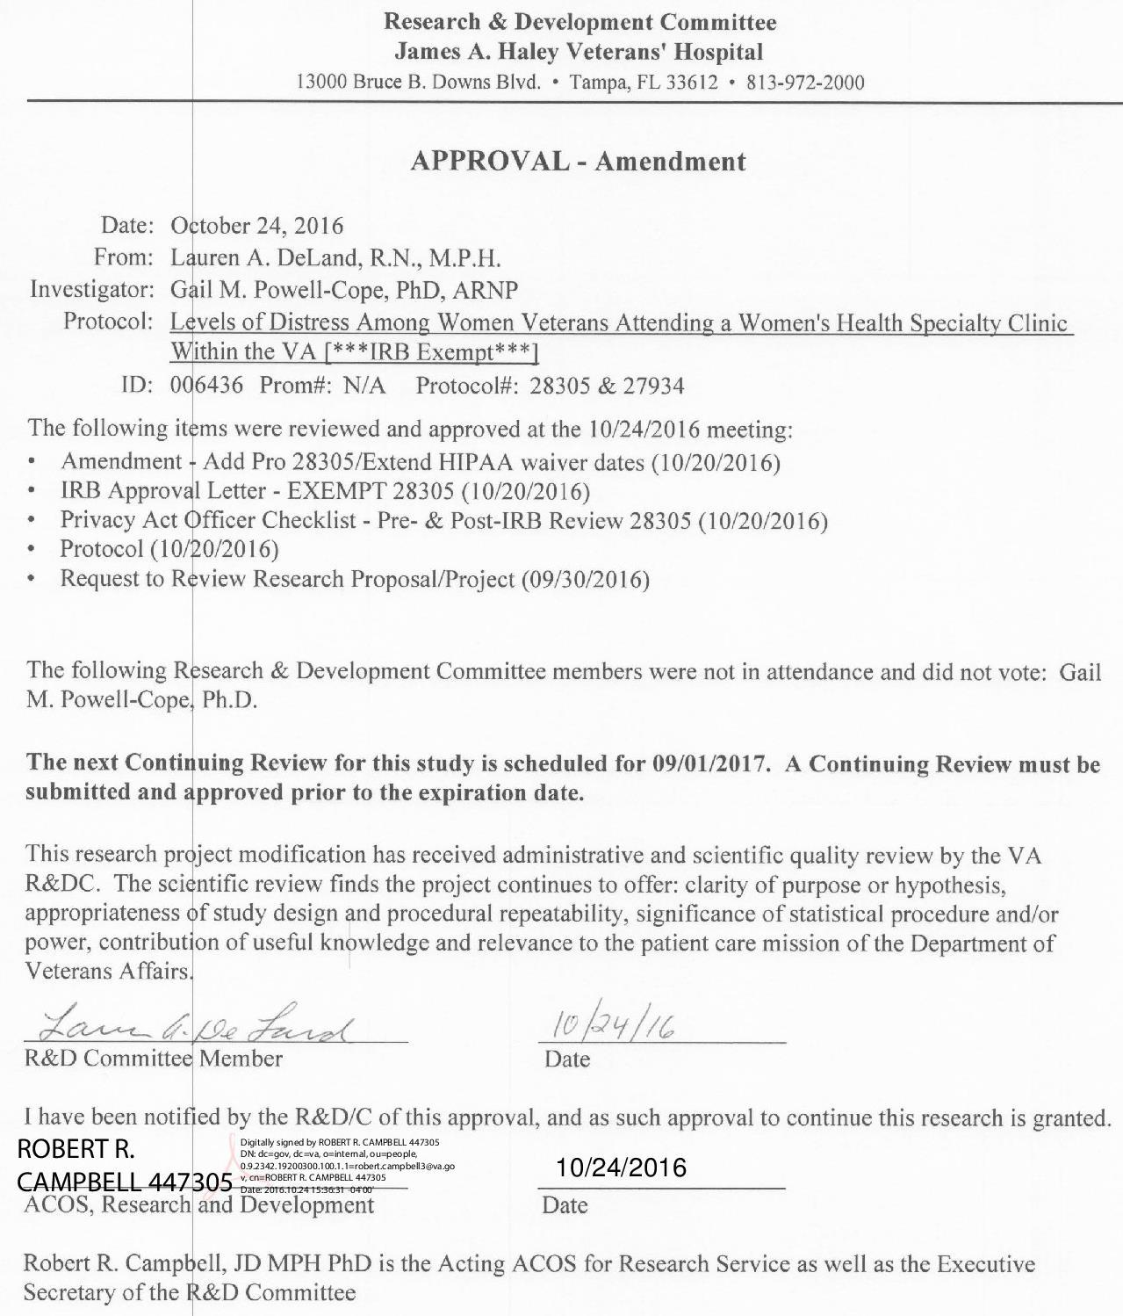

Appendix F: Permission Letter/Statement

Appendix F: JAMA Permission Letter
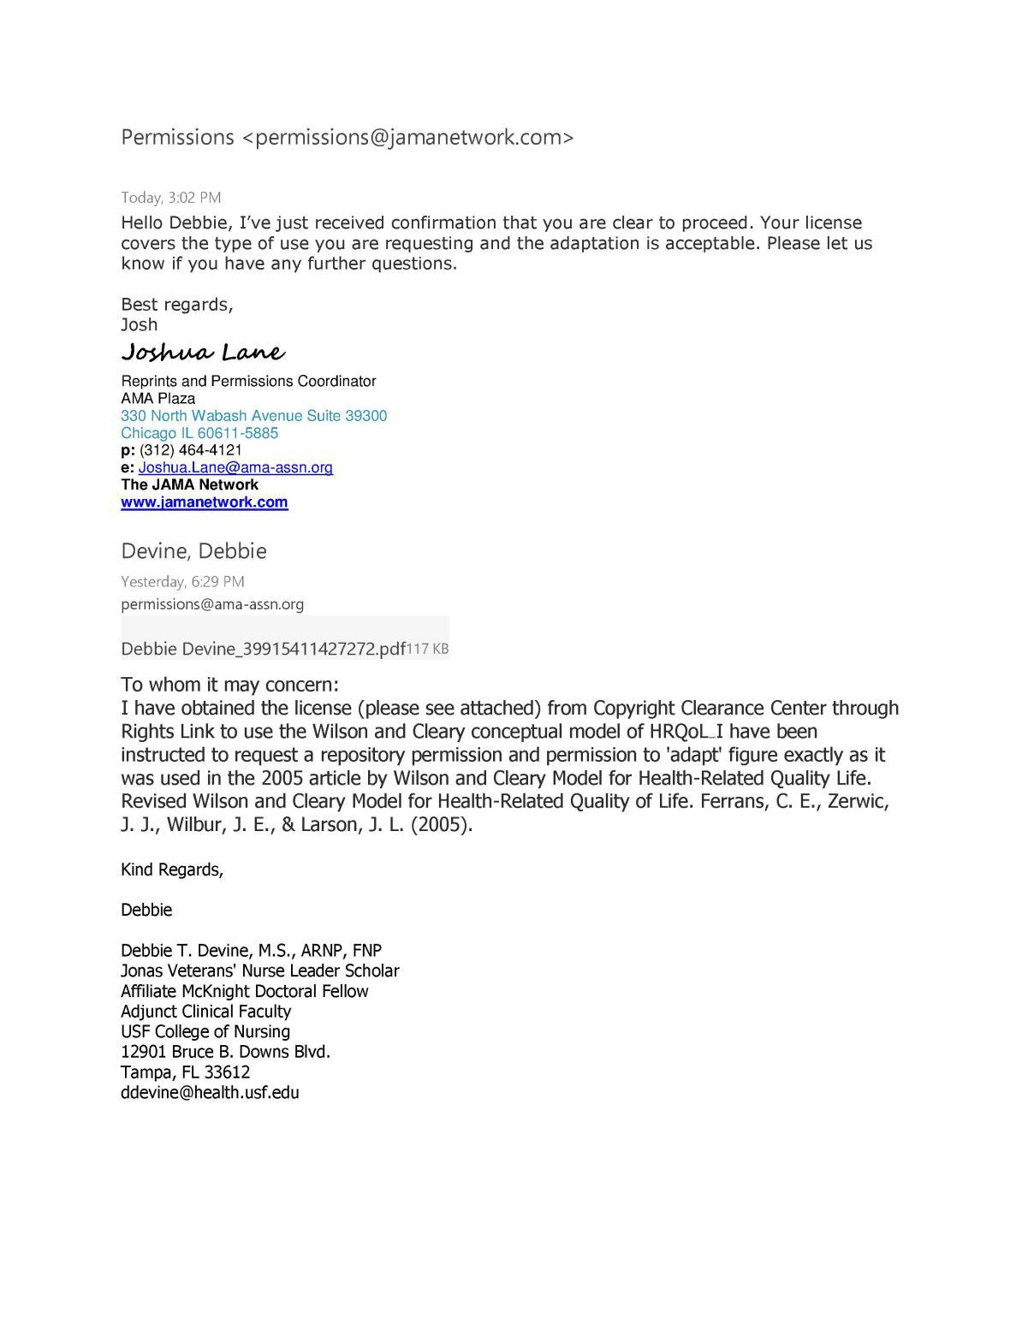

Appendix F: BioMed Central Permission Statement

