**Supplemental Materials**

**Table of Contents**

Table of Contents ………………………………………………………………………………………………………………………….. ii

Literature Search …………………….…………………………………………………………………………………………………….. 1

Database Search Terms …………..…………………………………………………………………………………………………….. 3

Direct Comparison Data Summary …………………………………………………………………………………………………. 5

Quality Evaluation Key …………………………………………………………………………………………………………………... 9

Quality Evaluation for All Included Articles ……………………………………………………………………………………. 10

Meta Regression …………………………………………………………………………………………………………………………… 14

Funnel Plots ………………………………………………………………………………………………………………………………….. 15

Forest Plots …………………………………………………………………………………………………………………………………… 17

Rank Probabilities …………………………………………………………………………………………………………………………. 30

Cumulative Rank Probabilities ………………………………………………………………………………………………………. 31

Top Rank Probabilities for Most Effective Treatment ……………………………………………………………………. 32

Articles with Quantitative and Qualitative Heterogeneity …………………………………………………………….. 34

Excluded Articles ………………………………………………………………………………………………………………………...… 35

Articles Excluded as Not Best Available Evidence …………………………………………………………….……………. 86

**Literature Search**

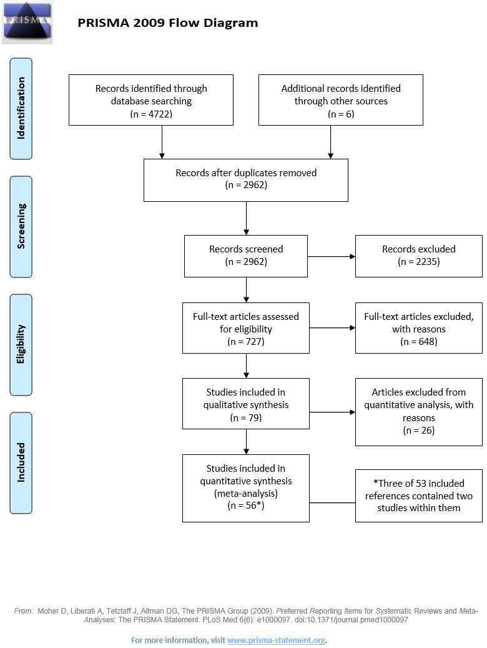

PubMed  
All years   
1,672 Citations

Embase   
All years   
2,089 Citations

CENTRAL   
All years   
961 Citations

2,956 Non-Duplicate   
Citations Screened

6 Articles Retrieved Through Manual   
Bibliography Search

2,235 Articles Excluded After Title/Abstract Screen

26 Articles Excluded During Data Extractions

53 References included

648 Articles Excluded After Full Text Screen

727 Total Articles Retrieved

**Inclusion/Exclusion Criteria:**Written in English language  
Study performed using human subjects  
RCT design   
Population > 80% otherwise healthy OAK patients   
Contained treatment(s), outcome(s), and comparison(s) of interest   
> 30 patients per study group   
Follow-up > 28 days

**Inclusion/Exclusion Criteria:**Written in English language  
Study performed using human subjects  
RCT design   
Population > 80% otherwise healthy OAK patients   
Contained treatment(s), outcome(s), and comparison(s) of interest   
> 30 patients per study group   
Follow-up > 28 days

**Best Evidence Inclusion/Exclusion Criteria:**

Articles rated high quality (when >3 available)   
Consistent durations within each comparison   
Statistical heterogeneity present, with potential confounding treatments, >20% loss to follow-up, inadequate reporting, or inconsistent number of injections being compared

**Database: PubMed**

**Interface**: <http://www.ncbi.nlm.nih.gov/pubmed/>

#1 "Osteoarthritis, Knee"[mh] OR (("Knee"[mh] OR "Knee Joint"[mh]) AND "Osteoarthritis"[mh]) OR (knee*[tiab] AND (osteoarthriti*[tiab] OR osteoarthros*[tiab] OR arthrosis[tiab] OR arthriti*[tiab])) OR gonarthros*[tiab] OR gonitis[tiab] OR gonarthritis[tiab]

#2 "Injections, Intra-Articular"[mh] OR ((intraarticular[tiab] OR "intra articular"[tiab]) AND (delivery[tiab] OR administration[tiab] OR injection*[tiab] OR infusion[tiab]))

#3 "Hyaluronic Acid"[mh] OR hyaluron*[tiab] OR "hylan"[tiab]

#4 "Adrenal Cortex Hormones"[mh] OR corticoid*[tiab] OR cortical[tiab] OR corticosteroid*[tiab] OR "cortico steroid"[tiab] OR corticotherapy[tiab]

#5 "Platelet-Rich Plasma"[mh] OR "platelet rich plasma"[tiab]

#6 "Ibuprofen"[mh] OR "ibuprofen"[tiab] OR "ibuprophen"[tiab]

#7 "naproxen"[mh] OR naproxen[tiab]

#8 "Acetaminophen"[mh] OR "paracetamol"[tiab] OR "acetaminophen"[tiab]

#9 "celecoxib"[nm] OR "celecoxib"[tiab]

#10 "Diclofenac"[mh] OR "diclofenac"[tiab]

#11 (animal[mh] NOT human[mh]) OR cadaver[mh] OR cadaver*[ti] OR comment[pt] OR editorial[pt] OR letter[pt] OR "historical article"[pt] OR addresses[pt] OR news[pt] OR "newspaper article"[pt] OR "case report"[ti]

#12 #2 AND #4

#13 #1 AND (#3 OR #5 OR #6 OR #7 OR #8 OR #9 OR #10 OR #12)

#14 (#13 NOT #11) AND English[la]

**Database: Embase**

**Interface**: <http://www.embase.com/>

#1 'knee osteoarthritis'/exp OR 'knee arthritis'/exp/dm_dt,dm_th,dm_dr,dm_si,dm_dm OR gonarthros*:ti,ab OR gonitis:ti,ab OR gonarthritis:ab,ti OR (knee* NEAR/3 (osteoarthriti* OR osteoarthros* OR arthrosis OR arthriti*)):ab,ti

#2 'intraarticular drug administration'/exp OR (joint* NEAR/2 (infusion* OR injection*)):ab,ti OR ((intraarticular OR 'intra articular') NEAR/2 (delivery OR administration OR injection*)):ab,ti

#3 'hyaluronic acid'/exp/dd_ar OR '31799 91 4':rn OR '9004 61 9':rn OR '9067 32 7':rn OR hyaluron*:ab,ti OR 'hylan':ab,ti

#4 'corticosteroid'/exp OR 'corticosteroid therapy'/exp OR corticoid*:ab,ti OR cortical:ab,ti OR corticosteroid*:ab,ti OR 'cortico steroid':ab,ti OR corticotherapy:ab,ti

#5 #2 AND #4

#6 'thrombocyte rich plasma'/exp OR 'platelet-rich plasma cell'/exp OR 'platelet rich plasma':ab,ti

#7 'ibuprofen'/exp OR ibuprofen:ab,ti OR ibuprophen:ab,it OR '15687 27 1':rn OR '31121 93 4':rn OR '527688 20 6':rn OR '79261 49 7':rn

#8 'naproxen'/exp OR naproxen:ab,ti OR '22204 53 1':rn OR '26159 34 2':rn

#9 'paracetamol'/exp OR paracetemol:ab,ti OR acetaminophen:ab,ti OR '103 90 2':rn

#10 'celecoxib'/exp OR celecoxib:ab,ti OR '169590 42 5':rn

#11 'diclofenac'/exp OR diclofenac:ti,ab OR '15307 79 6':rn OR '15307 86 5':rn

#12 cadaver/de OR 'in vitro study'/exp OR 'abstract report'/de OR book/de OR editorial/de OR note/de OR letter/de OR 'case study'/de OR 'case report'/de OR 'conference abstract'/it

#13 #1 AND (#3 OR #5 OR #6 OR #7 OR #8 OR #9 OR #10 OR #11)

#14 (#13 NOT #12) AND [english]/lim

**Database: Cochrane Central Register of Controlled Trials (CENTRAL)**

**Interface**: Wiley Online Library (<http://onlinelibrary.wiley.com/cochranelibrary/search>)

#1 [mh "Osteoarthritis, Knee"] OR (([mh "Knee"] OR [mh "Knee Joint"]) AND [mh "Osteoarthritis"]) OR (knee*:ti,ab,kw AND (osteoarthriti*:ti,ab,kw OR osteoarthros*:ti,ab,kw OR arthrosis:ti,ab,kw OR arthriti*:ti,ab,kw)) OR gonarthros*:ti,ab,kw OR gonitis:ti,ab,kw OR gonarthritis:ti,ab,kw

#2 [mh "Injections, Intra-Articular"] or ((intraarticular:ti,ab,kw or "intra articular":ti,ab,kw) near/2 (delivery:ti,ab,kw or administration:ti,ab,kw or injection*:ti,ab,kw or infusion:ti,ab,kw))

#3 [mh "Hyaluronic Acid"] OR hyaluron*:ti,ab,kw OR "hylan":ti,ab,kw

#4 [mh "Adrenal Cortex Hormones"] OR corticoid*:ti,ab,kw OR cortical:ti,ab,kw OR corticosteroid*:ti,ab,kw OR "cortico steroid":ti,ab,kw OR corticotherapy:ti,ab,kw

#5 [mh "Platelet-Rich Plasma"] OR "platelet rich plasma":ti,ab,kw

#6 [mh "Ibuprofen"] OR "ibuprofen":ti,ab,kw OR "ibuprophen":ti,ab,kw

#7 [mh "naproxen"] OR "naproxen":ti,ab,kw

#8 [mh "Acetaminophen"] OR "paracetamol":ti,ab,kw OR "acetaminophen":ti,ab,kw

#9 "celecoxib":ti,ab,kw

#10 [mh "Diclofenac"] OR "diclofenac":ti,ab,kw

#11 #2 AND #4

#12 #1 AND (#3 OR #5 OR #6 OR #7 OR #8 OR #9 OR #10 OR #11)

#13 "conference abstract":pt

#14 #12 not #13

**Table S1. OAK Direct Comparison Data Summary**

| **Reference** | **Individual Direct Comparison** | **Favored Group** | **Outcome Domain** | **Quality** | **Total N** | **Statistical Significance** | **Clinical Significance** |
| --- | --- | --- | --- | --- | --- | --- | --- |
| Altman,R.D., 2007 | Acetaminophen Vs Oral Placebo | Acetaminophen | Pain | Moderate | 320 | Yes | No |
| Herrero-Beaumont,G., 2007 | Acetaminophen Vs Oral Placebo | Acetaminophen | Pain | High | 216 | No | No |
| Pincus,T., 2004 (A) | Acetaminophen Vs Oral Placebo | Acetaminophen | Pain | Moderate | 342 | Yes | No |
| Pincus,T., 2004 (B) | Acetaminophen Vs Oral Placebo | Acetaminophen | Pain | Moderate | 370 | Yes | No |
| Prior,M.J., 2014 | Acetaminophen Vs Oral Placebo | Acetaminophen | Pain | Moderate | 534 | Yes | No |
| Geba,G.P., 2002 | Celecoxib Vs Acetaminophen | Celecoxib | Pain | High | 191 | No | No |
| Pincus,T., 2004 (A) | Celecoxib Vs Acetaminophen | Celecoxib | Pain | Moderate | 352 | No | No |
| Pincus,T., 2004 (B) | Celecoxib Vs Acetaminophen | Celecoxib | Pain | Moderate | 374 | Yes | No |
| Schnitzer,T.J., 2005 | Celecoxib Vs Acetaminophen | Celecoxib | Pain | High | 792 | Yes | No |
| McKenna,F., 2001 (B) | Celecoxib Vs Diclofenac | Diclofenac | Pain | Moderate | 398 | No | No |
| Essex,M.N., 2012 | Celecoxib Vs Naproxen | Naproxen | Pain | High | 249 | No | No |
| Essex,M.N., 2014 | Celecoxib Vs Naproxen | Celecoxib | Pain | High | 254 | No | No |
| Hochberg,M.C., 2011 (A) | Celecoxib Vs Naproxen | Naproxen | Pain | High | 488 | No | No |
| Hochberg,M.C., 2011 (B) | Celecoxib Vs Naproxen | Naproxen | Pain | High | 485 | No | No |
| Birbara,C., 2006 (A) | Celecoxib Vs Oral Placebo | Celecoxib | Pain | High | 245 | No | No |
| Birbara,C., 2006 (B) | Celecoxib Vs Oral Placebo | Celecoxib | Pain | High | 234 | No | No |
| Clegg,D.O., 2006 | Celecoxib Vs Oral Placebo | Celecoxib | Pain | High | 631 | No | No |
| Conaghan,P.G., 2013 | Celecoxib Vs Oral Placebo | Celecoxib | Pain | High | 460 | Yes | No |
| Essex,M.N., 2014 | Celecoxib Vs Oral Placebo | Celecoxib | Pain | High | 186 | No | No |
| Gibofsky,A., 2003 | Celecoxib Vs Oral Placebo | Celecoxib | Pain | High | 285 | Yes | No |
| Hochberg,M.C., 2011 (A) | Celecoxib Vs Oral Placebo | Celecoxib | Pain | High | 366 | Yes | No |
| Lehmann,R., 2005 | Celecoxib Vs Oral Placebo | Celecoxib | Pain | High | 844 | Yes | No |
| McKenna,F., 2001 (A) | Celecoxib Vs Oral Placebo | Celecoxib | Pain | High | 123 | No | No |
| Rother,M., 2007 | Celecoxib Vs Oral Placebo | Celecoxib | Pain | High | 259 | Yes | No |
| Sheldon,E., 2005 | Celecoxib Vs Oral Placebo | Celecoxib | Pain | High | 775 | Yes | No |
| Tannenbaum,H., 2004 | Celecoxib Vs Oral Placebo | Celecoxib | Pain | High | 724 | Yes | No |
| Verkleij,S.P., 2015 | Diclofenac Vs Acetaminophen | Acetaminophen | Pain | Moderate | 104 | No | No |
| Dickson,D.J., 2001 | Diclofenac Vs IA Placebo | IA Placebo | Pain | Moderate | 112 | No | No |
| Gibofsky,A., 2014 | Diclofenac Vs Oral Placebo | Diclofenac | Pain | High | 201 | Yes | No |
| Sandelin,J., 1997 | Diclofenac Vs Oral Placebo | Diclofenac | Pain | High | 157 | Yes | No |
| Sangdee,C., 2002 | Diclofenac Vs Oral Placebo | Diclofenac | Pain | High | 94 | Yes | No |
| Simon,L.S., 2009 | Diclofenac Vs Oral Placebo | Diclofenac | Pain | High | 306 | Yes | No |
| Housman,L., 2014 | HA V IA Corticosteroids | IA Corticosteroids | Pain | High | 262 | Yes | No |
| Leighton,R., 2014 | HA V IA Corticosteroids | IA Corticosteroids | Pain | Moderate | 386 | No | No |
| Filardo,G., 2012 | HA V PRP | PRP | Pain | High | 109 | No | No |
| Filardo,G., 2015 | HA V PRP | PRP | Pain | High | 183 | No | No |
| Gormeli,G., 2015 | HA V PRP | PRP | Pain | High | 78 | No | No |
| Dickson,D.J., 2001 | HA Vs Diclofenac | HA | Pain | Moderate | 108 | No | No |
| Altman,R.D., 2004 | HA Vs IA Placebo | IA Placebo | Pain | High | 346 | No | No |
| Altman,R.D., 2009 | HA Vs IA Placebo | HA | Pain | High | 586 | No | No |
| Arden,N.K., 2014 | HA Vs IA Placebo | IA Placebo | Pain | High | 218 | No | No |
| Baltzer,A.W., 2009 | HA Vs IA Placebo | IA Placebo | Pain | High | 242 | No | No |
| Chevalier,X., 2010 | HA Vs IA Placebo | HA | Pain | High | 253 | No | No |
| Gormeli,G., 2015 | HA Vs IA Placebo | HA | Pain | High | 79 | No | No |
| Henderson,E.B., 1994 | HA Vs IA Placebo | Neither | Pain | High | 84 | No | No |
| Huang,T.L., 2011 | HA Vs IA Placebo | HA | Pain | High | 198 | Yes | No |
| Lundsgaard,C., 2008 | HA Vs IA Placebo | HA | Pain | High | 162 | No | No |
| Neustadt,D., 2005 | HA Vs IA Placebo | HA | Pain | High | 229 | No | No |
| Pham,T., 2004 | HA Vs IA Placebo | IA Placebo | Pain | High | 216 | No | No |
| van der Weegen,W., 2015 | HA Vs IA Placebo | IA Placebo | Pain | High | 196 | No | No |
| Altman,R.D., 1998 | HA Vs Naproxen | Naproxen | Pain | Moderate | 290 | No | No |
| Chao,J., 2010 | IA Corticosteroids Vs IA Placebo | IA Corticosteroids | Pain | High | 67 | No | No |
| Gaffney,K., 1995 | IA Corticosteroids Vs IA Placebo | IA Corticosteroids | Pain | Moderate | 83 | No | No |
| Raynauld,J.-P., 2003 | IA Corticosteroids Vs IA Placebo | IA Corticosteroids | Pain | High | 66 | No | No |
| Bradley,J.D., 1991 | Ibuprofen Vs Acetaminophen | Ibuprofen | Pain | High | 121 | Yes | No |
| Davies,G.M., 1999 | Ibuprofen Vs Oral Placebo | Ibuprofen | Pain | High | 104 | No | No |
| Puopolo,A., 2007 | Ibuprofen Vs Oral Placebo | Ibuprofen | Pain | High | 320 | Yes | No |
| Williams,H.J., 1993 | Naproxen Vs Acetaminophen | Naproxen | Pain | Moderate | 148 | No | No |
| Altman,R.D., 1998 | Naproxen Vs IA Placebo | Naproxen | Pain | Moderate | 303 | No | No |
| Essex,M.N., 2014 | Naproxen Vs Oral Placebo | Naproxen | Pain | High | 190 | No | No |
| Hochberg,M.C., 2011 (A) | Naproxen Vs Oral Placebo | Naproxen | Pain | High | 370 | Yes | No |
| Hochberg,M.C., 2011 (B) | Naproxen Vs Oral Placebo | Naproxen | Pain | High | 363 | Yes | No |
| Schnitzer,T.J., 2010 | Naproxen Vs Oral Placebo | Naproxen | Pain | High | 333 | Yes | No |
| Schnitzer,T.J., 2011 | Naproxen Vs Oral Placebo | Naproxen | Pain | High | 511 | Yes | No |
| Svensson,O., 2006 | Naproxen Vs Oral Placebo | Naproxen | Pain | High | 355 | Yes | No |
| Gormeli,G., 2015 | PRP Vs IA Placebo | PRP | Pain | High | 79 | No | No |
| Herrero-Beaumont,G., 2007 | Acetaminophen Vs Oral Placebo | Acetaminophen | Function | High | 212 | No | No |
| Prior,M.J., 2014 | Acetaminophen Vs Oral Placebo | Acetaminophen | Function | Moderate | 542 | Yes | No |
| Geba,G.P., 2002 | Celecoxib Vs Acetaminophen | Celecoxib | Function | High | 191 | No | No |
| Schnitzer,T.J., 2005 | Celecoxib Vs Acetaminophen | Celecoxib | Function | High | 792 | Yes | No |
| McKenna,F., 2001 | Celecoxib Vs Diclofenac | Diclofenac | Function | Moderate | 398 | No | No |
| Essex,M.N., 2012 | Celecoxib Vs Naproxen | Naproxen | Function | High | 249 | No | No |
| Essex,M.N., 2014 | Celecoxib Vs Naproxen | Celecoxib | Function | High | 254 | No | No |
| Hochberg,M.C., 2011 (A) | Celecoxib Vs Naproxen | Neither | Function | High | 488 | No | No |
| Hochberg,M.C., 2011 (B) | Celecoxib Vs Naproxen | Naproxen | Function | High | 485 | No | No |
| Birbara,C., 2006 (A) | Celecoxib Vs Oral Placebo | Celecoxib | Function | High | 234 | No | No |
| Birbara,C., 2006 (B) | Celecoxib Vs Oral Placebo | Celecoxib | Function | High | 246 | No | No |
| Essex,M.N., 2014 | Celecoxib Vs Oral Placebo | Celecoxib | Function | High | 186 | Yes | No |
| Gibofsky,A., 2003 | Celecoxib Vs Oral Placebo | Celecoxib | Function | High | 285 | Yes | Yes |
| Hochberg,M.C., 2011 (A) | Celecoxib Vs Oral Placebo | Celecoxib | Function | High | 366 | Yes | Yes |
| Hochberg,M.C., 2011 (B) | Celecoxib Vs Oral Placebo | Celecoxib | Function | High | 366 | Yes | No |
| Lehmann,R., 2005 | Celecoxib Vs Oral Placebo | Celecoxib | Function | High | 844 | Yes | No |
| Rother,M., 2007 | Celecoxib Vs Oral Placebo | Celecoxib | Function | High | 259 | Yes | No |
| Sheldon,E., 2005 | Celecoxib Vs Oral Placebo | Celecoxib | Function | High | 775 | Yes | No |
| Tannenbaum,H., 2004 | Celecoxib Vs Oral Placebo | Celecoxib | Function | High | 724 | Yes | No |
| Verkleij,S.P., 2015 | Diclofenac Vs Acetaminophen | Acetaminophen | Function | Moderate | 104 | No | No |
| Dickson,D.J., 2001 | Diclofenac Vs IA Placebo | Diclofenac | Function | Moderate | 112 | No | No |
| Dickson,D.J., 2001 | Diclofenac Vs Oral Placebo | Diclofenac | Function | Moderate | 112 | No | No |
| McKenna,F., 2001 | Diclofenac Vs Oral Placebo | Diclofenac | Function | Moderate | 399 | Yes | Yes |
| Sangdee,C., 2002 | Diclofenac Vs Oral Placebo | Diclofenac | Function | High | 94 | No | No |
| Simon,L.S., 2009 | Diclofenac Vs Oral Placebo | Diclofenac | Function | High | 306 | Yes | No |
| Dickson,D.J., 2001 | HA Vs Diclofenac | HA | Function | Moderate | 108 | No | No |
| Altman,R.D., 2004 | HA Vs IA Placebo | IA Placebo | Function | High | 346 | No | No |
| Arden,N.K., 2014 | HA Vs IA Placebo | HA | Function | High | 218 | No | No |
| Baltzer,A.W., 2009 | HA Vs IA Placebo | IA Placebo | Function | High | 242 | No | No |
| Huang,T.L., 2011 | HA Vs IA Placebo | HA | Function | High | 198 | Yes | No |
| van der Weegen,W., 2015 | HA Vs IA Placebo | HA | Function | High | 196 | No | No |
| Leighton,R., 2014 | HA Vs IA Corticosteroids | IA Corticosteroids | Function | Moderate | 386 | No | No |
| Filardo,G., 2012 | HA Vs PRP | PRP | Function | High | 109 | No | No |
| Filardo,G., 2015 | HA Vs PRP | PRP | Function | High | 183 | No | No |
| Henriksen,M., 2015 | IA Corticosteroids Vs IA Placebo | PRP | Function | High | 100 | No | No |
| Raynauld,J.-P., 2003 | IA Corticosteroids Vs IA Placebo | PRP | Function | High | 66 | No | No |
| Bradley,J.D., 1991 | Ibuprofen Vs Acetaminophen | Ibuprofen | Function | High | 121 | No | No |
| Davies,G.M., 1999 | Ibuprofen Vs Oral Placebo | Ibuprofen | Function | High | 104 | No | No |
| Puopolo,A., 2007 | Ibuprofen Vs Oral Placebo | Ibuprofen | Function | High | 318 | Yes | No |
| Essex,M.N., 2014 | Naproxen Vs Oral Placebo | Naproxen | Function | High | 190 | Yes | No |
| Hochberg,M.C., 2011 (A) | Naproxen Vs Oral Placebo | Naproxen | Function | High | 370 | Yes | Yes |
| Hochberg,M.C., 2011 (B) | Naproxen Vs Oral Placebo | Naproxen | Function | High | 363 | Yes | Yes |
| Schnitzer,T.J., 2010 | Naproxen Vs Oral Placebo | Naproxen | Function | High | 447 | Yes | Yes |
| Schnitzer,T.J., 2011 | Naproxen Vs Oral Placebo | Naproxen | Function | High | 511 | Yes | Yes |
| Svensson,O., 2006 | Naproxen Vs Oral Placebo | Naproxen | Function | High | 350 | Yes | Yes |

**Table S2. Quality Evaluation Key**

|  |  |
| --- | --- |
| **Overall Article Quality** | **Quality Flaw Count** |
| High Quality | <2 Flaws |
| Moderate Quality | 2 - 3.5 Flaws |



**Table S3. Quality Evaluation for All Included Articles: Randomized Trials**

| **Reference** | **Random Sequence Generation** | **Allocation Concealment** | **Blinding** | **Incomplete Outcome Data** | **Selective Reporting** | **Other Bias** | **Inclusion in Data Analysis** | **Quality** |
| --- | --- | --- | --- | --- | --- | --- | --- | --- |
| Altman,R.D., 1998 |  |  |  |  |  |  | Included | Moderate Quality |
| Altman,R.D., 2004 |  |  |  |  |  |  | Included | High Quality |
| Altman,R.D., 2007 |  |  |  |  |  |  | Included | Moderate Quality |
| Altman,R.D., 2009 |  |  |  |  |  |  | Included | High Quality |
| Arden,N.K., 2014 |  |  |  |  |  |  | Included | High Quality |
| Asmus,M.J., 2014 (A) |  |  |  |  |  |  | **Not best available** | Moderate Quality |
| Asmus,M.J., 2014 (B) |  |  |  |  |  |  | **Not best available** | Moderate Quality |
| Baltzer,A.W., 2009 |  |  |  |  |  |  | Included | High Quality |
| Bensen,W.G., 1999 |  |  |  |  |  |  | **Not best available** | High Quality |
| Bingham,C.O.,III, 2007 (A) |  |  |  |  |  |  | **Not best available** | Moderate Quality |
| Bingham,C.O.,III, 2007 (B) |  |  |  |  |  |  | **Not best available** | Moderate Quality |
| Birbara,C., 2006 (A) |  |  |  |  |  |  | Included | High Quality |
| Birbara,C., 2006 (B) |  |  |  |  |  |  | Included | High Quality |
| Boswell,D.J., 2008 |  |  |  |  |  |  | **Not best available** | Moderate Quality |
| Bradley,J.D., 1991 |  |  |  |  |  |  | Included | High Quality |
| Caborn,D., 2004 |  |  |  |  |  |  | **Not best available** | Moderate Quality |
| Chao,J., 2010 |  |  |  |  |  |  | Included | High Quality |
| Chevalier,X., 2010 |  |  |  |  |  |  | Included | High Quality |
| Clegg,D.O., 2006 |  |  |  |  |  |  | Included | High Quality |
| Conaghan,P.G., 2013 |  |  |  |  |  |  | Included | High Quality |
| Davies,G.M., 1999 |  |  |  |  |  |  | Included | High Quality |
| Day,R., 2004 |  |  |  |  |  |  | **Not best available** | High Quality |
| Dickson,D.J., 2001 |  |  |  |  |  |  | Included | Moderate Quality |
| Doherty,M., 2011 |  |  |  |  |  |  | **Not best available** | High Quality |
| Dougados,M., 1993 |  |  |  |  |  |  | **Not best available** | Moderate Quality |
| Ekman,E.F., 2014 (A) |  |  |  |  |  |  | **Not best available** | Moderate Quality |
| Ekman,E.F., 2014 (B) |  |  |  |  |  |  | **Not best available** | Moderate Quality |
| Essex,M.N., 2012 (A) |  |  |  |  |  |  | **Not best available** | Moderate Quality |
| Essex,M.N., 2012 (B) |  |  |  |  |  |  | Included | High Quality |
| Essex,M.N., 2014 |  |  |  |  |  |  | Included | High Quality |
| Essex,M.N., 2015 |  |  |  |  |  |  | **Not best available** | Moderate Quality |
| Filardo,G., 2012 |  |  |  |  |  |  | Included | High Quality |
| Filardo,G., 2015 |  |  |  |  |  |  | Included | High Quality |
| Fleischmann,R., 2006 |  |  |  |  |  |  | **Not best available** | Moderate Quality |
| Frizziero,L., 2002 |  |  |  |  |  |  | **Not best available** | Moderate Quality |
| Gaffney,K., 1995 |  |  |  |  |  |  | Included | Moderate Quality |
| Geba,G.P., 2002 |  |  |  |  |  |  | Included | High Quality |
| Ghosh,S., 2007 |  |  |  |  |  |  | **Not best available** | Moderate Quality |
| Gibofsky,A., 2003 |  |  |  |  |  |  | Included | High Quality |
| Gibofsky,A., 2014 |  |  |  |  |  |  | Included | High Quality |
| Gormeli,G., 2015 |  |  |  |  |  |  | Included | High Quality |
| Henderson,E.B., 1994 |  |  |  |  |  |  | Included | High Quality |
| Henriksen,M., 2015 |  |  |  |  |  |  | Included | High Quality |
| Herrero-Beaumont,G., 2007 |  |  |  |  |  |  | Included | High Quality |
| Hochberg,M.C., 2011 (A) |  |  |  |  |  |  | Included | High Quality |
| Hochberg,M.C., 2011 (B) |  |  |  |  |  |  | Included | High Quality |
| Housman,L., 2014 |  |  |  |  |  |  | Included | High Quality |
| Huang,T.L., 2011 |  |  |  |  |  |  | Included | High Quality |
| Huskisson,E.C., 1999 |  |  |  |  |  |  | **Not best available** | Moderate Quality |
| Jorgensen,A., 2010 |  |  |  |  |  |  | **Not best available** | High Quality |
| Jubb,R.W., 2003 |  |  |  |  |  |  | **Not best available** | Moderate Quality |
| Karlsson,J., 2002 |  |  |  |  |  |  | **Not best available** | Moderate Quality |
| Kivitz,A., 2002 |  |  |  |  |  |  | **Not best available** | High Quality |
| Lehmann,R., 2005 |  |  |  |  |  |  | Included | High Quality |
| Leighton,R., 2014 |  |  |  |  |  |  | Included | Moderate Quality |
| Lundsgaard,C., 2008 |  |  |  |  |  |  | Included | High Quality |
| McKenna,F., 2001 (B) |  |  |  |  |  |  | Included | High Quality |
| McKenna,F., 2001 (A) |  |  |  |  |  |  | Included | Moderate Quality |
| Miceli-Richard,C., 2004 |  |  |  |  |  |  | **Not best available** | Moderate Quality |
| Neustadt,D., 2005 |  |  |  |  |  |  | Included | High Quality |
| Pham,T., 2004 |  |  |  |  |  |  | Included | High Quality |
| Pincus,T., 2004 (A) |  |  |  |  |  |  | Included | Moderate Quality |
| Pincus,T., 2004 (B) |  |  |  |  |  |  | Included | Moderate Quality |
| Prior,M.J., 2014 |  |  |  |  |  |  | Included | Moderate Quality |
| Puopolo,A., 2007 |  |  |  |  |  |  | Included | High Quality |
| Raeissadat,S.A., 2015 |  |  |  |  |  |  | **Not best available** | Moderate Quality |
| Raynauld,J.-P., 2003 |  |  |  |  |  |  | Included | High Quality |
| Rother,M., 2007 |  |  |  |  |  |  | Included | High Quality |
| Sandelin,J., 1997 |  |  |  |  |  |  | Included | High Quality |
| Sangdee,C., 2002 |  |  |  |  |  |  | Included | High Quality |
| Schnitzer,T.J., 2005 |  |  |  |  |  |  | Included | High Quality |
| Schnitzer,T.J., 2010 |  |  |  |  |  |  | Included | High Quality |
| Schnitzer,T.J., 2011 |  |  |  |  |  |  | Included | High Quality |
| Sheldon,E., 2005 |  |  |  |  |  |  | Included | High Quality |
| Simon,L.S., 2009 |  |  |  |  |  |  | Included | High Quality |
| Smugar,S.S., 2006 (A) |  |  |  |  |  |  | **Not best available** | Moderate Quality |
| Smugar,S.S., 2006 (B) |  |  |  |  |  |  | **Not best available** | Moderate Quality |
| Strand,V., 2012 |  |  |  |  |  |  | **Not best available** | High Quality |
| Svensson,O., 2006 |  |  |  |  |  |  | Included | High Quality |
| Tannenbaum,H., 2004 |  |  |  |  |  |  | Included | High Quality |
| van der Weegen,W., 2015 |  |  |  |  |  |  | Included | High Quality |
| Verkleij,S.P., 2015 |  |  |  |  |  |  | Included | Moderate Quality |
| Williams,G.W., 2000 |  |  |  |  |  |  | **Not best available** | Moderate Quality |
| Williams,G.W., 2001 |  |  |  |  |  |  | **Not best available** | Moderate Quality |
| Williams,H.J., 1993 |  |  |  |  |  |  | Included | High Quality |
| Yavuz,U., 2012 |  |  |  |  |  |  | **Not best available** | Moderate Quality |

**Table S4. Meta-Regression**



*\*P-values show no statistically significant differences among quality appraisal components*

**Figure S1. Publication Bias Assessment: Funnel Plot for Meta-Analyzed Treatment Comparisons for Pain**



**Figure S2. Publication Bias Assessment: Funnel Plot for Meta-Analyzed Treatment Comparisons for Function**



**Figures S3- S27. Direct Comparison Forest Plots of “Best Available Evidence” for Target Outcomes**

**Figure S3. Acetaminophen vs. Oral Placebo (Pain)**

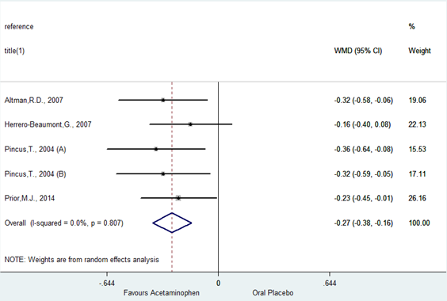

**Figure S4. Acetaminophen vs. Oral Placebo (Function)**

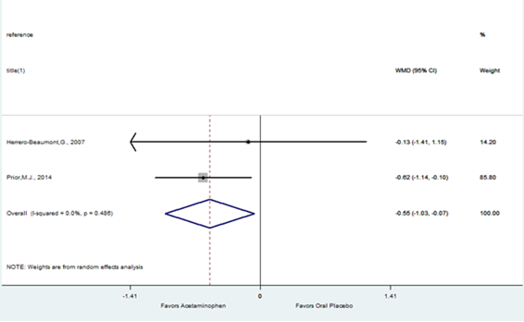

**Figure S5. Celecoxib vs. Acetaminophen (Pain)**

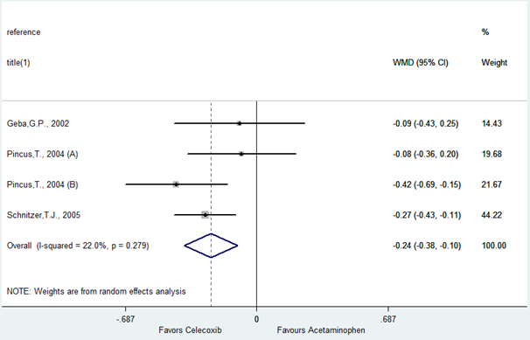

**Figure S6. Celecoxib vs. Acetaminophen (Function)**

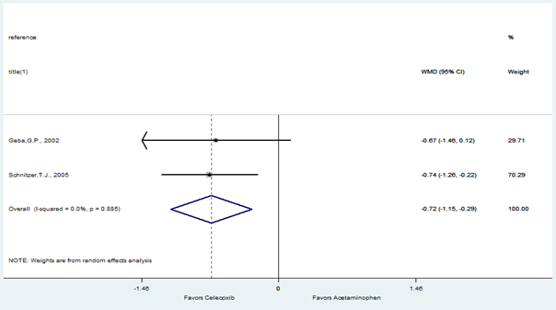

**Figure S7. Celecoxib vs. Naproxen (Pain)**

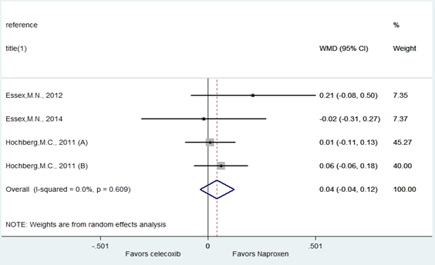

**Figure S8. Celecoxib vs. Naproxen (Function)**

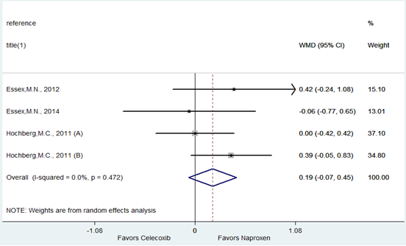

**Figure S9. Celecoxib vs. Oral Placebo (Pain)**

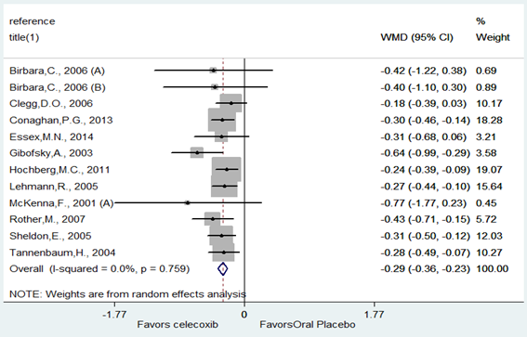

**Figure S10. Celecoxib vs. Oral Placebo (Function)**

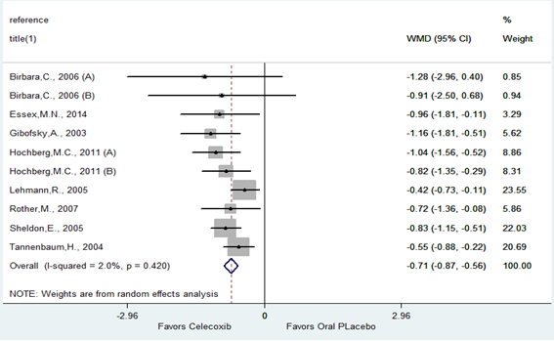

**Figure S11. Diclofenac vs. Oral Placebo (Pain)**

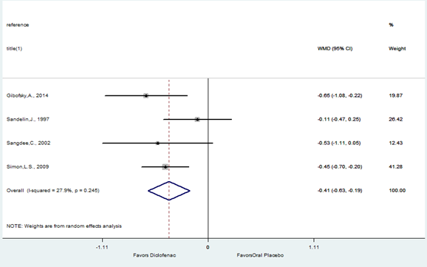

**Figure S12. Diclofenac vs. Oral Plcaebo (Function)**

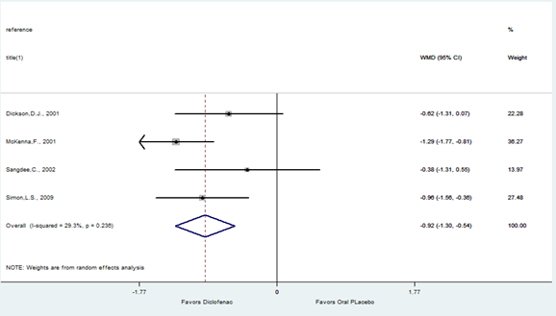

**Figure S13. HA vs. IA Steroid (Pain)**

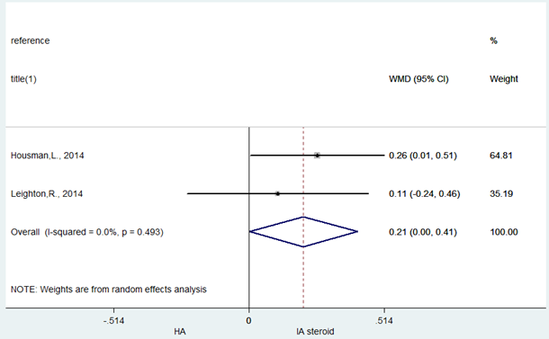

**Figure S14. HA vs. IA Steroid (Function)**

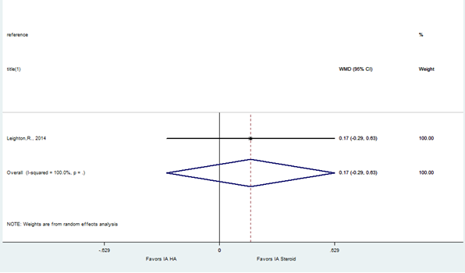

**Figure S15. HA vs. IA PRP (Pain)**

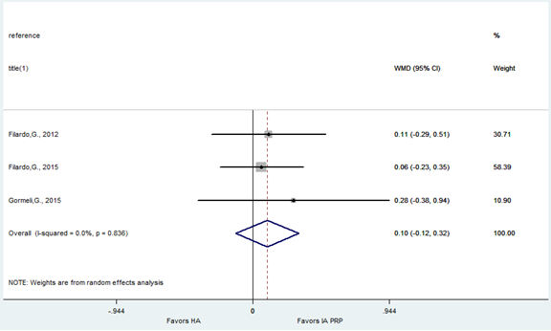

**Figure S16. HA vs. IA PRP (Function)**

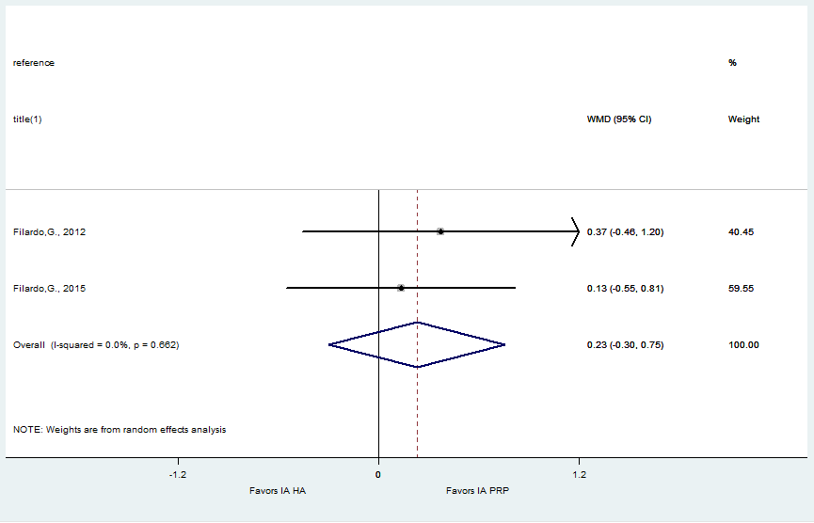

**Figure S17. HA vs. IA Placebo (Pain)**

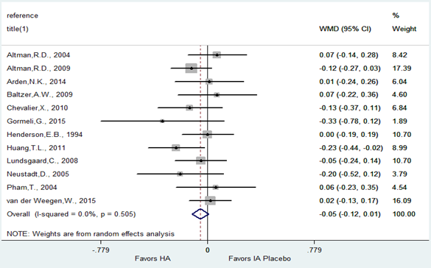

**Figure S18. HA vs. IA Placebo (Function)**

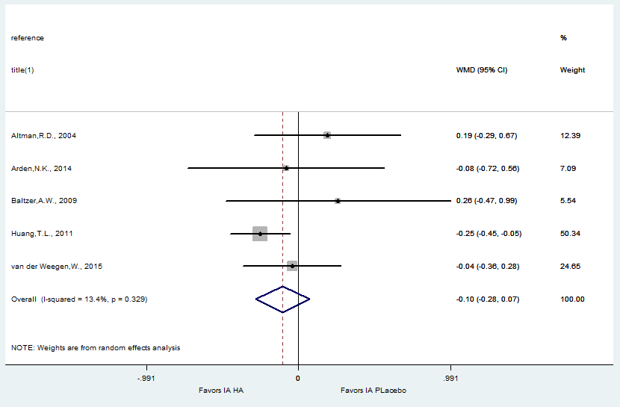

**Figure S19. IA Steroid vs. IA Placebo (Pain)**

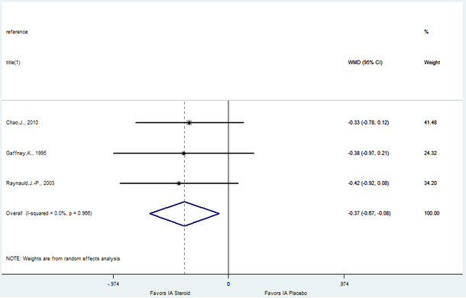

**Figure S20. Ibuprofen vs. Acetaminophen (Pain)**

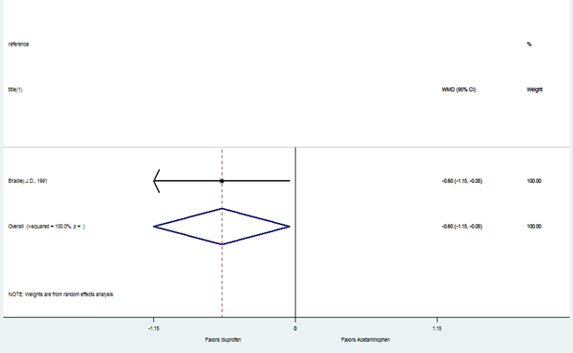

**Figure S21. Ibuprofen vs. Oral Placebo (Pain)**

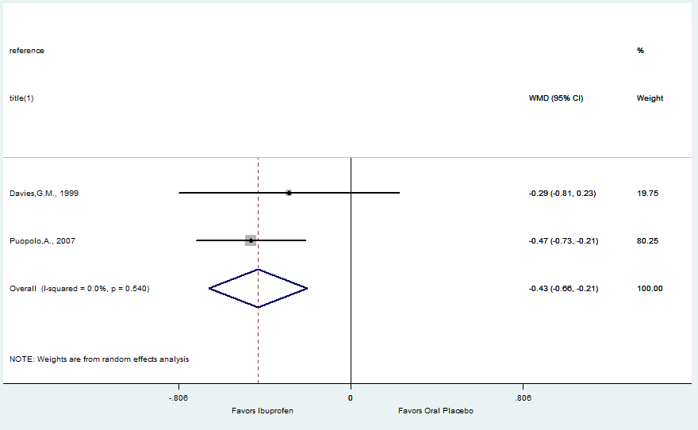

**Figure S22. Ibuprofen vs. Oral Placebo (Function)**

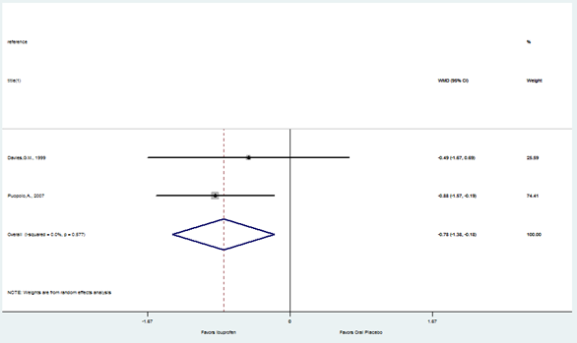

**Figure S23. Naproxen vs. Oral Placebo (Pain)**

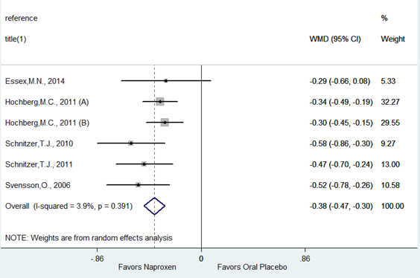

**Figure S24. Naproxen vs. Oral Placebo (Function)**

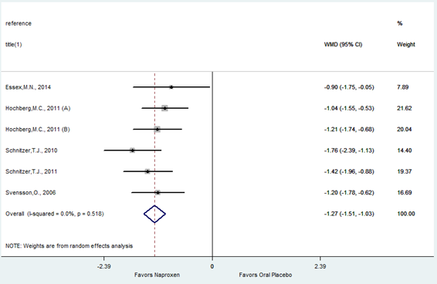

**Figure S25. Individual Comparisons Found Only in One Study (Pain)**

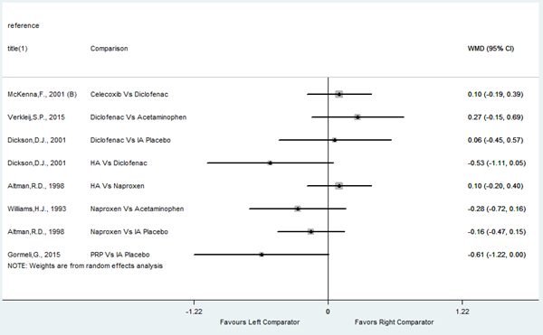

**Figure S26. Individual Comparisons Found Only in One Study (Function)**

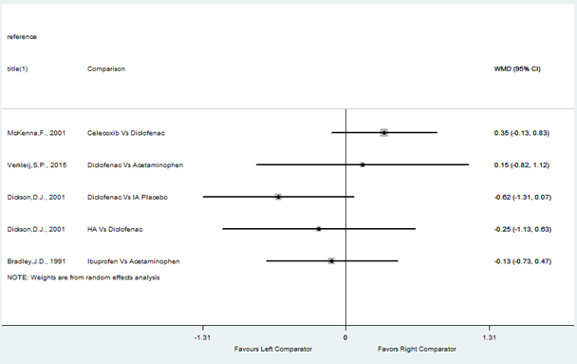

**Table S5. Network Meta-Analysis Output of Rank Probability for All Target Treatments**







**Table S6. Ordered Effectiveness by Cumulative Rank Probability Sums**







**Figure S28. Individual Rank Probabilities for Most Effective Treatment Options**

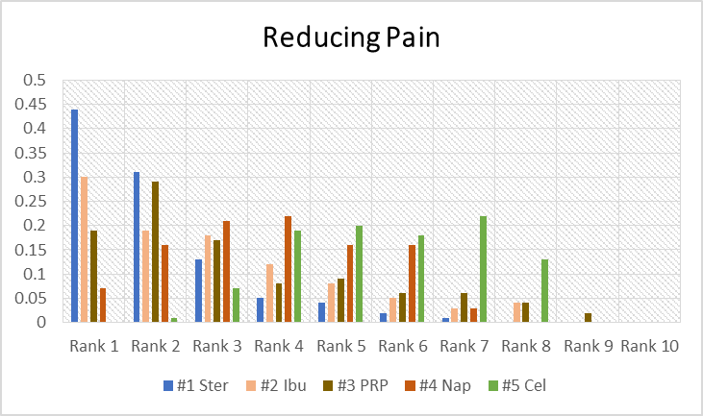

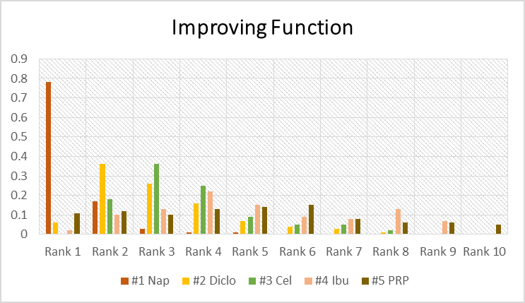

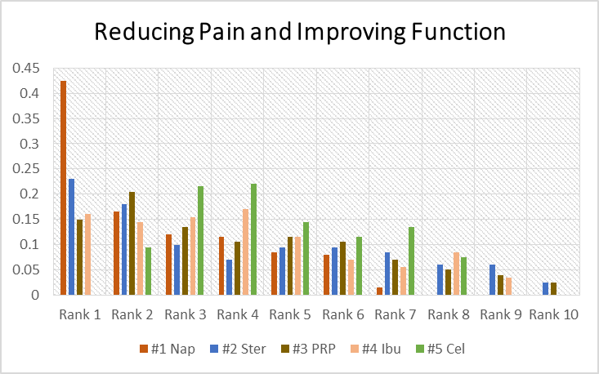

**Figure S29. Individual Rank Probabilities for Least Effective Treatment Options** 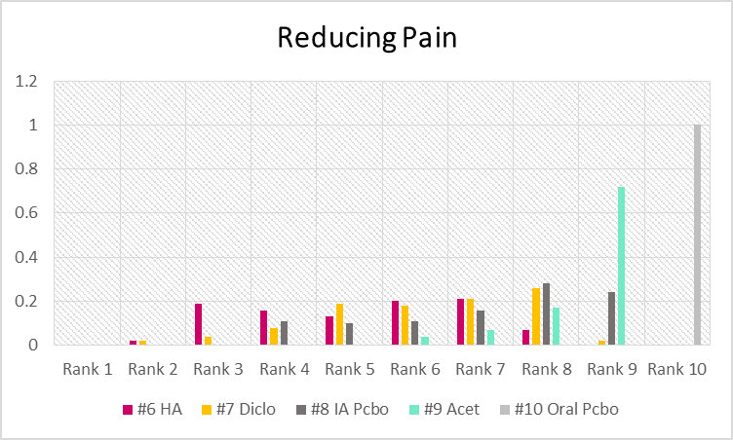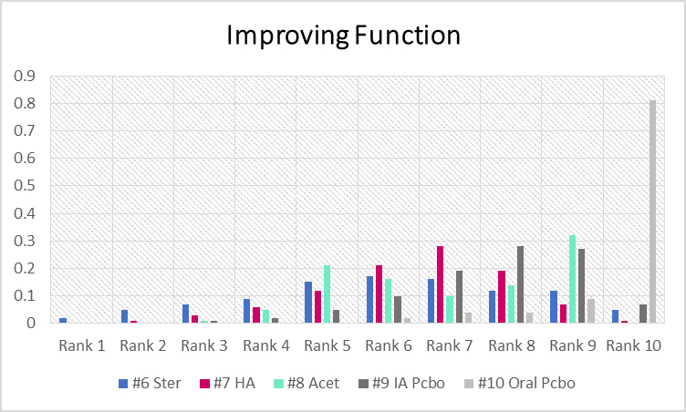

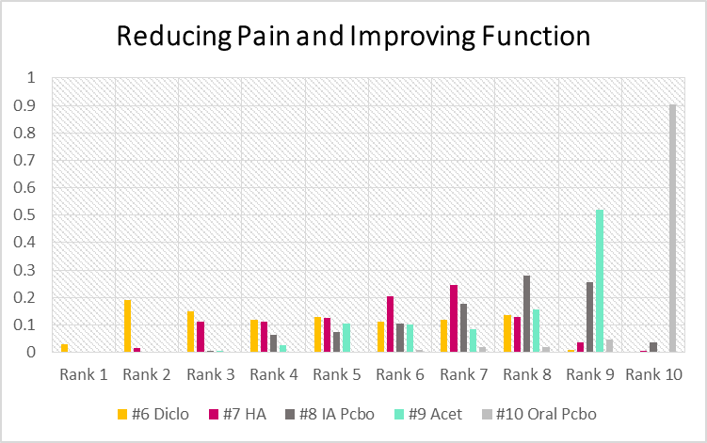

**Table S7. Reasons for Exclusion from Analysis: Articles with Quantitative and Qualitative Heterogeneity**

|  |  |  |
| --- | --- | --- |
| **Reference** | **Quality** | **Reason For Exclusion from Analysis** |
| Asmus,M.J., 2014 | Moderate | Not best available evidence |
| Bensen,W.G., 1999 | High | Only composite outcomes |
| Bingham,C.O.,III, 2007 | Moderate | Not best available evidence |
| Boswell,D.J., 2008 | Moderate | Not best available evidence |
| Caborn,D., 2004 | Moderate | 3:1 injections of treatments (not an applicable comparison) |
| Day,R., 2004 | High | Concomitant medication allowed |
| Doherty,M., 2011 | High | Duration inconsistent/outside applicable limits |
| Dougados,M., 1993 | Moderate | Blinding risk |
| Ekman,E.F., 2014 | Moderate | Not best available evidence |
| Essex,M.N., 2012 | Moderate | Not best available evidence |
| Essex,M.N., 2015 | Moderate | Not best available evidence |
| Fleischmann,R., 2006 | Moderate | Not best available evidence |
| Frizziero,L., 2002 | Moderate | 3:1 injections of treatments (not an applicable comparison) |
| Ghosh,S., 2007 | Moderate | Not best available evidence |
| Huskisson,E.C., 1999 | Moderate | Not best available evidence |
| Jorgensen,A., 2010 | High | Inadequate outcome reporting |
| Jubb,R.W., 2003 | Moderate | Not best available evidence |
| Karlsson,J., 2002 | Moderate | Not best available evidence |
| Kivitz,A., 2002 | High | Only composite outcomes |
| Miceli-Richard,C., 2004 | Moderate | >20% losses to follow up |
| Raeissadat,S.A., 2015 | Moderate | Not best available evidence/Duration |
| Smugar,S.S., 2006 | Moderate | Not best available evidence |
| Strand,V., 2012 | High | Concomitant medications allowed |
| Williams,G.W., 2000 | Moderate | Not best available evidence |
| Williams,G.W., 2001 | Moderate | Not best available evidence |
| Yavuz,U., 2012 | Moderate | Blinding risk |

**Table S8. All Excluded Articles**

| **Authors** | **Year** | **Article Title** | **Reason for Exclusion** |
| --- | --- | --- | --- |
| Abate,M.; Vanni,D.; Pantalone,A.; Salini,V. | 2015 | Hyaluronic acid in knee osteoarthritis: preliminary results using a four months administration schedule | <30 patients per group |
| Abate,M.; Verna,S.; Schiavone,C.; Di,Gregorio P.; Salini,V. | 2015 | Efficacy and safety profile of a compound composed of platelet-rich plasma and hyaluronic acid in the treatment for knee osteoarthritis (preliminary results) | not comparison of interest; PRP vs PRP+HA |
| Abou-Raya,A.; Abou-Raya,S.; Khadrawi,T.; Helmii,M. | 2014 | Effect of low-dose oral prednisolone on symptoms and systemic inflammation in older adults with moderate to severe knee osteoarthritis: A randomized placebo-controlled trial | not comparison of interest; oral corticosteroid vs placebo |
| Abrams,G.D.; Frank,R.M.; Fortier,L.A.; Cole,B.J. | 2013 | Platelet-rich plasma for articular cartilage repair | review |
| Adams,M.E. | 1993 | An analysis of clinical studies of the use of crosslinked hyaluronan, hylan, in the treatment of osteoarthritis | review |
| Adams,M.E.; Atkinson,M.H.; Lussier,A.J.; Schulz,J.I.; Siminovitch,K.A.; Wade,J.P.; Zummer,M. | 1995 | The role of viscosupplementation with hylan G-F 20 (Synvisc) in the treatment of osteoarthritis of the knee: a Canadian multicenter trial comparing hylan G-F 20 alone, hylan G-F 20 with non-steroidal anti-inflammatory drugs (NSAIDs) and NSAIDs alone | <30 patients per group; HA vs various NSAIDs |
| Adegbehingbe,O.O.; Adesanya,S.A.; Idowu,T.O.; Okimi,O.C.; Oyelami,O.A.; Iwalewa,E.O. | 2008 | Clinical effects of Garcinia kola in knee osteoarthritis | <30 patients per subgroup |
| Admani,A.K.; Verma,S. | 1983 | A study of sulindac versus ibuprofen in elderly patients with osteoarthritis | not comparison of interest; sulindac; ibuprofen |
| Aggarwal,A.; Sempowski,I.P. | 2004 | Hyaluronic acid injections for knee osteoarthritis. Systematic review of the literature | systematic review |
| Aggarwal,A.K.; Shashikanth,V.S.; Marwaha,N. | 2014 | Platelet-rich plasma prevents blood loss and pain and enhances early functional outcome after total knee arthroplasty: a prospective randomised controlled study | <30 patients per subgroup |
| Agrawal,N.M.; Caldwell,J.; Kivitz,A.J.; Weaver,A.L.; Bocanegra,T.S.; Ball,J.; Dhadda,S.; Hurley,S.; Hancock,L. | 1999 | Comparison of the upper gastrointestinal safety of Arthrotec 75 and nabumetone in osteoarthritis patients at high risk for developing nonsteroidal anti-inflammatory drug-induced gastrointestinal ulcers | no outcomes of interest; GI scores and ulcers |
| Al,Omran A.; Azam,Q. | 2014 | Efficacy of viscosupplementation in knee osteoarthritis: A clinical trial of three agents | not comparison of interest; same drug diff formulation |
| Alarcon-Segovia,D. | 1980 | Long-term treatment of symptomatic osteoarthritis with benoxaprofen. Double-blind comparison with aspirin and ibuprofen | insufficient data; lack of clear means, SD, or CI |
| Al-Omran,A.; Azam,Q. | 2014 | Efficacy of viscosupplementation in knee osteoarthritis: A clinical trial of three agents | not comparison of interest; same drug diff formulation |
| Altman,R.D.; Hochberg,M.C.; Moskowitz,R.W.; Schnitzer,T.J. | 2000 | Recommendations for the medical management of osteoarthritis of the hip and knee: 2000 update | systematic review |
| Altman,R.D.; Schemitsch,E.; Bedi,A. | 2015 | Assessment of clinical practice guideline methodology for the treatment of knee osteoarthritis with intra-articular hyaluronic acid | systematic review |
| Altman,R.D.; Strand,V.; Hochberg,M.C.; Gibofsky,A.; Markenson,J.A.; Hopkins,W.E.; Cryer,B.; Kivitz,A.; Nezzer,J.; Imasogie,O.; Young,C.L. | 2015 | Low-dose SoluMatrix diclofenac in the treatment of osteoarthritis: A 1-year, open-label, Phase III safety study | not comparison of interest; same drug diff application |
| Alvarez-Soria,M.A.; Herrero-Beaumont,G.; Moreno-Rubio,J.; Calvo,E.; Santillana,J.; Egido,J.; Largo,R. | 2008 | Long-term NSAID treatment directly decreases COX-2 and mPGES-1 production in the articular cartilage of patients with osteoarthritis | <60 patients |
| Alvarez-Soria,M.A.; Largo,R.; Santillana,J.; Sanchez-Pernaute,O.; Calvo,E.; Hernandez,M.; Egido,J.; Herrero-Beaumont,G. | 2006 | Long term NSAID treatment inhibits COX-2 synthesis in the knee synovial membrane of patients with osteoarthritis: differential proinflammatory cytokine profile between celecoxib and aceclofenac | <30 patients per group; celecoxib; aceclofenac; control |
| Amor,B.; Benarrosh,C. | 1988 | A method for comparing analgesics: glafenine and paracetamol. Multicenter cross-over approach | not comparison of interest |
| Andrade,L.; Fernandez,A. | 1978 | SULINDAC in the treatment of osteoarthritis: a double-blind 8-week study comparing SULINDAC with ibuprofen and 96 weeks of long term therapy | not comparison of interest; sundilac vs ibuprofen |
| Arjmandi,B.H.; Ormsbee,L.T.; Elam,M.L.; Campbell,S.C.; Rahnama,N.; Payton,M.E.; Brummel-Smith,K.; Daggy,B.P. | 2014 | A combination of Scutellaria baicalensis and Acacia catechu extracts for short-term symptomatic relief of joint discomfort associated with osteoarthritis of the knee | not comparison of interest; naproxen vs supplement |
| Arrich,J.; Piribauer,F.; Mad,P.; Schmid,D.; Klaushofer,K.; Mullner,M. | 2005 | Intra-articular hyaluronic acid for the treatment of osteoarthritis of the knee: systematic review and meta-analysis | systematic review |
| Arroll,B.; Goodyear-Smith,F. | 2004 | Corticosteroid injections for osteoarthritis of the knee: meta-analysis | systematic review |
| Astolfi,M.; McGuire,K.; Kaminski,T.W. | 2014 | The effectiveness of autologous conditioned serum in the treatment of knee osteoarthritis | systematic review |
| Atra,E.; Metz,C.A.; Brown,B.L.; Teoh,K. | 1990 | Flurbiprofen versus diclofenac for the treatment of osteoarthritis of the knee | not comparison of interest |
| Avouac,J.; Vicaut,E.; Bardin,T.; Richette,P. | 2010 | Efficacy of joint lavage in knee osteoarthritis: meta-analysis of randomized controlled studies | systematic review |
| Axe,J.M.; Snyder-Mackler,L.; Axe,M.J. | 2013 | The role of viscosupplementation | review |
| Aydogan,N.H.; Baydar,M.L.; Atay,T.; Perktas,I.; Baykal,B.Y.; Ozmeric,A. | 2008 | The effect of arthroscopic surgery and intraarticular drug injection to the antioxidation system and lipid peroxidation at osteoarthritis of knee | <30 patients per group |
| Ayhan,E.; Kesmezacar,H.; Akgun,I. | 2014 | Intraarticular injections (corticosteroid, hyaluronic acid, platelet rich plasma) for the knee osteoarthritis | background info |
| Bacon,P. | 1993 | Worldwide experience with etodolac (Lodine) 300 mg b.i.d. in the treatment of osteoarthritis | pooled data from other trials; trials included |
| Bacon,T.H.; Hole,J.G.; North,M.; Burnett,I. | 2002 | Analgesic efficacy of sustained release paracetamol in patients with osteoarthritis of the knee | no comparison group; same drug multiple doses |
| Baer,P.A.; Thomas,L.M.; Shainhouse,Z. | 2005 | Treatment of osteoarthritis of the knee with a topical diclofenac solution: a randomised controlled, 6-week trial [ISRCTN53366886] | no treatment of interest; diclofenac vs placebo topical gels |
| Bagis,S.; Sahin,G.; Oztuna,V.; Milcan,A.; Erdogan,C.; Camdeviren,H. | 2002 | The long-term effect of intra-articular hyaluronic acid on pain and functional status in knee osteoarthritis (one year follow-up) | no comparison group; before and after with HA |
| Bain,L.S.; Balch,H.W.; Wetherly,J.M.; Yeadon,A. | 1972 | Intraarticular triamcinolone hexacetonide: double-blind comparison with methylprednisolone | <30 patients per group |
| Baker,J.F.; Solayar,G.N.; Byrne,D.P.; Moran,R.; Mulhall,K.J. | 2012 | Analgesic control and functional outcome after knee arthroscopy: results of a randomized double-blinded trial comparing a hyaluronic acid supplement with bupivacaine | not a comparison of interest; HA vs bupivicaine |
| Balanescu,A.R.; Feist,E.; Wolfram,G.; Davignon,I.; Smith,M.D.; Brown,M.T.; West,C.R. | 2014 | Efficacy and safety of tanezumab added on to diclofenac sustained release in patients with knee or hip osteoarthritis: a double-blind, placebo-controlled, parallel-group, multicentre phase III randomised clinical trial | not comparison of interest; same drug diff admin |
| Balfour,J.A.; Benfield,P. | 1997 | [In Process Citation] | background info |
| Balfour,J.A.; Benfield,P. | 1997 | Rimexolone | review; rimexelone |
| Bannuru,R.R.; Natov,N.S.; Dasi,U.R.; Schmid,C.H.; McAlindon,T.E. | 2011 | Therapeutic trajectory following intra-articular hyaluronic acid injection in knee osteoarthritis--meta-analysis | systematic review |
| Bannuru,R.R.; Natov,N.S.; Obadan,I.E.; Price,L.L.; Schmid,C.H.; McAlindon,T.E. | 2009 | Therapeutic trajectory of hyaluronic acid versus corticosteroids in the treatment of knee osteoarthritis: a systematic review and meta-analysis | systematic review |
| Bannuru,R.R.; Schmid,C.H.; Kent,D.M.; Vaysbrot,E.E.; Wong,J.B.; McAlindon,T.E. | 2015 | Comparative effectiveness of pharmacologic interventions for knee osteoarthritis: a systematic review and network meta-analysis | systematic review |
| Bannuru,R.R.; Vaysbrot,E.E.; Sullivan,M.C.; McAlindon,T.E. | 2014 | Relative efficacy of hyaluronic acid in comparison with NSAIDs for knee osteoarthritis: a systematic review and meta-analysis | systematic review |
| Baraf,H.S.; Strand,V.; Hosokawa,H.; Akahane,O.; Lim,S.; Yaguchi,M. | 2009 | Duration of a single intraarticular injection of Gel-200 and safety of re-treatment of Gel-200, a new cross-linked formulation of Hyaluronic Acid [HA] in the treatment of symptomatic osteoarthritis [OA] of the knee | summary doc |
| Bartels,E.M.; Bliddal,H.; Schondorff,P.K.; Altman,R.D.; Zhang,W.; Christensen,R. | 2010 | Symptomatic efficacy and safety of diacerein in the treatment of osteoarthritis: a meta-analysis of randomized placebo-controlled trials | systematic review |
| Barthel,H.R.; Haselwood,D.; Longley,S.,III; Gold,M.S.; Altman,R.D. | 2009 | Randomized controlled trial of diclofenac sodium gel in knee osteoarthritis | no treatment of interest; diclofenac vs placebo topical gels |
| Bastick,A.N.; Belo,J.N.; Runhaar,J.; Bierma-Zeinstra,S.M. | 2015 | What Are the Prognostic Factors for Radiographic Progression of Knee Osteoarthritis? A Meta-analysis | systematic review |
| Batlle,Gualda E.; RomÃ¡n,Ivorra J.; MartÃ­n,Mola E.; Carbonell,AbellÃ³ J.; Linares-Ferrando,L.F.; Tornero,Molina J.; Raber,BÃ©jar A.; Fortea,Busquets J. | 2007 | Aceclofenac vs paracetamol in the management of symptomatic osteoarthritis of the knee: a double-blind 6-week randomized controlled trial | not comparison of interest; paracetamol; aceclofenac |
| Batlle-Gualda,E.; Roman,Ivorra J.; Martin-Mola,E.; Carbonell,Abello J.; Linares Ferrando,L.F.; Tornero,Molina J.; Raber,Bejar A.; Fortea,Busquets J. | 2007 | Aceclofenac vs paracetamol in the management of symptomatic osteoarthritis of the knee: a double-blind 6-week randomized controlled trial | only 1 target treatment; paracetamol vs aceclofenac |
| Battisti,W.P.; Katz,N.P.; Weaver,A.L.; Matsumoto,A.K.; Kivitz,A.J.; Polis,A.B.; Geba,G.P. | 2004 | Pain management in osteoarthritis: a focus on onset of efficacy--a comparison of rofecoxib, celecoxib, acetaminophen, and nabumetone across four clinical trials | systematic review |
| Baumgartner,H.; Schwarz,H.A.; Blum,W.; Bruhin,A.; Gallachi,G.; Goldinger,G.; Saxer,M.; Trost,H. | 1996 | Ibuprofen and diclofenac sodium in the treatment of osteoarthritis: a comparative trial of two once-daily sustained-release NSAID formulations | <30 knee patients per group |
| Bayramoglu,M.; Karatas,M.; Cetin,N.; Akman,N.; Sozay,S.; Dilek,A. | 2003 | Comparison of two different viscosupplements in knee osteoarthritis -- a pilot study | <30 patients per group; HA vs HA with physical therapy |
| Beaulieu,A.D.; Peloso,P.M.; Haraoui,B.; Bensen,W.; Thomson,G.; Wade,J.; Quigley,P.; Eisenhoffer,J.; Harsanyi,Z.; Darke,A.C. | 2008 | Once-daily, controlled-release tramadol and sustained-release diclofenac relieve chronic pain due to osteoarthritis: a randomized controlled trial | only 1 target treatment; tramadol vs diclofenac |
| Bellamy,N.; Bell,M.J.; Goldsmith,C.H.; Pericak,D.; Walker,V.; Raynauld,J.P.; Torrance,G.W.; Tugwell,P.; Polisson,R. | 2005 | The effectiveness of hylan G-F 20 in patients with knee osteoarthritis: an application of two sets of response criteria developed by the OARSI and one set developed by OMERACT-OARSI | insufficient outcome data; responder rates |
| Bellamy,N.; Bensen,W.G.; Beaulieu,A.; Siminovitch,K.A.; Kraag,G.R.; Lussier,A.; Ahmad,S.; Khanna,V.N.; Davis,P.; Bell,M.J.; . | 1995 | A multicenter study of nabumetone and diclofenac SR in patients with osteoarthritis | only 1 target treatment; nabumetone vs diclofenac |
| Bellamy,N.; Bensen,W.G.; Ford,P.M.; Huang,S.H.; Lang,J.Y. | 1992 | Double-blind randomized controlled trial of flurbiprofen-SR (ANSAID-SR) and diclofenac sodium-SR (Voltaren-SR) in the treatment of osteoarthritis | not comparison of interest; fluriprofen vs diclofenac |
| Bellamy,N.; Buchanan,W.W.; Chalmers,A.; Ford,P.M.; Kean,W.F.; Kraag,G.R.; Gerecz-Simon,E.; Campbell,J. | 1993 | A multicenter study of tenoxicam and diclofenac in patients with osteoarthritis of the knee | not comparison of interest; only 1 target treatment and no placebo |
| Bellamy,N.; Campbell,J.; Robinson,V.; Gee,T.; Bourne,R.; Wells,G. | 2006 | Intraarticular corticosteroid for treatment of osteoarthritis of the knee | systematic review |
| Bellamy,N.; Campbell,J.; Robinson,V.; Gee,T.; Bourne,R.; Wells,G. | 2006 | Viscosupplementation for the treatment of osteoarthritis of the knee | systematic review |
| Bellamy,N.; Campbell,J.; Robinson,V.; Gee,T.; Bourne,R.; Wells,G. | 2005 | Viscosupplementation for the treatment of osteoarthritis of the knee | systematic review |
| Bennell,K.L.; Hunter,D.J.; Hinman,R.S. | 2012 | Management of osteoarthritis of the knee | review |
| Bensen,W.G. | 2000 | Antiinflammatory and analgesic efficacy of COX-2 specific inhibition: from investigational trials to clinical experience | pooled analysis; review |
| Bentley,G.; Goodfellow,J.W. | 1969 | Disorganisation of the knees following intra-articular hydrocortisone injections | Case Report |
| Berenbaum,F. | 2010 | Targeted therapies in osteoarthritis: a systematic review of the trials on www.clinicaltrials.gov | systematic review |
| Berenbaum,F.; Grifka,J.; Cazzaniga,S.; D'Amato,M.; Giacovelli,G.; Chevalier,X.; Rannou,F.; Rovati,L.C.; Maheu,E. | 2012 | A randomised, double-blind, controlled trial comparing two intra-articular hyaluronic acid preparations differing by their molecular weight in symptomatic knee osteoarthritis | not comparison of interest; same drug diff molecular weight |
| Beyaz,S.G. | 2012 | Comparison of efficacy of intra-articular morphine and steroid in patients with knee osteoarthritis | <30 patients per group; corticosteroid, saline, morphine |
| Biesalski,H.K.; Grune,T.; Tinz,J.; Zollner,I.; Blumberg,J.B. | 2010 | Reexamination of a meta-analysis of the effect of antioxidant supplementation on mortality and health in randomized trials | systematic review |
| Bingham Iii,C.O.; Bird,S.R.; Smugar,S.S.; Xu,X.; Tershakovec,A.M. | 2008 | Responder analysis and correlation of outcome measures: pooled results from two identical studies comparing etoricoxib, celecoxib, and placebo in osteoarthritis | insufficient data; <80% knee patients with combined data |
| Bingham Iii,C.O.; Smugar,S.S.; Wang,H.; Tershakovec,A.M. | 2009 | Early response to COX-2 inhibitors as a predictor of overall response in osteoarthritis: Pooled results from two identical trials comparing etoricoxib, celecoxib and placebo | no outcomes of interest; responder rates and <80% knee patients |
| Bingham,C.O.,III; Bird,S.R.; Smugar,S.S.; Xu,X.; Tershakovec,A.M. | 2008 | Responder analysis and correlation of outcome measures: pooled results from two identical studies comparing etoricoxib, celecoxib, and placebo in osteoarthritis | Pooled data from two other trials; already have data from the two trials included |
| Bingham,C.O.,III; Smugar,S.S.; Wang,H.; Peloso,P.M.; Gammaitoni,A. | 2011 | Predictors of response to cyclo-oxygenase-2 inhibitors in osteoarthritis: pooled results from two identical trials comparing etoricoxib, celecoxib, and placebo | no outcomes of interest; odds ratios and p-values reported; <80% knee subjects |
| Bingham,C.O.,III; Smugar,S.S.; Wang,H.; Tershakovec,A.M. | 2009 | Early response to COX-2 inhibitors as a predictor of overall response in osteoarthritis: pooled results from two identical trials comparing etoricoxib, celecoxib and placebo | Pooled data from two other trials; already have data from the two trials included |
| Bjordal,J. | 2006 | NSAIDs in osteoarthritis: Irreplaceable or troublesome guidelines? | commentary |
| Bjordal,J.M.; Klovning,A.; Ljunggren,A.E.; Slordal,L. | 2007 | Short-term efficacy of pharmacotherapeutic interventions in osteoarthritic knee pain: A meta-analysis of randomised placebo-controlled trials | systematic review |
| Bjordal,J.M.; Ljunggren,A.E.; Klovning,A.; Slordal,L. | 2004 | Non-steroidal anti-inflammatory drugs, including cyclo-oxygenase-2 inhibitors, in osteoarthritic knee pain: Meta-analysis of randomised placebo controlled trials | systematic review |
| Bjorkenheim,J.M.; Helland,J.; Peltonen,J. | 1985 | A double-blind crossover evaluation of naproxen and piroxicam in osteoarthritis of hip or knee | not comparison of interest; piroxicam, naproxen, no control |
| Blandino,D. | 2001 | Are NSAIDs more effective than acetaminophen in patients with osteoarthritis? | summary doc |
| Blechman,W.; Willkens,R.; Boncaldo,G.L.; Hoffmeister,R.T.; Lockie,L.M.; Multz,C. | 1978 | Naproxen in osteoarthrosis. Double-blind crossover trial | Insufficient data; combined knee and hip patients |
| Bliddal,H.; Rosetzsky,A.; Schlichting,P.; Weidner,M.S.; Andersen,L.A.; Ibfelt,H.H.; Christensen,K.; Jensen,O.N.; Barslev,J. | 2000 | A randomized, placebo-controlled, cross-over study of ginger extracts and ibuprofen in osteoarthritis | <60 patients with KOA |
| Bobacz,K. | 2013 | Pharmacologic treatment of hand-, knee- and hip-osteoarthritis | background info |
| Bocanegra,T.S.; Weaver,A.L.; Tindall,E.A.; Sikes,D.H.; Ball,J.A.; Wallemark,C.B.; Geis,G.S.; Fort,J.G. | 1998 | Diclofenac/misoprostol compared with diclofenac in the treatment of osteoarthritis of the knee or hip: a randomized, placebo controlled trial. Arthrotec Osteoarthritis Study Group | insufficient data for target outcomes; knee and hip patients combined |
| Bodick,N.; Lufkin,J.; Willwerth,C.; Kumar,A.; Bolognese,J.; Schoonmaker,C.; Ballal,R.; Hunter,D.; Clayman,M. | 2015 | An intra-articular, extended-release formulation of triamcinolone acetonide prolongs and amplifies analgesic effect in patients with osteoarthritis of the knee: a randomized clinical trial | not comparison of interest; same drug diff application |
| Boissier,C.; Perpoint,B.; Laporte-Simitsidis,S.; Mismetti,P.; Hocquart,J.; Gayet,J.L.; Rambaud,C.; Queneau,P.; Decousus,H. | 1992 | Acceptability and efficacy of two associations of paracetamol with a central analgesic (dextropropoxyphene or codeine): comparison in osteoarthritis | no treatment of interest; paracetamol mixed with two different drugs |
| Bolten,W.W.; Glade,M.J.; Raum,S.; Ritz,B.W. | 2015 | The safety and efficacy of an enzyme combination in managing knee osteoarthritis pain in adults: a randomized, double-blind, placebo-controlled trial | insufficient data; median scores due to massive loss to FU |
| Bond,M.; Davis,A.; Lohmander,S.; Hawker,G. | 2012 | Responsiveness of the OARSI-OMERACT osteoarthritis pain and function measures | <30 patients per group; naproxen doses vs ibuprofen |
| Bookman,A.A.; Williams,K.S.; Shainhouse,J.Z. | 2004 | Effect of a topical diclofenac solution for relieving symptoms of primary osteoarthritis of the knee: a randomized controlled trial | no treatment of interest; diclofenac vs placebo topical gels |
| Boureau,F.; Schneid,H.; Zeghari,N.; Wall,R.; Bourgeois,P. | 2004 | The IPSO study: ibuprofen, paracetamol study in osteoarthritis. A randomised comparative clinical study comparing the efficacy and safety of ibuprofen and paracetamol analgesic treatment of osteoarthritis of the knee or hip | <80% patients have knee OA; combined data only |
| Boyer,K.A.; Angst,M.S.; Asay,J.; Giori,N.J.; Andriacchi,T.P. | 2012 | Sensitivity of gait parameters to the effects of anti-inflammatory and opioid treatments in knee osteoarthritis patients | <30 day follow up; crossover study design |
| Bradley,J.D.; Brandt,K.D.; Katz,B.P.; Kalasinski,L.A.; Ryan,S.I. | 1992 | Treatment of knee osteoarthritis: relationship of clinical features of joint inflammation to the response to a nonsteroidal antiinflammatory drug or pure analgesic | insufficient data; no relevant means for comparison groups |
| Bradley,J.D.; Katz,B.P.; Brandt,K.D. | 2001 | Severity of knee pain does not predict a better response to an antiinflammatory dose of ibuprofen than to analgesic therapy in patients with osteoarthritis | insufficient data; no mean or SD scores for comparison groups |
| Bradley,J.D.; Rudy,A.C.; Katz,B.P.; Ryan,S.I.; Kalasinski,L.A.; Brater,D.C.; Hall,S.D.; Brandt,K.D. | 1992 | Correlation of serum concentrations of ibuprofen stereoisomers with clinical response in the treatment of hip and knee osteoarthritis | <30 patients per subgroup |
| Bragantini,A.; Cassini,M.; De,Bastiani; Perbellini,A. | 1987 | Controlled single-blind trial of intra-articularly injected hyaluronic acid (Hyalgan(registered trademark)) in osteo-arthritis of the knee | <30 patients per group |
| Brander,V.A.; Stadler,T.S. | 2009 | Functional improvement with hylan G-F 20 in patients with knee osteoarthritis | systematic review |
| Brandt,K.D.; Block,J.A.; Michalski,J.P.; Moreland,L.W.; Caldwell,J.R.; Lavin,P.T. | 2001 | Efficacy and safety of intraarticular sodium hyaluronate in knee osteoarthritis. ORTHOVISC Study Group | insufficient data; lack of SD or CI |
| Brandt,K.D.; Smith,G.N.,Jr.; Simon,L.S. | 2000 | Intraarticular injection of hyaluronan as treatment for knee osteoarthritis: what is the evidence? | systematic review |
| Briem,K.; Axe,M.J.; Snyder-Mackler,L. | 2009 | Medial knee joint loading increases in those who respond to hyaluronan injection for medial knee osteoarthritis | <60 patients; no comparison group |
| Briem,K.; Axe,M.J.; Snyder-Mackler,L. | 2009 | Functional and perceived response to intra-articular hyaluronan injection in patients with knee osteoarthritis: persistence of treatment effects over 5 months | No comparison group |
| Brighton,S.; Mody,G.M.; Tikly,M.; Bouwer,D. | 2003 | Osteoarthritis: Clinical guideline 2003 | systematic review |
| Bruhlmann,P.; de,Vathaire F.; Dreiser,R.L.; Michel,B.A. | 2006 | Short-term treatment with topical diclofenac epolamine plaster in patients with symptomatic knee osteoarthritis: pooled analysis of two randomised clinical studies | no treatment of interest |
| Brzusek,D.; Petron,D. | 2008 | Treating knee osteoarthritis with intra-articular hyaluronans | systematic review |
| Buckland-Wright,J.C.; MacFarlane,D.G.; Lynch,J.A.; Jasani,M.K. | 1995 | Quantitative microfocal radiography detects changes in OA knee joint space width in patients in placebo controlled trial of NSAID therapy | <30 patients per subgroup |
| Bunyaratavej,N.; Chan,K.M.; Subramanian,N. | 2001 | Treatment of painful osteoarthritis of the knee with hyaluronic acid. Results of a multicenter Asian study | <30 patients in each treatment group |
| Campbell,J.; Bellamy,N.; Gee,T. | 2007 | Differences between systematic reviews/meta-analyses of hyaluronic acid/hyaluronan/hylan in osteoarthritis of the knee | review of reviews |
| Campbell,K.A.; Erickson,B.J.; Saltzman,B.M.; Mascarenhas,R.; Bach,B.R.,Jr.; Cole,B.J.; Verma,N.N. | 2015 | Is Local Viscosupplementation Injection Clinically Superior to Other Therapies in the Treatment of Osteoarthritis of the Knee: A Systematic Review of Overlapping Meta-analyses | systematic review |
| Campbell,K.A.; Saltzman,B.M.; Mascarenhas,R.; Khair,M.M.; Verma,N.N.; Bach,B.R.,Jr.; Cole,B.J. | 2015 | Does Intra-articular Platelet-Rich Plasma Injection Provide Clinically Superior Outcomes Compared With Other Therapies in the Treatment of Knee Osteoarthritis? A Systematic Review of Overlapping Meta-analyses | systematic review |
| Campos,G.C.; Rezende,M.U.; Pailo,A.F.; Frucchi,R.; Camargo,O.P. | 2013 | Adding triamcinolone improves viscosupplementation: a randomized clinical trial | only 1 target treatment; HA vs HA plus steroid |
| Cannon,G.W.; Caldwell,J.R.; Holt,P.; McLean,B.; Seidenberg,B.; Bolognese,J.; Ehrich,E.; Mukhopadhyay,S.; Daniels,B. | 2000 | Rofecoxib, a specific inhibitor of cyclooxygenase 2, with clinical efficacy comparable with that of diclofenac sodium: results of a one-year, randomized, clinical trial in patients with osteoarthritis of the knee and hip. Rofecoxib Phase III Protocol 035 Study Group | not comparison of interest; only 1 target treatment and no placebo |
| Cannon,G.W.; Caldwell,J.R.; Holt,P.; McLean,B.; Seidenberg,B.; Bolognese,J.; Ehrich,E.; Mukhopadhyay,S.; Daniels,B. | 2000 | Rofecoxib, a specific inhibitor of cyclooxygenase 2, with clinical efficacy comparable with that of diclofenac sodium: Results of a one-year, randomized, clinical trial in patients with osteoarthritis of the knee and hip | not comparison of interest; rofecoxib vs diclofenac |
| Capretto,C.; Cremona,C.; Canaparo,L. | 1985 | A double-blind controlled study of S-adenosylmethionine (SAMe) v. ibuprofen in gonarthrosis, coxarthrosis and spondylarthrosis | not comparison of interest; <30 knee patients per group |
| Cardoe,N.; Hart,F.D. | 1986 | Double-blind multicentre UK hospital studies of isoxicam vs naproxen | not comparison of interest; isoxicam; naproxen |
| Carlson,A. | 1998 | NSAIDs improve quality of sleep in patients with osteoarthritis pain | summary doc |
| Carrabba,M.; Paresce,E.; Angelini,M.; Re,K.A.; Torchiana,E.E.M.; Perbellini,A. | 1995 | The safety and efficacy of different dose schedules of hyaluronic acid in the treatment of painful osteoarthritis of the knee with joint effusion | <30 patients per group |
| Caruso,I.; Pietrogrande,V. | 1987 | Italian double-blind multicenter study comparing S-adenosylmethionine, naproxen, and placebo in the treatment of degenerative joint disease | <80% patients have knee OA; combined data only |
| Case,J.P.; Baliunas,A.J.; Block,J.A. | 2003 | Lack of efficacy of acetaminophen in treating symptomatic knee osteoarthritis: a randomized, double-blind, placebo-controlled comparison trial with diclofenac sodium | <30 patients per subgroup |
| Castano,Carou A.; Pita,Fernandez S.; Pertega,Diaz S.; de Toro Santos,F.J. | 2015 | Clinical profile, level of affection and therapeutic management of patients with osteoarthritis in primary care: The Spanish multicenter study EVALUA | cross sectional prevalence study |
| Castelnuovo,E.; Cross,P.; Mt-Isa,S.; Spencer,A.; Underwood,M. | 2008 | Cost-effectiveness of advising the use of topical or oral ibuprofen for knee pain; the TOIB study [ISRCTN: 79353052] | no comparison of interest; same drug diff admin; no outcome of interest |
| CederlÃ?Â¶f,S.; Jonson,G. | 1966 | Intraarticular prednisolone injection for osteoarthritis of the knee. A double blind test with placebo | <60 total patients |
| Cederlof,S.; Jonson,G. | 1966 | Intraarticular prednisolone injection for osteoarthritis of the knee. A double blind test with placebo | <60 total patients; insufficient data |
| Cefalu,C.A.; Waddell,D.S. | 1999 | Viscosupplementation: treatment alternative for osteoarthritis of the knee | review |
| Cerza,F.; Carni,S.; Carcangiu,A.; Di,Vavo,I; Schiavilla,V.; Pecora,A.; De,Biasi G.; Ciuffreda,M. | 2012 | Comparison between hyaluronic acid and platelet-rich plasma, intra-articular infiltration in the treatment of gonarthrosis | improper randomization; unblinded |
| Chahade,W.H.; Marques,G.C. | 1987 | Tenoxicam or diclofenac in the treatment of gonarthrosis | <30 patients; not comparison of interest; tenoxicam; diclofenac |
| Chang,K.V.; Hung,C.Y.; Aliwarga,F.; Wang,T.G.; Han,D.S.; Chen,W.S. | 2014 | Comparative effectiveness of platelet-rich plasma injections for treating knee joint cartilage degenerative pathology: a systematic review and meta-analysis | systematic review |
| Chareancholvanich,K.; Pornrattanamaneewong,C.; Narkbunnam,R. | 2014 | Increased cartilage volume after injection of hyaluronic acid in osteoarthritis knee patients who underwent high tibial osteotomy | 20 patients per group; single blinding |
| Chau,J.Y.; Chan,W.L.; Woo,S.B.; Cheng,S.C.; Wong,T.M.; Wong,T.K.; Yen,C.H.; Wong,K.; Wong,W.C. | 2012 | Hyaluronic acid instillation following arthroscopic anterior cruciate ligament reconstruction: a double-blinded, randomised controlled study | <30 patients |
| Chen,Y.-F.; Jobanputra,P.; Barton,P.; Bryan,S.; Fry-Smith,A.; Harris,G.; Taylor,R.S. | 2008 | Cyclooxygenase-2 selective non-steroidal anti-inflammatory drugs (etodolac, meloxicam, celecoxib, rofecoxib, etoricoxib, valdecoxib and lumiracoxib) for osteoarthritis and rheumatoid arthritis: A systematic review and economic evaluation | systematic review |
| Cheng,O.T.; Souzdalnitski,D.; Vrooman,B.; Cheng,J. | 2012 | Evidence-based knee injections for the management of arthritis | systematic review |
| Chia,S.K.; Wernecke,G.C.; Harris,I.A.; Bohm,M.T.; Chen,D.B.; Macdessi,S.J. | 2013 | Peri-articular steroid injection in total knee arthroplasty: a prospective, double blinded, randomized controlled trial | surgical study; post-op pain control |
| Chikanza,I.C.; Clarke,B.; Hopkins,R.; MacFarlane,D.G.; Bird,H.; Grahame,R. | 1994 | A comparative study of the efficacy and toxicity of etodolac and naproxen in the treatment of osteoarthritis | <30 patients per subgroup |
| Chiranthanut,N.; Hanprasertpong,N.; Teekachunhatean,S. | 2014 | Thai massage, and Thai herbal compress versus oral ibuprofen in symptomatic treatment of osteoarthritis of the knee: a randomized controlled trial | not comparison of interest; ibuprofen vs homeopathic |
| Choi,C.B.; Song,J.S.; Kang,Y.M.; Suh,C.H.; Lee,J.; Choe,J.Y.; Lee,C.K.; Shim,S.C.; Chung,W.T.; Song,G.G.; Kim,H.A.; Ji,J.D.; Nam,E.J.; Park,S.H.; Hong,Y.H.; Sheen,D.H.; Lim,M.K.; Seo,Y.I.; Sung,Y.K.; Kim,T.H.; Lee,J.T.; Bae,S.C. | 2007 | A 2-week, multicenter, randomized, double-blind, double-dummy, add-on study of the effects of titration on tolerability of tramadol/acetaminophen combination tablet in Korean adults with knee osteoarthritis pain | no treatment of interest; follow-up<4 weeks |
| Chou,C.W.; Lue,K.H.; Lee,H.S.; Lin,R.C.; Lu,K.H. | 2009 | Hylan G-F 20 has better pain relief and cost-effectiveness than sodium hyaluronate in treating early osteoarthritic knees in Taiwan | not comparison of interest; same drug diff admin |
| Cimmino,M.A.; Cutolo,M.; Samanta,E.; Accardo,S. | 1982 | Short-term treatment of osteoarthritis: a comparison of sodium meclofenamate and ibuprofen | <30 patients; not comparison of interest; ibuprofen; sodium meclofenamate |
| Civinini,R.; Nistri,L.; Martini,C.; Redl,B.; Ristori,G.; Innocenti,M. | 2013 | Growth factors in the treatment of early osteoarthritis | review |
| Clijsen,R.; Taeymans,J.; Baeyens,J.P.; Barel,A.O.; Clarys,P. | 2012 | The effects of iontophoresis in the treatment of musculoskeletal disorders - a systematic review and meta-analysis | systematic review |
| Colen,S.; Haverkamp,D.; Mulier,M.; van den Bekerom,M.P. | 2012 | Hyaluronic acid for the treatment of osteoarthritis in all joints except the knee: what is the current evidence? | systematic review |
| Colen,S.; van den Bekerom,M.P.; Mulier,M.; Haverkamp,D. | 2012 | Hyaluronic acid in the treatment of knee osteoarthritis: a systematic review and meta-analysis with emphasis on the efficacy of different products | systematic review |
| Collantes-Estevez,E.; Fernandez-Perez,C. | 2003 | Improved control of osteoarthritis pain and self-reported health status in non-responders to celecoxib switched to rofecoxib: results of PAVIA, an open-label post-marketing survey in Spain | only 1 target treatment and no outcomes of interest; celecoxib vs rofecoxib |
| Contreras-Hernandez,I.; Mould-Quevedo,J.F.; Torres-Gonzalez,R.; Goycochea-Robles,M.V.; Pacheco-Dominguez,R.L.; Sanchez-Garcia,S.; Mejia-Arangure,J.M.; Garduno-Espinosa,J. | 2008 | Cost-effectiveness analysis for joint pain treatment in patients with osteoarthritis treated at the Instituto Mexicano del Seguro Social (IMSS): Comparison of nonsteroidal anti-inflammatory drugs (NSAIDs) vs. cyclooxygenase-2 selective inhibitors | no outcome of interest; review design |
| Corbett,M.; Seifert,M.H.; Hacking,C.; Webb,S. | 1970 | Comparison between local injections of silicone oil and hydrocortisone acetate in chronic arthritis | <30 patients; no treatment of interest |
| Cornhill,J.; Rowley-Jones,D. | 1984 | Is sustained-release ibuprofen as effective as piroxicam? A comparison in patients with osteoarthritis | not comparison of interest; piroxicam; ibuprofen |
| Corrado,E.M.; Peluso,G.F.; Gigliotti,S.; De,Durante C.; Palmieri,D.; Savoia,N.; Oriani,G.O.; Tajana,G.F. | 1995 | The effects of intra-articular administration of hyaluronic acid on osteoarthritis of the knee: A clinical study with immunological and biochemical evaluations | <30 patients per group |
| Corts Giner,J.R.; Garcia Borras,J.J. | 1991 | Double-blind, randomized and parallel comparison between droxicam and diclofenac sodium in patients with coxarthrosis and gonarthrosis | not comparison of interest |
| Corts,Giner,Jr.; GarcÃ­a-BorrÃ¡s,J.J. | 1991 | Double-blind, randomized and parallel comparison between droxicam and diclofenac sodium in patients with coxarthrosis and gonarthrosis | not comparison of interest; droxicam vs diclofenac |
| Corvelli,M.; Che,B.; Saeui,C.; Singh,A.; Elisseeff,J. | 2015 | Biodynamic performance of hyaluronic acid versus synovial fluid of the knee in osteoarthritis | bio-study; no patients |
| Creamer,P.; Sharif,M.; George,E.; Meadows,K.; Cushnaghan,J.; Shinmei,M.; Dieppe,P. | 1994 | Intra-articular hyaluronic acid in osteoarthritis of the knee: an investigation into mechanisms of action | <30 patients per group; HA vs placebo injections |
| Cryer,B.L.; Sostek,M.B.; Fort,J.G.; Svensson,O.; Hwang,C.; Hochberg,M.C. | 2011 | A fixed-dose combination of naproxen and esomeprazole magnesium has comparable upper gastrointestinal tolerability to celecoxib in patients with osteoarthritis of the knee: results from two randomized, parallel-group, placebo-controlled trials | no outcomes of interest; GI pain scores |
| Cubukcu,D.; Ardic,F.; Karabulut,N.; Topuz,O. | 2005 | Hylan G-F 20 efficacy on articular cartilage quality in patients with knee osteoarthritis: clinical and MRI assessment | <30 patients per group; HA vs placebo injections |
| Cuckler,J.M. | 2000 | Alternative therapies for arthritis of the knee: A triumph of hope over reason? | review |
| Curran,M.P. | 2010 | Hyaluronic acid (Supartz(R)): a review of its use in osteoarthritis of the knee | systematic review |
| Curtis,S.P.; Bockow,B.; Fisher,C.; Olaleye,J.; Compton,A.; Ko,A.T.; Reicin,A.S. | 2005 | Etoricoxib in the treatment of osteoarthritis over 52-weeks: a double-blind, active-comparator controlled trial [NCT00242489] | insufficient data; no outcome means or SD; possibly duplicate data from ID 1185 |
| da Costa,B.R.; Nuesch,E.; Rutjes,A.W.; Johnston,B.C.; Reichenbach,S.; Trelle,S.; Guyatt,G.H.; Juni,P. | 2013 | Combining follow-up and change data is valid in meta-analyses of continuous outcomes: A meta-epidemiological study | systematic review |
| Dahlberg,L.E.; Holme,I.; Hoye,K.; Ringertz,B. | 2009 | A randomized, multicentre, double-blind, parallel-group study to assess the adverse event-related discontinuation rate with celecoxib and diclofenac in elderly patients with osteoarthritis | combined knee and hip patients; <80% knee |
| Das,A.; Neher,J.O.; Safranek,S. | 2009 | Clinical inquiries. Do hyaluronic acid injections relieve OA knee pain? | commentary / review design of HA on market |
| Davalillo,C.A.T.; Vasavilbaso,C.T.; Alvarez,J.M.N.; Granado,P.C.; Jimenez,O.A.G.; Del Sol,M.G.; Orbezo,F.G. | 2015 | Clinical efficacy of intra-articular injections in knee osteoarthritis: A prospective randomized study comparing hyaluronic acid and betamethasone | confounding treatment; meloxicam administered with HA and BM; single blind |
| Day,R.; Morrison,B.; Luza,A.; Castaneda,O.; Strusberg,A.; Nahir,M.; Helgetveit,K.B.; Kress,B.; Daniels,B.; Bolognese,J.; Krupa,D.; Seidenberg,B.; Ehrich,E. | 2000 | A randomized trial of the efficacy and tolerability of the COX-2 inhibitor rofecoxib vs ibuprofen in patients with osteoarthritis. Rofecoxib/Ibuprofen Comparator Study Group | <80% patients have knee OA; combined data only |
| de Blecourt,J.J. | 1981 | Double-blind controlled evaluation of benoxaprofen for treatment of coxarthrosis and gonarthrosis | not comparison of interest; benoxaprofen; naproxen |
| de Campos,G.C.; Rezende,M.U.; Pailo,A.F.; Frucchi,R.; Camargo,O.P. | 2013 | Adding triamcinolone improves viscosupplementation: a randomized clinical trial | only 1 target treatment; HA vs HA plus steroid |
| de,Silva,V; El-Metwally,A.; Ernst,E.; Lewith,G.; Macfarlane,G.J. | 2011 | Evidence for the efficacy of complementary and alternative medicines in the management of osteoarthritis: A systematic review | systematic review |
| Deal,C.L.; Moskowitz,R.W. | 1986 | Efficacy of diflunisal versus naproxen in osteoarthritis of the knee: an open study | <30 patients per group; naproxen |
| Decaria,J.; Petrella,R.; Petrella,R.; Wolfe,D.; Chesworth,B.M.; Montero,Odasso M. | 2011 | Effect of intra-articular hyaluronic acid on gait variability in older adults with knee osteoarthritis | <30 patients per group; |
| DeCaria,J.E.; Montero-Odasso,M.; Wolfe,D.; Chesworth,B.M.; Petrella,R.J. | 2012 | The effect of intra-articular hyaluronic acid treatment on gait velocity in older knee osteoarthritis patients: a randomized, controlled study | <30 patients per group |
| Dehghan,M. | 2015 | Comparative effectiveness of B and e vitamins with diclofenac in reducing pain due to osteoarthritis of the knee | Not comparison of interest; same drug multiple doses |
| Delafuente,J.C. | 2004 | Emerging controversies in the treatment of osteoarthritis in older individuals | systematic review |
| Derry,S.; Moore,R.A.; Rabbie,R. | 2012 | Topical NSAIDs for chronic musculoskeletal pain in adults | systematic review |
| Detrembleur,C.; De,Nayer J.; van den Hecke,A. | 2005 | Celecoxib improves the efficiency of the locomotor mechanism in patients with knee osteoarthritis. A randomised, placebo, double-blind and cross-over trial | <60 patients |
| Dhillon,M.S.; Patel,S. | 2015 | Role of platelet rich plasma in early osteoarthritis of knee | editorial |
| Dhillon,M.S.; Patel,S.; Marwaha,N. | 2013 | Platelet-rich plasma for knee osteoarthritis--authors' response | letter to the editor |
| Diaz,C.; Geli,C.; Lopez,Munoz F.; Alamo,C. | 1996 | An efficacy and safety comparative study of microcapsulated butibufen and diclofenac in patients with gonarthrosis | not comparison of interest; butiprofen vs diclofenac |
| Diaz-Heredia,J.; Loza,E.; Cebreiro,I.; Ruiz Iban,M.A. | 2015 | Preventive analgesia in hip or knee arthroplasty: a systematic review | systematic review |
| Dieppe,P.; Cushnaghan,J.; Jasani,M.K.; McCrae,F.; Watt,I. | 1993 | A two-year, placebo-controlled trial of non-steroidal anti-inflammatory therapy in osteoarthritis of the knee joint | <30 patients per subgroup |
| Dijkmans,B.A.C.; De,S.P.B.J.; Schardijn,G.H.C.; Hazes,J.M.W. | 1990 | Pirprofen versus naproxen in osteoarthritis of hip and knee: a multicentre randomised double-blind cross-over trial | only 1 target treatment; pirprofen vs naproxen |
| Diracoglu,D.; Vural,M.; Baskent,A.; Dikici,F.; Aksoy,C. | 2009 | The effect of viscosupplementation on neuromuscular control of the knee in patients with osteoarthritis | <30 patients per group |
| Divine,J.G.; Zazulak,B.T.; Hewett,T.E. | 2007 | Viscosupplementation for knee osteoarthritis: a systematic review | systematic review |
| Dixon,A.S.; Jacoby,R.K.; Berry,H.; Hamilton,E.B. | 1988 | Clinical trial of intra-articular injection of sodium hyaluronate in patients with osteoarthritis of the knee | insufficient data; placebo included minimal HA dose |
| Doherty,M. | 1992 | The efficacy of Arthrotec in the treatment of osteoarthritis | no comparison group; diclofenac vs diclofenac/misoprostol combination |
| Doi,T.; Akai,M.; Fujino,K.; Hoshino,Y.; Iwaya,T.; Sunami,Y. | 2010 | Effect of nonsteroidal anti-inflammatory drug plasters for knee osteoarthritis in Japanese: A randomized controlled trial | Not comparison of interest; same drug diff admin |
| Dold,A.P.; Zywiel,M.G.; Taylor,D.W.; Dwyer,T.; Theodoropoulos,J. | 2014 | Platelet-rich plasma in the management of articular cartilage pathology: a systematic review | systematic review |
| Dooley,M.; Spencer,C.M.; Dunn,C.J. | 2001 | Aceclofenac: a reappraisal of its use in the management of pain and rheumatic disease | systematic review |
| Dore,R.; Ballard,I.; Constantine,G.; McDonald,P. | 1995 | Efficacy and safety of etodolac and naproxen in patients with osteoarthritis of the knee: a double-blind, placebo-controlled study | insufficient data; no SD, CI, baseline values, FU means, or validated outcomes; only change scores provided |
| Dougados,M.; Moore,A.; Yu,S.; Gitton,X. | 2007 | Evaluation of the patient acceptable symptom state in a pooled analysis of two multicentre, randomised, double-blind, placebo-controlled studies evaluating lumiracoxib and celecoxib in patients with osteoarthritis | Pooled data from two trials; we have already included these two trials |
| Dreiser,R.L.; Tisne-Camus,M. | 1993 | DHEP plasters as a topical treatment of knee osteoarthritis--a double-blind placebo-controlled study | no treatment of interest; DHEP plaster vs placebo only |
| Duif,C.; Vogel,T.; Topcuoglu,F.; Spyrou,G.; von Schulze,Pellengahr C.; Lahner,M. | 2015 | Does intraoperative application of leukocyte-poor platelet-rich plasma during arthroscopy for knee degeneration affect postoperative pain, function and quality of life? A 12-month randomized controlled double-blind trial | <30 patients per group; PRP vs control |
| Dunky,A.; Fasching,U.; Eberl,R.; Thumb,N.; Klein,G.; Rainer,F.; Siegmeth,W.; Broll,H.; Mayrhofer,F.; Singer,F. | 1990 | Tenoxicam versus diclofenac retard in osteoarthritis of the knee. A double-blind multicentre study | not comparison of interest; diclofenac vs tenoxicam |
| Dworkin,R.H.; Peirce-Sandner,S.; Turk,D.C.; McDermott,M.P.; Gibofsky,A.; Simon,L.S.; Farrar,J.T.; Katz,N.P. | 2011 | Outcome measures in placebo-controlled trials of osteoarthritis: Responsiveness to treatment effects in the REPORT database | systematic review |
| Edelson,R.; Burks,R.T.; Bloebaum,R.D. | 1995 | Short-term effects of knee washout for osteoarthritis | <60 patients |
| Ediz,L.; Tekeoglu,I. | 2012 | Symptom modifying effect of colchicine in patients with knee osteoarthritis | <30 patients per group |
| Ehrich,E.W.; Davies,G.M.; Watson,D.J.; Bolognese,J.A.; Seidenberg,B.C.; Bellamy,N. | 2000 | Minimal perceptible clinical improvement with the Western Ontario and McMaster Universities osteoarthritis index questionnaire and global assessments in patients with osteoarthritis | <80% patients have knee OA; combined data only |
| Erturk,C.; Altay,M.A.; Altay,N.; Kalender,A.M.; Ozturk,I.A. | 2014 | Will a single periarticular lidocaine-corticosteroid injection improve the clinical efficacy of intraarticular hyaluronic acid treatment of symptomatic knee osteoarthritis? | not comparison of interest; HA vs HA plus steroid |
| Espallargues,M.; Pons,J.M. | 2003 | Efficacy and safety of viscosupplementation with Hylan G-F 20 for the treatment of knee osteoarthritis: a systematic review | systematic review |
| Esselinckx,W.; Stenier,P. | 1990 | Double-blind comparative study of tenoxicam in arthrosis of the knee and hip | <80% knee patients with no subanalysis; diclofenac vs placebo safety study |
| Essex,M.N.; Brown,P.B.; Sands,G.H. | 2014 | The efficacy of continuous versus intermittent celecoxib treatment in osteoarthritis patients aged <60 and (greater-than or equal to)60 years | same drug different admin; combined knee and hip data |
| Essex,M.N.; Zhang,R.Y.; Berger,M.F.; Upadhyay,S.; Park,P.W. | 2013 | Safety of celecoxib compared with placebo and non-selective NSAIDs: Cumulative meta-analysis of 89 randomized controlled trials | systematic review |
| Felson,D. | 2015 | Paracetamol is ineffective for spinal pain and knee and hip osteoarthritis | systematic review |
| Filardo,G.; Di,Matteo B.; Kon,E.; Dhillon,M.S.; Patel,S.; Marwaha,N. | 2013 | Platelet-rich plasma for knee osteoarthritis | letter to the editor |
| Filardo,G.; Kon,E.; Pereira Ruiz,M.T.; Vaccaro,F.; Guitaldi,R.; Di,Martino A.; Cenacchi,A.; Fornasari,P.M.; Marcacci,M. | 2012 | Platelet-rich plasma intra-articular injections for cartilage degeneration and osteoarthritis: single- versus double-spinning approach | not comparison of interest; same drug diff severity |
| Fleischmann,R.; Tannenbaum,H.; Patel,N.P.; Notter,M.; Sallstig,P.; Reginster,J.Y. | 2008 | Long-term retention on treatment with lumiracoxib 100 mg once or twice daily compared with celecoxib 200 mg once daily: a randomised controlled trial in patients with osteoarthritis | only 1 target treatment; celecoxib vs lumiracoxib |
| Fleischmann,R.M.; Flint,K.; Constantine,G.; Kolecki,B. | 1997 | A double-masked comparison of Naprelan and nabumetone in osteoarthritis of the knee. Naprelan Study Group | insufficient data; lack of SD or CI |
| Formiguera,S.S.; Esteve,dMR | 1995 | Intra-articular hyaluronic acid in the treatment osteoarthritis of the knee: A short term study | <30 patients per group |
| Fossaluzza,V.; Montagnani,G. | 1989 | Efficacy and tolerability of nimesulide in elderly patients with osteoarthritis: double-blind trial versus naproxen | <30 patients; not comparison of interest |
| Frampton,J.E. | 2010 | Hylan G-F 20 single-injection formulation | no comparison group; before and after with HA |
| Franchimont,P. | 1990 | A double blind study to compare a once daily dose of 1600 mg sustained release ibuprofen with standard 400 mg ibuprofen tablets given four times daily in patients with osteoarthritis of the knee | summary doc |
| Frias,G.; Caracuel,M.A.; Escudero,A.; Rumbao,J.; Perez-Gujo,V.; Castro,M.D.C.; Font,P.; Gonzalez,J.; Collantes,E. | 2004 | Assessment of the efficacy of joint lavage versus joint lavage plus corticoids in patients with osteoarthritis of the knee | not comparison of interest; lavage with or without steroids |
| Friedman,D.M.; Moore,M.E. | 1980 | The efficacy of intraarticular steroids in osteoarthritis: a double-blind study | <30 patients |
| Frost,R.; MacPherson,H.; O'Meara,S. | 2013 | A critical scoping review of external uses of comfrey (Symphytum spp.) | systematic review |
| Fu,P.L.; Xiao,J.; Zhu,Y.L.; Wu,H.S.; Li,X.H.; Wu,Y.L.; Qian,Q.R. | 2010 | Efficacy of a multimodal analgesia protocol in total knee arthroplasty: a randomized, controlled trial | confounding treatment; comparing celecoxib to placebo pre/post TKA |
| Fujii,T.; Takana,K.; Orita,S.; Inoue,G.; Ochiai,N.; Kuniyoshi,K.; Aoki,Y.; Ishikawa,T.; Miyagi,M.; Kamoda,H.; Suzuki,M.; Sakuma,Y.; Kubota,G.; Oikawa,Y.; Inage,K.; Sainoh,T.; Sato,J.; Yamauchi,K.; Toyone,T.; Nakamura,J.; Kishida,S.; Takahashi,K.; Ohtori,S. | 2014 | Progressive change in joint degeneration in patients with knee or hip osteoarthritis treated with fentanyl in a randomized trial | not comparison of interest; combination drug with no comparison of interest |
| Gallagher,B.; Tjoumakaris,F.P.; Harwood,M.I.; Good,R.P.; Ciccotti,M.G.; Freedman,K.B. | 2015 | Chondroprotection and the prevention of osteoarthritis progression of the knee: a systematic review of treatment agents | systematic review |
| Gallelli,L.; Galasso,O.; Falcone,D.; Southworth,S.; Greco,M.; Ventura,V.; Romualdi,P.; Corigliano,A.; Terracciano,R.; Savino,R.; Gulletta,E.; Gasparini,G.; De,Sarro G. | 2013 | The effects of nonsteroidal anti-inflammatory drugs on clinical outcomes, synovial fluid cytokine concentration and signal transduction pathways in knee osteoarthritis. A randomized open label trial | <30 patients per group; open label NSAID compaisons |
| Gallelli,L.; Galasso,O.; Urzino,A.; Sacca,S.; Falcone,D.; Palleria,C.; Longo,P.; Corigliano,A.; Terracciano,R.; Savino,R.; Gasparini,G.; De,Sarro G.; Southworth,S.R. | 2012 | Characteristics and clinical implications of the pharmacokinetic profile of ibuprofen in patients with knee osteoarthritis | no comparison group; same drug multiple doses |
| Garg,N.; Perry,L.; Deodhar,A. | 2014 | Intra-articular and soft tissue injections, a systematic review of relative efficacy of various corticosteroids | systematic review |
| Garner,S.E.; Fidan,D.D.; Frankish,R.; Maxwell,L. | 2005 | Rofecoxib for osteoarthritis | systematic review |
| George,E. | 1998 | Intra-articular hyaluronan treatment for osteoarthritis | background info |
| Germain,B.F. | 1985 | A placebo-controlled study of diclofenac sodium for the treatment of osteoarthritis of the hip and knee | insufficient data; lack of clear means, SD, or CI |
| Ghosh,A.K.; Rastogi,A.K. | 1982 | Symptomatic osteoarthritis in the elderly: a comparative study of sulindac and ibuprofen | <30 patients; not a comparison of interest; ibuprofen; sulindac |
| Ghosh,A.K.; Rastogi,A.K. | 1981 | A randomized comparison between sulindac and ibuprofen in osteoarthritis of the aged | <30 patients; not comparison of interest; sulindac; ibuprofen |
| Giarratana,L.S.; Marelli,B.M.; Crapanzano,C.; De Martinis,S.E.; Gala,L.; Ferraro,M.; Marelli,N.; Albisetti,W. | 2014 | A randomized double-blind clinical trial on the treatment of knee osteoarthritis: the efficacy of polynucleotides compared to standard hyaluronian viscosupplementation | not comparison of interest; HA vs polynucleotides |
| Gibofsky,A.; Altman,R.; Daniels,S.; Imasogie,O.; Young,C. | 2015 | Low-dose SoluMatrix diclofenac : a review of safety across two Phase III studies in patients with acute and osteoarthritis pain | review |
| Gigante,A.; Callegari,L. | 2011 | The role of intra-articular hyaluronan (Sinovial(registered trademark)) in the treatment of osteoarthritis | Review |
| Gimenez,S.; Armada,B.; Iturralde,Iriso J.; Ginel,Mendoza L.; Fernandez-Morales,B. | 2014 | Clinical management of patients with hip and knee osteoarthritis: patient satisfaction with treatment switch | not an intervention study; no comparison of interest |
| Gineyts,E.; Mo,J.A.; Ko,A.; Henriksen,D.B.; Curtis,S.P.; Gertz,B.J.; Garnero,P.; Delmas,P.D. | 2004 | Effects of ibuprofen on molecular markers of cartilage and synovium turnover in patients with knee osteoarthritis | no outcome of interest |
| Ginsberg,F.; Famaey,J.P. | 1984 | A double-blind, parallel trial of oxaprozin versus naproxen in the treatment of osteoarthritis | <30 patients, not comparison of interest; oxaprozin; naproxen |
| Glorioso,S.; Todesco,S.; Mazzi,A.; Marcolongo,R.; Giordano,M.; Colombo,B.; Cherie-Ligniere,G.; Mattara,L.; Leardini,G.; Passeri,M.; . | 1985 | Double-blind multicentre study of the activity of S-adenosylmethionine in hip and knee osteoarthritis | not comparison of interest; SAMe; ibuprofen |
| Gobbi,A.; Lad,D.; Karnatzikos,G. | 2014 | The effects of repeated intra-articular PRP injections on clinical outcomes of early osteoarthritis of the knee | not comparison of interest; same drug diff admin; no placebo |
| Godwin,M.; Dawes,M. | 2004 | Intra-articular steroid injections for painful knees. Systematic review with meta-analysis | systematic review |
| Goei The HS; Lund,B.; Distel,M.R.; Bluhmki,E. | 1997 | A double-blind, randomized trial to compare meloxicam 15 mg with diclofenac 100 mg in the treatment of osteoarthritis of the knee | only 1 target treatment; meloxicam vs diclofenac |
| Goel,T.C. | 1977 | Injection treatment for pain in osteo arthrosis of knee joint | summary doc |
| Goldberg,V.M.; Buckwalter,J.A. | 2005 | Hyaluronans in the treatment of osteoarthritis of the knee: evidence for disease-modifying activity | systematic review |
| Golden,H.E.; Moskowitz,R.W.; Minic,M. | 2004 | Analgesic efficacy and safety of nonprescription doses of naproxen sodium compared with acetaminophen in the treatment of osteoarthritis of the knee | follow-up<4 weeks |
| Goldzweig,O.; Carrasco,R.; Hashkes,P.J. | 2013 | Systemic adverse events following intraarticular corticosteroid injections for the treatment of juvenile idiopathic arthritis: two patients with dermatologic adverse events and review of the literature | systematic review |
| Gong,L.; Dong,J.Y.; Li,Z.R. | 2013 | Effects of combined application of muscle relaxants and celecoxib administration after total knee arthroplasty (TKA) on early recovery: a randomized, double-blind, controlled study | confounding treatment; TKA performed on subjects |
| Gosal,H.S.; Jackson,A.M.; Bickerstaff,D.R. | 1999 | Intra-articular steroids after arthroscopy for osteoarthritis of the knee | background info |
| Gottesdiener,K.; Schnitzer,T.; Fisher,C.; Bockow,B.; Markenson,J.; Ko,A.; DeTora,L.; Curtis,S.; Geissler,L.; Gertz,B.J. | 2002 | Results of a randomized, dose-ranging trial of etoricoxib in patients with osteoarthritis | no comparison of interest; eterocoxib |
| Grace,D.; Rogers,J.; Skeith,K.; Anderson,K. | 1999 | Topical diclofenac versus placebo: a double blind, randomized clinical trial in patients with osteoarthritis of the knee | no comparison of interest; <4-week follow up |
| Grecomoro,G.; Martorana,U.; Di,Marco C. | 1987 | Intra-articular treatment with sodium hyaluronate in gonarthrosis: a controlled clinical trial versus placebo | <30 patients |
| Grecomoro,G.; Piccione,F.; Letizia,G. | 1992 | Therapeutic synergism between hyaluronic acid and dexamethasone in the intra-articular treatment of osteoarthritis of the knee: a preliminary open study | <60 patients; non-blinded |
| Griffin,X.L.; Smith,C.M.; Costa,M.L. | 2009 | The clinical use of platelet-rich plasma in the promotion of bone healing: A systematic review | systematic review |
| Grisanti,A.M.; Vaz,A.A.; Samara,A.M. | 1992 | Comparison of etodolac and diclofenac in osteoarthritis of the knee | only 1 target treatment; etodolac vs diclofenac |
| Guidolin,D.D.; Ronchetti,I.P.; Lini,E.; Guerra,D.; Frizziero,L. | 2001 | Morphological analysis of articular cartilage biopsies from a randomized, clinical study comparing the effects of 500-730 kDa sodium hyaluronate (Hyalgan) and methylprednisolone acetate on primary osteoarthritis of the knee | in vitro study; biopsy samples |
| Guler,O.; Mahirogullari,M.; Donmez,F.; Mutlu,S.; Cakmak,S.; Mutlu,H. | 2015 | Evaluation of the short-term outcomes of platelet-rich plasma intraarticular injections for treating patients with early stage gonarthrosis | retrospective design |
| Guler,O.; Mutlu,S.; Isyar,M.; Seker,A.; Kayaalp,M.E.; Mahirogullari,M. | 2015 | Comparison of short-term results of intraarticular platelet-rich plasma (PRP) and hyaluronic acid treatments in early-stage gonarthrosis patients | retrospective design; PRP vs HA |
| Habib,G.; Artul,S.; Chernin,M.; Hakim,G.; Jabbour,A. | 2013 | The effect of intra-articular injection of betamethasone acetate/betamethasone sodium phosphate at the knee joint on the hypothalamic-pituitary-adrenal axis: a case-controlled study | case control; <30 patients per group |
| Habib,G.; Jabbour,A.; Artul,S.; Hakim,G. | 2014 | Intra-articular methylprednisolone acetate injection at the knee joint and the hypothalamic-pituitary-adrenal axis: a randomized controlled study | <30 patients per group; steroid vs steroid |
| Hall,M.; Doherty,S.; Courtney,P.; Latief,K.; Zhang,W.; Doherty,M. | 2014 | Ultrasound detected synovial change and pain response following intra-articular injection of corticosteroid and a placebo in symptomatic osteoarthritic knees: A pilot study | <30 patients per group; pilot study |
| Han,C.D.; Kim,N.H.; Kang,H.J. | 1992 | Clinical evaluation of sodium hyaluronate (ARTZ(registered trademark)) on osteoarthritis of the knee | no comparison of interest; <30 patients per group |
| Hassan,A.S.; El-Shafey,A.M.; Ahmed,H.S.; Hamed,M.S. | 2014 | Effectiveness of the intra-articular injection of platelet rich plasma in the treatment of patients with primary knee osteoarthritis | <30 patients per group; PRP |
| Heisel,J.; Kipshoven,C. | 2013 | Safety and efficacy findings from a non-interventional study of a new hyaluronic acid/sorbitol formulation (GO-ON(R) matrix) for intra-articular injection to relieve pain and disability in osteoarthritis patients | not an intervention study; no comparison of interest |
| Hempfling,H. | 2007 | Intra-articular hyaluronic acid after knee arthroscopy: a two-year study | confounding treatement; intra-op patients receiving HA |
| Hepper,C.T.; Halvorson,J.J.; Duncan,S.T.; Gregory,A.J.; Dunn,W.R.; Spindler,K.P. | 2009 | The efficacy and duration of intra-articular corticosteroid injection for knee osteoarthritis: a systematic review of level I studies | systematic review |
| Herrera,J.A.; Gonzalez,M. | 2003 | Comparative evaluation of the effectiveness and tolerability of nimesulide versus rofecoxib taken once a day in the treatment of patients with knee osteoarthritis | no treatment of interest; rofecoxib vs nimesulide |
| Highton,J.; Grahame,R. | 1980 | Benoxaprofen in the treatment of osteoarthritis--a comparison with ibuprofen | not comparison of interest; benoxaprofen; ibuprofen |
| Hingorani,K. | 1976 | A comparative study of azapropazone and ibuprofen in the treatment of osteoarthrosis of the knee | <4 week FU; intervention patients serve also placebo patients |
| Hirsch,G.; Kitas,G.; Klocke,R. | 2013 | Intra-articular corticosteroid injection in osteoarthritis of the knee and hip: factors predicting pain relief--a systematic review | systematic review |
| Hochberg,M.C. | 2001 | What a difference a year makes: reflections on the ACR recommendations for the medical management of osteoarthritis | systematic review |
| Hochberg,M.C.; Altman,R.D.; April,K.T.; Benkhalti,M.; Guyatt,G.; McGowan,J.; Towheed,T.; Welch,V.; Wells,G.; Tugwell,P. | 2012 | American College of Rheumatology 2012 recommendations for the use of nonpharmacologic and pharmacologic therapies in osteoarthritis of the hand, hip, and knee | systematic review |
| Hochberg,M.C.; Altman,R.D.; Brandt,K.D.; Clark,B.M.; Dieppe,P.A.; Griffin,M.R.; Moskowitz,R.W.; Schnitzer,T.J. | 1995 | Guidelines for the medical management of osteoarthritis. Part II. Osteoarthritis of the knee. American College of Rheumatology | review; no outcome or treatment of interest; guideline |
| Hochberg,M.C.; Dougados,M. | 2001 | Pharmacological therapy of osteoarthritis | systematic review |
| Hodge,B.; Skolnik,D. | 2015 | Clinical inquiry: does topical diclofenac relieve osteoarthritis pain? | review |
| Holt,R.J.; Fort,J.G.; Grahn,A.Y.; Kent,J.D.; Bello,A.E. | 2015 | Onset and durability of pain relief in knee osteoarthritis: pooled results from two placebo trials of naproxen/esomeprazole combination and celecoxib | duplicate data of ID 488; pooled results |
| Horne,G.; Devane,P.; Davidson,A.; Adams,K.; Purdie,G. | 2008 | The influence of steroid injections on the incidence of infection following total knee arthroplasty | Retrospective study |
| Hoyeraal,H.M.; Fagertun,H.; Ingemann-Hansen,T.; Ersmark,H.; Ronn,O. | 1993 | Characterization of responders and nonresponders to tiaprofenic acid and naproxen in the treatment of patients with osteoarthritis | <4 week FU; naproxen vs placebo |
| Hrnack,S.A.; Barber,F.A. | 2014 | Managing the pain of knee osteoarthritis | review |
| Hsu,W.K.; Mishra,A.; Rodeo,S.R.; Fu,F.; Terry,M.A.; Randelli,P.; Canale,S.T.; Kelly,F.B. | 2013 | Platelet-rich plasma in orthopaedic applications: evidence-based recommendations for treatment | systematic review |
| Huelin,R.; Pokora,T.; Foster,T.S.; Mould,J.F. | 2012 | Economic outcomes for celecoxib: A systematic review of pharmacoeconomic studies | systematic review |
| Huggins,J.P.; Smart,T.S.; Langman,S.; Taylor,L.; Young,T. | 2012 | An efficient randomised, placebo-controlled clinical trial with the irreversible fatty acid amide hydrolase-1 inhibitor PF-04457845, which modulates endocannabinoids but fails to induce effective analgesia in patients with pain due to osteoarthritis of the knee | <30 patients per group crossover study; naproxen vs placebo |
| Hurwitz,D.E.; Ryals,A.R.; Block,J.A.; Sharma,L.; Schnitzer,T.J.; Andriacchi,T.P. | 2000 | Knee pain and joint loading in subjects with osteoarthritis of the knee | <30 patients per group; nsaid vs placebo |
| Huskin,J.P.; Vandekerckhove,B.; Delince,P.; Verdonk,R.; Dubuc,J.E.; Willems,S.; Hardy,P.; Blanco,F.J.; Charrois,O.; Handelberg,F. | 2008 | Multicentre, prospective, open study to evaluate the safety and efficacy of hylan G-F 20 in knee osteoarthritis subjects presenting with pain following arthroscopic meniscectomy | no comparison group; before and after with HA |
| Huskisson,E.; Donnelly,S. | 2000 | Is hyaluronic acid effective in patients with osteoarthritis of the knee? | summary; full article extracted |
| Huskisson,E.C.; Berry,H.; Gishen,P.; Jubb,R.W.; Whitehead,J. | 1995 | Effects of antiinflammatory drugs on the progression of osteoarthritis of the knee. LINK Study Group. Longitudinal Investigation of Nonsteroidal Antiinflammatory Drugs in Knee Osteoarthritis | no treatment of interest; tiaprofenic acid, indomethacin, placebo |
| Huskisson,E.C.; Doyle,D.V.; Lanham,J.G. | 1985 | Drug treatment of osteoarthritis | systematic review |
| Imran,M.; Ur,Rehman M.; Kang,T.A. | 2014 | Efficacy of infra articular injections in different grades of osteoarthritis of knee | no comparison group; change from baseline HA |
| Ioannidou,D.; Krasagakis,K.; Stefanidou,M.; Tosca,A. | 2002 | Erythema annulare centrifugum and osteoarthritis treated with hyaluronic acid | case report |
| Ishijima,M.; Nakamura,T.; Shimizu,K.; Hayashi,K.; Kikuchi,H.; Soen,S.; Omori,G.; Yamashita,T.; Uchio,Y.; Chiba,J.; Ideno,Y.; Kubota,M.; Kurosawa,H.; Kaneko,K. | 2014 | Intra-articular hyaluronic acid injection versus oral non-steroidal anti-inflammatory drug for the treatment of knee osteoarthritis: a multi-center, randomized, open-label, non-inferiority trial | only 1 target treatment; HA vs loxoprofen |
| JÃ¸rgensen,A.; Stengaard,Pedersen K.; Simonsen,O.; Pfeiffer,Jensen M.; Eriksen,C.; Bliddal,H.; Pedersen,N.W.; BÃ¸dtker,S.; HÃ¸rslev,Petersen K.; Snerum,L.Ã?; Egund,N.; Frimer,Larsen H. | 2010 | Intra-articular hyaluronan is without clinical effect in knee osteoarthritis: a multicentre, randomised, placebo-controlled, double-blind study of 337 patients followed for 1 year | duplicate of 569 |
| JÃ¼ni,P.; Reichenbach,S.; Trelle,S.; Tschannen,B.; Wandel,S.; Jordi,B.; ZÃ¼llig,M.; Guetg,R.; HÃ¤uselmann,H.J.; Schwarz,H.; Theiler,R.; Ziswiler,H.R.; Dieppe,P.A.; Villiger,P.M.; Egger,M. | 2007 | Efficacy and safety of intraarticular hylan or hyaluronic acids for osteoarthritis of the knee: a randomized controlled trial | not comparison of interest; same drug diff formulation |
| Janke,P.G.; Diggins,J.B.; Currie,W.J.; Dasgupta,P.K.; Glick,E.N.; Sheikh,N.A.; Shujja,Ud Din | 1984 | A multi-centre study of sulindac versus naproxen in the treatment of elderly osteoarthritic patients | not comparison of interest; sulindac; naproxen |
| Jazrawi,L.M.; Rosen,J. | 2011 | Intra-articular hyaluronic acid: potential treatment of younger patients with knee injury and/or post-traumatic arthritis | review |
| Jean,Y.-H.; Wen,Z.-H.; Chang,Y.-C.; Lee,H.-S.; Hsieh,S.-P.; Wu,C.-T.; Yeh,C.-C.; Wong,C.-S. | 2006 | Hyaluronic acid attenuates osteoarthritis development in the anterior cruciate ligament-transected knee: Association with excitatory amino acid release in the joint dialysate | <30 patients per group; HA vs placebo injections |
| Jensen,M.P.; Molton,I.R. | 2014 | The reciprocal effects of pain intensity and activity limitations: implications for outcomes assessment in clinical trials | topical treatments; diclofenac vs control |
| Jones,A.; Doherty,M. | 1996 | Intra-articular corticosteroids are effective in osteoarthritis but there are no clinical predictors of response | <60 total patients |
| Jones,A.C.; Pattrick,M.; Doherty,S.; Doherty,M. | 1995 | Intra-articular hyaluronic acid compared to intra-articular triamcinolone hexacetonide in inflammatory knee osteoarthritis | <30 patients per group at first follow-up |
| Jones,T.; Kelsberg,G.; Safranek,S. | 2014 | FPIN's clinical inquiries: Intra-articular corticosteroid injections for osteoarthritis of the knee | review |
| Jordan,K.M.; Arden,N.K.; Doherty,M.; Bannwarth,B.; Bijlsma,J.W.J.; Dieppe,P.; Gunther,K.; Hauselmann,H.; Herrero-Beaumont,G.; Kaklamanis,P.; Lohmander,S.; Leeb,B.; Lequesne,M.; Mazieres,B.; Martin-Mola,E.; Pavelka,K.; Pendleton,A.; Punzi,L.; Serni,U.; Swoboda,B.; Verbruggen,G.; Zimmerman-Gorska,I.; Dougados,M. | 2003 | EULAR Recommendations 2003: An evidence based approach to the management of knee osteoarthritis: Report of a Task Force of the Standing Committee for International Clinical Studies Including Therapeutic Trials (ESCISIT) | systematic review |
| Juni,P.; Reichenbach,S.; Trelle,S.; Tschannen,B.; Wandel,S.; Jordi,B.; Zullig,M.; Guetg,R.; Hauselmann,H.J.; Schwarz,H.; Theiler,R.; Ziswiler,H.R.; Dieppe,P.A.; Villiger,P.M.; Egger,M. | 2007 | Efficacy and safety of intraarticular hylan or hyaluronic acids for osteoarthritis of the knee: a randomized controlled trial | not comparison of interest; same drug diff formulation |
| Kadic,L.; Boonstra,M.C.; DE Waal Malefijt,M.C.; Lako,S.J.; VAN,Egmond J.; Driessen,J.J. | 2009 | Continuous femoral nerve block after total knee arthroplasty? | <60 patients |
| Kageyama,T. | 1973 | Clinical evaluation of naproxen in the treatment of osteoarthritis--double-blind, cross-over trial | <30 patients; insufficient data |
| Kahan,A.; Lleu,P.L.; Salin,L. | 2003 | Prospective randomized study comparing the medicoeconomic benefits of Hylan GF-20 vs. conventional treatment in knee osteoarthritis | unspecified comparison treatment; HA vs conventional treatments |
| Kaik,B.; Bauer,K.; Broll,H. | 1991 | Double-blind randomized clinical trial on imidazole salicylate vs ibuprofen in osteoarthritis | <30 patients per subgroup |
| Kalman,D.S.; Heimer,M.; Valdeon,A.; Schwartz,H.; Sheldon,E. | 2008 | Effect of a natural extract of chicken combs with a high content of hyaluronic acid (Hyal-Joint) on pain relief and quality of life in subjects with knee osteoarthritis: a pilot randomized double-blind placebo-controlled trial | <60 patients |
| Kanchanatawan,W.; Arirachakaran,A.; Chaijenkij,K.; Prasathaporn,N.; Boonard,M.; Piyapittayanun,P.; Kongtharvonskul,J. | 2015 | Short-term outcomes of platelet-rich plasma injection for treatment of osteoarthritis of the knee | systematic review |
| Karatay,S.; Kiziltunc,A.; Yildirim,K.; Karanfil,R.C.; Senel,K. | 2004 | Effects of different hyaluronic acid products on synovial fluid levels of intercellular adhesion molecule-1 and vascular cell adhesion molecule-1 in knee osteoarthritis | <30 patients; not comparison of interest |
| Karatosun,V.; Unver,B.; Gocen,Z.; Sen,A. | 2005 | Comparison of two hyaluronan drugs in patients with advanced osteoarthritis of the knee. A prospective, randomized, double-blind study with long term follow-up | not comparison of interest |
| Karlsson,J.; Pivodic,A.; Aguirre,D.; Schnitzer,T.J. | 2009 | Efficacy, safety, and tolerability of the cyclooxygenase-inhibiting nitric oxide donator naproxcinod in treating osteoarthritis of the hip or knee | no treatment of interest; naproxcinod, rofecoxib, placebo |
| Kawasaki,T.; Kurosawa,H.; Ikeda,H.; Takazawa,Y.; Ishijima,M.; Kubota,M.; Kajihara,H.; Maruyama,Y.; Kim,S.G.; Kanazawa,H.; Doi,T. | 2009 | Therapeutic home exercise versus intraarticular hyaluronate injection for osteoarthritis of the knee: 6-month prospective randomized open-labeled trial | not comparison of interest; HA vs exercise |
| Kay,A.G.; Griffiths,L.G.; Volans,G.N.; Grahame,R. | 1980 | Preliminary experience with diacetylrhein in the treatment of osteoarthritis | <30 patients; no comparison group |
| Keet,J.G. | 1979 | A comparative clinical trial of diflunisal and ibuprofen in the control of pain in osteoarthritis | <30 patients; not comparison of interest; diflunisal; ibuprofen |
| Keith,M.P. | 2012 | Updates on intra-articular hyaluronic Acid therapy for knee osteoarthritis | review |
| Kemper,F.; Gebhardt,U.; Meng,T.; Murray,C. | 2005 | Tolerability and short-term effectiveness of hylan G-F 20 in 4253 patients with osteoarthritis of the knee in clinical practice | <30 days follow-up; no comparison group |
| Khalaj,N.; Abu Osman,N.A.; Mokhtar,A.H.; George,J.; Abas,W.A. | 2014 | Effect of intra-articular hyaluronic injection on postural stability and risk of fall in patients with bilateral knee osteoarthritis | <30 patients per subgroup |
| Khan,F.M.; Williams,P.I. | 1992 | Double-blind comparison of etodolac SR and diclofenac SR in the treatment of patients with degenerative joint disease of the knee | not comparison of interest; etodolac vs diclofenac |
| Khoshbin,A.; Leroux,T.; Wasserstein,D.; Marks,P.; Theodoropoulos,J.; Ogilvie-Harris,D.; Gandhi,R.; Takhar,K.; Lum,G.; Chahal,J. | 2013 | The efficacy of platelet-rich plasma in the treatment of symptomatic knee osteoarthritis: a systematic review with quantitative synthesis | systematic review |
| Kirchner,M.; Marshall,D. | 2006 | A double-blind randomized controlled trial comparing alternate forms of high molecular weight hyaluronan for the treatment of osteoarthritis of the knee | not comparison of interest; bio-HA; CL-HA |
| Kivitz,A.J.; Makarowski,W.S.; Fiechtner,J.J.; Recker,D.P. | 2001 | A flexible daily dosage regimen of oxaprozin potassium in patients with acute knee pain associated with osteoarthritis: 24-Hour analgesic durability and safety | no outcomes of interest; 24 hour FU |
| Kogstad,O. | 1981 | Double blind crossover trial of piroxicam and naproxen in the treatment of osteoarthritis of hip and knee | <4 week FU for placebo; intervention patients serve also placebo patients |
| Kon,E.; Mandelbaum,B.; Buda,R.; Filardo,G.; Delcogliano,M.; Timoncini,A.; Fornasari,P.M.; Giannini,S.; Marcacci,M. | 2011 | Platelet-rich plasma intra-articular injection versus hyaluronic acid viscosupplementation as treatments for cartilage pathology: from early degeneration to osteoarthritis | not random or properly blinded |
| Koog,Y.H.; Gil,M.; We,S.R.; Wi,H.; Min,B.-I. | 2013 | Barriers to Participant Retention in Knee Osteoarthritis Clinical Trials: A Systematic Review | systematic review |
| Kornasoff,D.; Frerick,H.; Bowdler,J.; Montull,E. | 1997 | Aceclofenac is a well-tolerated alternative to naproxen in the treatment of osteoarthritis | not comparison of interest; aceclofenac vs naproxen |
| Kotevoglu,N.; Iyibozkurt,P.C.; Hiz,O.; Toktas,H.; Kuran,B. | 2006 | A prospective randomised controlled clinical trial comparing the efficacy of different molecular weight hyaluronan solutions in the treatment of knee osteoarthritis | <30 patients per group; HA vs placebo injections |
| Koyonos,L.; Yanke,A.B.; McNickle,A.G.; Kirk,S.S.; Kang,R.W.; Lewis,P.B.; Cole,B.J. | 2009 | A randomized, prospective, double-blind study to investigate the effectiveness of adding DepoMedrol to a local anesthetic injection in postmeniscectomy patients with osteoarthritis of the knee | <60 patients |
| Kubovy,P.; Mensikova,L.; Kurkova,E.; Lopot,F.; Hojka,V.; Jelen,K. | 2012 | Influence of SYSADOA group chemicals on progression of human knee joint osteoarthritis: new objective evaluation method - measuring of rheological properties in vivo | <30 patients in control group |
| Kul-Panza,E.; Berker,N. | 2010 | Is hyaluronate sodium effective in the management of knee osteoarthritis? A placebo-controlled double-blind study | <60 patients |
| Kuptniratsaikul,V.; Dajpratham,P.; Taechaarpornkul,W.; Buntragulpoontawee,M.; Lukkanapichonchut,P.; Chootip,C.; Saengsuwan,J.; Tantayakom,K.; Laongpech,S. | 2014 | Efficacy and safety of Curcuma domestica extracts compared with ibuprofen in patients with knee osteoarthritis: a multicenter study | not comparison of interest; ibuprofen vs homeopathic |
| La,Montagna G.; Tirri,G.; Cacace,E.; Perpignano,G.; Covelli,M.; Pipitone,V.; D'Agostino,P.; Magaro,M.; Ferraccioli,G.; Mascia,M.T.; Manzini,E.; Minari,C.; Barreca,C.; Marcolongo,R.; Paresce,E.; Colombo,B. | 1998 | Quality of life assessment during six months of NSAID treatment [Gonarthrosis and Quality of Life (GOAL) Study] | not comparison of interest ; 1 target treatment no placebo |
| Lai,L.P.; Stitik,T.P.; Foye,P.M.; Georgy,J.S.; Patibanda,V.; Chen,B. | 2015 | Use of Platelet-Rich Plasma in Intra-Articular Knee Injections for Osteoarthritis: A Systematic Review | systematic review |
| Langford,R.; McKenna,F.; Ratcliffe,S.; Vojtassak,J.; Richarz,U. | 2006 | Transdermal fentanyl for improvement of pain and functioning in osteoarthritis: a randomized, placebo-controlled trial | No treatment of interest; Fentanyl is opiate; transdermal is patch |
| Lapane,K.L.; Yang,S.; Driban,J.B.; Liu,S.-H.; Dube,C.E.; McAlindon,T.E.; Eaton,C.B. | 2015 | Effects of prescription nonsteroidal antiinflammatory drugs on symptoms and disease progression among patients with knee osteoarthritis | not comparison of interest; including various NSAIDs |
| LaPrade,R.F.; Swiontkowski,M.F. | 1999 | New horizons in the treatment of osteoarthritis of the knee | background info |
| Laudy,A.B.; Bakker,E.W.; Rekers,M.; Moen,M.H. | 2015 | Efficacy of platelet-rich plasma injections in osteoarthritis of the knee: a systematic review and meta-analysis | systematic review |
| Law,T.Y.; Nguyen,C.; Frank,R.M.; Rosas,S.; McCormick,F. | 2015 | Current concepts on the use of corticosteroid injections for knee osteoarthritis | background info |
| Leardini,G.; Franceschini,M.; Mattara,L.; Bruno,R.; Perbellini,A. | 1987 | Intra-articular sodium hyaluronate (Hyalgan(registered trademark)) in gonarthrosis. A controlled study comparing methylprednisolone acetate | <30 patients per group; HA vs MPA; single blind |
| Leardini,G.; Mattara,L.; Franceschini,M.; Perbellini,A. | 1991 | Intra-articular treatment of knee osteoarthritis. A comparative study between hyaluronic acid and 6-methyl prednisolone acetate | <30 patients per subgroup; non-blinded |
| Leatham,P.A.; Bird,H.A.; Wright,V.; Seymour,D.; Gordon,A. | 1983 | A double blind study of antrafenine, naproxen and placebo in osteoarthrosis | <30 patients per group |
| Lee,C.; Hunsche,E.; Balshaw,R.; Kong,S.X.; Schnitzer,T.J. | 2005 | Need for common internal controls when assessing the relative efficacy of pharmacologic agents using a meta-analytic approach: case study of cyclooxygenase 2-selective inhibitors for the treatment of osteoarthritis | systematic review |
| Lee,C.; Straus,W.L.; Balshaw,R.; Barlas,S.; Vogel,S.; Schnitzer,T.J. | 2004 | A comparison of the efficacy and safety of nonsteroidal antiinflammatory agents versus acetaminophen in the treatment of osteoarthritis: a meta-analysis | systematic review |
| Lee,K.S.; Shetty,A.A.; Kim,S.J.; Kim,Y.J.; Jun,Y.J.; Choi,N.Y.; Park,G.B. | 2013 | Intra-articular injections of platelet-rich plasma in patients with knee pain of articular cartilage origin (degenerative chondropathy and early OA) | no comparison group; before and after with PRP |
| Lee,P.B.; Kim,Y.C.; Lim,Y.J.; Lee,C.J.; Sim,W.S.; Ha,C.W.; Bin,S.I.; Lim,K.B.; Choi,S.S.; Lee,S.C. | 2006 | Comparison between high and low molecular weight hyaluronates in knee osteoarthritis patients: open-label, randomized, multicentre clinical trial | not comparison if interest; HMW HA; LMW HA |
| Lehn,O.F.; Jensen,O.N.; Andersen,L.A.; Christensen,K.A.; Solheim,L.; Barslev,J.; Mjolstad,W.; Wiig,G.; Ibfelt,H.H.; Kjonniksen,T.; . | 1992 | Enteric-coated and plain naproxen tablets in osteoarthritis; tolerability and efficacy | not comparison of interest; same drug diff admin |
| Leopold,M. | 1980 | A double-blind cross-over comparative study of ketoprofen versus naproxen in the treatment of osteo-arthritis of the knee | poster; not comparison of interest |
| Leopold,S.S.; Redd,B.B.; Warme,W.J.; Wehrle,P.A.; Pettis,P.D.; Shott,S. | 2003 | Corticosteroid compared with hyaluronic acid injections for the treatment of osteoarthritis of the knee. A prospective, randomized trial | insufficient data; lack of SD or CI; potential confounders; single blind |
| Leopold,S.S.; Warme,W.J.; Pettis,P.D.; Shott,S. | 2002 | Increased frequency of acute local reaction to intra-articular hylan GF-20 (synvisc) in patients receiving more than one course of treatment | <30 patients in each treatment group |
| Lester,D.K.; Zhang,K. | 2010 | Gait analysis of knee arthritis treated with hyaluronic acid | no comparison group; before and after with HA |
| Leung,A.; Liew,D.; Lim,J.; Page,C.; Boukris-Sayag,V.; Mundae,M.; Wong,M.; Choong,P.; Dowsey,M.; Clemens,L.; Lim,K. | 2011 | The effect of joint aspiration and corticosteroid injections in osteoarthritis of the knee | retrospective design |
| Leung,A.T.; Malmstrom,K.; Gallacher,A.E.; Sarembock,B.; Poor,G.; Beaulieu,A.; Castro,R.; Sanchez,M.; Detora,L.M.; Ng,J. | 2002 | Efficacy and tolerability profile of etoricoxib in patients with osteoarthritis: A randomized, double-blind, placebo and active-comparator controlled 12-week efficacy trial | <80% patients have knee OA; combined data only |
| Levy,R.; Khokhlov,A.; Kopenkin,S.; Bart,B.; Ermolova,T.; Kantemirova,R.; Mazurov,V.; Bell,M.; Caldron,P.; Pillai,L.; Burnett,B. | 2010 | Efficacy and safety of flavocoxid compared with naproxen in subjects with osteoarthritis of the knee- a subset analysis | only 1 target treatment; naproxen vs flavocoxid |
| Levy,R.M.; Khokhlov,A.; Kopenkin,S.; Bart,B.; Ermolova,T.; Kantemirova,R.; Mazurov,V.; Bell,M.; Caldron,P.; Pillai,L.; Burnett,B.P. | 2010 | Efficacy and safety of flavocoxid, a novel therapeutic, compared with naproxen: a randomized multicenter controlled trial in subjects with osteoarthritis of the knee | only 1 target treatment; flavocoxid vs naproxen |
| Levy,R.M.; Saikovsky,R.; Shmidt,E.; Khokhlov,A.; Burnett,B.P. | 2009 | Flavocoxid is as effective as naproxen for managing the signs and symptoms of osteoarthritis of the knee in humans: a short-term randomized, double-blind pilot study | not comparison of interest; flavocoxid vs naproxen |
| Lewis,B.; Lewis,D.; Cumming,G. | 1994 | The comparative analgesic efficacy of transcutaneous electrical nerve stimulation and a non-steroidal anti-inflammatory drug for painful osteoarthritis | <30 patients per group; naproxen vs placebo |
| Liang,T.H.; Hsu,P.N. | 2003 | Double-blind, randomised, comparative trial of etodolac SR versus diclofenac in the treatment of osteoarthritis of the knee | only 1 target treatment; etodolac vs diclofenac |
| Lim,Y.Z.; Wang,Y.; Wluka,A.E.; Davies-Tuck,M.L.; Hanna,F.; Urquhart,D.M.; Cicuttini,F.M. | 2014 | Association of obesity and systemic factors with bone marrow lesions at the knee: A systematic review | systematic review |
| Lisse,J.; Espinoza,L.; Zhao,S.Z.; Dedhiya,S.D.; Osterhaus,J.T. | 2001 | Functional status and health-related quality of life of elderly osteoarthritic patients treated with celecoxib | pooled data from three other trials |
| Lisse,J.R.; Perlman,M.; Johansson,G.; Shoemaker,J.R.; Schechtman,J.; Skalky,C.S.; Dixon,M.E.; Polis,A.B.; Mollen,A.J.; Geba,G.P. | 2003 | Gastrointestinal tolerability and effectiveness of rofecoxib versus naproxen in the treatment of osteoarthritis: a randomized, controlled trial | no outcomes of interest; GI pain scores and AEs |
| Listrat,V.; Ayral,X.; Patarnello,F.; Bonvarlet,J.P.; Simonnet,J.; Amor,B.; Dougados,M. | 1997 | Arthroscopic evaluation of potential structure modifying activity of hyaluronan (Hyalgan) in osteoarthritis of the knee | <30 patients per group |
| Liyanage,S.P.; Macauley,D.I.; English,J.R. | 1981 | Naproxen and sulindac in the treatment of osteoarthritis of the hip and knee | <30 patients; not comparison of interest; sulindac; naproxen |
| Lo,G.H.; LaValley,M.; McAlindon,T.; Felson,D.T. | 2003 | Intra-articular hyaluronic acid in treatment of knee osteoarthritis: a meta-analysis | systematic review |
| Lohmander,L.S.; Dalen,N.; Englund,G.; Hamalainen,M.; Jensen,E.M.; Karlsson,K.; Odensten,M.; Ryd,L.; Sernbo,I.; Suomalainen,O.; Tegnander,A. | 1996 | Intra-articular hyaluronan injections in the treatment of osteoarthritis of the knee: a randomised, double blind, placebo controlled multicentre trial. Hyaluronan Multicentre Trial Group | insufficient data; lack of SD or CI |
| Lohmander,L.S.; McKeith,D.; Svensson,O.; Malmenas,M.; Bolin,L.; Kalla,A.; Genti,G.; Szechinski,J.; Ramos-Remus,C. | 2005 | A randomised, placebo controlled, comparative trial of the gastrointestinal safety and efficacy of AZD3582 versus naproxen in osteoarthritis | insufficient data; lack of SD, CI, and pvalues for FU |
| Lopes,Vaz A. | 1982 | Double-blind clinical evaluation of the relative efficacy of ibuprofen and glucosamine sulphate in the management of osteoarthrosis of the knee in out-patients | <30 patients; not a comparison of interest; ibuprofen; glucosamine |
| Louthrenoo,W.; Nilganuwong,S.; Aksaranugraha,S.; Asavatanabodee,P.; Saengnipanthkul,S. | 2007 | The efficacy, safety and carry-over effect of diacerein in the treatment of painful knee osteoarthritis: a randomised, double-blind, NSAID-controlled study | no treatment of interest |
| Lund,B.; Distel,M.; Bluhmki,E. | 1998 | A double-blind, randomized, placebo-controlled study of efficacy and tolerance of meloxicam treatment in patients with osteoarthritis of the knee | no comparison of interest; meloxicam vs placebo |
| Luyten,F.P.; Geusens,P.; Malaise,M.; De,Clerck L.; Westhovens,R.; Raeman,F.; Vander,Mijnsbrugge D.; Mathy,L.; Hauzeur,J.P.; De,Keyser F.; Van den Bosch,F. | 2007 | A prospective randomised multicentre study comparing continuous and intermittent treatment with celecoxib in patients with osteoarthritis of the knee or hip | not comparison of interest; same drug diff application |
| Machado,G.C.; Maher,C.G.; Ferreira,P.H.; Pinheiro,M.B.; Lin,C.W.; Day,R.O.; McLachlan,A.J.; Ferreira,M.L. | 2015 | Efficacy and safety of paracetamol for spinal pain and osteoarthritis: systematic review and meta-analysis of randomised placebo controlled trials | systematic review |
| Machado,G.C.; Maher,C.G.; Ferreira,P.H.; Pinheiro,M.B.; Lin,C.-W.; Day,R.O.; McLachlan,A.J.; Ferreira,M.L. | 1931 | Efficacy and safety of paracetamol for spinal pain and osteoarthritis: Systematic review and meta-analysis of randomised placebo controlled trials | systematic review |
| Magana-Villa,M.C.; Rocha-Gonzalez,H.I.; Fernandez,del,V; Granados-Soto,V.; Rodriguez-Silverio,J.; Flores-Murrieta,F.J.; Carrasco-Portugal,M.C.; Reyes-Garcia,J.G. | 2013 | B-vitamin mixture improves the analgesic effect of diclofenac in patients with osteoarthritis: a double blind study | not comparison of interest; diclofenac vs diclofenac plus B vitamins |
| Magilavy,D.; Polisson,R.; Parenti,D. | 2003 | Re: Karlsson et al. Comparison of two hyaluronan drugs and placebo in patients with knee osteoarthritis. A controlled, randomized, double-blind, parallel-design multicentre study | commentary; real article included |
| Magill,C.D. | 1968 | Non-surgical aid for the degenerated knee | Review |
| Maheu,E.; Zaim,M.; Appelboom,T.; Jeka,S.; Trc,T.; Berenbaum,F.; Maasalu,K.; Berenbaum,F. | 2011 | Comparative efficacy and safety of two different molecular weight (MW) hyaluronans F60027 and Hylan G-F20 in symptomatic osteoarthritis of the knee (KOA). Results of a non inferiority, prospective, randomized, controlled trial | not comparison of interest; same drug diff molecular weight |
| Makris,U.E.; Abrams,R.C.; Gurland,B.; Reid,M.C. | 2014 | Management of persistent pain in the older patient: A clinical review | systematic review |
| Malonne,H.; Coffiner,M.; Sonet,B.; Sereno,A.; Vanderbist,F. | 2004 | Efficacy and tolerability of sustained-release tramadol in the treatment of symptomatic osteoarthritis of the hip or knee: a multicenter, randomized, double-blind, placebo-controlled study | no treatment of interest; tramadol vs placebo |
| Manchikanti,L.; Ailinani,H.; Koyyalagunta,D.; Datta,S.; Singh,V.; Eriator,I.; Sehgal,N.; Shah,R.; Benyamin,R.; Vallejo,R.; Fellows,B.; Christo,P.J. | 2011 | A systematic review of randomized trials of long-term opioid management for chronic non-cancer pain | systematic review |
| Manek,N.J.; Lane,N.E. | 2000 | Osteoarthritis: current concepts in diagnosis and management | background info |
| Maneksha,S. | 1973 | 'Safapryn' and benorylate--a comparative trial of two new preparations of aspirin and paracetamol in the treatment of rheumatoid arthritis and osteoarthritis | not comparison of interest |
| Mani,P.M.; Kumar,N.; Manjunath,G.N.; Swamy,R.M. | 2012 | Assessment of pain by the performance on the Visual Analogue Scale (VAS) in patients treated with celecoxib and diclofenac in osteoarthritis of knee joint: A follow up study | <4 week FU; diclofenac vs celecoxib |
| Manicourt,D.H.; Bevilacqua,M.; Righini,V.; Famaey,J.P.; Devogelaer,J.P. | 2005 | Comparative effect of nimesulide and ibuprofen on the urinary levels of collagen type II C-telopeptide degradation products and on the serum levels of hyaluronan and matrix metalloproteinases-3 and -13 in patients with flare-up of osteoarthritis | no outcomes of interest; bio-measurements |
| Marcolongo,R.; Giordano,N.; Mattara,L. | 1983 | A short-term, double-blind comparison between indoprofen and diclofenac in osteoarthritis | not comparison of interest; diclofenac vs indoprofen |
| Maricar,N.; Callaghan,M.J.; Felson,D.T.; O'Neill,T.W. | 2013 | Predictors of response to intra-articular steroid injections in knee osteoarthritis--a systematic review | systematic review |
| Marsland,D.; Mumith,A.; Barlow,I.W. | 2014 | Systematic review: the safety of intra-articular corticosteroid injection prior to total knee arthroplasty | systematic review |
| Mazieres,B.; Masquelier,A.M.; Capron,M.H. | 1991 | A French controlled multicenter study of intraarticular orgotein versus intraarticular corticosteroids in the treatment of knee osteoarthritis: a one-year followup | only 1 target treatment; orgotein vs corticosteroid |
| Mazzuca,S.A.; Brandt,K.D.; Katz,B.P.; Dittus,R.S.; Freund,D.A.; Lubitz,R.; Hawker,G.; Eckert,G. | 1997 | Comparison of general internists, family physicians, and rheumatologists managing patients with symptoms of osteoarthritis of the knee | not comparison of interest; evaluating patient sources |
| McAlindon,T.E.; Bannuru,R.R.; Sullivan,M.C.; Arden,N.K.; Berenbaum,F.; Bierma-Zeinstra,S.M.; Hawker,G.A.; Henrotin,Y.; Hunter,D.J.; Kawaguchi,H.; Kwoh,K.; Lohmander,S.; Rannou,F.; Roos,E.M.; Underwood,M. | 2014 | OARSI guidelines for the non-surgical management of knee osteoarthritis | systematic review |
| McArthur,B.A.; Dy,C.J.; Fabricant,P.D.; Valle,A.G. | 2012 | Long term safety, efficacy, and patient acceptability of hyaluronic acid injection in patients with painful osteoarthritis of the knee | systematic review |
| McIlwain,H.H.; Platt,R.D. | 1988 | Piroxicam versus naproxen in the treatment of acute musculoskeletal disorders in athletes | not comparison of interest; piroxicam, naproxen, no control |
| Medina,J.M.; Thomas,A.; Denegar,C.R. | 2006 | Knee osteoarthritis: should your patient opt for hyaluronic acid injection? | systematic review |
| Meheux,C.J.; McCulloch,P.C.; Lintner,D.M.; Varner,K.E.; Harris,J.D. | 2015 | Efficacy of Intra-articular Platelet-Rich Plasma Injections in Knee Osteoarthritis: A Systematic Review | systematic review |
| Melo Gomes,J.A.; Roth,S.H.; Zeeh,J.; Bruyn,G.A.; Woods,E.M.; Geis,G.S. | 1993 | Double-blind comparison of efficacy and gastroduodenal safety of diclofenac/misoprostol, piroxicam, and naproxen in the treatment of osteoarthritis | combined knee and hip patients without subgroups; no outcomes of interest |
| Melton,J.W.,III; Lussier,A.; Ward,J.R.; Neustadt,D.; Multz,C. | 1978 | Naproxen vs. aspirin in osteoarthritis of the hip and knee | Mixed site of OA; hip and knee data combined |
| Metcalf,K.B.; Mandelbaum,B.R.; McIlwraith,C.W. | 2013 | Application of Platelet-Rich Plasma to Disorders of the Knee Joint | systematic review |
| Meunier,A.; Aspenberg,P.; Good,L. | 2009 | Celecoxib does not appear to affect prosthesis fixation in total knee replacement: A randomized study using radiostereometry in 50 patients | <60 patients |
| Meunier,A.; Lisander,B.; Good,L. | 2007 | Effects of celecoxib on blood loss, pain, and recovery of function after total knee replacement: a randomized placebo-controlled trial | <30 patients per group; celecoxib vs placebo |
| Meyerhoff,J. | 2002 | Rofecoxib, 25 mg/d, was more effective than rofecoxib, 12.5 mg/d, celecoxib, or acetaminophen in osteoarthritis of the knee | commentary |
| Mibielli,M.A.; Nunes,C.P.; Cezar,P.H.N.; Mezitis,S.G.E.; Daher,J.P.L.; Ozeri,D.; Bendavit,G.G.; De,Paoli F.; Oliveira,L.; Geller,M. | 2009 | Osteoarthritis: Clinical evaluation of diclofenac combined with the B complex vitamins | no specific to OAK; hand and hip patients included |
| Michael,J.W.-P.; Schluter-Brust,K.U.; Eysel,P. | 2010 | The epidemiology, etiology, diagnosis, and treatment of osteoarthritis of the knee | systematic review |
| Migliore,A.; Giovannangeli,F.; Granata,M.; Lagana,B. | 2010 | Hylan g-f 20: review of its safety and efficacy in the management of joint pain in osteoarthritis | systematic review |
| MILLER,J.H.; WHITE,J.; NORTON,T.H. | 1958 | The value of intra-articular injections in osteoarthritis of the knee | not comparison of interest; <30 knee patients per group |
| Miller,L.E.; Block,J.E. | 2013 | US-Approved Intra-Articular Hyaluronic Acid Injections are Safe and Effective in Patients with Knee Osteoarthritis: Systematic Review and Meta-Analysis of Randomized, Saline-Controlled Trials | systematic review |
| Miltner,O.; Schneider,U.; Siebert,C.H.; Niedhart,C.; Niethard,F.U. | 2002 | Efficacy of intraarticular hyaluronic acid in patients with osteoarthritis--a prospective clinical trial | not comparison of interest; subject's contralateral knee was control group |
| Miranda,J.A.; Stanley,P.; Gore,K.; Turner,J.; Dias,R.; Rees,H. | 2014 | A preclinical physiological assay to test modulation of knee joint pain in the spinal cord: effects of oxycodone and naproxen | animal study |
| Modawal,A.; Ferrer,M.; Choi,H.K.; Castle,J.A. | 2005 | Hyaluronic acid injections relieve knee pain | systematic review |
| Monticone,M.; Frizziero,A.; Rovere,G.; Vittadini,F.; Uliano,D.; La,Bruna S.; Gatto,R.; Nava,C.; Leggero,V.; Masiero,S. | 2015 | Hyaluronic acid intra-articular Injection and exercise therapy: effects on pain and disability in subjects affected by lower limb joints osteoarthritis. The Italian Society of Physical and Rehabilitation Medicine (SIMFER) systematic review | systematic review |
| Moor,M.; Jolie,P.; Schreurs,F. | 1990 | Double blind comparison of tenoxicam diclofenac Na and placebo in patients suffering from coxarthrosis and /or gonarthrosis | poster; not comparison of interest |
| Moore,R.A.; Moore,O.A.; Derry,S.; Peloso,P.M.; Gammaitoni,A.R.; Wang,H. | 2010 | Responder analysis for pain relief and numbers needed to treat in a meta-analysis of etoricoxib osteoarthritis trials: bridging a gap between clinical trials and clinical practice | systematic review |
| Moreland,L.W. | 1999 | New therapeutic options for treating knee osteoarthritis | background info |
| Morishita,M.; Ishida,K.; Matsumoto,T.; Kuroda,R.; Kurosaka,M.; Tsumura,N. | 2014 | Intraoperative platelet-rich plasma does not improve outcomes of total knee arthroplasty | not comparison of interest; post TKA recovery PRP to control |
| Moskowitz,R.W.; Sunshine,A.; Brugger,A.; Lefkowith,J.B.; Zhao,W.W.; Geis,G.S. | 2003 | American pain society pain questionnaire and other pain measures in the assessment of osteoarthritis pain: a pooled analysis of three celecoxib pivotal studies | pooled analysis; separate studies examined |
| Muller-Fassbender,H. | 1987 | Double-blind clinical trial of S-adenosylmethionine versus ibuprofen in the treatment of osteoarthritis | <30 patients; not comparison of interest; SAMe, ibuprofen |
| Myllykangas,LuosujÃ¤rvi R.; Lu,H.S.; Chen,S.L.; Choon,D.; Amante,C.; Chow,C.T.; Pasero,G.; Genti,G.; Sarembock,B.; Zerbini,C.A.; Vrijens,F.; Moan,A.; Rodgers,D.B.; Tora,L.; Laurenzi,M. | 2002 | Comparison of low-dose rofecoxib versus 1000 mg naproxen in patients with osteoarthritis. Results of two randomized treatment trials of six weeks duration | not comparison of interest; naproxen vs rofecoxib |
| Myllykangas-Luosujarvi,R.; Lu,H.S.; Chen,S.L.; Choon,D.; Amante,C.; Chow,C.T.; Pasero,G.; Genti,G.; Sarembock,B.; Zerbini,C.A.; Vrijens,F.; Moan,A.; Rodgers,D.B.; De,Tora L.; Laurenzi,M. | 2002 | Comparison of low-dose rofecoxib versus 1000 mg naproxen in patients with osteoarthritis. Results of two randomized treatment trials of six weeks duration | not comparison of interest |
| Nagaoka,I.; Nabeshima,K.; Murakami,S.; Yamamoto,T.; Watanabe,K.; Tomonaga,A.; Yamaguchi,H. | 2010 | Evaluation of the effects of a supplementary diet containing chicken comb extract on symptoms and cartilage metabolism in patients with knee osteoarthritis | <30 patients |
| Namiki,O.; Toyoshima,H.; Morisaki,N. | 1982 | Therapeutic effect of intra-articular injection of high molecular weight hyaluronic acid on osteoarthritis of the knee | no comparison group |
| National Institute for Health and Care Excellence (UK) | 2014 | Osteoarthritis: Care and Management in Adults | systematic review |
| Navarro,Sarabia F.; Coronel,P.; Collantes,E.; Navarro,F.J.; Serna,A.R.; Naranjo,A.; Gimeno,M.; Herrero,Beaumont G. | 2011 | A 40-month multicentre, randomised placebo-controlled study to assess the efficacy and carry-over effect of repeated intra-articular injections of hyaluronic acid in knee osteoarthritis: the AMELIA project | no outcomes of interest; OARSI responder rates |
| Neame,R.; Zhang,W.; Doherty,M. | 2004 | A historic issue of the Annals: Three papers examine paracetamol in osteoarthritis | review |
| Nelson,F.R.; Zvirbulis,R.A.; Zonca,B.; Li,K.W.; Turner,S.M.; Pasierb,M.; Wilton,P.; Martinez-Puig,D.; Wu,W. | 2015 | Erratum to: The effects of an oral preparation containing hyaluronic acid (Oralvisc((R))) on obese knee osteoarthritis patients determined by pain, function, bradykinin, leptin, inflammatory cytokines, and heavy water analyses | not full article; correction |
| Neustadt,D.H. | 2003 | Long-term efficacy and safety of intra-articular sodium hyaluronate (Hyalgan(registered trademark)) in patients with osteoarthritis of the knee | no comparison group; before and after with HA |
| Niccoli,L.; Bellino,S.; Cantini,F. | 2002 | Renal tolerability of three commonly employed non-steroidal anti-inflammatory drugs in elderly patients with osteoarthritis | not comparison of interest |
| Nicol,W.J.; Sarkin,T.L. | 1972 | Indications for intra-articular steroid in osteo-arthritis of the knee | Correspondence |
| Niethard,F.U.; Gold,M.S.; Solomon,G.S.; Liu,J.M.; Unkauf,M.; Albrecht,H.H.; Elkik,F. | 2005 | Efficacy of topical diclofenac diethylamine gel in osteoarthritis of the knee | no treatment of interest; acetaminophen as rescue |
| NORCROSS,B.M. | 1958 | Intra-articular administration of hydrocortisone in high concentration; use in treatment of arthritic knees | not RCT; summary doc |
| Nuesch,E.; Trelle,S.; Reichenbach,S.; Rutjes,A.W.S.; Tschannen,B.; Altman,D.G.; Egger,M.; Juni,P. | -32676 | Small study effects in meta-analyses of osteoarthritis trials: Meta-epidemiological study | systematic review |
| Oka,H.; Akune,T.; Muraki,S.; Tanaka,S.; Kawaguchi,H.; Nakamura,K.; Yoshimura,N. | 2013 | The mid-term efficacy of intra-articular hyaluronic acid injections on joint structure: a nested case control study | nested case control; IA HA vs no IA HA |
| Ormrod,D.; Wellington,K.; Wagstaff,A.J. | 2002 | Valdecoxib | systematic review |
| Oteo-Alvaro,A.; Marin,M.T.; Ruiz-Iban,M.A.; Armada,B.; Rejas,J. | 2012 | Treatment satisfaction after switching to another therapy in Spanish orthopaedic clinic outpatients with knee or hip osteoarthritis previously refractory to paracetamol | not an intervention study; no comparison of interest |
| Ottillinger,B.; Gomor,B.; Michel,B.A.; Pavelka,K.; Beck,W.; Elsasser,U. | 2001 | Efficacy and safety of eltenac gel in the treatment of knee osteoarthritis | no treatment of interest; eltenac vs placebo topical gels |
| Pagliara,L.; Baldelli,A.; Sanguineti,F.; Siri,R. | 1986 | Proxen in the treatment of gonarthrosis. A controlled clinical double-blind study | not comparison if interest; proxen; naproxen; <30 patients |
| Pagnano,M.; Westrich,G. | 2005 | Successful nonoperative management of chronic osteoarthritis pain of the knee: safety and efficacy of retreatment with intra-articular hyaluronans | systematic review |
| Pai,S.K.; Allgar,V.; Giannoudis,P.V. | 2014 | Are intra-articular injections of Hylan G-F 20 efficacious in painful osteoarthritis of the knee? A systematic review & meta-analysis | systematic review |
| Pal,S.; Thuppal,S.; Reddy,K.J.; Avasthi,S.; Aggarwal,A.; Bansal,H.; Mohanasundaram,S.; Bailleul,F. | 2014 | Long-Term (1-Year) Safety and Efficacy of a Single 6-mL Injection of Hylan G-F 20 in Indian Patients with Symptomatic Knee Osteoarthritis | no comparison group; before and after with HA |
| Palacios,L.C.; Jones,W.Y.; Mayo,H.G. | 2004 | Do steroid injections help with osteoarthritis of the knee? | review |
| Palferman,T.G.; Struthers,G.R.; Williams,P.I. | 1991 | Double-blind, parallel comparison of etodolac and naproxen in patients with osteoarthritis of the knee | not comparison of interest; etodolac vs naproxen |
| Palmieri,B.; Lodi,D.; Capone,S. | 2010 | Osteoarthritis and degenerative joint disease: Local treatment options update | review |
| Palmieri,B.; Rottigni,V.; Iannitti,T. | 2013 | Preliminary study of highly cross-linked hyaluronic acid-based combination therapy for management of knee osteoarthritis-related pain | not comparison of interest; unequal doses of HA combination therapies |
| Paramdeep,G. | 2013 | Efficacy and tolerability of ginger (Zingiber officinale) in patients of osteoarthritis of knee | <30 patients per group |
| Pareek,A.; Chandurkar,N. | 2013 | Comparison of gastrointestinal safety and tolerability of aceclofenac with diclofenac: a multicenter, randomized, double-blind study in patients with knee osteoarthritis | only 1 target treatment; aceclofenac vs diclofenac |
| Paresce,E.; Carabba,M.; Angelini,M.; Perbellini,A.; Franchini,S.; Colombo,S. | 1990 | Intra-articular hyaluronic acid in osteoarthritis of the knee. Middle-term study vs orgotein | summary doc |
| Park,K.S.; Choi,J.J.; Kim,W.U.; Min,J.K.; Park,S.H.; Cho,C.S. | 2012 | The efficacy of tramadol/acetaminophen combination tablets (Ultracet(R)) as add-on and maintenance therapy in knee osteoarthritis pain inadequately controlled by nonsteroidal anti-inflammatory drug (NSAID) | not comparison of interest; combination drug compared to various NSAID group |
| Pasquali,Ronchetti,I; Guerra,D.; Taparelli,F.; Boraldi,F.; Bergamini,G.; Mori,G.; Zizzi,F.; Frizziero,L. | 2001 | Morphological analysis of knee synovial membrane biopsies from a randomized controlled clinical study comparing the effects of sodium hyaluronate (Hyalgan) and methylprednisolone acetate (Depomedrol) in osteoarthritis | in vitro study |
| Patel,S.; Dhillon,M.S.; Aggarwal,S.; Marwaha,N.; Jain,A. | 2013 | Treatment with platelet-rich plasma is more effective than placebo for knee osteoarthritis: a prospective, double-blind, randomized trial | not best evidence; randomized by patient rather than knees with <30 patients |
| Pathy,M.S. | 1982 | Osteoarthritis and non-steroidal and anti-inflammatory drugs: a multi-centre comparative study | Insufficient data; combined knee and hip patients |
| Paul,S.; Das,N.; Ghosh,S. | 2009 | The effects of aceclofenac and nabumetone in osteoarthritis | no treatment of interest |
| Pavelka,K. | 2004 | Symptomatic treatment of osteoarthritis: paracetamol or NSAIDs? | review |
| Pavelka,K.,Jr.; Sedlackova,M.; Gatterova,J.; Becvar,R.; Pavelka,K.,Sr. | 1995 | Glycosaminoglycan polysulfuric acid (GAGPS) in osteoarthritis of the knee | no treatment of interest; GAGPS vs placebo |
| Pavelka,K.; Peliskova,Z.; Stehlikova,H.; Ratcliffe,S.; Repas,C. | 1998 | Intraindividual differences in pain relief and functional improvement in osteoarthritis with diclofenac or tramadol | <60 patients with KOA |
| Pavelka,K.; Uebelhart,D. | 2011 | Efficacy evaluation of highly purified intra-articular hyaluronic acid (Sinovial(registered trademark)) vs hylan G-F20 (Synvisc(registered trademark)) in the treatment of symptomatic knee osteoarthritis. A double-blind, controlled, randomized, parallel-group non-inferiority study | not comparison of interest; same drug diff formulation |
| Payne,M.W.; Petrella,R.J. | 2000 | Viscosupplementation effect on proprioception in the osteoarthritic knee | <30 patients per subgroup |
| Pelletier,J.-P.; Martel-Pelletier,J.; Raynauld,J.-P. | 2006 | Most recent developments in strategies to reduce the progression of structural changes in osteoarthritis: Today and tomorrow | pubmed search revealed background info |
| Pelletier,J.P.; Raynauld,J.P.; Caron,J.; Mineau,F.; Abram,F.; Dorais,M.; Haraoui,B.; Choquette,D.; Martel-Pelletier,J. | 2010 | Decrease in serum level of matrix metalloproteinases is predictive of the disease-modifying effect of osteoarthritis drugs assessed by quantitative MRI in patients with knee osteoarthritis | insufficient data; lack of FU data for outcomes of interest |
| Peloso,P.M. | 2001 | Opioid therapy for osteoarthritis of the hip and knee: Use it or lose it? | review |
| Pena,M.; Lizarazo,H. | 1991 | Double-blind comparison of etodolac and naproxen in patients with osteoarthritis | not comparison of interest; etodolac vs naproxen |
| Peniston,J.H.; Gold,M.S.; Wieman,M.S.; Alwine,L.K. | 2013 | Tolerability of diclofenac sodium 1% gel with concomitant medications known to interact with diclofenac | no treatment of interest |
| Percope de Andrade,M.A.; Campos,T.V.; Abreu-E-Silva GM | 2015 | Supplementary methods in the nonsurgical treatment of osteoarthritis | systematic review |
| Perez,Busquier M.; Calero,E.; Rodriguez,M.; Castellon,Arce P.; Bermudez,A.; Linares,L.F.; Mesa,J.; Ffernandez,Crisostomos C.; Garcia,C.; Garcia,Lopez A.; Valenzuela,A.; Povedano,A.; Garcia,Perez S.; Lopez,M.A.; Caliz,R.; Garcia,Villalba F.; Cano,M.; Gines,Martinez F.; Gonzalez,J.; Caracuel,M.A.; Roldan,R.; Guzman,Ubeda M.; Gonzalez,A.; Marenco de la Fuente IL; Alepuz,Pou M.; . | 1997 | Comparison of aceclofenac with piroxicam in the treatment of osteoarthritis | no comparison of interest; meloxicam, aceclofenac, placebo |
| Petersen,S.G.; Saxne,T.; Heinegard,D.; Hansen,M.; Holm,L.; Koskinen,S.; Stordal,C.; Christensen,H.; Aagaard,P.; Kjaer,M. | 2010 | Glucosamine but not ibuprofen alters cartilage turnover in osteoarthritis patients in response to physical training | <60 patients |
| Peterson,C.; Hodler,J. | 2010 | Evidence-based radiology (part 2): Is there sufficient research to support the use of therapeutic injections into the peripheral joints? | systematic review |
| Petrella,R.J.; Cogliano,A.; Decaria,J. | 2008 | Combining two hyaluronic acids in osteoarthritis of the knee: a randomized, double-blind, placebo-controlled trial | insufficient data; lack of clear means, SD, or CI for FU |
| Petrella,R.J.; Decaria,J.; Petrella,M.J. | 2011 | Long term efficacy and safety of a combined low and high molecular weight hyaluronic acid in the treatment of osteoarthritis of the knee | no outcomes of interest; percent of changes |
| Petrella,R.J.; DiSilvestro,M.D.; Hildebrand,C. | 2002 | Effects of hyaluronate sodium on pain and physical functioning in osteoarthritis of the knee: a randomized, double-blind, placebo-controlled clinical trial | <30 patients per group; HA, placebo, diclofenac |
| Petrella,R.J.; Emans,P.J.; Alleyne,J.; Dellaert,F.; Gill,D.P.; Maroney,M. | 2015 | Safety and performance of Hydros and Hydros-TA for knee osteoarthritis: a prospective, multicenter, randomized, double-blind feasibility trial | no comparison group; same drug multiple doses |
| Petrella,R.J.; Emans,P.J.; Alleyne,J.; Dellaert,F.; Gill,D.P.; Maroney,M. | 2015 | Safety and performance of Hydros and Hydros-TA for knee osteoarthritis: A prospective, multicenter, randomized, double-blind feasibility trial Clinical rheumatology and osteoporosis | not comparison of interest; same drug diff formulation |
| Petrella,R.J.; Petrella,M. | 2006 | A prospective, randomized, double-blind, placebo controlled study to evaluate the efficacy of intraarticular hyaluronic acid for osteoarthritis of the knee | <4 week FU for HA vs placebo |
| Phiphobmongkol,V.; Sudhasaneya,V. | 2009 | The effectiveness and safety of intra-articular injection of sodium hyaluronate (500-730 kDa) in the treatment of patients with painful knee osteoarthritis | <30 patients per group; no comparison group |
| Phleps,W. | 2001 | Overview on clinical data of dexibuprofen | systematic review |
| Pietrogrande,V.; Melanotte,P.L.; D'Agnolo,B.; Ulivi,M.; Benigni,G.A.; Turchetto,L.; Pierfederici,P.; Perbellini,A. | 1991 | Hyaluronic acid versus methylprednisolone intra-articularly injected for treatment of osteoarthritis of the knee | confounding treatments; sig diff in NSAID consumption between HA and MPA groups; single blinded |
| Pincus,T.; Koch,G.G.; Sokka,T.; Lefkowith,J.; Wolfe,F.; Jordan,J.M.; Luta,G.; Callahan,L.F.; Wang,X.; Schwartz,T.; Abramson,S.B.; Caldwell,J.R.; Harrell,R.A.; Kremer,J.M.; Lautzenheiser,R.L.; Markenson,J.A.; Schnitzer,T.J.; Weaver,A.; Cummins,P.; Wilson,A.; Morant,S.; Fort,J. | 2001 | A randomized, double-blind, crossover clinical trial of diclofenac plus misoprostol versus acetaminophen in patients with osteoarthritis of the hip or knee | <80% patients have knee OA; combined data only |
| Pincus,T.; Wang,X.; Chung,C.; Sokka,T.; Koch,G.G. | 2005 | Patient preference in a crossover clinical trial of patients with osteoarthritis of the knee or hip: face validity of self-report questionnaire ratings | no outcomes of interest; responder rates and med preference after crossover |
| Platt,P.N. | 1989 | Recent clinical experience with etodolac in the treatment of osteoarthritis of the knee | not comparison of interest |
| Poitras,S.; Rossignol,M.; Avouac,J.; Avouac,B.; Cedraschi,C.; Nordin,M.; Rousseaux,C.; Rozenberg,S.; Savarieau,B.; Thoumie,P.; Valat,J.P.; Vignon,E.; Hilliquin,P. | 2010 | Management recommendations for knee osteoarthritis: how usable are they? | systematic review |
| Pope,J.E.; Prashker,M.; Anderson,J. | 2004 | The efficacy and cost effectiveness of N of 1 studies with diclofenac compared to standard treatment with nonsteroidal antiinflammatory drugs in osteoarthritis | n of 1 |
| Porcheret,M.; Jordan,K.; Croft,P. | 2007 | Treatment of knee pain in older adults in primary care: development of an evidence-based model of care | systematic review |
| Printz,J.O.; Lee,J.J.; Knesek,M.; Urquhart,A.G. | 2013 | Conflict of interest in the assessment of hyaluronic acid injections for osteoarthritis of the knee: an updated systematic review | systematic review |
| Puhl,W.; Bernau,A.; Greiling,H.; Kopcke,W.; Pforringer,W.; Steck,K.J.; Zacher,J.; Scharf,H.P. | 1993 | Intra-articular sodium hyaluronate in osteoarthritis of the knee: a multicenter, double-blind study | no comparison of interest; control group is low dose HA |
| Punzi,L. | 2001 | Intra-articular sodium hyaluronate reduces pain and improves function in osteoarthritis of knee | summary doc |
| Qiu,G.X.; Gao,S.N.; Giacovelli,G.; Rovati,L.; Setnikar,I. | 1998 | Efficacy and safety of glucosamine sulfate versus ibuprofen in patients with knee osteoarthritis | not comparison of interest; glucosamine vs ibuprofen |
| Raman,R.; Dutta,A.; Day,N.; Sharma,H.K.; Shaw,C.J.; Johnson,G.V. | 2008 | Efficacy of Hylan G-F 20 and Sodium Hyaluronate in the treatment of osteoarthritis of the knee -- a prospective randomized clinical trial | not comparison of interest; 1 target treatment; 2 different types of HA |
| Rastogi,S.; Sharma,V.K.; Chandra,R.; Sivaraman,S.T. | 2005 | Open label multicentre trial on safety and efficacy of intra-articular hyaluronic acid in the treatment of osteoarthritis of the knee - A prospective study | <30 patients per group; no comparison group |
| Ravaud,P.; Moulinier,L.; Giraudeau,B.; Ayral,X.; Guerin,C.; Noel,E.; Thomas,P.; Fautrel,B.; Mazieres,B.; Dougados,M. | 1999 | Effects of joint lavage and steroid injection in patients with osteoarthritis of the knee: results of a multicenter, randomized, controlled trial | <30 patients per subgroup |
| Rayegani,S.M.; Raeissadat,S.A.; Taheri,M.S.; Babaee,M.; Bahrami,M.H.; Eliaspour,D.; Ghorbani,E. | 2014 | Does intra articular platelet rich plasma injection improve function, pain and quality of life in patients with osteoarthritis of the knee? A randomized clinical trial | no blinding; confounding treatments |
| Raynauld,J.P. | 1999 | Clinical trials: impact of intraarticular steroid injections on the progression of knee osteoarthritis | summary doc |
| Raynauld,J.P.; Goldsmith,C.H.; Bellamy,N.; Torrance,G.W.; Polisson,R.; Belovich,D.; Pericak,D.; Tugwell,P. | 2005 | Effectiveness and safety of repeat courses of hylan G-F 20 in patients with knee osteoarthritis | not comparison of interest; appropriate care including various NSAIDs |
| Raynauld,J.P.; Martel-Pelletier,J.; Bias,P.; Laufer,S.; Haraoui,B.; Choquette,D.; Beaulieu,A.D.; Abram,F.; Dorais,M.; Vignon,E.; Pelletier,J.P. | 2009 | Protective effects of licofelone, a 5-lipoxygenase and cyclo-oxygenase inhibitor, versus naproxen on cartilage loss in knee osteoarthritis: a first multicentre clinical trial using quantitative MRI | not comparison of interest; licofelone vs naproxen |
| Raynauld,J.P.; Torrance,G.W.; Band,P.A.; Goldsmith,C.H.; Tugwell,P.; Walker,V.; Schultz,M.; Bellamy,N. | 2002 | A prospective, randomized, pragmatic, health outcomes trial evaluating the incorporation of hylan G-F 20 into the treatment paradigm for patients with knee osteoarthritis (Part 1 of 2): clinical results | not comparison of interest; appropriate care including various NSAIDs |
| Reginster,J.Y.; Malmstrom,K.; Mehta,A.; Bergman,G.; Ko,A.T.; Curtis,S.P.; Reicin,A.S. | 2007 | Evaluation of the efficacy and safety of etoricoxib compared with naproxen in two, 138-week randomised studies of patients with osteoarthritis | <80% patients have knee OA; combined data only |
| Reichenbach,S.; Blank,S.; Rutjes,A.W.; Shang,A.; King,E.A.; Dieppe,P.A.; Juni,P.; Trelle,S. | 2007 | Hylan versus hyaluronic acid for osteoarthritis of the knee: a systematic review and meta-analysis | systematic review |
| Reid,M.C.; Shengelia,R.; Parker,S.J. | 2012 | Pharmacologic Management of Osteoarthritis-Related Pain in Older Adults: A Review Shows that Many Drug Therapies Provide Small-to-Modest Pain Relief | systematic review |
| Reid,M.C.; Shengelia,R.; Parker,S.J. | 2012 | Pharmacologic management of osteoarthritis-related pain in older adults | systematic review |
| Reid,M.C.; Shengelia,R.; Parker,S.J. | 2012 | Pharmacologic management of osteoarthritis-related pain in older adults: a review shows that many drug therapies provide small-to-modest pain relief | systematic review |
| Riboh,J.C.; Saltzman,B.M.; Yanke,A.B.; Fortier,L.; Cole,B.J. | 2015 | Effect of Leukocyte Concentration on the Efficacy of Platelet-Rich Plasma in the Treatment of Knee Osteoarthritis | systematic review |
| Richmond,J.; Hunter,D.; Irrgang,J.; Jones,M.H.; Levy,B.; Marx,R.; Snyder-Mackler,L.; Watters,W.C.,III; Haralson,R.H.,III; Turkelson,C.M.; Wies,J.L.; Boyer,K.M.; Anderson,S.; St,Andre J.; Sluka,P.; McGowan,R. | 2009 | Treatment of osteoarthritis of the knee (nonarthroplasty) | systematic review |
| Richmond,J.; Hunter,D.; Irrgang,J.; Jones,M.H.; Snyder-Mackler,L.; Van,Durme D.; Rubin,C.; Matzkin,E.G.; Marx,R.G.; Levy,B.A.; Watters III,W.C.; Goldberg,M.J.; Keith,M.; Haralson III,R.H.; Turkelson,C.M.; Wies,J.L.; Anderson,S.; Boyer,K.; Sluka,P.; St,Andre J.; McGowan,R. | 2010 | American academy of orthopaedic surgeons clinical practice guideline on the treatment of osteoarthritis (OA) of the knee | systematic review |
| Rolf,C.G.; Engstrom,B.; Ohrvik,J.; Valentin,A.; Lilja,B.; Levine,D.W. | 2005 | A comparative study of the efficacy and safety of hyaluronan viscosupplements and placebo in patients with symptomatic and arthroscopy-verified cartilage pathology | no outcomes of interest |
| Roman,J.A.; Chismol,J.; Morales,M.; Donderis,J.L. | 2000 | Intra-articular treatment with hyaluronic acid. Comparative study of Hyalgan and Adant | not comparison of interest; same drug diff formulation |
| Ronchetti,I.P.; Guerra,D.; Taparelli,F.; Boraldi,F.; Bergamini,G.; Mori,G.; Zizzi,F.; Frizziero,L. | 2001 | Morphological analysis of knee synovial membrane biopsies from a randomized controlled clinical study comparing the effets of sodium hyaluronate (Hyalgan (registered trademark)) and methylprednisolone acetate (Depomedrol(registered trademark)) in osteoarthritis | biopsy study |
| Roos,E.M.; Juhl,C.B. | 2012 | Osteoarthritis 2012 year in review: Rehabilitation and outcomes | systematic review |
| Rossini,M.; Adami,S.; Fracassi,E.; Viapiana,O.; Orsolini,G.; Povino,M.R.; Idolazzi,L.; Gatti,D. | 2015 | Effects of intra-articular clodronate in the treatment of knee osteoarthritis: results of a double-blind, randomized placebo-controlled trial | not comparison of interest; clodronate vs placebo |
| Roth,S.H. | 2013 | Diclofenac in the treatment of osteoarthritis | background info |
| Roth,S.H.; Shainhouse,J.Z. | 2004 | Efficacy and safety of a topical diclofenac solution (pennsaid) in the treatment of primary osteoarthritis of the knee: a randomized, double-blind, vehicle-controlled clinical trial | no treatment of interest; diclofenac vs placebo topical gels |
| Roubille,C.; Pelletier,J.-P.; Martel-Pelletier,J. | 2013 | New and emerging treatments for osteoarthritis management: Will the dream come true with personalized medicine? | systematic review |
| Rovati,L.C. | 1992 | Clinical research in osteoarthritis: design and results of short-term and long-term trials with disease-modifying drugs | review; commentary |
| Rovensky,J.; Micekova,D.; Gubzova,Z.; Fimmers,R.; Lenhard,G.; Vogtle-Junkert,U.; Schreyger,F. | 2001 | Treatment of knee osteoarthritis with a topical non-steroidal antiinflammatory drug. Results of a randomized, double-blind, placebo-controlled study on the efficacy and safety of a 5% ibuprofen cream | no treatment of interest |
| Rutjes,A.W.; Juni,P.; da Costa,B.R.; Trelle,S.; Nuesch,E.; Reichenbach,S. | 2012 | Viscosupplementation for osteoarthritis of the knee: a systematic review and meta-analysis | systematic review |
| SÃ¡nchez,M.; Fiz,N.; Azofra,J.; Usabiaga,J.; Aduriz,Recalde E.; Garcia,Gutierrez A.; Albillos,J.; GÃ¡rate,R.; Aguirre,J.J.; Padilla,S.; Orive,G.; Anitua,E. | 2012 | A randomized clinical trial evaluating plasma rich in growth factors (PRGF-Endoret) versus hyaluronic acid in the short-term treatment of symptomatic knee osteoarthritis | duplicate of ID 363 |
| Saag,K.; van der Heijde,D.; Fisher,C.; Samara,A.; DeTora,L.; Bolognese,J.; Sperling,R.; Daniels,B. | 2000 | Rofecoxib, a new cyclooxygenase 2 inhibitor, shows sustained efficacy, comparable with other nonsteroidal anti-inflammatory drugs: a 6-week and a 1-year trial in patients with osteoarthritis. Osteoarthritis Studies Group | <80% patients have knee OA; combined data only |
| Saggini,R.; Di,Stefano A.; Dodaj,I.; Scarcello,L.; Bellomo,R.G. | 2015 | Pes Anserine Bursitis in Symptomatic Osteoarthritis Patients: A Mesotherapy Treatment Study | not comparison of interest; same drug diff application |
| Saltzman,B.M.; Campbell,K.A. | 2015 | In knee osteoarthritis, pharmacological interventions, with the exception of acetaminophen, significantly improve pain; with intra-articular administration being more effective | systematic review |
| Sambrook,P.N.; Champion,G.D.; Browne,C.D.; Cairns,D.; Cohen,M.L.; Day,R.O.; Graham,S.; Handel,M.; Jaworski,R.; Kempler,S.; . | 1989 | Corticosteroid injection for osteoarthritis of the knee: peripatellar compared to intra-articular route | <30 patients, no outcomes of interest |
| Sampalis,J.S.; Brownell,L.A. | 2012 | A randomized, double blind, placebo and active comparator controlled pilot study of UP446, a novel dual pathway inhibitor anti-inflammatory agent of botanical origin | <30 patients |
| Samson,D.J.; Grant,M.D.; Ratko,T.A.; Bonnell,C.J.; Ziegler,K.M.; Aronson,N. | 2007 | Treatment of primary and secondary osteoarthritis of the knee | systematic review |
| Sanchez,M.; Anitua,E.; Azofra,J.; Aguirre,J.J.; Andia,I. | 2008 | Intra-articular injection of an autologous preparation rich in growth factors for the treatment of knee OA: a retrospective cohort study | retrospective cohort |
| Sanchez,M.; Fiz,N.; Azofra,J.; Usabiaga,J.; Aduriz,Recalde E.; Garcia,Gutierrez A.; Albillos,J.; Garate,R.; Aguirre,J.J.; Padilla,S.; Orive,G.; Anitua,E. | 2012 | A randomized clinical trial evaluating plasma rich in growth factors (PRGF-Endoret) versus hyaluronic acid in the short-term treatment of symptomatic knee osteoarthritis | not comparison of interest; PRGF vs placebo |
| Sands,G.H.; Brown,P.B.; Essex,M.N. | 2013 | The Efficacy of Continuous Versus Intermittent Celecoxib Treatment in Osteoarthritis Patients with Body Mass Index >/=30 and <30 kg/m(2.) | not comparison of interest; same drug diff application |
| Sands,G.H.; Brown,P.B.; Essex,M.N. | 2013 | The efficacy of continuous versus intermittent celecoxib treatment in osteoarthritis patients with body mass index (greater-than or equal to)30 and <30 kg/m(2) | not comparison of interest; same drug diff application |
| Sawitzke,A.D.; Shi,H.; Finco,M.F.; Dunlop,D.D.; Bingham,C.O.,III; Harris,C.L.; Singer,N.G.; Bradley,J.D.; Silver,D.; Jackson,C.G.; Lane,N.E.; Oddis,C.V.; Wolfe,F.; Lisse,J.; Furst,D.E.; Reda,D.J.; Moskowitz,R.W.; Williams,H.J.; Clegg,D.O. | 2008 | The effect of glucosamine and/or chondroitin sulfate on the progression of knee osteoarthritis: a report from the glucosamine/chondroitin arthritis intervention trial | No outcome of interest; only concerned with JSW |
| Sawitzke,A.D.; Shi,H.; Finco,M.F.; Dunlop,D.D.; Harris,C.L.; Singer,N.G.; Bradley,J.D.; Silver,D.; Jackson,C.G.; Lane,N.E.; Oddis,C.V.; Wolfe,F.; Lisse,J.; Furst,D.E.; Bingham,C.O.; Reda,D.J.; Moskowitz,R.W.; Williams,H.J.; Clegg,D.O. | 2010 | Clinical efficacy and safety of glucosamine, chondroitin sulphate, their combination, celecoxib or placebo taken to treat osteoarthritis of the knee: 2-year results from GAIT | insufficient randomization; original data in ID 929 |
| Say,F.; Gurler,D.; Yener,K.; Bulbul,M.; Malkoc,M. | 2013 | Platelet-rich plasma injection is more effective than hyaluronic acid in the treatment of knee osteoarthritis | not randomized |
| Scale,D.; Wobig,M.; Wolpert,W. | 1994 | Viscosupplementation of osteoarthritic knees with hylan: A treatment schedule study | <30 patients per group |
| Scharf,Y.; Nahir,M.; Schapira,D.; Lorber,M. | 1982 | A comparative study of naproxen with diclofenac sodium in osteoarthrosis of the knees | insufficient data |
| Schiff,M.; Minic,M. | 2004 | Comparison of the analgesic efficacy and safety of nonprescription doses of naproxen sodium and Ibuprofen in the treatment of osteoarthritis of the knee | follow-up<4 weeks |
| Schiff,M.H. | 1996 | A comparison of Naprelan and Naprosyn in the treatment of osteoarthritis of the knee | no outcomes of interest |
| Schnitzer,T.J.; Ekman,E.F.; Spierings,E.L.; Greenberg,H.S.; Smith,M.D.; Brown,M.T.; West,C.R.; Verburg,K.M. | 2015 | Efficacy and safety of tanezumab monotherapy or combined with non-steroidal anti-inflammatory drugs in the treatment of knee or hip osteoarthritis pain | not comparison of interest; mixed NSAID group vs tanezumab |
| Schnitzer,T.J.; Fricke,Jr; Gitton,X.; Jayawardene,S.; Sloan,V.S. | 2005 | Lumiracoxib in the treatment of osteoarthritis, rheumatoid arthritis and acute postoperative dental pain: Results of three dose-response studies | combined knee and hip patients without subgroup analysis; insufficient diclofenac info |
| Schnitzer,T.J.; Kamin,M.; Olson,W.H. | 1999 | Tramadol allows reduction of naproxen dose among patients with naproxen-responsive osteoarthritis pain: a randomized, double-blind, placebo-controlled study | not comparison of interest; tramadol; naproxen |
| Schnitzer,T.J.; Kivitz,A.J.; Lipetz,R.S.; Sanders,N.; Hee,A. | 2005 | Comparison of the COX-inhibiting nitric oxide donator AZD3582 and rofecoxib in treating the signs and symptoms of Osteoarthritis of the knee | no outcomes of interest for target treatment; naproxen vs placebo |
| Schnitzer,T.J.; Tesser,J.R.; Cooper,K.M.; Altman,R.D. | 2009 | A 4-week randomized study of acetaminophen extended-release vs rofecoxib in knee osteoarthritis | not comparison of interest; acetaminophen; rofecoxib |
| Scholtissen,S.; Bruyere,O.; Neuprez,A.; Severens,J.L.; Herrero-Beaumont,G.; Rovati,L.; Hiligsmann,M.; Reginster,J.Y. | 2010 | Glucosamine sulphate in the treatment of knee osteoarthritis: cost-effectiveness comparison with paracetamol | *no outcomes of interest |
| Schuermans,Y. | 1983 | Comparison of suprofen and ibuprofen in the treatment of pain secondary to osteoarthritis | <30 patients; not comparison of interest; suprofen; ibuprofen |
| Schumacher,H.R.; Paul,C.; Hitchon,C.A.; El-Gabalawy,H.; Zonay,L.; Clayburne,G.; Sieck,M.; Schwab,E. | 2006 | Hyaluronate effects on synovium and synovial fluid. A prospective blinded study in patients with osteoarthritis of the knee | <30 patients per group |
| Scott,D.; Kowalczyk,A. | 2007 | Osteoarthritis of the knee | systematic review |
| Scott,D.L. | 1993 | Guidelines for the diagnosis, investigation and management of osteoarthritis of the hip and knee | guideline review |
| Scott,D.L.; Berry,H.; Capell,H.; Coppock,J.; Daymond,T.; Doyle,D.V.; Fernandes,L.; Hazleman,B.; Hunter,J.; Huskisson,E.C.; Jawad,A.; Jubb,R.; Kennedy,T.; McGill,P.; Nichol,F.; Palit,J.; Webley,M.; Woolf,A.; Wotjulewski,J. | 2000 | The long-term effects of non-steroidal anti-inflammatory drugs in osteoarthritis of the knee: a randomized placebo-controlled trial | no comparison of interest; indomethacin, tiaprofenic acid, placebo |
| Sezgin,M.; Demirel,A.C.; Karaca,C.; Ortancil,O.; Ulkar,G.B.; Kanik,A.; Cakci,A. | 2005 | Does hyaluronan affect inflammatory cytokines in knee osteoarthritis? | <30 patients per group; single blind |
| Shah,K.D.; Wright,V. | 1967 | Intra-articular hydrocortisone in osteo-arthrosis | not comparison of interest; hydrocortisone |
| Shamoon,M.; Hochberg,M.C. | 2001 | The role of acetaminophen in the management of patients with osteoarthritis | review |
| Sheldon,E.A.; Beaulieu,A.; Paster,Z.; Yu,S.; Rebuli,R. | 2008 | Long-term efficacy and safety of lumiracoxib 100 mg: an open-label extension of a 13-week randomized controlled trial in patients with primary osteoarthritis of the knee | extension study; open-label; no comparison group; no washout period |
| Shen,H.; Sprott,H.; Aeschlimann,A.; Gay,R.E.; Michel,B.A.; Gay,S.; Sprott,H. | 2006 | Analgesic action of acetaminophen in symptomatic osteoarthritis of the knee | <30 patients |
| Shen,X.; Gatti,R. | 2013 | The safety and efficacy of intra-articular dual molecular weighted hyaluronic Acid in the treatment of knee osteoarthritis: the I.d.e.h.a. Study | no comparison group; multiple doses of HA |
| Shimizu,M.; Higuchi,H.; Takagishi,K.; Shinozaki,T.; Kobayashi,T. | 2010 | Clinical and biochemical characteristics after intra-articular injection for the treatment of osteoarthritis of the knee: prospective randomized study of sodium hyaluronate and corticosteroid | <30 patients per group |
| Silverstein,E.; Leger,R.; Shea,K.P. | 2007 | The use of intra-articular hylan G-F 20 in the treatment of symptomatic osteoarthritis of the shoulder: a preliminary study | glenohumeral osteoarthritis; case series; <60 patients |
| Silverstein,F.E.; Faich,G.; Goldstein,J.L.; Simon,L.S.; Pincus,T.; Whelton,A.; Makuch,R.; Eisen,G.; Agrawal,N.M.; Stenson,W.F.; Burr,A.M.; Zhao,W.W.; Kent,J.D.; Lefkowith,J.B.; Verburg,K.M.; Geis,G.S. | 2000 | Gastrointestinal toxicity with celecoxib vs nonsteroidal anti-inflammatory drugs for osteoarthritis and rheumatoid arthritis: the CLASS study: A randomized controlled trial. Celecoxib Long-term Arthritis Safety Study | no outcomes of interest; GI based outcomes |
| Simon,L.S.; Lanza,F.L.; Lipsky,P.E.; Hubbard,R.C.; Talwalker,S.; Schwartz,B.D.; Isakson,P.C.; Geis,G.S. | 1998 | Preliminary study of the safety and efficacy of SC-58635, a novel cyclooxygenase 2 inhibitor: efficacy and safety in two placebo-controlled trials in osteoarthritis and rheumatoid arthritis, and studies of gastrointestinal and platelet effects | follow-up<4 weeks |
| Singh,G.; Fort,J.G.; Goldstein,J.L.; Levy,R.A.; Hanrahan,P.S.; Bello,A.E.; Andrade-Ortega,L.; Wallemark,C.; Agrawal,N.M.; Eisen,G.M.; Stenson,W.F.; Triadafilopoulos,G. | 2006 | Celecoxib versus naproxen and diclofenac in osteoarthritis patients: SUCCESS-I Study | combined data; no subgroup of only knee patient data |
| Siraux,P. | 1977 | Diclofenac (Voltaren) for the treatment of osteo-arthrosis: a double-blind comparison with naproxen | <30 patients per group; naproxen vs diclofenac |
| Skou,S.T.; Roos,E.M.; Laursen,M.B.; Rathleff,M.S.; Arendt-Nielsen,L.; Simonsen,O.; Rasmussen,S. | 2012 | Efficacy of multimodal, systematic non-surgical treatment of knee osteoarthritis for patients not eligible for a total knee replacement: a study protocol of a randomised controlled trial | multimodal, confounding treatments of interest |
| Skwara,A.; Peterlein,C.D.; Tibesku,C.O.; Rosenbaum,D.; Fuchs-Winkelmann,S. | 2009 | Changes of gait patterns and muscle activity after intraarticular treatment of patients with osteoarthritis of the knee: a prospective, randomised, doubleblind study | <30 patients per group; HA vs steroid |
| Skwara,A.; Ponelis,R.; Tibesku,C.O.; Rosenbaum,D.; Fuchs-Winkelmann,S. | 2009 | Gait patterns after intraarticular treatment of patients with osteoarthritis of the knee--hyaluronan versus triamcinolone: a prospective, randomized, doubleblind, monocentric study | <60 patients |
| Smith,M.D.; Wetherall,M.; Darby,T.; Esterman,A.; Slavotinek,J.; Roberts-Thomson,P.; Coleman,M.; Ahern,M.J. | 2003 | A randomized placebo-controlled trial of arthroscopic lavage versus lavage plus intra-articular corticosteroids in the management of symptomatic osteoarthritis of the knee | not comparison of interest; main outcome of joint lavage; no CI or SD for secondary data |
| Snijders,G.F.; van den Ende,C.H.; van den Bemt,B.J.; van Riel,P.L.; van den Hoogen,F.H.; den Broeder,A.A. | 2012 | Treatment outcomes of a Numeric Rating Scale (NRS)-guided pharmacological pain management strategy in symptomatic knee and hip osteoarthritis in daily clinical practice | cohort study; prognostic eval |
| Solomon,L.; Abrams,G. | 1974 | Orudis in the management of osteo-arthritis of the knee. A double-blind trial | <30 patients; insufficient data |
| Spakova,T.; Rosocha,J.; Lacko,M.; Harvanova,D.; Gharaibeh,A. | 2012 | Treatment of knee joint osteoarthritis with autologous platelet-rich plasma in comparison with hyaluronic acid | prospective cohort design; no allocation or blinding methods discussed |
| Stam,W.; Jansen,J.; Taylor,S. | 2012 | Efficacy of etoricoxib, celecoxib, lumiracoxib, non-selective NSAIDs, and acetaminophen in osteoarthritis: a mixed treatment comparison | systematic review |
| Stengaard-Pedersen,K.; Ekesbo,R.; Karvonen,A.L.; Lyster,M. | 2004 | Celecoxib 200 mg q.d. is efficacious in the management of osteoarthritis of the knee or hip regardless of the time of dosing | no comparison group; same drug multiple doses |
| Stitik,T.P.; Blacksin,M.F.; Stiskal,D.M.; Kim,J.H.; Foye,P.M.; Schoenherr,L.; Choi,E.S.; Chen,B.; Saunders,H.J.; Nadler,S.F. | 2007 | Efficacy and safety of hyaluronan treatment in combination therapy with home exercise for knee osteoarthritis pain | <30 patients per group; no comparison group; same drug different doses |
| Stitik,T.P.; Levy,J.A. | 2006 | Viscosupplementation (biosupplementation) for osteoarthritis | background info |
| Strand,V.; Conaghan,P.G.; Lohmander,L.S.; Koutsoukos,A.D.; Hurley,F.L.; Bird,H.; Brooks,P.; Day,R.; Puhl,W.; Band,P.A. | 2006 | An integrated analysis of five double-blind, randomized controlled trials evaluating the safety and efficacy of a hyaluronan product for intra-articular injection in osteoarthritis of the knee | review; bib reviewed |
| Strand,V.; McIntyre,L.F.; Beach,W.R.; Miller,L.E.; Block,J.E. | 2015 | Safety and efficacy of US-approved viscosupplements for knee osteoarthritis: a systematic review and meta-analysis of randomized, saline-controlled trials | systematic review |
| Strand,V.; Simon,L.S.; Dougados,M.; Sands,G.H.; Bhadra,P.; Breazna,A.; Immitt,J. | 2011 | Treatment of osteoarthritis with continuous versus intermittent celecoxib | not comparison of interest; same drug diff application |
| Szanto,E. | 1977 | Long-term follow-up of 90Yttrium-treated knee-joint arthritis | No OAK patients; no treatment of interest; 90Yttrium; methyl-prednisolone acetate |
| Tamir,E.; Robinson,D.; Koren,R.; Agar,G.; Halperin,N. | 2001 | Intra-articular hyaluronan injections for the treatment of osteoarthritis of the knee: a randomized, double blind, placebo controlled study | <30 patients per group; HA vs placebo; lack of clear means and SD |
| Tanaka,S.; Ito,T.; Mori,E.; Muroga,T.; Nakajima,A. | 1976 | Double-blind study of Naproxen in osteoarthritis of the knee joint | <30 patients per group; naproxen vs placebo |
| Tang,A.C.; Hong,W.H.; Chen,H.C.; Tang,S.F. | 2015 | Intra-articular intervention by hyaluronic acid for knee osteoarthritis can modify locomotor pattern of muscle activity | case control; <30 patients per group |
| Tang,A.C.; Tang,S.F.; Hong,W.H.; Chen,H.C. | 2015 | Kinetics features changes before and after intra-articular hyaluronic acid injections in patients with knee osteoarthritis | not comparison of interest; all OA patients treated with HA |
| Tasciotaoglu,F.; Oner,C. | 2003 | Efficacy of intra-articular sodium hyaluronate in the treatment of knee osteoarthritis | <30 patients per group; HA vs MPA |
| Telhag,H.; Bach-Andersen,R.; Persson,B. | 1981 | A double-blind comparative evaluation of tolmetin versus naproxen in osteoarthritis | not comparison of interest; tolmetin; naproxen; mixed site of OA |
| Temple,A.R.; Benson,G.D.; Zinsenheim,J.R.; Schweinle,J.E. | 2006 | Multicenter, randomized, double-blind, active-controlled, parallel-group trial of the long-term (6-12 months) safety of acetaminophen in adult patients with osteoarthritis | Combined knee and hip patients |
| Tetik,S.; Ones,K.; Tetik,C. | 2003 | Efficacy of intra-articular Hylan G-F 20 on osteoarthritis of the knee | no injection comparison group; only exercise or no exercise for control |
| Theiler,R.; Bischoff,H.A.; Good,M.; Uebelhart,D. | 2002 | Rofecoxib improves quality of life in patients with hip or knee osteoarthritis | no comparison or treatment of interest; following rofecoxib patients |
| Thein,R.; Haviv,B.; Kidron,A.; Bronak,S. | 2010 | Intra-articular injection of hyaluronic acid following arthroscopic partial meniscectomy of the knee | no OAK patients; single blind surgical study |
| Thomas,A.; Eichenberger,G.; Kempton,C.; Pape,D.; York,S.; Decker,A.M.; Kohia,M. | 2009 | Recommendations for the treatment of knee osteoarthritis, using various therapy techniques, based on categorizations of a literature review | systematic review |
| Tietze,D.C.; Geissler,K.; Borchers,J. | 2014 | The effects of platelet-rich plasma in the treatment of large-joint osteoarthritis: a systematic review | systematic review |
| Tinsley,B.A.; Ferreira,J.V.; Dukas,A.G.; Mazzocca,A.D. | 2012 | Platelet-Rich Plasma Nonoperative Injection Therapy-A Review of Indications and Evidence | systematic review |
| Tiso,R.L.; Tong-Ngork,S.; Fredlund,K.L. | 2010 | Oral versus topical Ibuprofen for chronic knee pain: a prospective randomized pilot study | not comparison of interest; same drug diff application |
| Todd,C. | 2002 | Meeting the therapeutic challenge of the patient with osteoarthritis | systematic review |
| Torralba,T.P. | 1976 | A short term between patient comparison of diclofenac sodium and acetylsalicylic acid in osteoarthritis of the knee and hip | <30 patients per group; diclofenac vs ASA |
| Torrance,G.W.; Raynauld,J.P.; Walker,V.; Goldsmith,C.H.; Bellamy,N.; Band,P.A.; Schultz,M.; Tugwell,P. | 2002 | A prospective, randomized, pragmatic, health outcomes trial evaluating the incorporation of hylan G-F 20 into the treatment paradigm for patients with knee osteoarthritis (Part 2 of 2): economic results | not comparison of interest; appropriate care including various NSAIDs |
| Towheed,T.E. | 2006 | Pennsaid therapy for osteoarthritis of the knee: a systematic review and metaanalysis of randomized controlled trials | systematic review |
| Towheed,T.E. | 2002 | Published meta-analyses of pharmacological therapies for osteoarthritis | systematic review |
| Towheed,T.E.; Hochberg,M.C. | 1997 | A systematic review of randomized controlled trials of pharmacological therapy in osteoarthritis of the knee, with an emphasis on trial methodology | systematic review |
| Towheed,T.E.; Judd,M.J.; Hochberg,M.C.; Wells,G. | 2003 | Acetaminophen for osteoarthritis | systematic review |
| Towheed,T.E.; Maxwell,L.; Judd,M.G.; Catton,M.; Hochberg,M.C.; Wells,G. | 2006 | Acetaminophen for osteoarthritis | systematic review |
| Trigkilidas,D.; Anand,A. | 2013 | The effectiveness of hyaluronic acid intra-articular injections in managing osteoarthritic knee pain | systematic review |
| Trijau,S.; Avouac,J.; Escalas,C.; Gossec,L.; Dougados,M. | 2010 | Influence of flare design on symptomatic efficacy of non-steroidal anti-inflammatory drugs in osteoarthritis: A meta-analysis of randomized placebo-controlled trials | systematic review |
| Trnavsky,K.; Fischer,M.; Vogtle-Junkert,U.; Schreyger,F. | 2004 | Efficacy and safety of 5% ibuprofen cream treatment in knee osteoarthritis. Results of a randomized, double-blind, placebo-controlled study | no treatment of interest; <60 patients |
| Trudeau,J.; Van,Inwegen R.; Eaton,T.; Bhat,G.; Paillard,F.; Ng,D.; Tan,K.; Katz,N.P. | 2015 | Assessment of pain and activity using an electronic pain diary and actigraphy device in a randomized, placebo-controlled crossover trial of celecoxib in osteoarthritis of the knee | <30 patients per group at completion; <4 week FU |
| Tuncer,T.; Cay,H.F.; Kacar,C.; Altan,L.; Atik,O.S.; Aydin,A.T.; Figen,Ayhan F.; Corekci,Yanik B.; Durmaz,B.; Eskiyurt,N.; Genc,H.; Gokce,Kutsal Y.; Gunaydin,R.; Hepguler,S.; Hizmetli,S.; Kaya,T.; Kurtais,Y.; Olmez,N.; Saridogan,M.; Sindel,D.; Sonel,Tur B.; Sutbeyaz,S.; Sendur,O.F.; Ugurlu,H.; Unlu,Z. | 2012 | Evidence-based recommendations for the management of knee osteoarthritis: A consensus report of the Turkish league against rheumatism | systematic review |
| Turajane,T.; Amphansap,T.; Labpiboonpong,V.; Maungsiri,S. | 2009 | Total knee replacement following repeated cycles of intra-articular sodium hyaluronate (500-730 Kda) in failed conservative treatment of knee osteoarthritis: a 54-month follow-up | not comparison of interest; surgical intervention |
| Turajane,T.; Chaweevanakorn,U.; Sungkhun,P.; Larbphiboonpong,V.; Wongbunnak,R. | 2012 | Cost-utility analysis and economic burden of knee osteoarthritis treatment: the analysis from the real clinical practice | no outcomes of interest; GI pain scores and cost |
| Turajane,T.; Tanavaree,A.; Labpiboonpong,V.; Maungsiri,S. | 2007 | Outcomes of intra-articular injection of sodium hyaluronate for the treatment of osteoarthritis of the knee | Not comparison of interest; only 1 target treatment and no placebo; retrospective cohort |
| Tyson,V.C.; Glynne,A. | 1980 | A comparative study of benoxaprofen and ibuprofen in osteoarthritis in general practice | only 1 target treatment; ibuprofen vs benoxiprofen |
| Ucar,D.; Diracoglu,D.; Suleyman,T.; Capan,N. | 2013 | Intra-articular hyaluronic Acid as treatment in elderly and middle-aged patients with knee osteoarthritis | no comparison group; baseline vs HA injection |
| Underwood,M.; Ashby,D.; Carnes,D.; Castelnuovo,E.; Cross,P.; Harding,G.; Hennessy,E.; Letley,L.; Martin,J.; Mt-Isa,S.; Parsons,S.; Spencer,A.; Vickers,M.; Whyte,K. | 2008 | Topical or oral ibuprofen for chronic knee pain in older people. The TOIB study | no comparison group; same drug diff admin |
| Underwood,M.; Ashby,D.; Cross,P.; Hennessy,E.; Letley,L.; Martin,J.; Mt-Isa,S.; Parsons,S.; Vickers,M.; Whyte,K. | 2008 | Advice to use topical or oral ibuprofen for chronic knee pain in older people: randomised controlled trial and patient preference study | no comparison of interest; same drug diff admin |
| Unlisted | 2015 | Efficacy of paracetamol for spinal pain and osteoarthritis | systematic review |
| Unlisted | 2014 | Intra-articular hyaluronic acid for osteoarthritis of the knee | systematic review |
| Unlisted | 2013 | Intra-articular hyaluronic acid injection: not for gonarthrosis | systematic review |
| Unlisted | 2012 | Alternative treatments for knee pain. Are these popular therapies effective or just snake oil? | background info |
| Unlisted | 2011 | Knee osteoarthritis | review |
| Unlisted | 2008 | Hyaluronic acid for osteoarthritis? | Medical letter; no study |
| Unlisted | 2005 | Intra-articular viscosupplementation with hylan g-f 20 to treat osteoarthritis of the knee: an evidence-based analysis | systematic review |
| Unlisted | 1999 | Hyaluronan or hylans for knee osteoarthritis? | background info |
| Unlisted | 1998 | Hyaluronan injections for osteoarthritis of the knee | review |
| Unlisted | 1998 | Knocking out knee pain | commentary |
| Unlisted | 1984 | A study of naproxen and ibuprofen in patients with osteoarthritis seen in general practice. The Manchester General Practitioner Group | Mixed OA patients; knee, hip, spine |
| Unlisted | 0 | Guidelines for the non-surgical treatment of osteoarthritis of the hip and knee | systematic review |
| Unlisted | 0 | Hyaluronate sodium | review |
| Unlisted | 0 | A study of naproxen and ibuprofen in patients with osteoarthritis seen in general practice | hip, spine, knee data combined; knee count and data not isolated |
| van,Middelkoop M.; Dziedzic,K.S.; Doherty,M.; Zhang,W.; Bijlsma,J.W.; McAlindon,T.E.; Lohmander,S.L.; Bierma-Zeinstra,S.M. | 2013 | Individual patient data meta-analysis of trials investigating the effectiveness of intra-articular glucocorticoid injections in patients with knee or hip osteoarthritis: an OA Trial Bank protocol for a systematic review | systematic review |
| Van,Pham P.; Bui,K.H.-T.; Duong,T.D.; Nguyen,N.T.; Nguyen,T.D.; Le,V.T.; Mai,V.T.; Phan,N.L.-C.; Le,D.M.; Ngoc,N.K. | 2014 | Symptomatic knee osteoarthritis treatment using autologous adipose derived stem cells and platelet-rich plasma: a clinical study | <30 patients per group; not outcomes of interest |
| Vaquerizo,V.; Plasencia,M.A.; Arribas,I.; Seijas,R.; Padilla,S.; Orive,G.; Anitua,E. | 2013 | Comparison of intra-articular injections of plasma rich in growth factors (PRGF-Endoret) versus Durolane hyaluronic acid in the treatment of patients with symptomatic osteoarthritis: a randomized controlled trial | not comparison of interest; PRGF vs placebo |
| Varadi,G.; Zhu,Z.; Blattler,T.; Hosle,M.; Loher,A.; Pokorny,R.; Frey,D.; Carter,S.G. | 2013 | Randomized clinical trial evaluating transdermal Ibuprofen for moderate to severe knee osteoarthritis | two week followup; ibuprofen cream vs placebo |
| Vavken,P.; Dorotka,R. | 2009 | A systematic review of conflicting meta-analyses in orthopaedic surgery | systematic review |
| Verkleij,S.P.; Luijsterburg,P.A.; Bohnen,A.M.; Koes,B.W.; Bierma-Zeinstra,S.M. | 2011 | NSAIDs vs acetaminophen in knee and hip osteoarthritis: a systematic review regarding heterogeneity influencing the outcomes | systematic review |
| Verkleij,S.P.; Luijsterburg,P.A.; Koes,B.W.; Bohnen,A.M.; Bierma-Zeinstra,S.M. | 2010 | Effectiveness of diclofenac versus acetaminophen in primary care patients with knee osteoarthritis: [NTR1485], DIPA-trial: design of a randomized clinical trial | study protocol; no data provided |
| Vetter,G. | 1985 | A comparison of naproxen and diclofenac sodium in the treatment of osteoarthritis in elderly patients | <30 knee patients per group |
| Vitanzo,Jr; Sennett,B.J. | 2006 | Hyaluronans: is clinical effectiveness dependent on molecular weight? | review |
| Voelker,R. | 2009 | Guideline provides evidence-based advice for treating osteoarthritis of the knee | systematic review |
| Vojtassak,J.; Vojtassak,J.; Jacobs,A.; Rynn,L.; Waechter,S.; Richarz,U. | 2011 | A Phase IIIb, Multicentre, Randomised, Parallel-Group, Placebo-Controlled, Double-Blind Study to Investigate the Efficacy and Safety of OROS Hydromorphone in Subjects with Moderate-to-Severe Chronic Pain Induced by Osteoarthritis of the Hip or the Knee | *no treatment of interest; hydromorphone vs placebo |
| Wada,J.; Koshino,T.; Morii,T.; Sugimoto,K. | 1993 | Natural course of osteoarthritis of the knee treated with or without intraarticular corticosteroid injections | <30 patients per subgroup |
| Waddell,B.S.; Waddell,W.H.; Waddell,D.D. | 2015 | Comparison of Efficacy and Tolerability of Hylan G-F 20 in Patients with and without Effusions at the Time of Initial Injection | not comparison of interest; same drug diff application |
| Waddell,D.D. | 2007 | Viscosupplementation with hyaluronans for osteoarthritis of the knee: clinical efficacy and economic implications | systematic review |
| Wagenitz,A.; Mueller,E.A.; Frentzel,A.; Cambon,N. | 2007 | Comparative efficacy and tolerability of two sustained-release formulations of diclofenac: results of a double-blind, randomised study in patients with osteoarthritis and a reappraisal of diclofenac's use in this patient population | no comparison group; same drug multiple doses |
| Waikakul,S.; Penkitti,P.; Soparat,K.; Boonsanong,W. | 1997 | Topical analgesics for knee arthrosis: a parallel study of ketoprofen gel and diclofenac emulgel | no treatment of interest; gel analgesics |
| Wang,C.T.; Lin,J.; Chang,C.J.; Lin,Y.T.; Hou,S.M. | 2004 | Therapeutic effects of hyaluronic acid on osteoarthritis of the knee. A meta-analysis of randomized controlled trials | systematic review |
| Wang,F.; He,X. | 2015 | Intra-articular hyaluronic acid and corticosteroids in the treatment of knee osteoarthritis: A meta-analysis | systematic review |
| Wang,Y.; Hall,S.; Hanna,F.; Wluka,A.E.; Grant,G.; Marks,P.; Feletar,M.; Cicuttini,F.M. | 2011 | Effects of Hylan G-F 20 supplementation on cartilage preservation detected by magnetic resonance imaging in osteoarthritis of the knee: a two-year single-blind clinical trial | no outcome of interest; <30 patients per group |
| Ward,D.E.; Veys,E.M.; Bowdler,J.M.; Roma,J. | 1995 | Comparison of aceclofenac with diclofenac in the treatment of osteoarthritis | only 1 target treatment; aceclofenac vs diclofenac |
| Ward,J.R. | 1986 | Efficacy of diclofenac in osteoarthritis. Experience in the United States | No usable data reported; |
| Watson,M.; Brookes,S.T.; Faulkner,A.; Kirwan,J. | 2006 | WITHDRAWN: Non-aspirin, non-steroidal anti-inflammatory drugs for treating osteoarthritis of the knee | systematic review |
| Wegman,A.; van der Windt,D.; van,Tulder M.; Stalman,W.; de,Vries T. | 2004 | Nonsteroidal antiinflammatory drugs or acetaminophen for osteoarthritis of the hip or knee? A systematic review of evidence and guidelines | systematic review |
| Weiss,C.; Balasz,E.A.; St.Onge,R.; Denlinger,J.L. | 1981 | Clinical studies of the intraarticular injection of Healon (sodium hyaluronate) in the treatment of osteoarthritis of human knees | <30 patients per group |
| Westrich,G.; Schaefer,S.; Walcott-Sapp,S.; Lyman,S. | 2009 | Randomized prospective evaluation of adjuvant hyaluronic acid therapy administered after knee arthroscopy | <30 patients in each treatment group; confounding treatment; knee arthroscopy |
| Wiesenhutter,C.W.; Boice,J.A.; Ko,A.; Sheldon,E.A.; Murphy,F.T.; Wittmer,B.A.; Aversano,M.L.; Reicin,A.S. | 2005 | Evaluation of the comparative efficacy of etoricoxib and ibuprofen for treatment of patients with osteoarthritis: A randomized, double-blind, placebo-controlled trial | <80% patients have knee OA; combined data only |
| Wildi,L.M.; Raynauld,J.P.; Martel-Pelletier,J.; Abram,F.; Dorais,M.; Pelletier,J.P. | 2010 | Relationship between bone marrow lesions, cartilage loss and pain in knee osteoarthritis: results from a randomised controlled clinical trial using MRI | duplicate data of ID 658 |
| Williams,N.H.; Amoakwa,E.; Burton,K.; Hendry,M.; Lewis,R.; Jones,J.; Bennett,P.; Neal,R.D.; Andrew,G.; Wilkinson,C. | 2010 | The hip and knee book: Developing an active management booklet for hip and knee osteoarthritis | systematic review |
| Wittenberg,R.H.; Schell,E.; Krehan,G.; Maeumbaed,R.; Runge,H.; Schluter,P.; Fashola,T.O.; Thurston,H.J.; Burger,K.J.; Trechsel,U. | 2006 | First-dose analgesic effect of the cyclo-oxygenase-2 selective inhibitor lumiracoxib in osteoarthritis of the knee: a randomized, double-blind, placebo-controlled comparison with celecoxib [NCT00267215] | follow-up<4 weeks |
| Wobig,M. | 1999 | Hylan G-F 20 (Synvisc) for the treatment of osteoarthritis of the knee: Clinical studies and practical considerations | systematic review |
| Wobig,M.; Bach,G.; Beks,P.; Dickhut,A.; Runzheimer,J.; Schwieger,G.; Vetter,G.; Balazs,E. | 1999 | The role of elastoviscosity in the efficacy of viscosupplementation for osteoarthritis of the knee: a comparison of hylan G-F 20 and a lower-molecular-weight hyaluronan | not comparison of interest; different molecular weights of HA |
| Wobig,M.; Beks,P.; Dickhut,A.; Maier,R.; Vetter,G. | 1999 | Open-label multicenter trial of the safety and efficacy of viscosupplementation with Hylan G-F 20 (Synvisc) in primary osteoarthritis of the knee | not comparison of interest; only 1 target treatment and no placebo |
| Wobig,M.; Dickhut,A.; Maier,R.; Vetter,G. | 1998 | Viscosupplementation with hylan G-F 20: a 26-week controlled trial of efficacy and safety in the osteoarthritic knee | confounding treatement; NSAID, surgery, PT, and other OA trts allowed and sig diff |
| Wojtulewski,J.A.; Hart,F.D.; Huskisson,E.C. | 1974 | Fenoprofen in treatment of osteoarthrosis of hip and knee | Combined knee and hip patients; <30 patients |
| Wu,J.J.; Shih,L.Y.; Hsu,H.C.; Chen,T.H. | 1997 | The double-blind test of sodium hyaluronate (ARTZ) on osteoarthritis knee | insufficient data; no means, SD, CI, or validated outcome measures |
| Yaligod,V.; Raj,D.G.; Sharma,A.B.; Swami,B.M.; Batra,S.; Acharya,A.; Maroo,S.H.; Patel,K.R.; Prajapati,V. | 2014 | Dual release paracetamol in osteoarthritis of knee: a randomized controlled clinical trial | not comparison of interest; same drug diff application |
| Yan,C.H.; Chan,W.L.; Yuen,W.H.; Yung,P.S.; Ip,K.Y.; Fan,J.C.; Chiu,K.Y. | 2015 | Efficacy and safety of hylan G-F 20 injection in treatment of knee osteoarthritis in Chinese patients: results of a prospective, multicentre, longitudinal study | case series; no comparison group |
| Yang,L.; Zhang,J.; Wang,G. | 2015 | The effect of sodium hyaluronate treating knee osteoarthritis on synovial fluid interleukin -1beta and clinical treatment mechanism | no outcomes of interest; severity and fluid content |
| Yelland,M.J.; Nikles,C.J.; McNairn,N.; Del Mar,C.B.; Schluter,P.J.; Brown,R.M. | 2007 | Celecoxib compared with sustained-release paracetamol for osteoarthritis: a series of n-of-1 trials | n-of-1 design |
| Yocum,D.; Fleischmann,R.; Dalgin,P.; Caldwell,J.; Hall,D.; Roszko,P. | 2000 | Safety and efficacy of meloxicam in the treatment of osteoarthritis: a 12-week, double-blind, multiple-dose, placebo-controlled trial. The Meloxicam Osteoarthritis Investigators | insufficient data; lack of SD or CI; 78% knee patients |
| Yoo,M.C.; Yoo,W.H.; Kang,S.B.; Park,Y.W.; Kim,S.S.; Moon,K.H.; Song,Y.W.; Min,B.W.; Cho,Y.J.; Moon,S.H.; Bin,S.I.; Baek,H.J.; Shim,S.C.; Lee,S.W.; Yoo,D.H.; Mehta,A.; Skuban,A.; Cukrow,D.M.; Vandormael,K.; Yan,L. | 2014 | Etoricoxib in the treatment of Korean patients with osteoarthritis in a double-blind, randomized controlled trial | not comparison of interest; same drug diff admin |
| Yoo,W.H.; Yoo,H.G.; Park,S.H.; Baek,H.J.; Lee,Y.J.; Shim,S.C.; Kang,S.W.; Kim,H.A.; Song,J.S.; Suh,C.H.; Choi,S.J.; Yoon,B.Y.; Tae,D.N.; Ko,H.S.; Song,Y.W. | 2014 | Efficacy and safety of PG201 (Layla((R))) and celecoxib in the treatment of symptomatic knee osteoarthritis: a double-blinded, randomized, multi-center, active drug comparative, parallel-group, non-inferiority, phase III study | not comparison of interest; new drug vs celecoxib |
| Yue,D.B.; Wang,B.L.; Liu,K.P.; Guo,W.S. | 2013 | Efficacy of multimodal cocktail periarticular injection with or without steroid in total knee arthroplasty | no treatment of interest; multimodal injection; periarticular injection |
| Zacher,J.; Feldman,D.; Gerli,R.; Scott,D.; Hou,S.M.; Uebelhart,D.; Rodger,I.W.; Ozturk,Z.E. | 2003 | A comparison of the therapeutic efficacy and tolerability of etoricoxib and diclofenac in patients with osteoarthritis | not comparison of interest |
| Zamani,O.; Bottcher,E.; Rieger,J.D.; Mitterhuber,J.; Hawel,R.; Stallinger,S.; Eller,N. | 2014 | Comparison of safety, efficacy and tolerability of dexibuprofen and ibuprofen in the treatment of osteoarthritis of the hip or knee | not comparison of interest; only one target treatment and no placebo |
| Zeng,C.; Wei,J.; Li,H.; Yang,T.; Gao,S.G.; Li,Y.S.; Xiong,Y.L.; Xiao,W.F.; Luo,W.; Yang,T.B.; Lei,G.H. | 2015 | Comparison between 200 mg QD and 100 mg BID oral celecoxib in the treatment of knee or hip osteoarthritis | systematic review |
| Zgradie,I. | 1999 | Comparison of therapeutic efficacy of nimesulide and diclofenac in patients with degenerative joint diseases | not comparison of interest; diclofenac vs nimesulide |
| Zhang,H.; Zhang,K.; Zhang,X.; Zhu,Z.; Yan,S.; Sun,T.; Guo,A.; Jones,J.; Steen,R.G.; Shan,B.; Zhang,J.; Lin,J. | 2015 | Comparison of two hyaluronic acid formulations for safety and efficacy (CHASE) study in knee osteoarthritis: a multicenter, randomized, double-blind, 26-week non-inferiority trial comparing Durolane to Artz | not comparison of interest; same drug diff application |
| Zhang,W.; Doherty,M. | 2006 | EULAR recommendations for knee and hip osteoarthritis: A critique of the methodology | systematic review |
| Zhang,W.; Jones,A.; Doherty,M. | 2004 | Does paracetamol (acetaminophen) reduce the pain of osteoarthritis? A meta-analysis of randomised controlled trials | systematic review |
| Zhang,W.; Moskowitz,R.W.; Nuki,G.; Abramson,S.; Altman,R.D.; Arden,N.; Bierma-Zeinstra,S.; Brandt,K.D.; Croft,P.; Doherty,M.; Dougados,M.; Hochberg,M.; Hunter,D.J.; Kwoh,K.; Lohmander,L.S.; Tugwell,P. | 2008 | OARSI recommendations for the management of hip and knee osteoarthritis, Part II: OARSI evidence-based, expert consensus guidelines | systematic review |
| Zhang,W.; Moskowitz,R.W.; Nuki,G.; Abramson,S.; Altman,R.D.; Arden,N.; Bierma-Zeinstra,S.; Brandt,K.D.; Croft,P.; Doherty,M.; Dougados,M.; Hochberg,M.; Hunter,D.J.; Kwoh,K.; Lohmander,L.S.; Tugwell,P. | 2007 | OARSI recommendations for the management of hip and knee osteoarthritis, part I: critical appraisal of existing treatment guidelines and systematic review of current research evidence | systematic review |
| Zhang,W.; Nuki,G.; Moskowitz,R.W.; Abramson,S.; Altman,R.D.; Arden,N.K.; Bierma-Zeinstra,S.; Brandt,K.D.; Croft,P.; Doherty,M.; Dougados,M.; Hochberg,M.; Hunter,D.J.; Kwoh,K.; Lohmander,L.S.; Tugwell,P. | 2010 | OARSI recommendations for the management of hip and knee osteoarthritis: part III: Changes in evidence following systematic cumulative update of research published through January 2009 | systematic review |
| Zhao,S.Z.; McMillen,J.I.; Markenson,J.A.; Dedhiya,S.D.; Zhao,W.W.; Osterhaus,J.T.; Yu,S.S. | 1999 | Evaluation of the functional status aspects of health-related quality of life of patients with osteoarthritis treated with celecoxib | insufficient data; change scores with no SD or CI |
| Zheng,Y.; Kostenbader,K.; Barrett,T.; Hisaw,E.; Giuliani,M.J.; Chen,Y.; Young,J.L. | 2015 | Tolerability of Biphasic-Release Hydrocodone Bitartrate/Acetaminophen Tablets (MNK-155): A Phase III, Multicenter, Open-Label Study in Patients With Osteoarthritis or Chronic Low Back Pain | not comparison of interest; med for two conditions |
| Zietz,P.M.; Selesnick,H. | 2008 | The use of hylan G-F 20 after knee arthroscopy in an active patient population with knee osteoarthritis | <30 patients per group; arthroscopy study |
| Zoboli,A.A.; de Rezende,M.U.; de Campos,G.C.; Pasqualin,T.; Frucchi,R.; de Camargo,O.P. | 2013 | Prospective randomized clinical trial: single and weekly viscosupplementation | no comparison group; same drug multiple doses |

**Articles Excluded as Not Best Available Evidence**

1. Asmus MJ, Essex MN, Brown PB, Mallen SR. Efficacy and tolerability of celecoxib in osteoarthritis patients who previously failed naproxen and ibuprofen: Results from two trials. International Journal of Clinical Rheumatology 2014; 6: 551-558.
2. Bensen WG, Fiechtner JJ, McMillen JI, et al. Treatment of osteoarthritis with celecoxib, a cyclooxygenase-2 inhibitor: a randomized controlled trial. Mayo Clin Proc 1999/11; 11: 1095-1105.
3. Bingham CO III, Sebba AI, Rubin BR, et al. Efficacy and safety of etoricoxib 30 mg and celecoxib 200 mg in the treatment of osteoarthritis in two identically designed, randomized, placebo-controlled, non-inferiority studies. Rheumatology (Oxford) 2007/3; 3: 496-507.
4. Boswell DJ, Ostergaard K, Philipson RS, et al. Evaluation of GW406381 for treatment of osteoarthritis of the knee: two randomized, controlled studies. Medscape J Med 2008; 11: 259.
5. Caborn D, Rush J, Lanzer W, Parenti D, Murray C. A randomized, single-blind comparison of the efficacy and tolerability of hylan G-F 20 and triamcinolone hexacetonide in patients with osteoarthritis of the knee. J Rheumatol. 2004/2; 2: 333-343.
6. Day R, Brooks P, Conaghan PG, Petersen M. A double blind, randomized, multicenter, parallel group study of the effectiveness and tolerance of intraarticular hyaluronan in osteoarthritis of the knee. J Rheumatol. 2004/4; 4: 775-782.
7. Doherty M, Hawkey C, Goulder M, et al. A randomised controlled trial of ibuprofen, paracetamol or a combination tablet of ibuprofen/paracetamol in community-derived people with knee pain. Ann Rheum.Dis 2011/9; 9: 1534-1541.
8. Dougados M, Nguyen M, Listrat V, Amor B. High molecular weight sodium hyaluronate (hyalectin) in osteoarthritis of the knee: a 1 year placebo-controlled trial. Osteoarthritis Cartilage 1993/4; 2: 97-103.
9. Ekman EF, Gimbel JS, Bello AE, et al. Efficacy and safety of intravenous tanezumab for the symptomatic treatment of osteoarthritis: 2 randomized controlled trials versus naproxen. J Rheumatol. 2014/11; 11: 2249-2259.
10. Essex MN, O'Connell M, Bhadra Brown P. Response to nonsteroidal anti-inflammatory drugs in African Americans with osteoarthritis of the knee. J Int Med Res 2012; 6: 2251-2266.
11. Essex MN, O'Connell MA, Behar R, Bao W. Efficacy and safety of nonsteroidal anti-inflammatory drugs in Asian patients with knee osteoarthritis: summary of a randomized, placebo-controlled study. Int J Rheum.Dis 2015/5/20; 0.
12. Fleischmann R, Sheldon E, Maldonado-Cocco J, Dutta D, Yu S, Sloan VS. Lumiracoxib is effective in the treatment of osteoarthritis of the knee: a prospective randomized 13-week study versus placebo and celecoxib. Clin Rheumatol. 2006/2; 1: 42-53.
13. Frizziero L, Pasquali Ronchetti I. Intra-articular treatment of osteoarthritis of the knee: An arthroscopic and clinical comparison between sodium hyaluronate (500-730 kDa) and methylprednisolone acetate. Journal of Orthopaedics and Traumatology 2002; 2: 89-96.
14. Ghosh S, Paul S, Das N, Bhattacharyya TK. A study on the effects of diclofenac sodium and etoricoxib in the treatment of osteoarthritis. J Indian Med Assoc 2007/5; 5: 260-262.
15. Huskisson EC, Donnelly S. Hyaluronic acid in the treatment of osteoarthritis of the knee. Rheumatology (Oxford) 1999/7; 7: 602-607.
16. Jorgensen A, Stengaard-Pedersen K, Simonsen O, et al. Intra-articular hyaluronan is without clinical effect in knee osteoarthritis: a multicentre, randomised, placebo-controlled, double-blind study of 337 patients followed for 1 year. Ann Rheum.Dis 2010/6; 6: 1097-1102.
17. Jubb RW, Piva S, Beinat L, Dacre J, Gishen P. A one-year, randomised, placebo (saline) controlled clinical trial of 500-730 kDa sodium hyaluronate (Hyalgan) on the radiological change in osteoarthritis of the knee. Int J Clin Pract 2003/7; 6: 467-474.
18. Karlsson J, Sjogren LS, Lohmander LS. Comparison of two hyaluronan drugs and placebo in patients with knee osteoarthritis. A controlled, randomized, double-blind, parallel-design multicentre study. Rheumatology (Oxford) 2002/11; 11: 1240-1248.
19. Kivitz A, Eisen G, Zhao WW, Bevirt T, Recker DP. Randomized placebo-controlled trial comparing efficacy and safety of valdecoxib with naproxen in patients with osteoarthritis. J Fam Pract 2002/6; 6: 530-537.
20. Miceli-Richard C, LeBars M, Schmidely N, Dougados M. Paracetamol in osteoarthritis of the knee. Ann Rheum.Dis 2004/8; 8: 923-930.
21. Raeissadat SA, Rayegani SM, Hassanabadi H, et al. Knee Osteoarthritis Injection Choices: Platelet- Rich Plasma (PRP) Versus Hyaluronic Acid (A one-year randomized clinical trial). Clin Med Insights Arthritis Musculoskelet.Disord. 2015; 0: 1-8.
22. Smugar SS, Schnitzer TJ, Weaver AL, Rubin BR, Polis AB, Tershakovec AM. Rofecoxib 12.5 mg, rofecoxib 25 mg, and celecoxib 200 mg in the treatment of symptomatic osteoarthritis: results of two similarly designed studies. Curr Med Res Opin 2006/7; 7: 1353-1367.
23. Strand V, Baraf HS, Lavin PT, Lim S, Hosokawa H. A multicenter, randomized controlled trial comparing a single intra-articular injection of Gel-200, a new cross-linked formulation of hyaluronic acid, to phosphate buffered saline for treatment of osteoarthritis of the knee. Osteoarthritis Cartilage 2012/5; 5: 350-356.
24. Williams GW, Ettlinger RE, Ruderman EM, et al. Treatment of osteoarthritis with a once-daily dosing regimen of celecoxib: a randomized, controlled trial. J Clin Rheumatol. 2000/4; 2: 65-74.
25. Williams GW, Hubbard RC, Yu SS, Zhao W, Geis GS. Comparison of once-daily and twice-daily administration of celecoxib for the treatment of osteoarthritis of the knee. Clin Ther 2001/2; 2: 213-227.
26. Yavuz U, Sokucu S, Albayrak A, Ozturk K. Efficacy comparisons of the intraarticular steroidal agents in the patients with knee osteoarthritis. Rheumatol.Int 2012/11; 11: 3391-3.