APPENDIX

In general, wide distributions of health confidence in clinical settings and hospital service areas indicate that higher levels of health confidence are attainable [3,14]. Clinical practices have also described methods they have used to improve health confidence [6,7,22].

Most directly, patients who are not very health-confident can be asked to describe what they want or need to become more health-confident so that a specific plan can be tailored to their suggestions. These inquiries can be easily automated, as in one approach freely available at www.HowsYourHealth.org.

Such individualized plans can conserve resources that would otherwise be deployed to address metrics not relevant to the patient and will thus not further burden clinical settings that were resource-constrained even before the Covid-19 pandemic. As additional patients are asked about what they want and need, their aggregated information can be sorted for population management. Patients’ suggestions generally fall into a few categories: changes in their own actions; improvements in professional services; specific interventions for their pain, emotional problems, or medications; and availability of non-professional help such as that provided by family or social services [14,15]. A patient’s expressed interest in becoming more health-confident can assist a practice or health system to prepare for the needs of that patient and many patients, delivering much-needed efficiency as the pandemic further strains resources.

The What Matters Index presented in Table 3 offers one approach to supporting health confidence through simple measures of pain, emotional problems, and medication effects. These measures are strongly associated with patients’ quality of life [16,23], and they can be easily assessed at the point of care to guide clinical responses that improve health confidence. As rigorous research increasingly demonstrates the ineffectiveness of computer-generated risk models used for targeting and “hot-spotting” a few patients who might later use costly care [24,25], remote or in-person administration of the WMI also offers an ethical and much more cost-effective alternative regardless of patients’ financial status.

TABLE THREE
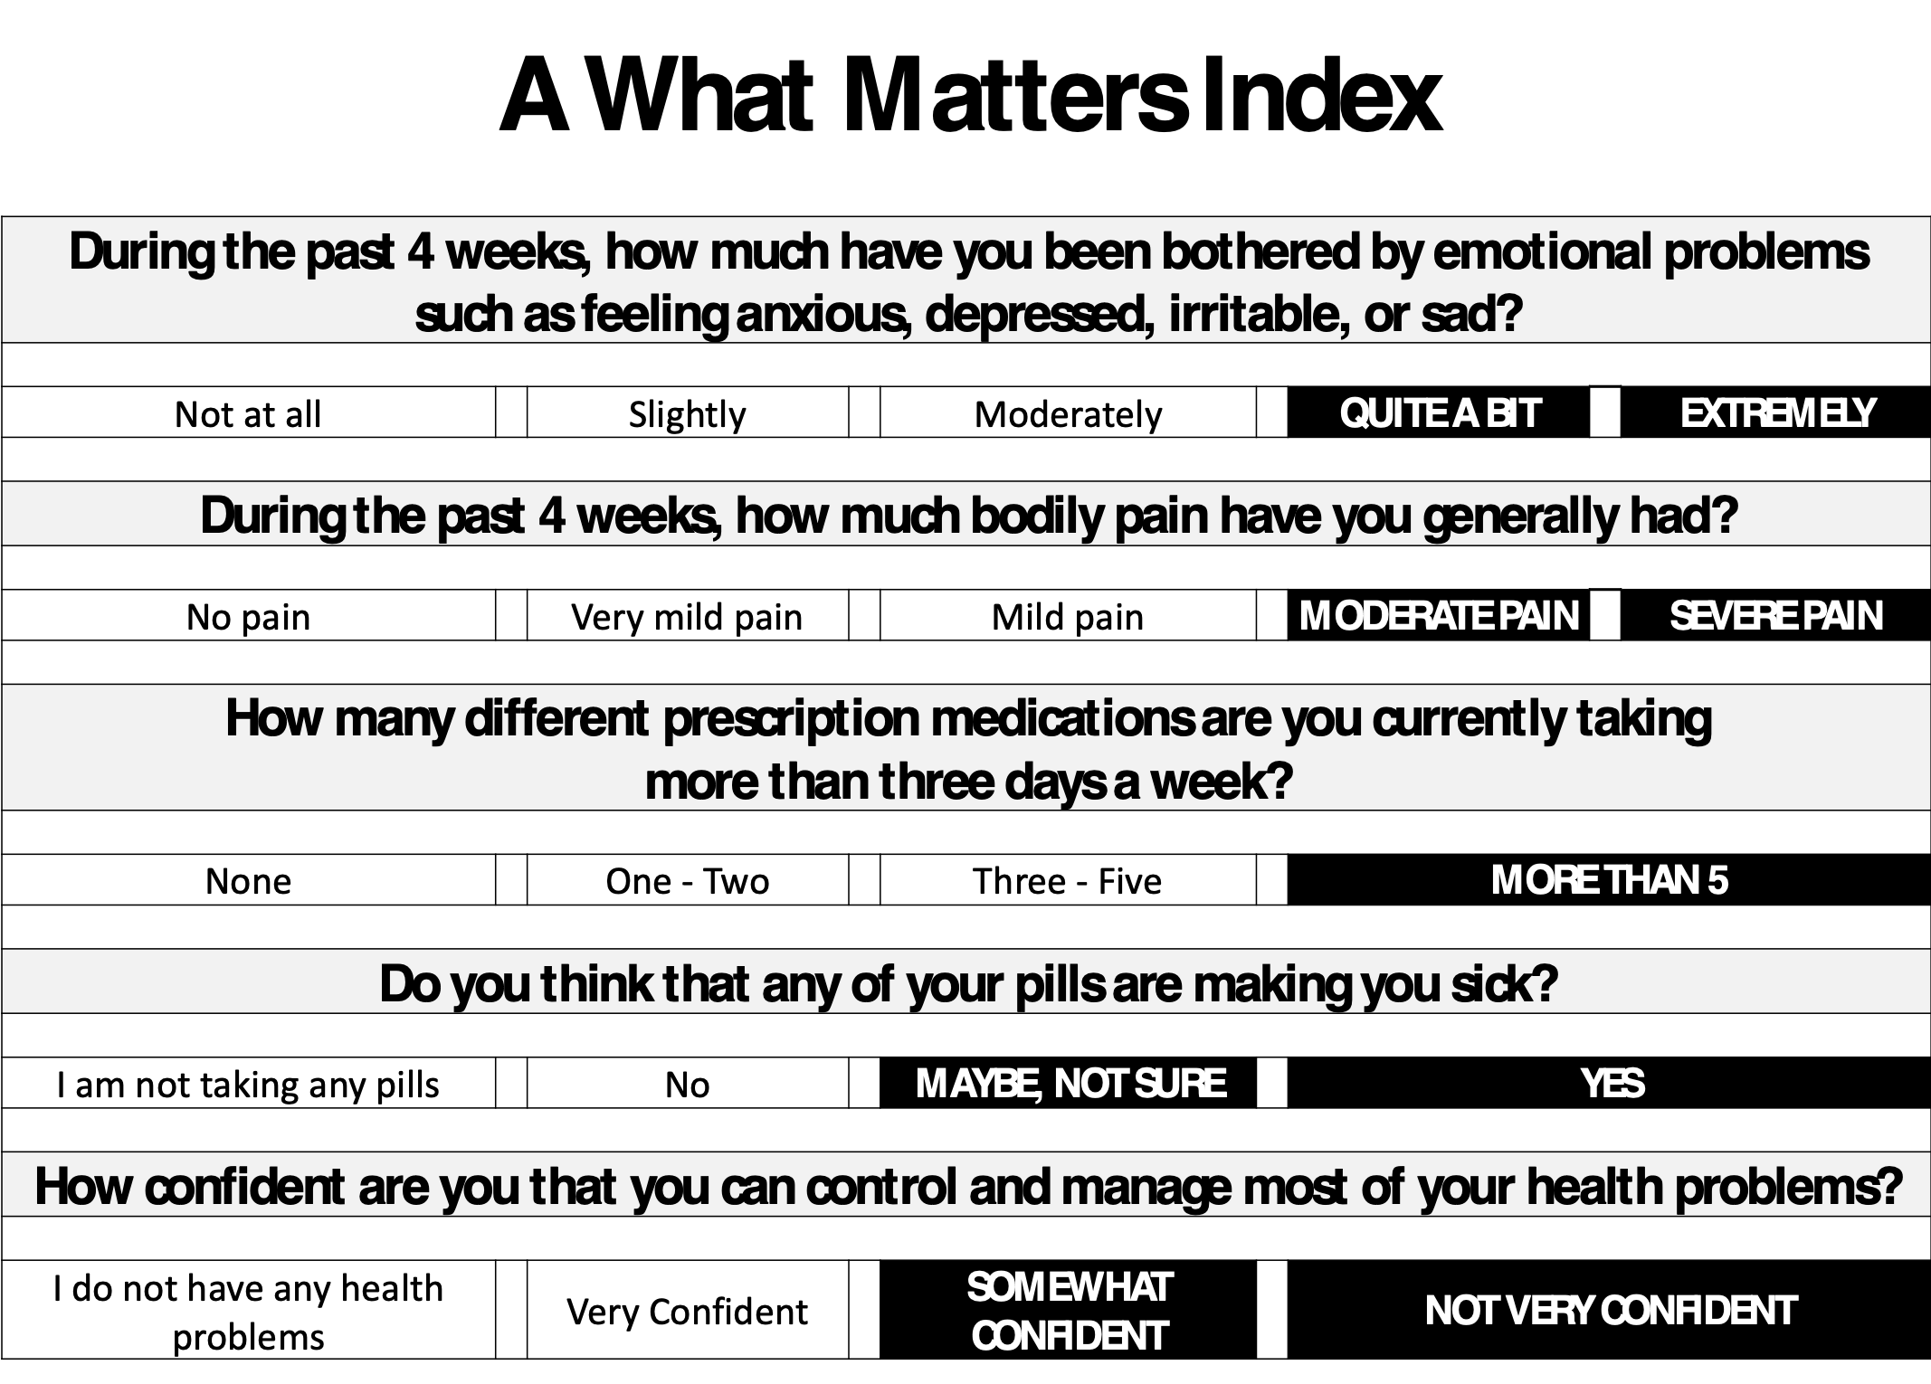

Legend. The odds of future hospital use increase with the sum of the responses highlighted in black relative to the base score of no such responses: 1 = 1.1–1.6; 2 = 1.6–2.4; 3+ = 2.9–4.0. For future emergency use relative to base score: 1 = 1.1–1.4; 2 = 1.6–2.1; 3+ = 2.6–3.3 [15].

