Supplemental Digital Content
Search strategy
PubMed:
No. | Query | Results | Date
#1 | (((((chronic idiopathic constipation) OR idiopathic constipation) OR functional constipation) OR chronic constipation) OR constipation) | 20662 | 2-January-18
#2 | (((((((((((((((((lubiprostone) OR amitiza) OR plecanatide) OR truancy) OR linaclotide) OR linzess) OR 5-HT4) OR prucalopride) OR velusetrag) OR TD-5108) OR naronapride) OR ATI-7505) OR elobixibat) OR A3309) OR bisacodyl) OR sodium picosulphate) OR lactulose) OR polyethylene glycol) OR PEG | 94700 | 2-January-18
#3 | (#1 AND #2 ) | 1241 | 2-January-18
#4 | Limited to Clinical trial | 265 | 2-January-18

EMBASE:
No. | Query | Results | Date
#1 | (((((constipation) OR idiopathic constipation) OR functional constipation) OR chronic constipation) OR chronic idiopathic constipation) | 37056 | 2-January-18
#2 | ((((((((((((((((((Lubiprostone) OR amitiza) OR plecanatide) OR trulance) OR linaclotide) OR linzess) OR 5-ht4) OR procaloprid) OR velusetrag) OR td-5108) OR naronapride) OR ati-7505) OR elobixibat) OR A3309) OR bisacodyl) OR sodium picosulphate) OR lactulose) OR polyethylene glycol) OR peg) | 71320 | 2-January-18
#3 | #1 AND #2 | 1990 | 2-January-18
#4 | randomized OR placebo OR trial | 1136231 | 2-January-18
#5 | #3 AND #4 | 699 | 2-January-18

Cochrane Library:
No. | Query | Results | Date
#1 | (((((constipation) OR idiopathic constipation) OR functional constipation) OR chronic constipation) OR chronic idiopathic constipation) | 8412 | 2-January-18
#2 | ((((((((((((((((((Lubiprostone) OR amitiza) OR plecanatide) OR trulance) OR linaclotide) OR linzess) OR 5-ht4) OR procaloprid) OR velusetrag) OR td-5108) OR naronapride) OR ati-7505) OR elobixibat) OR A3309) OR bisacodyl) OR sodium picosulphate) OR lactulose) OR polyethylene glycol) OR peg) | 4740 | 2-January-18
#3 | #1 AND #2 | 530 | 2-January-18
#4 | Limited to Clinical trial | 499 | 2-January-18

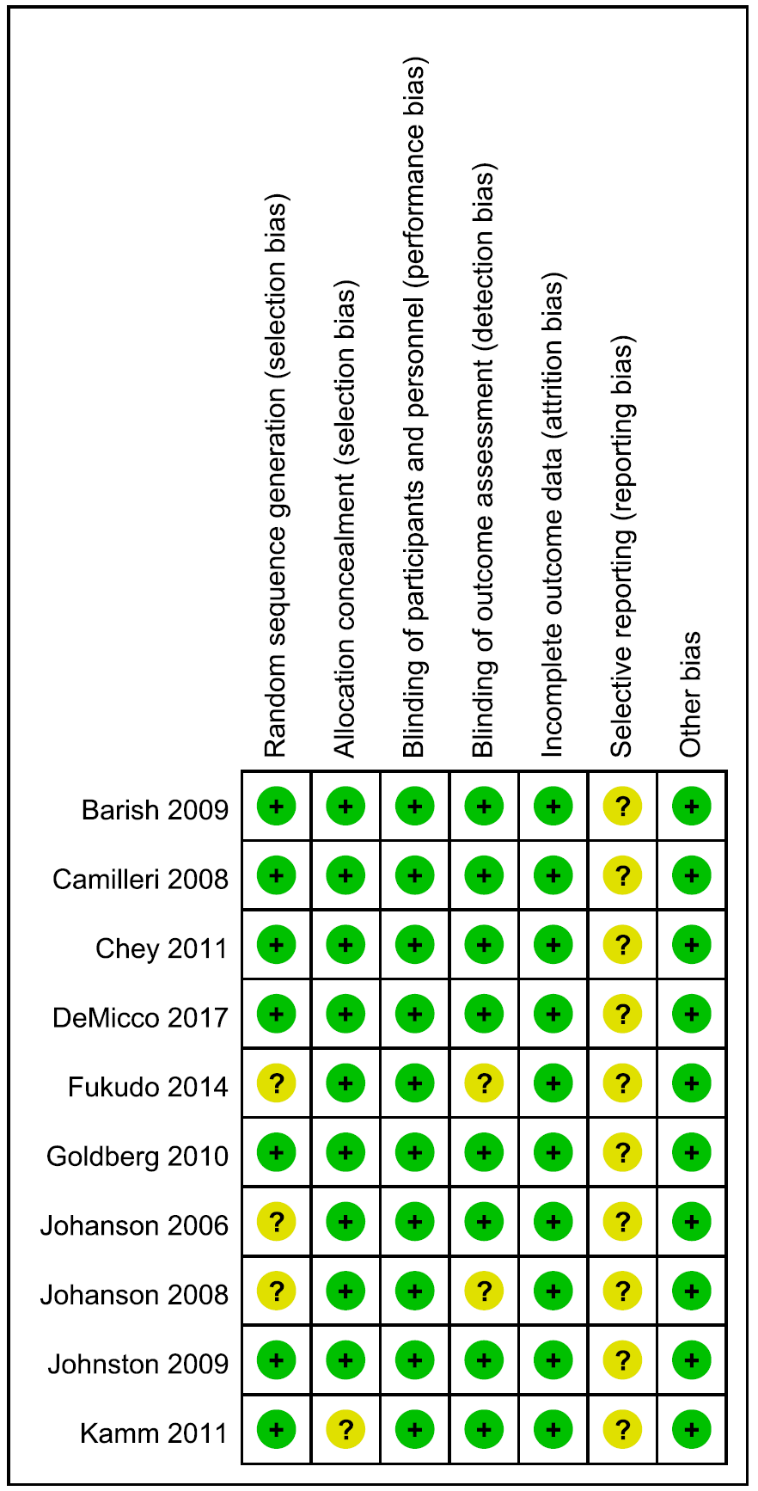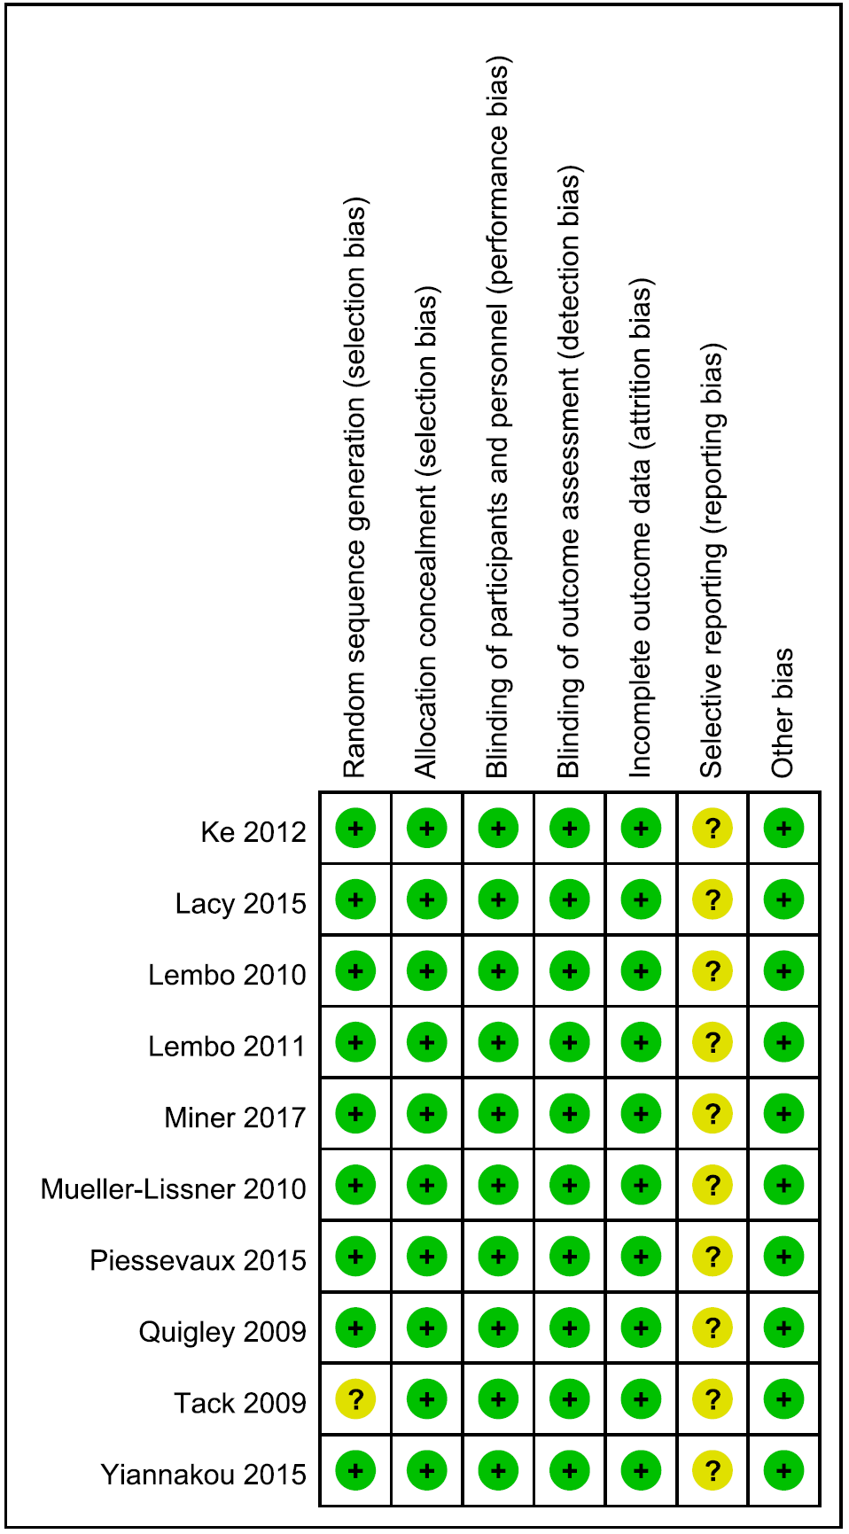
(a)
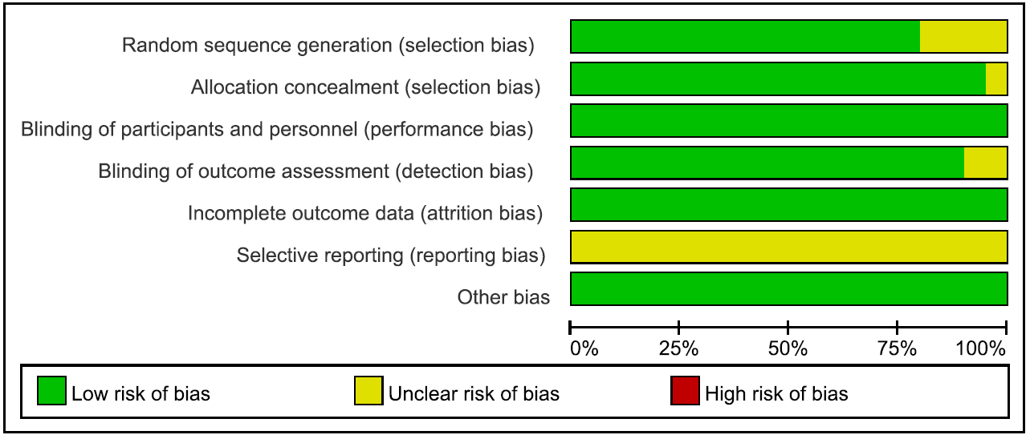
(b)

Figure 1 Risk of bias assessment. Study-level (a) and Overall (b) risk of bias, using Cochrane’s risk of bias assessment tool.

Table 1 Parameter estimations of each drug group on SBM.
Study | Arm | E_{max} (SE) | τ (SE)
Barish 2009 | Lubiprostone 24μg | 2.2(0.3) | -0.028(0.042)
Fukudo 2014 | Lubiprostone 24μg | 1.9(0.4) | -0.077(0.046)
Johanson 2008 | Lubiprostone 24μg | 2.5(0.3) | -0.021(0.040)
Johanson 2006 | Lubiprostone 24μg | 2.0(0.5) | -0.054(0.048)
Johanson 2006 | Lubiprostone 48μg | 2.4(0.5) | -0.063(0.048)
Johanson 2006 | Lubiprostone 72μg | 2.4(0.5) | -0.053(0.048)
DeMicco 2017 | Plecanatide 3mg | 1.3(0.3) | -0.015(0.025)
DeMicco 2017 | Plecanatide 6mg | 1.5(0.3) | -0.012(0.022)
Miner 2017 | Plecanatide 3mg | 1.9(0.3) | -0.009(0.017)
Miner 2017 | Plecanatide 6mg | 1.6(0.3) | 0.009(0.018)
Johnston 2009 | Linaclotide 100μg | 3.1(0.9) | -0.042(0.049)
Johnston 2009 | Linaclotide 300μg | 2.7(0.9) | -0.047(0.049)
Johnston 2009 | Linaclotide 1000μg | 2.4(0.9) | -0.050(0.049)
Lacy 2015 | Linaclotide 145μg | 2.9(1.0) | -0.028(0.029)
Lacy 2015 | Linaclotide 290μg | 2.9(1.0) | -0.026(0.029)
Lembo 2010 | Linaclotide 75μg | 1.4(0.3) | -0.052(0.048)
Lembo 2010 | Linaclotide 150μg | 2.0(0.4) | -0.055(0.046)
Lembo 2010 | Linaclotide 300μg | 2.4(0.4) | -0.038(0.044)
Lembo 2010 | Linaclotide 600μg | 3.0(0.4) | -0.030(0.041)
Lembo 2011  (Two studies) | 1-Linaclotide 145μg | 2.8(1.0) | -0.034(0.029)
Lembo 2011  (Two studies) | 1-Linaclotide 290μg | 2.8(1.0) | -0.034(0.029)
Lembo 2011  (Two studies) | 2-Linaclotide 145μg | 2.9(1.0) | -0.025(0.028)
Lembo 2011  (Two studies) | 2-Linaclotide 290μg | 3.0(1.0) | -0.018(0.028)
Goldberg 2010 | Velusetrag 15mg | 2.5(0.3) | -0.046(0.042)
Goldberg 2010 | Velusetrag 30mg | 2.5(0.4) | -0.110(0.044)
Goldberg 2010 | Velusetrag 50mg | 2.5(0.3) | -0.076(0.043)
Chey 2011 | Elobixibat 5mg | 1.4(0.4) | -0.048(0.044)
Chey 2011 | Elobixibat 10mg | 2.3(0.5) | -0.049(0.039)
Chey 2011 | Elobixibat 15mg | 3.6(0.5) | -0.022(0.028)
Kamm 2011 | Bisacodyl 10 mg | 6.8(0.4) | -0.165(0.023)
Mueller-Lissner 2010 | Sodium Picosulfate 10mg | 3.8(0.3) | -0.057(0.029)
SBM, spontaneous bowel movements; E_{max}, theoretical maximal frequency of change from baseline of SBM; τ,rate of loss of efficacy; SE, standard error.

Table 2 Parameter estimations of each placebo group on SBM.
Study | Arm | E_{max} (SE) | τ (SE)
Barish 2009 | Placebo | 1.9(0.1) | -0.017(-)*
DeMicco 2017 | Placebo | 1.7(0.1) | -0.017(-)
Fukudo 2014 | Placebo | 1.6(0.1) | -0.017(-)
Goldberg 2010 | Placebo | 1.5(0.1) | -0.017(-)
Johanson 2008 | Placebo | 1.6(0.1) | -0.017(-)
Johanson 2006 | Placebo | 1.9(0.2) | -0.017(-)
Johnston 2009 | Placebo | 1.8(0.2) | -0.017(-)
Kamm 2011 | Placebo | 1.7(0.1) | -0.017(-)
Lacy 2015 | Placebo | 1.7(0.2) | -0.017(-)
Lembo 2010 | 1-Placebo | 1.9(0.1) | -0.017(-)
Lembo 2010 | 2-Placebo | 1.7(0.1) | -0.017(-)
Lembo 2011 | Placebo | 1.7(0.1) | -0.017(-)
Miner 2017 | Placebo | 1.7(0.1) | -0.017(-)
Mueller-Lissner 2010 | Placebo | 1.5(0.1) | -0.017(-)
Chey 2011 | Placebo | 1.9(0.1) | -0.017(-)
SBM, spontaneous bowel movements; E_{max}, theoretical maximal frequency of change from baseline of SBM; τ,rate of loss of efficacy; SE, standard error.
*The inter-arm variability of parameter τ of placebo was fixed to zero.

Table 3 Parameter estimations of each drug group on CSBM.
Study | Arm | E_{max} (SE) | τ (SE)
DeMicco 2017 | Plecanatide 3mg | 0.8(0.1) | 0.010(0.009)
DeMicco 2017 | Plecanatide 6mg | 0.8(0.1) | 0.007(0.010)
Miner 2017 | Plecanatide 3mg | 1.3(0.1) | -0.004(0.006)
Miner 2017 | Plecanatide 6mg | 1.0(0.1) | -0.001(0.008)
Johnston 2009 | Linaclotide 100μg | 1.1(0.5) | -0.033(0.044)
Johnston 2009 | Linaclotide 300μg | 1.7(0.5) | -0.030(0.044)
Johnston 2009 | Linaclotide 1000μg | 1.8(0.5) | -0.028(0.043)
Lacy 2015 | Linaclotide 145μg | 1.7(0.6) | -0.025(0.030)
Lacy 2015 | Linaclotide 290μg | 1.7(0.6) | -0.025(0.030)
Lembo 2010 | Linaclotide 75μg | 1.0(0.2) | -0.034(0.041)
Lembo 2010 | Linaclotide 150μg | 1.0(0.2) | -0.031(0.041)
Lembo 2010 | Linaclotide 300μg | 1.2(0.2) | -0.019(0.040)
Lembo 2010 | Linaclotide 600μg | 1.9(0.2) | -0.062(0.037)
Lembo 2011  (Two studies) | 1-Linaclotide 145μg | 1.6(0.1) | -0.011(0.011)
Lembo 2011  (Two studies) | 1-Linaclotide 290μg | 1.7(0.1) | -0.019(0.011)
Lembo 2011  (Two studies) | 2-Linaclotide 145μg | 1.7(0.6) | -0.025(0.030)
Lembo 2011  (Two studies) | 2-Linaclotide 290μg | 2.1(0.7) | -0.003(0.027)
Camilleri 2008 | Prucalopride 2mg | 1.7(0.6) | -0.025(0.030)
Camilleri 2008 | Prucalopride 4mg | 1.9(0.6) | -0.011(0.028)
Ke 2012 | Prucalopride 2mg | 1.7(0.6) | -0.025(0.030)
Piessevaux 2015 | Prucalopride 2mg | 1.5(0.7) | -0.048(0.023)
Quigley 2009 | Prucalopride 2mg | 1.3(0.5) | -0.047(0.035)
Quigley 2009 | Prucalopride 4mg | 1.3(0.5) | -0.047(0.035)
Tack 2009 | Prucalopride 2mg | 1.1(0.5) | -0.050(0.036)
Tack 2009 | Prucalopride 4mg | 1.4(0.6) | -0.043(0.034)
Yiannakou 2015 | Prucalopride 2mg | 1.5(0.6) | -0.039(0.033)
Chey 2011 | Elobixibat 5mg | 1.3(0.2) | 0.008(0.026)
Chey 2011 | Elobixibat 10mg | 1.4(0.2) | 0.016(0.025)
Chey 2011 | Elobixibat 15mg | 2.8(0.2) | 0.022(0.014)
Kamm 2011 | Bisacodyl 10 mg | 4.7(0.2) | -0.159(0.017)
Mueller-Lissner 2010 | Sodium Picosulfate 10 mg | 2.1(0.1) | -0.028(0.025)
CSBM,complete spontaneous bowel movements; E_{max}, theoretical maximal frequency of change from baseline of CSBM; τ,rate of loss of efficacy; SE, standard error.

Table 4 Parameter estimations of each placebo group on CSBM.
Study | Arm | E_{max} (SE) | τ (SE)
Camilleri 2008 | Placebo | 0.6(0.1) | 0.029(0.010)
DeMicco 2017 | Placebo | 1.0(0.0) | 0.046(0.005)
Lembo 2010 | Placebo | 0.8(0.1) | 0.032(0.011)
Lembo 2011 | 1-Placebo | 0.5(0.1) | 0.029(0.010)
Lembo 2011 | 2-Placebo | 0.5(0.1) | 0.027(0.010)
Kamm 2011 | Placebo | 0.7(0.1) | 0.030(0.011)
Ke 2012 | Placebo | 0.6(0.1) | 0.029(0.010)
Lacy 2015 | Placebo | 0.7(0.1) | 0.031(0.010)
Johnston 2009 | Placebo | 0.7(0.2) | 0.031(0.011)
Miner 2017 | Placebo | 1.0(0.0) | 0.037(0.005)
Mueller-Lissner 2010 | Placebo | 0.9(0.0) | 0.031(0.011)
Piessevaux 2015 | Placebo | 0.6(0.1) | 0.029(0.008)
Quigley 2009 | Placebo | 0.6(0.1) | 0.029(0.010)
Tack 2009 | Placebo | 0.5(0.1) | 0.027(0.010)
Yiannakou 2015 | Placebo | 0.8(0.1) | 0.035(0.010)
Chey 2011 | Placebo | 0.9(0.1) | 0.034(0.010)
CSBM, complete spontaneous bowel movements; E_{max}, theoretical maximal frequency of change from baseline of CSBM; τ,rate of loss of efficacy; SE, standard error.

SBM-drug a | b | c | d
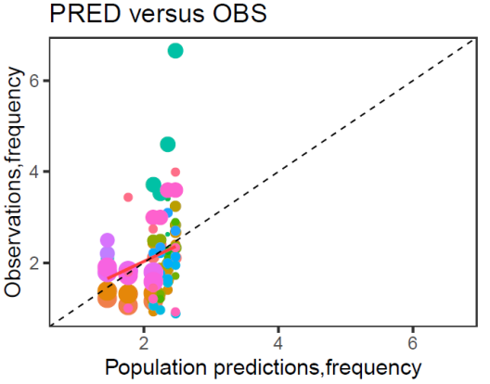 | 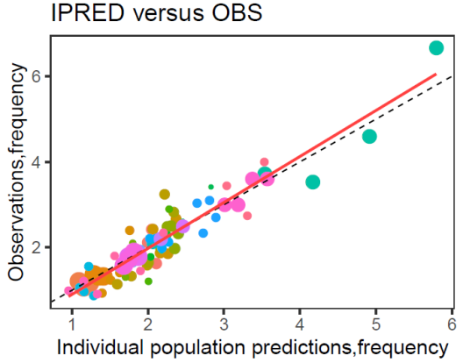 | 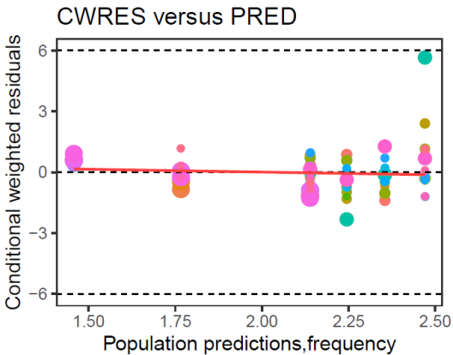 | 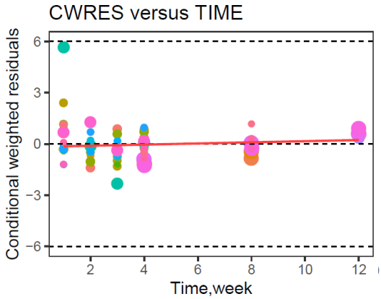
SBM-placebo a | b | c | d
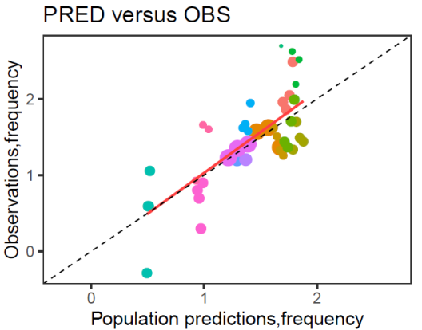 | 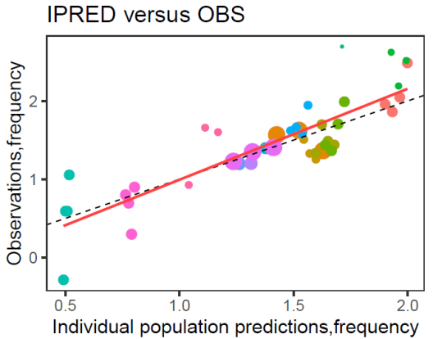 | 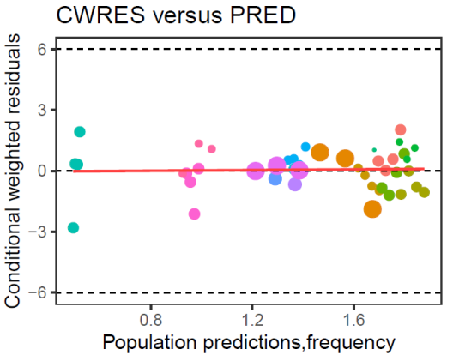 | 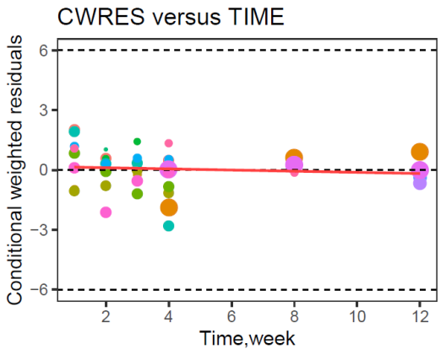

CSBM-drug a | b | c | d
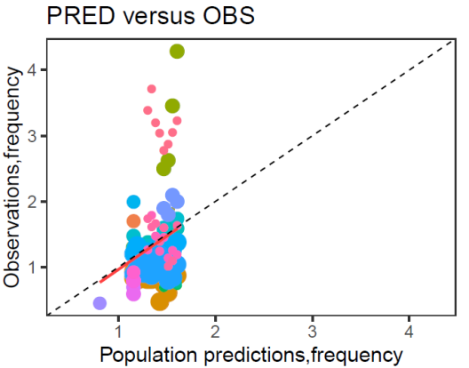 | 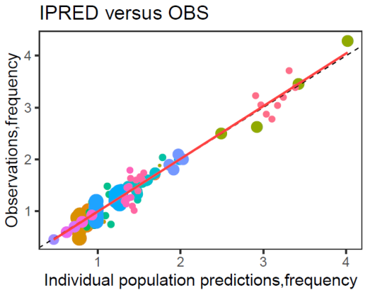 | 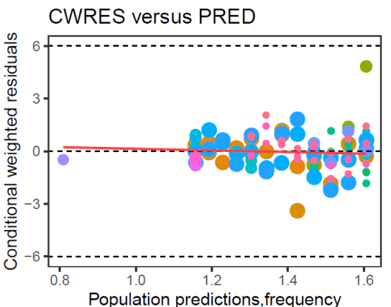 | 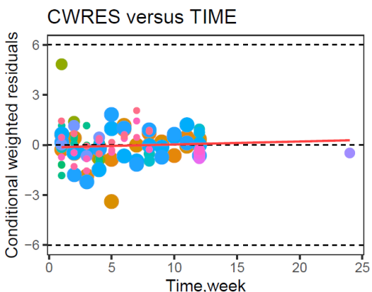
CSBM-placebo a | b | c | d
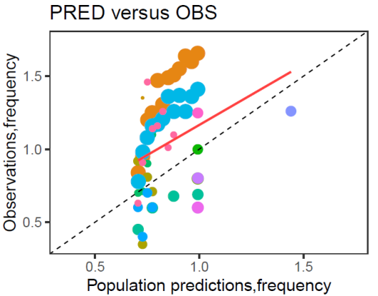 | 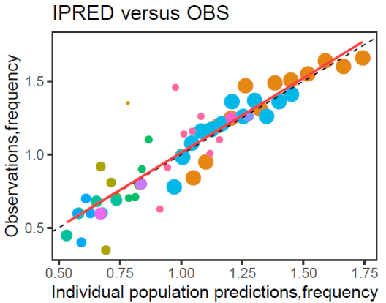 | 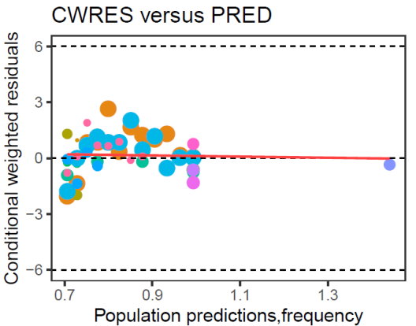 | 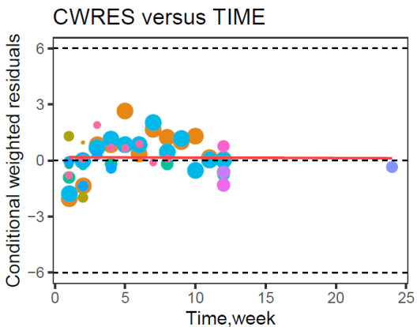

Figure 2 Goodness of fit plots. (a) Population predicted effect value versus observed effect value;(b)Individual predicted effect value versus observed effect value; (c) Conditional weighted residuals versus population predicted effect value; (d) Conditional weighted residuals versus time. The dashed and solid lines in A and B represent identity and regression lines, respectively, whereas in C and D, the dashed lines are the position where conditional weighted residual equal 0, 6 and -6, and the solid lines are the regression lines. SBM, spontaneous bowel movements; CSBM,complete spontaneous bowel movements.
(a)
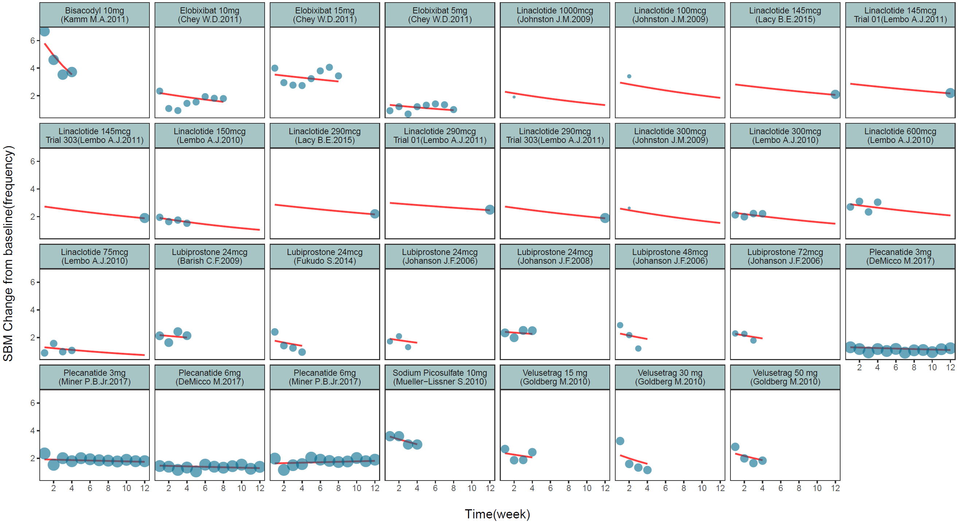
(b)
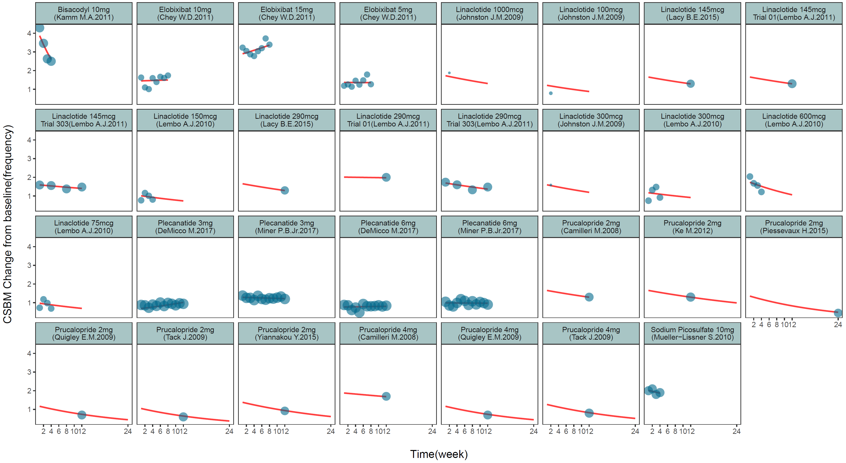

(c)
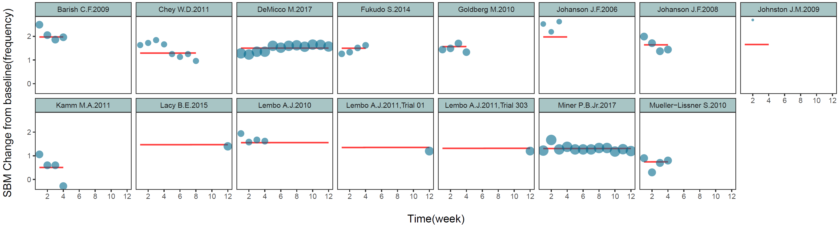
(d)

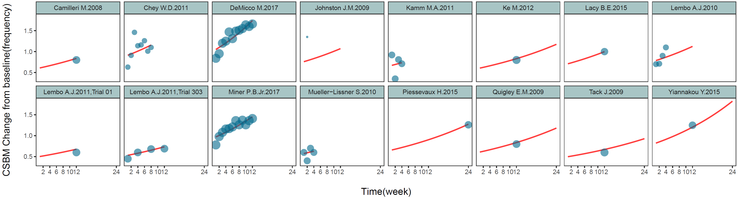

Figure 3 Individual time course check. Time course of SBM and CSBM change from baseline for each drug group(a)(b) and each placebo group(c)(d). The solid points represent observed data, and the symbol size is proportional to the number of subjects in each study.
is the typical predicted value of this arm

