Supplementary Digital Content Materials

Supplementary Text

Confounding of self-report with disease severity
To test whether self-reported indices AI and HI are confounded by disease severities we set up a series of three-way ANOVAs with illness severity contrasts (burden of complications, number of comorbidities, compensation of diabetes, severity of diabetes, severity of MetS), by age group and sex differences (Helmert contrasts): Figure, Supplemental Digital Content 2, http://links.lww.com/JCN/A12, depicts profile plots of the ANOVAs. As can be seen, these are non-significant in majority. Significant effects for AI are evident for complications, namely a main effect of sex differences (F(1, 101)=6.559, p<0.016, partial(p)-η²=0.186), and an interaction effect sex by complications (F(3, 101)=5.823, p<0.045, ηp²=0.780). For AI and comorbidities, there was a main effect of sex differences (F(1, 101)=10.808, p<0.002, ηp²=0.157), a main effect of age groups (F(1, 101)=5.373, p<0.023, ηp²=0.057), an interaction effect sex by comorbidities (F(4, 101)=2.764, p<0.033, ηp²=0.115), and an interaction effect age group by comorbidities (F(13, 101)=3.195, p<0.054, ηp²=0.841). There were no significant effects for compensation of diabetes, but for severity of diabetes, a main effect of severity (F(3, 101)=3.559, p<0.020, ηp²=0.181), and an interaction effect sex by severity (F(2, 101)=3.009, p<0.059, ηp²=0.109) was observed. For severity of MetS, there was a main effect of sex differences (F(1, 101)=7.615, p<0.007, ηp²=0.073), as well as a main effect of age groups (F(1, 101)=3.268, p<0.074, ηp²=0.033). Regarding covert hostility, there were no significant effects evident for levels of complications, compensation of diabetes, severity of diabetes, nor severity of MetS. For burden with co-morbidities, significant effects emerged, namely a main effect of sex differences (F(1, 101)=2.960, p<0.089, ηp²=0.034), a main effect of age groups (F(1, 101)=5.373, p<0.023, ηp²=0.057), and an interaction effect sex by co-morbidities (F(4, 101)=3.567, p<0.010, ηp²=0.144). Given the repeated gender effects we adjusted for sex differences in the comprehensive final SEM.

Ascertainment of latent variables
Beforehand exploratory factor analyses had revealed that the correlation matrix is decomposable into two factors that each exhibited the by far largest eigenvalues. Therefore the final PCA was constrained to these two main factors. The final PCA over all biological variables, and including Aggressivity and Hostility Indices, yielded two main components that accounted for 73.70% of the total variance: (a) component 1 with 46.69% and (b) component 2 with 27.01% explained variance: Component 1 is characterized by AI and component 2 is characterized by HI, each of which exhibited eigenvalues >15. Table, Supplemental Digital Content 3, http://links.lww.com/JCN/A13, shows eigenvalues and final factor loadings after rotation resulting for the two components. In sum, component 1 dominated by AI has positive loadings of waist girth, BMI and DBP. The component 2 dominated by HI has positive loadings of TG and HDL.

Estimation of path models by Hierarchical Regression Analysis
The robust OLS method implemented in STATA was used to re-model factor loadings with multiple regression analyses. In the HRA model for AI (Wald-χ²=5272.85, model-p<0.00001, adjusted R²=0.89) was predicted by BMI (Z=9.59, term-p<0.0001, 95%CIs0.937-1.419) and TCH (Z=1.59, term-p<0.087, 95%CIs-0.348-5.179). In the HRA model for HI (Wald-χ²=755.96, model-p<0.00001, adjusted R²=0.88), HI was also predicted by BMI (Z=3.73, term-p<0.0001, 95%CIs0.379-1.224) and by TG (Z=4.19, term-p<0.0001, 95%CIs5.126-14.149). In the HRA for BMI (Wald-χ²= 5553.47, model-p<0.00001, adjusted R²=0.98), there were significant terms for age (Z=-7.30, term-p<0.0001, 95% CIs-1.763--1.017), AI (Z=-2.30, term-p<0.021, 95%CIs-0.059--0.004), and TCH (Z=3.82, term-p<0.0001, 95%CIs0.624--1.940). In the HRA for dependent waist circumference (Wald-χ²=14494.85, model-p<0.00001, adjusted R²=0.98), predictors were AI (Z=2.24, term-p<0.025, 95%CIs0.017-.265) and DBP (Z=8.29, term-p<0.0001, 95%CIs0.508-0.823). In the HRA for TCH (Wald-χ²=2420.98, model-p<0.00001, adjusted R²=0.98), significant predictors were HI (Z=-1.83, term-p<0.067, 95%CIs-0.026-0.001), TG (Z=2.13, term-p<0.033, 95%CIs0.041-0.970), and SBP (Z=5.14, term-p<0.0001, 95%CIs0.014-0.033). In HRA, TG (Wald-χ²=572.85, model-p<0.00001, adjusted R²=0.95) was significantly explained by HI (Z=1.81, term-p<0.070, 95%CIs-0.007-0.020) and TCH (Z=53.65, term-p<0.0001, 95%CIs0.331-0.356). The HRA for DBP (Wald-χ²=36700.23, model-p<0.00001, adjusted R²=0.99) revealed waist (Z=4.72, term-p<0.0001, 95%CIs0.171-0.413) and SBP (Z=10.49, term-p<0.0001, 95%CIs0.270-.395) as predictors. Likewise, in HRA, SBP (Wald-χ²=7637.37, model-p<0.00001, adjusted R²=0.99) was predicted by LDL (Z=1.70, term-p<0.089, 95%CIs-0.179-2.790), and by DBP (Z=8.71, term-p<0.0001, 95%CIs0.981-1.551). The exact MVLR models for microalbuminuria, however, for HI and AI had marginal significance, albeit did not reach conventional significance levels. The variables HDL, LDL, and microalbuminuria were henceforth dropped as dependent variables. As compared to TCH, HDL and LDL add only minimally to overall CVD risk prediction ¹. In sum, the regression analyses confirmed and extended the results of the two-factor solution in the PCA. With exception of BMI, all other biological variables had either AI or HI amongst their predictors.

Additional SEMs
When relaxing the model an using OIM estimation method (model 3), the SEM fit indices were as follows: χ²=67.96, df=14, p=0.0001, root mean square of estimation RMSEA=0.131 (95%CIs0.0950-0.168), Bentler’s comparative fit index CFI=0.656, Tucker-Lewis index TLI=0.537, standardized root mean square of residuals SRMR=0.109, the latter indicating good fit. For a model of this sample size, these fit indices for the nonadjusted/unconstrained model 3 are approaching desirable values (i.e. CFI=0.7) ². Although the χ² of the relaxed model 3 was significant, the χ² divided by the degrees of freedom had a ratio of 3.5, suggesting still a satisfactory fit, which was confirmed by the fact that all other estimates of the model fit parameters obtained values indicating evidence of fairly good fit, although not perfectly close.

References:

- Di Angelantonio E, Gao P, Pennells L, et al. Lipid-related markers and cardiovascular disease prediction. JAMA. 2012;307:2499-2506.

- Bentler PM. SEM with simplicity and accuracy. J Consum Psychol. 2010;20:215-220.

Supplementary Figure 1

Profile plots of ANOVAs for sex differences and disease severity

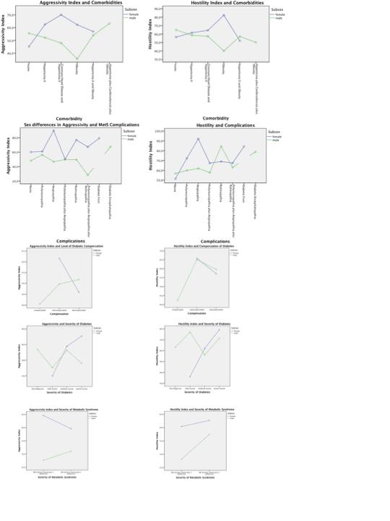

Supplementary Table 1

Results of the Principal Component Analysis

Rotated Component Matrixª
 | Eigenvalues |  | Factor loadings
 | Component |  | Component
 | 1 | 2 | 1 | 2
Aggressivity Index | 15.433 | 4.557 | 0.902 | 0.266
Hostility Index | 0.744 | 16.566 | 0.044 | 0.969
Waist | 10.338 | -5.120 | 0.738 | -0.366
BMI | 2.683 | -0.315 | 0.449 | -0.053
TG | -0.115 | 0.345 | -0.135 | 0.406
HDL | -0.077 | 0.037 | -0.625 | 0.297
LDL | -0.314 | -0.399 | -0.125 | -0.159
TCH | 0.044 | -0.156 | 0.036 | -0.129
Microalbuminuria | -0.103 | 0.159 | -0.207 | 0.317
SBP | -0.223 | 1.576 | -0.016 | 0.113
DBP | 2.051 | -0.515 | 0.283 | -0.071
Note: ⎯ªPCA with varimax rotation, three iterations.

