Longitudinal Analysis of Disease Burden in Refractory and Nonrefractory Generalized Myasthenia Gravis in the United States

Supplementary Fig. 1. Transitions between refractory and nonrefractory status during the study.

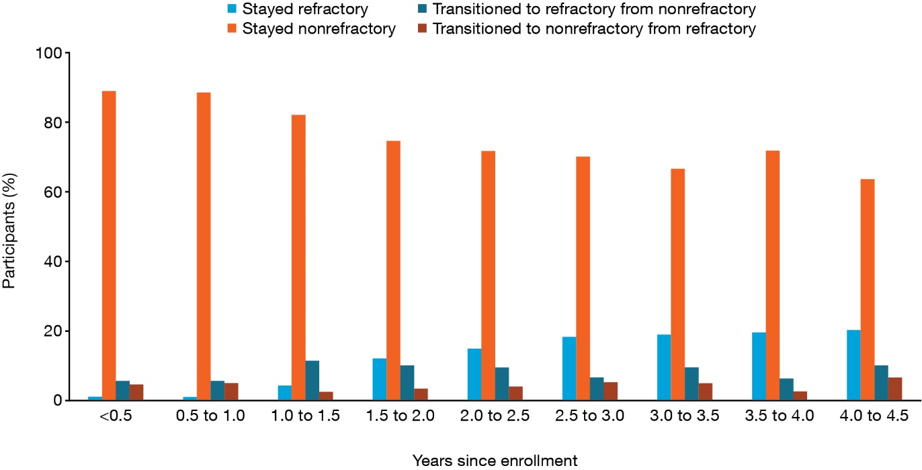

Transitions during each period are based on refractory status at the participant’s last completed survey in the previous period.

