Pharmacokinetic Evaluation of a One-Day Treatment Initiation Option for Starting Long-Acting Aripiprazole Lauroxil for Schizophrenia

Supplemental Digital Content 3

SUPPLEMENTAL FIGURE S1. Scatterplot of aripiprazole concentrations for patients receiving the 21-day initiation regimen in the present study (red symbols) and the phase 3 efficacy study (blue symbols) for the 441 mg and 882 mg AL dose groups combined (log scale)

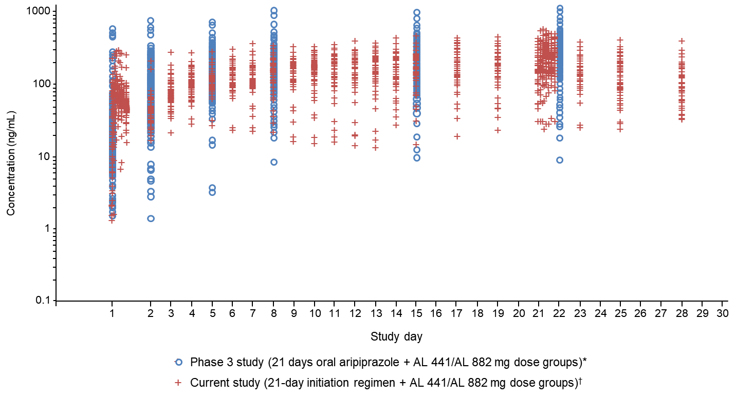
In the present phase 1 study, pharmacokinetic samples were taken daily on Days 1 to 15, every other day from Days 17 to 25, and on Day 28. Samples were collected within 1 hour pre-dose and 1, 2, 3, 4, 5, 6, and 8 hours (±15 minutes) post-dose on Days 1 and 21. On post-initiation Days 2 to 21, a single sample was collected before oral aripiprazole (or oral placebo) administration. For Days 23 to 28, a single sample was collected within ±2 hours of the Day 1 oral dosing time or as close to that time frame as possible. In the phase 3 efficacy study, single pharmacokinetic samples were taken before administration of study drug on Days 1, 2, 5, 8, 15, and 22. AL, aripiprazole lauroxil. *AL 441 mg (gluteal) or AL 882 mg (gluteal) plus 15 mg oral aripiprazole on Day 1 followed by 20 days of 15 mg oral aripiprazole. †21-day initiation: placebo intramuscular (gluteal) plus 15 mg oral aripiprazole plus intramuscular AL 441 mg (deltoid) or AL 882 mg (contralateral gluteal) on Day 1 followed by 20 days of 15 mg oral aripiprazole.

