Pharmacokinetic Evaluation of a One-Day Treatment Initiation Option for Starting Long-Acting Aripiprazole Lauroxil for Schizophrenia

Supplemental Digital Content 5

SUPPLEMENTAL FIGURE S3. Mean (+SD) dehydroaripiprazole concentrations over time (140 days) for treatment initiation with AL_{NCD} plus a single dose of oral aripiprazole (30 mg) or oral aripiprazole (15 mg over 21 days)
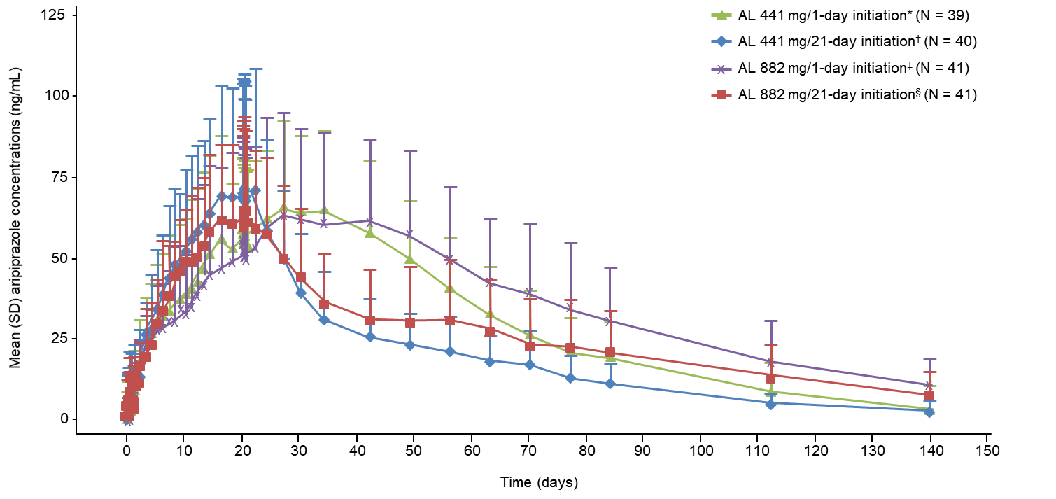
AL, aripiprazole lauroxil; AL_{NCD}, aripiprazole lauroxil NanoCrystal dispersion; SD, standard deviation. *AL 441 mg/1-day initiation: AL_{NCD} intramuscular (gluteal) plus 30 mg oral aripiprazole plus intramuscular AL 441 mg (deltoid) on Day 1 followed by 20 days of oral placebo. †AL 441 mg/21-day initiation: placebo injection (gluteal) plus 15 mg oral aripiprazole plus intramuscular AL 441 mg (deltoid) on Day 1 followed by 20 days of 15 mg oral aripiprazole. ‡AL 882 mg/1-day initiation: AL_{NCD} intramuscular (gluteal) plus 30 mg oral aripiprazole plus intramuscular AL 882 mg (contralateral gluteal) on Day 1 followed by 20 days of oral placebo. §AL 882 mg/21-day initiation: placebo intramuscular (gluteal) plus 15 mg oral aripiprazole plus intramuscular AL 882 mg (contralateral gluteal) on Day 1 followed by 20 days of 15 mg oral aripiprazole.

