SUPPLEMENTAL DATA
Supplemental Table 1. Demographics of Subjects Used for PK/PD Model Development

 | Phase 1 PK study in healthy adults | Phase 3 classroom efficacy and safety study in children with ADHD
 | DR/ER-MPH  N = 20 | DR/ER-MPH  (n = 64) | Placebo  (n = 53)
Gender, n (%)
Male | 6 (30.00) | 42 (65.63) | 38 (71.70)
Female | 14 (70.00) | 22 (34.38) | 15 (28.30)
Age (y)
Mean (SD) | 26.60 (5.81) | 9.58 (1.58) | 9.28 (1.68)
Median (min, max) | 26.00 (18.00, 39.00) | 10.00 (6.00, 12.00) | 9.00 (6.00, 12.00)
Height (cm)
Mean (SD) | 170.19 (9.56) | 136.49 (10.73) | 137.03 (12.47)
Median (min, max) | 136.10 (114.60, 169.00) | 136.10 (114.60, 169.00) | 137.00 (114.30, 163.80)
Weight (kg)ª
Mean (SD) | 67.59 (10.63) | 32.68 (8.88) | 32.76 (8.16)
Median (min, max) | 65.65 (51.8, 90.1) | 30.85 (19.8, 56.1) | 31.50 (20.9, 50.1)

ª Measured at the classroom day visit in the Phase 3 pediatric study

DR/ER-MPH, delayed-release and extended-release methylphenidate; PD, pharmacodynamic; PK, pharmacokinetic; SD, standard deviation.

Supplemental Table 2: Base Reference PK Model Development and Covariate Step-Wise Forward Addition and Backward Elimination Process Based on the Log-Likelihood Ratio Testing
Model | Description of Model Tested | Model Compared | OFV | Change in OFV | Degrees of Freedom | p value
Base Reference Model Development
1 | Single Weibull function | — | -410.352 | — | — | —
2 | Double Weibull function | 1 | -398.790 | 11.562 | 6 | 1
Preferred model | — | 1 | -410.352 | — | — | —
1 | No IOV | — | -410.352 | — | — | —
3 | With IOV | 1 | -1163.63 | -753.278 | 3 | <0.0001
Base reference modelª | — | 3 | -1163.63 | — | — | —
Covariate Analysis: Forward Addition Process^{b}
One Covariate
4 | Weight on V_{d}/F | 3 | -1170.081 | -6.451 | 0 | <0.001
5 | Weight on td | 3 | -1173.463 | -9.833 | 1 | 0.0017
6 | Weight on ss | 3 | -1165.890 | -2.260 | 1 | 0.1327
7 | Gender on td | 3 | -1175.043 | -11.413 | 1 | <0.001
Two Covariates
8 | Gender on td; Weight on V_{d}/F | 7 | -1181.652 | -6.609 | 0 | <0.001
9 | Gender on td; Weight on td | 7 | -1178.207 | -3.164 | 1 | 0.0752
Best performing model^{c} | — | 8 | -1181.652 | — | — | —
Covariate Analysis: Backward Elimination Process^{b}
10 | Remove weight on V_{d}/F | 8 | -1175.043 | 6.609 | — | 1
Final model^{c} | — | 8 | -1181.652 | — | — | —

ª The base reference model did not include any covariate effects.
^{b} A significance level of 0.05 for FOCE-I was used for the forward addition process (i.e., OFV of ≥3.84, χ² <0.05 for df 1), and a covariate was retained in the model if, upon removal using the backward elimination process, the OFV increases by more than 6.63 points (χ² <0.01 for 1 df) using FOCE-I.
^{c} The best performing and final models included the following covariates: weight on V_{d}/F and gender on td
FOCE-I, first-order conditional estimation with interaction method; IOV, inter-occasion variability; OFV, maximum likelihood objective function value; PK, pharmacokinetic; ss, sigmoidicity factor; td, time necessary to release 63.2% of the dose; V_{d}/F, apparent volume of distribution.

Supplemental Table 3: Base Reference PK/PD Model Development and Covariate Step-Wise Forward Addition and Backward Elimination Process Based on the Log-Likelihood Ratio Testing
Model | Description of Model Tested | Model Compared | OFV | Change in OFV | Degrees of Freedom | p value
Base Reference Model Development
1 | Base reference model | — | 2546.223 | — | — | —
Base reference modelª | — | — | 2546.223 | — | — | —
Covariate Analysis: Forward Addition Process^{b}
One Covariate
2 | Weight on EC₅₀ | 1 | 2542.852 | -3.371 | 1 | 0.066
3 | Age on EC₅₀ | 1 | 2537.380 | -8.843 | 1 | 0.003
4 | Gender on EC₅₀ | 1 | 2534.163 | -12.06 | 1 | 0.0005
Two Covariates
5 | Gender on EC₅₀ and Age on EC₅₀ | 4 | 2532.689 | -1.474 | 0 | 0.224
Best performing model^{c} | — | 4 | 2534.163 | — | — | —
Final model^{c} | — | 4 | 2534.163 | — | — | —

ª The base reference model did not include any covariate effects.
^{b} A significance level of 0.05 for FOCE-I was used for the forward addition process (i.e., OFV of ≥3.84, χ² <0.05 for df 1), and a covariate was retained in the model if, upon removal using the backward elimination process, the OFV increases by more than 6.63 points (χ² <0.01 for 1 df) using FOCE-I.
^{c} The best performing and final models included gender as covariate on EC₅₀
EC₅₀, half maximal effective concentration; E_{max}, maximum effect; g, shape of the exposure-response relationship; FOCE-I, first-order conditional estimation with interaction method; OFV, maximum likelihood objective function value; PD, pharmacodynamics; PK, pharmacokinetics.

Figure S1. Exploratory Covariate Analysis: Empirical Bayesian Estimates of Individual Pharmacokinetic Parameters Versus (a) Body Weight and (b) Gender for the Final PK Model (F=0, M=1).
a
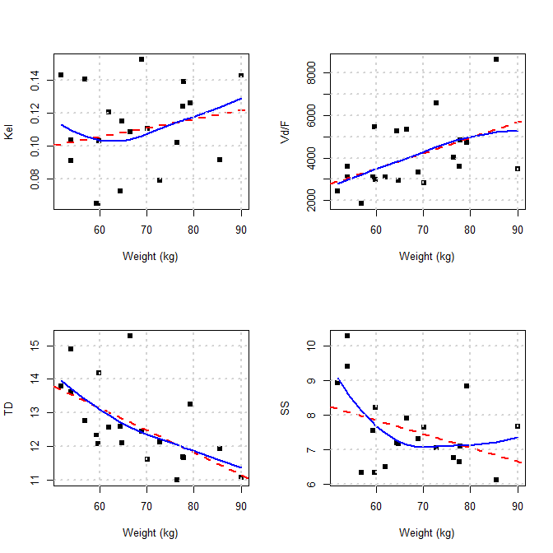

b
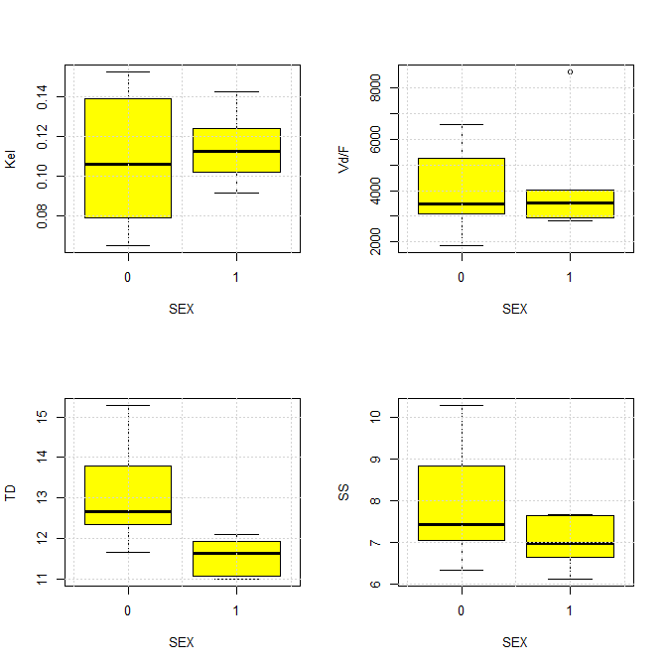

kel, elimination rate constant; ss, sigmoidicity factor; td, time necessary to release 63.2% of the dose; V_{d}, volume of distribution.
Squares represent observed values, dashed red lines represent the linear regression of the data, and solid blue lines represent a nonparametric smooth of the data. Box plots show median and interquartile range with tails showing minimum and maximum values exclusive of outliers (open circles).
The effect of weight on V_{d}/F was tested using an allometric scaling model (i.e., weight normalized against a standard weight of 70 kg)
Figure S2. Goodness-of-Fit Plots for the Final Population Pharmacokinetic Model at the Dose of (a) 20 mg and (b) 100 mg of DR/ER-MPH
a
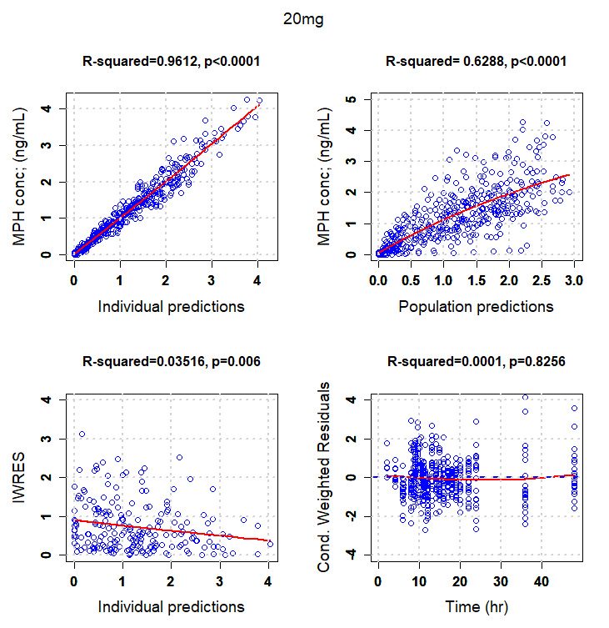

b
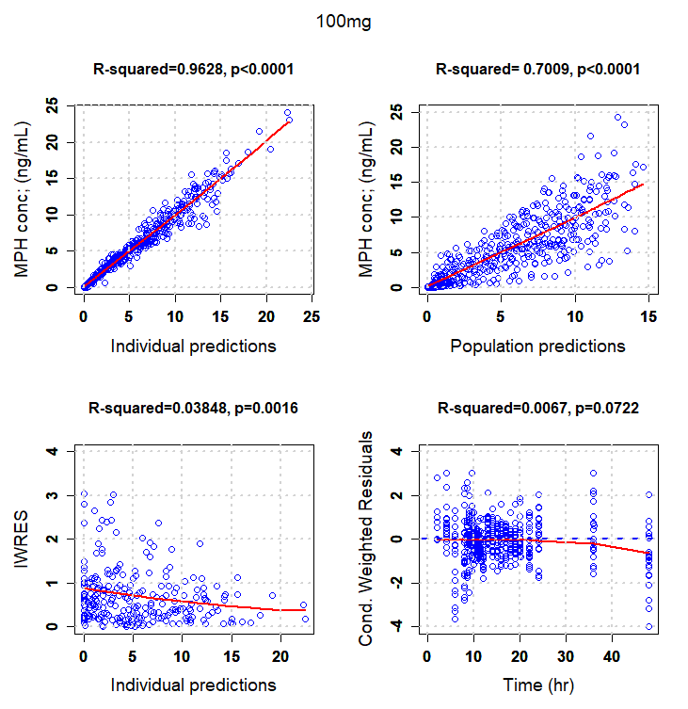
CWRES, conditional weighted residuals; DR/ER-MPH, delayed-release and extended-release methylphenidate; IWRES, individual weighted residuals; MPH, methylphenidate.

Figure S3. Visual Predictive Checks of the Relationship Between MPH Exposure and SKAMP Response for DR/ER-MPH
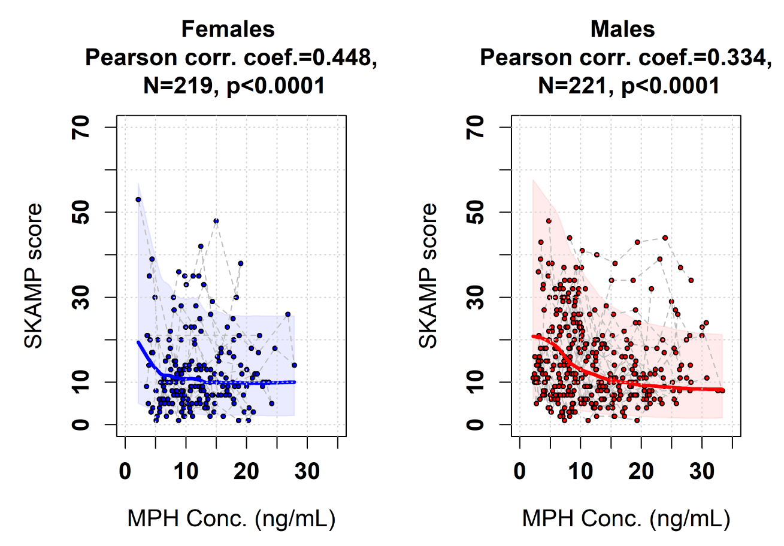Solid circles represent the observed data, solid lines represent the model-predicted median scores, and the shaded gray areas represent the 90% prediction interval.

MPH, methylphenidate; SKAMP, Swanson, Kotkin, Agler, M‑Flynn, and Pelham scale.

Figure S4. Exploratory Covariate Analysis: Empirical Bayesian Estimates of Individual Pharmacodynamic Parameters Versus Body Weight, Age, and Gender (F=0, M=1) for the Final PK/PD Model
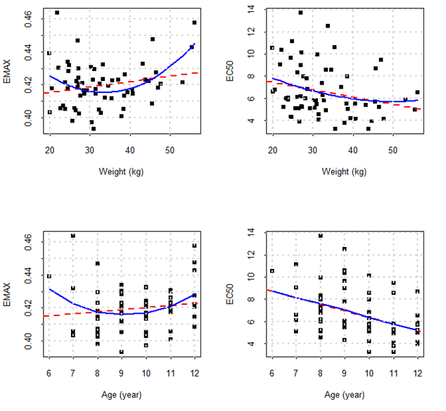
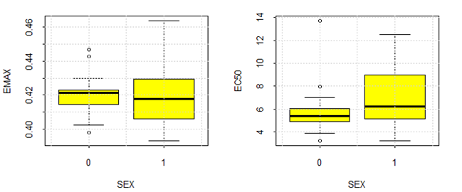
DR/ER-MPH, delayed-release and extended-release methylphenidate; E₅₀, half maximal effective concentration; E_{max}, maximum effect; PD, pharmacodynamic; PK, pharmacokinetic.

Squares represent observed values, dashed red lines represent the linear regression of the data, and solid blue lines represent a nonparametric smooth of the data. Box plots show median and interquartile range with tails showing minimum and maximum values exclusive of outliers (circles).
Figure S5. Goodness-of-Fit Plots for the Final Population PK/PD Model for DR/ER-MPH

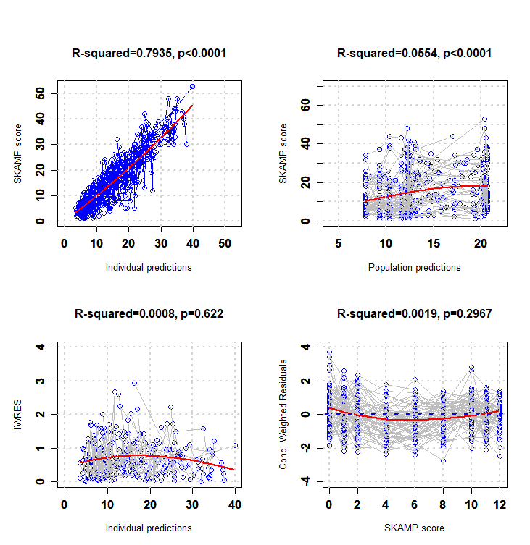

CWRES, conditional weighted residuals; DR/ER-MPH, delayed-release and extended-release
methylphenidate; IWRES, individual weighted residuals; PD, pharmacodynamic; PK, pharmacokinetic; SKAMP, Swanson, Kotkin, Agler, M‑Flynn, and Pelham scale.

Figure S6. Visual Predictive Check of the PK/PD Model for DR/ER-MPH

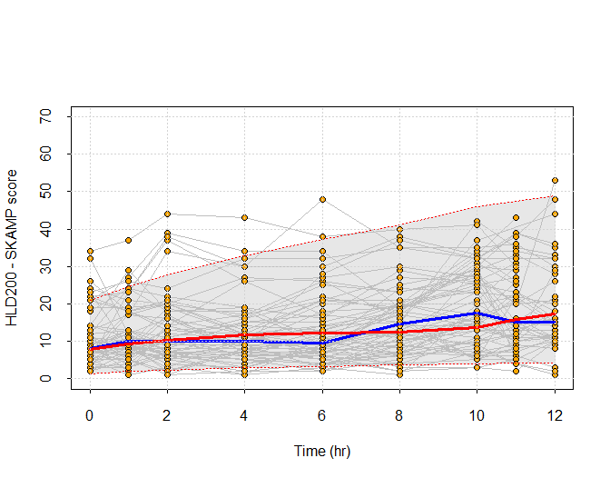

The red solid lines represent the model-predicted median scores and the blue solid lines represent the median observed scores. The shaded gray area represents the 90% prediction interval, and the orange dots represent the raw data.

DR/ER-MPH, delayed-release and extended-release methylphenidate; PK, pharmacokinetic; PD, pharmacodynamic; SKAMP, Swanson, Kotkin, Agler, M‑Flynn, and Pelham scale.

