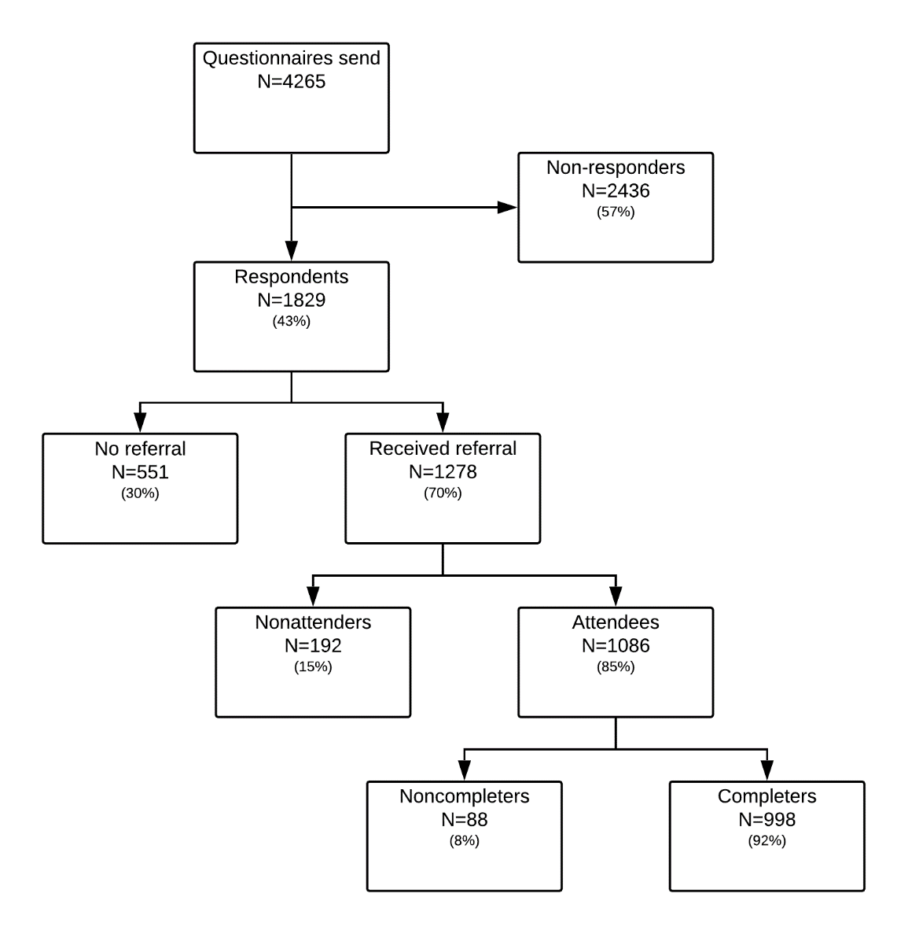
SDC 1. Flowchart of the questionnaire response

