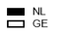
SDC4: Reasons for nonattendance per country (total numbers of agree)

