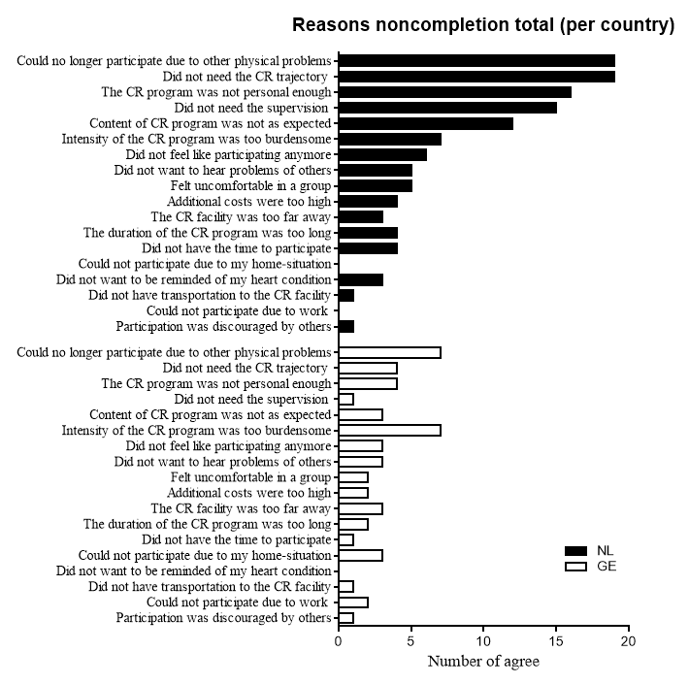
SDC 5: Reasons for noncompletion per country (total numbers of agree)

