Supplementary Information:
Chitosan Hydrogel Enhances the Therapeutic Efficacy of BMSCs for Myocardial Infarction by Alleviating Vascular Endothelial Cell Pyroptosis
Yang Liu, Panyang Li, Chenhui Qiao, Tiejun Wu, Xiaoke Sun, Meng Wen, Weihua Zhang

Supplemental Table 1: Primers used for real-time PCR
Gene | Forward primer | Reverse primer
mEGF | TTGACAAGTGGCAGGAGGTC | ATCCCTACGTCCGTCCAGAA
mPGF | ACTTGGGAACACAAGAAGCCT | CTCTCCAGAGCCGAATGTCC
mHGF | TTCTTTCAGCCCGGCATCTC | CAAGAACTTGTGCCGGTGTG
mIGF-1 | GCATACCTGCCTGGGTGTC | TTTGTCGATAGGGACGGGGA
mTNF-α | ACAGAAAGCATGATCCGCG | GCCCCCCATCTTTTGGG
mIL-6 | GAGGATACCACTCCCAACAGACC | AAGTGCATCATCGTTGTTCATACA
mIL-18 | AGCAGTGGTTTTCAGCTGGG | GGCAGGAGTCCAGAAAGCAT
mCaspase-11 | TGCAGAGCTATTACTCGCGG | GAGGCTTGGACGTGACTTGA
mCaspase-1 | GAAACGCCATGGCTGACAAG | ACTTGAGGGTCCCAGTCAGT
mGAPDH | CCCTTAAGAGGGATGCTGCC | ACTGTGCCGTTGAATTTGCC
hIL-1β | CAACCAACAAGTGATATTCTCCATG | GATCCACACTCTCCAGCTGCA
hIL-18 | AAGATGGCTGCTGAACCAGT | GAGGCCGATTTCCTTGGTCA
hCaspase-1 | ATGGCCGACAAGGTCCTC | TTAATGTCCTGGGAAGAGGTA
hNLPR3 | GCTGGCATCTGGGGAAACCT | CTTAGGCTTCGGTCCACACA
hGSDMD | CTCGCCGACTTCCGTAAACT | TCCAGCGATCCTGGGTTCTA
hICAM-1 | TCTTCCTCGGCCTTCCCATA | AGGTACCATGGCCCCAAATG
hGAPDH | AATGGGCAGCCGTTAGGAAA | GCGCCCAATACGACCAAATC

Supplemental Figure:
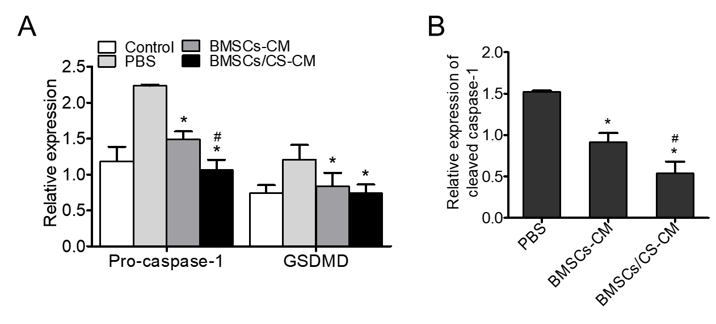
Supplemental Figure 1. (A) Quantitative data of the expression of Pro-caspase-1 and GSDMD. (B) Quantitative data of the expression of Cleaved-caspase-1. Data are expressed as mean ± SEM. *P < 0.05 versus PBS; #P < 0.05 versus BMSCs-CM. All experiments were performed in triplicate. BMSCs-CM, BMSCs conditioned medium; BMSCs/CS-CM, conditioned medium of co-culture BMSCs with CS hydrogel.

