Impact of COVID-19 on Medical Students Considering Orthopedic Surgery

- Are you a rising fourth year medical student?
- Yes
- No (If No, exit survey)

- Are you planning to apply to an Orthopedic Surgery Residency? (if Yes, skip 3)
- Yes
- No

- What residency are you planning on applying to? (drop-down)
- Anesthesiology
- Child Neurology
- Dermatology
- Emergency Medicine
- Emergency Med – Anesthesiology
- Emergency Med – Family Medicine
- Family Medicine
- Family Medicine – ONMM
- Family Medicine – Preventative Medicine
- Internal Medicine (Categorical)
- Medicine – Anesthesiology
- Medicine – Dermatology
- Medicine – Emergency Medicine
- Medicine – Medical Genetics
- Medicine – Pediatrics
- Medicine – Preliminary (PGY-1 Only)
- Medicine – Preventative Medicine
- Medicine – Primary
- Medicine – Psychiatry
- Interventional Radiology (Integrated)
- Neurodevelopmental Disabilities
- Neurological Surgery
- Neurology
- Obstetrics-Gynecology
- OB/GYN – Preliminary (PGY-1 Only)
- Osteo Neuromusculoskeletal Medicine
- Otolaryngology
- Pathology
- Pediatrics (Categorical)
- Pediatrics – Anesthesiology
- Pediatrics – Emergency Medicine
- Pediatrics – Medical Genetics
- Pediatrics – PM&R
- Pediatrics – Preliminary
- Pediatrics – Primary
- Peds/Psych/Child Psych
- Physical Medicine & Rehab
- Plastic Surgery (Integrated)
- Preventative Medicine
- Psychiatry
- Psychiatry – Family Medicine
- Psychiatry – Neurology
- Radiation Oncology
- Radiology – Diagnostic
- Surgery (Categorical)
- Surgery – Preliminary (PGY-1 Only)
- Thoracic Surgery
- Transitional (PGY-1 Only)
- Vascular Surgery
- Other

- Where is your medical school located?
  - West
  - Midwest
  - South
  - Northeast
  - Outside of the United States
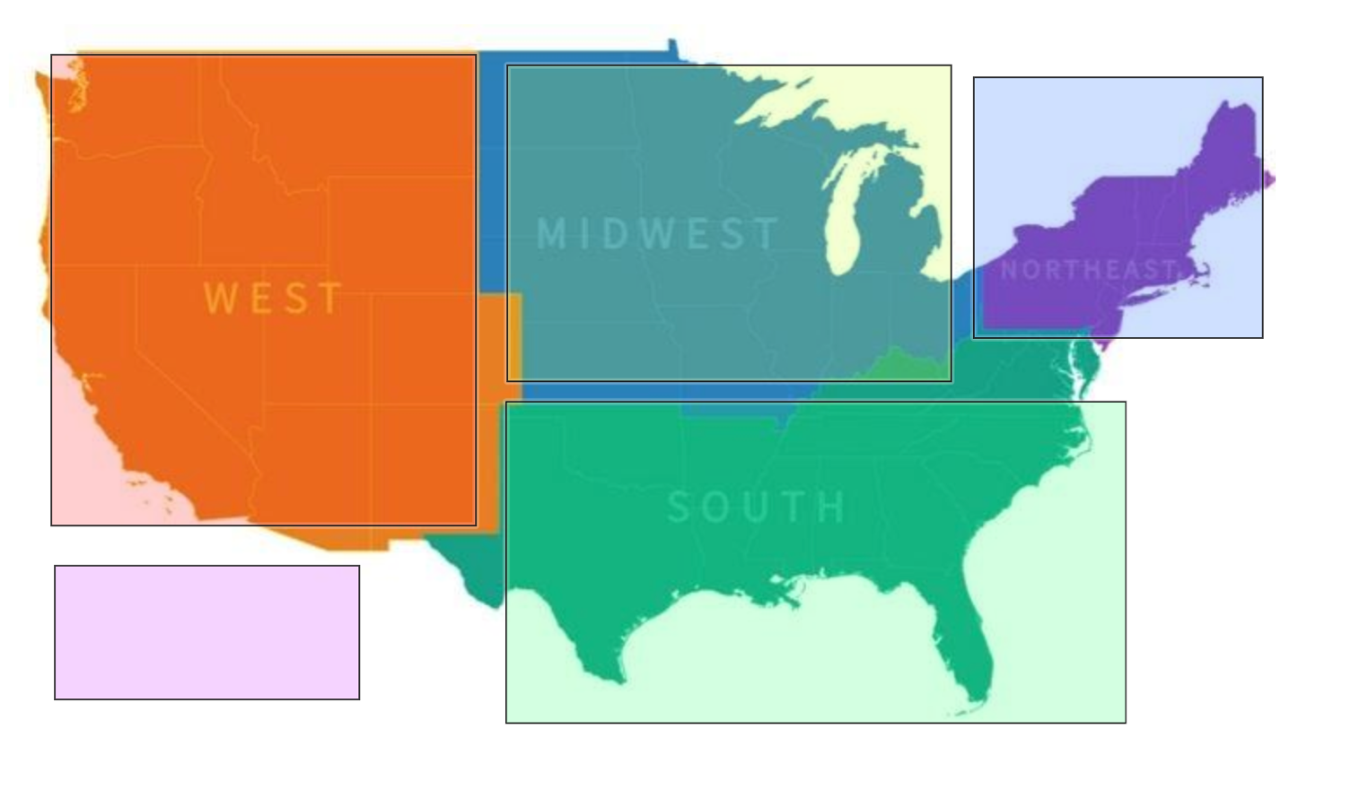
- What race or ethnicity do you identify with?
- Non-Hispanic white
- Black/African American
- Hispanic/Latino
- Asian
- Other
- I prefer not to respond

- What gender do you identify with?
- Man
- Woman
- Other
__________________________
- I prefer not to respond

- How confident are you that you will apply for a residency in orthopedic surgery?
- I am definitely applying
- I am most likely applying
- I am undecided
- I am most likely not applying
- N/A: I have already matched to a residency in orthopedic surgery

- Has the COVID-19 Pandemic impacted your decision to apply for a residency in orthopedic surgery?
- I am much more likely to apply to orthopedic surgery
- I am more likely to apply to orthopedic surgery
- No change
- I am less likely to apply to orthopedic surgery
- I am much less likely to apply to orthopedic surgery
- I am planning to apply to orthopedic surgery, but will defer to a later cycle

- How has the COVID-19 pandemic impacted your ability to get adequate exposure to orthopedic surgery in order to make a specialty choice?
  - I have many fewer opportunities for exposure to orthopedic surgery
  - I have fewer opportunities for exposure to orthopedic surgery
  - No change
  - I have somewhat more opportunities for exposure to orthopedic surgery
  - I have many more opportunities for exposure to orthopedic surgery

- Have you had rotations or exams canceled, altered, or postponed due to the COVID-19 pandemic?
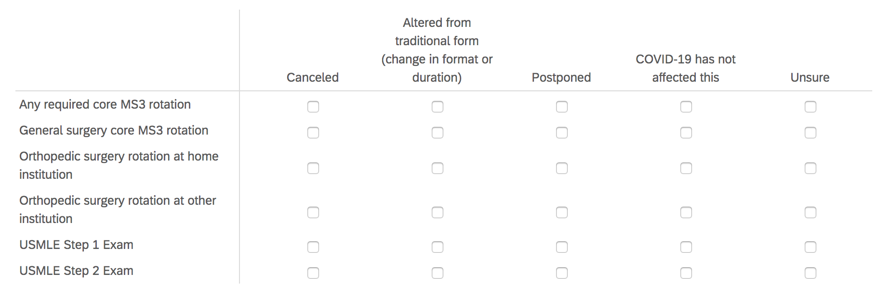
- As a result of the COVID-19 pandemic, have you considered taking the year off?
- Yes
- No

- With your year off, what would you plan to do?
- Research
- Travel
- Volunteer
- Repeat missed clinical rotations
- Other
__________________________

- How would you describe your level of concern regarding some of the possible alterations to traditional orthopedics rotations at your home institution as a result of COVID-19?
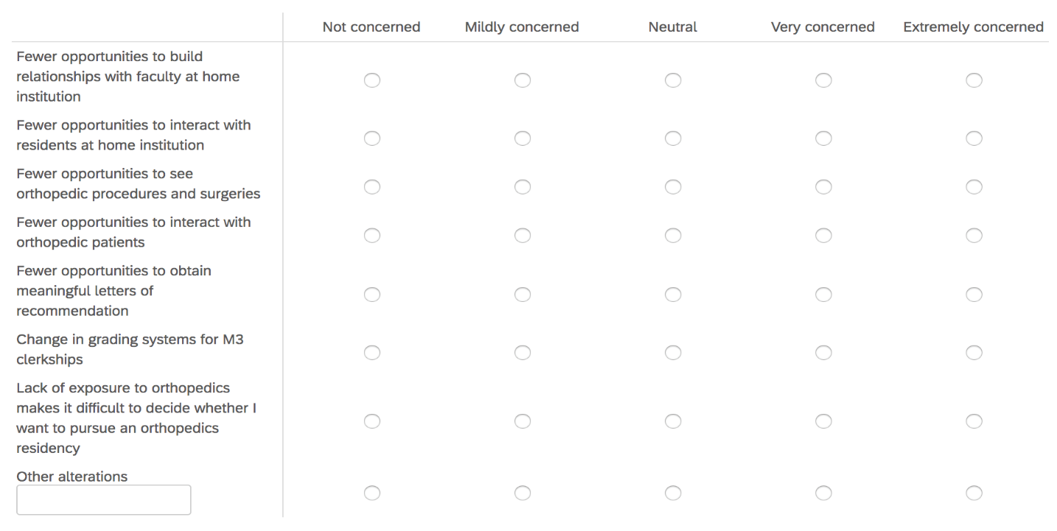

- It is possible that COVID-19 will lead to logistical alterations to the 2020-2021 away rotations, interview process, and match. Has your home program discussed this potential with you?
- Yes
- No
- I don’t have a home program

- It is possible that away rotations and interview day experiences for all specialties may be required to be virtual for the 2020-2021 cycle. As programs plan for this possibility, what type of opportunities and interactions would be most important to include?

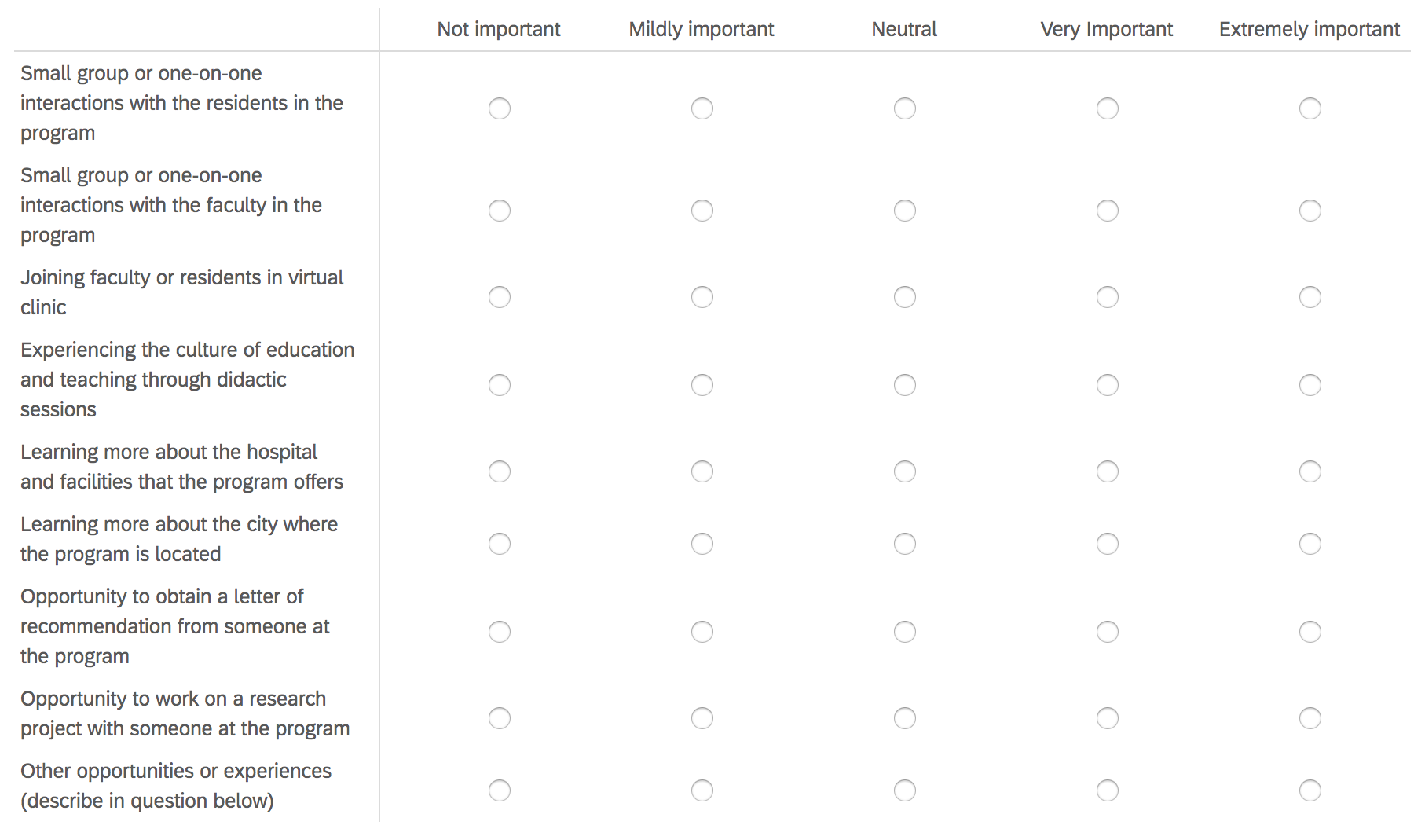

- If there are other opportunities and experiences that would be important to you, please describe (not required).
______________________________________

- Is your home program in a COVID-19 hotspot?
- Yes
- No

- If you are coming from a COVID-19 hotspot, are you concerned that there might be bias against your application?
- Yes
- No

- Do you plan to avoid applying to a program in a COVID-19 hotspot?
- I am definitely planning to avoid applying to a program in a COVID-19 hotspot
- I am probably planning to avoid applying to a program in a COVID-19 hotspot
- I am unsure if I will avoid applying to a program in a COVID-19 hotspot
- I will probably still apply to a program in a COVID-19 hotspot
- I will definitely still apply to a program in a COVID-19 hotspot

- What are your concerns about the orthopedics match process in the context of COVID-19 effects?
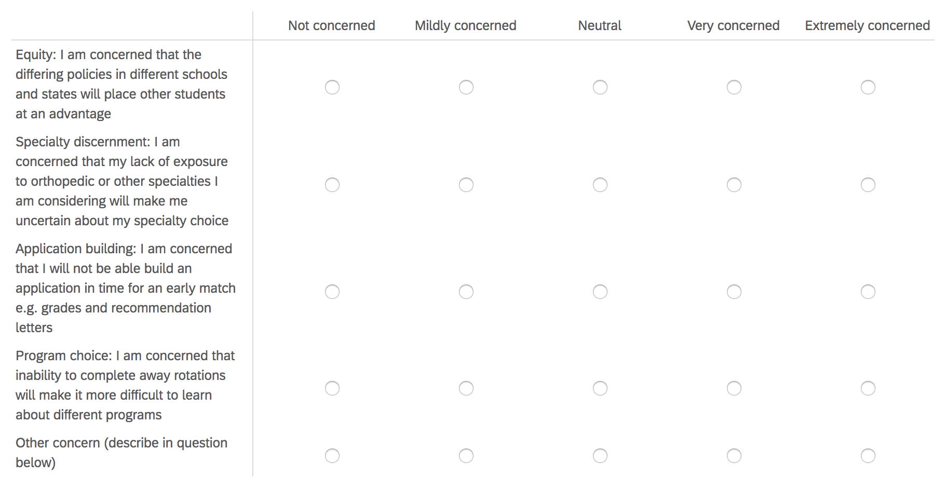
- If you have concerns that are not listed in the table above, please describe (not required).
________________________________________
- If you have concerns that are not mentioned in this survey, please describe (not required).
________________________________________

