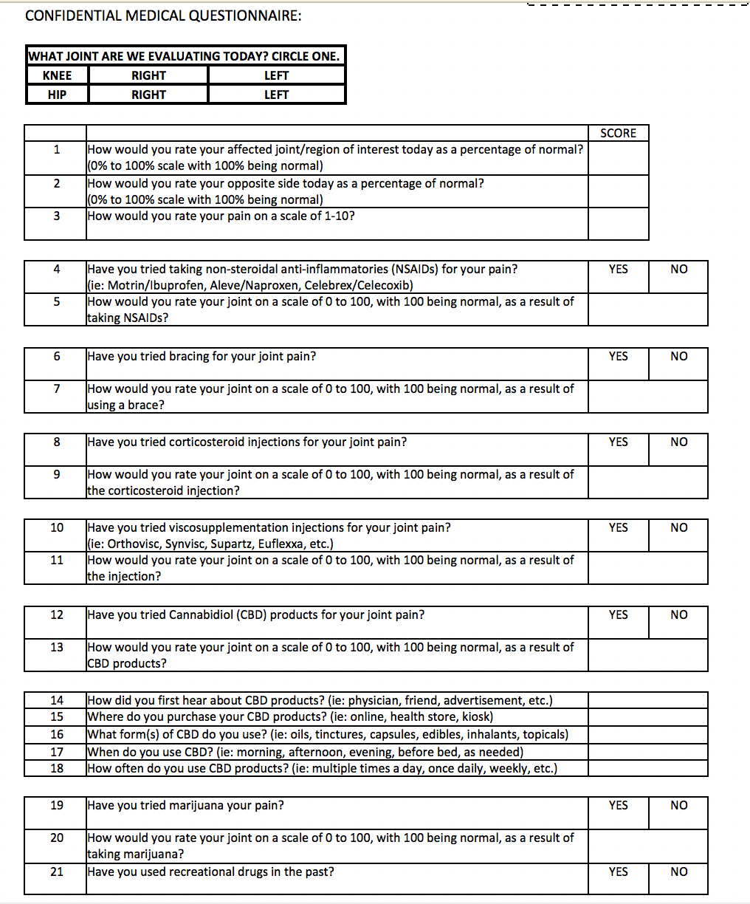
Appendix 1: Sample Questionnaire

