Figure 1: Sample HCAHPS Survey
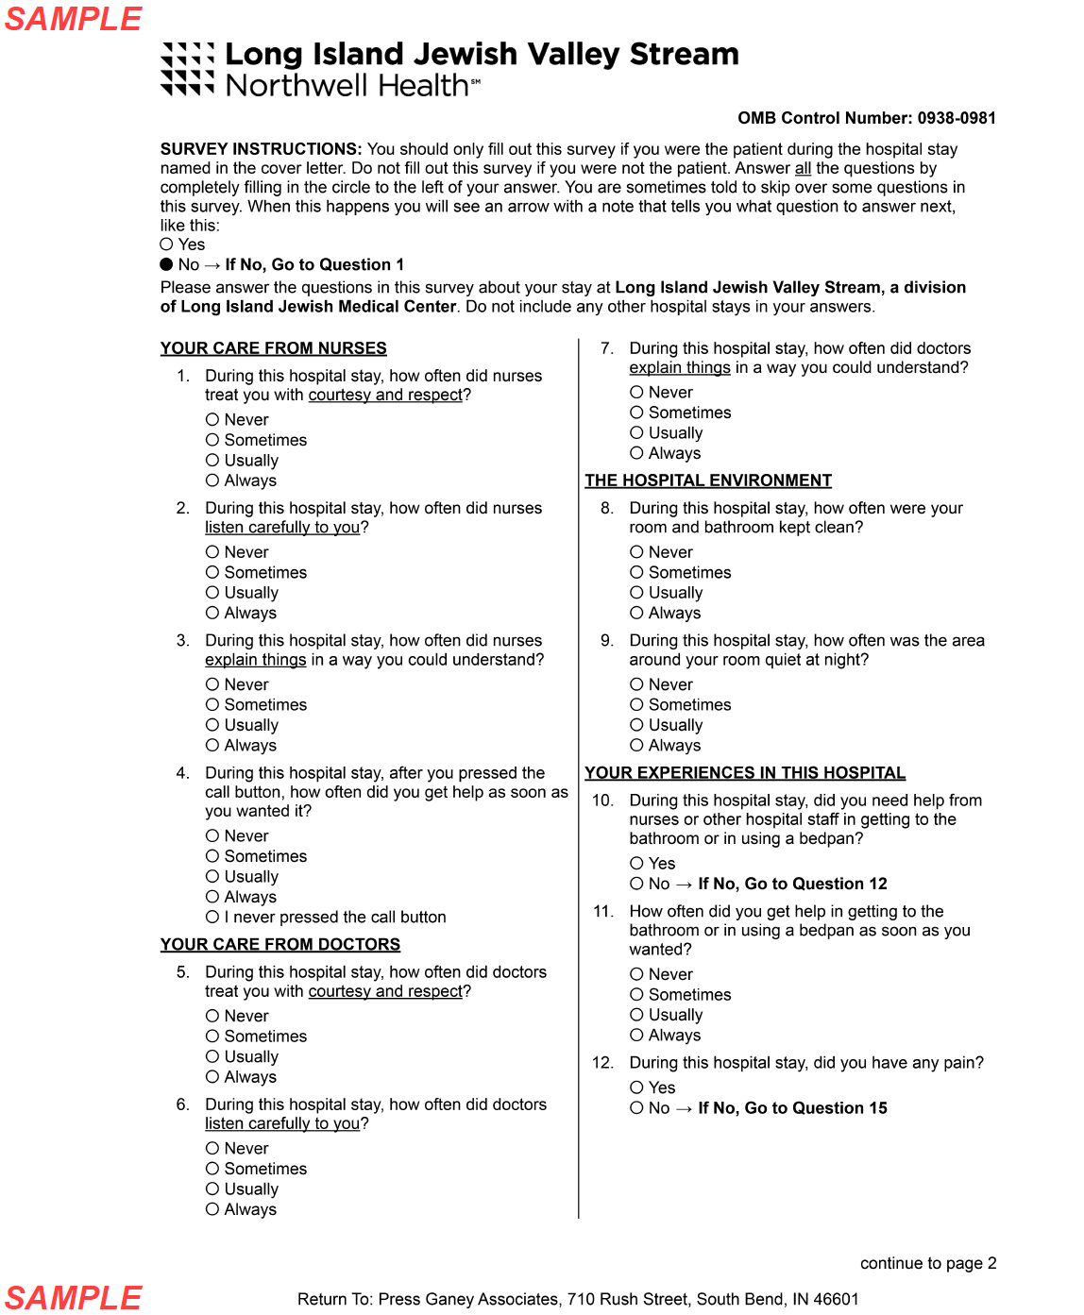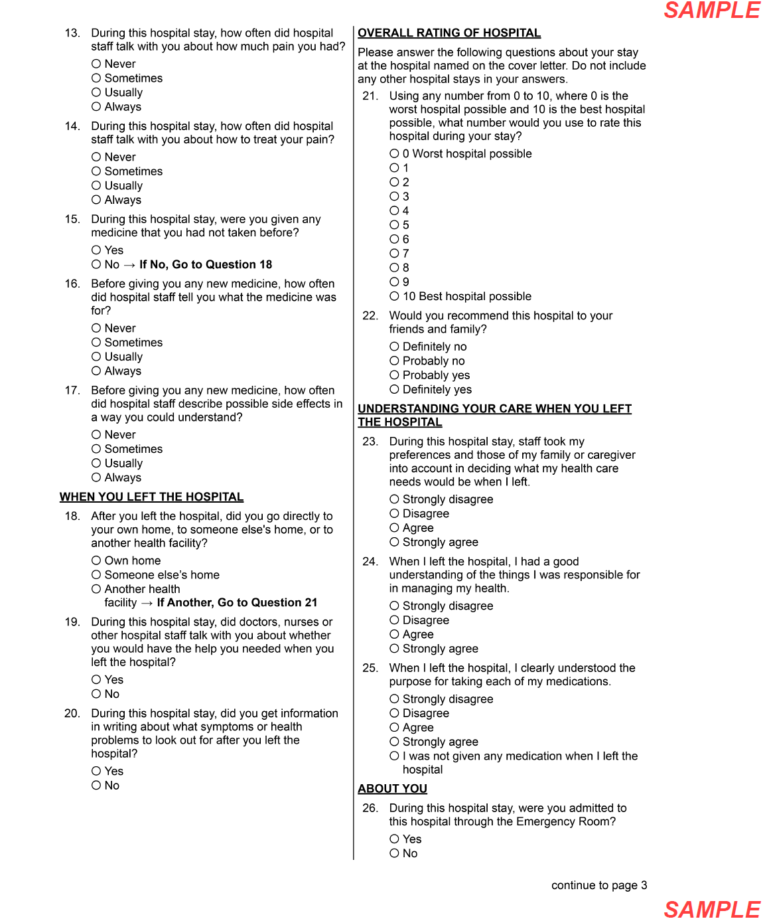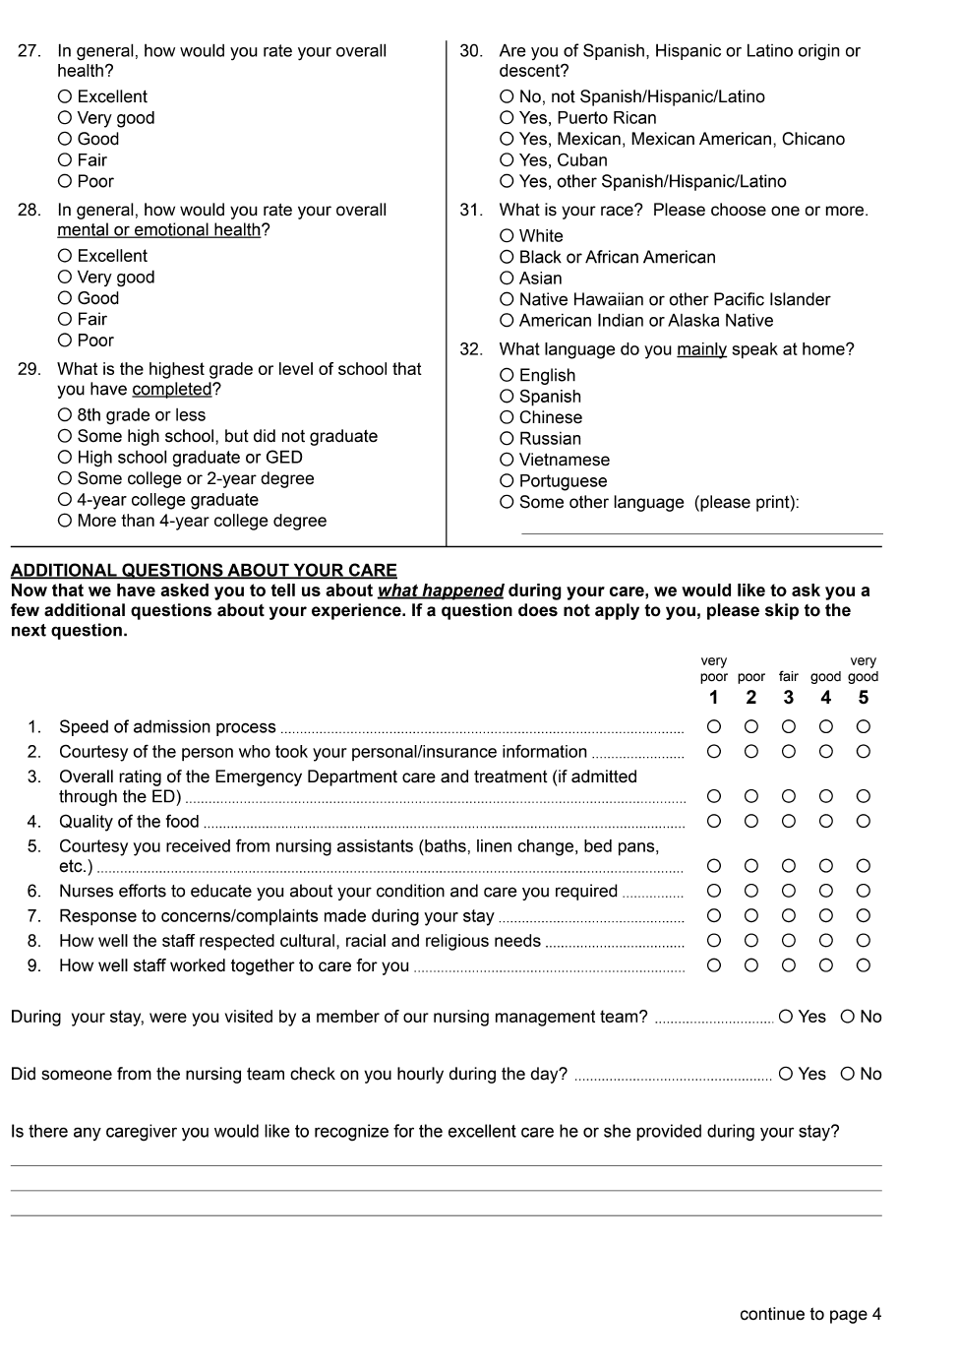

Figure 2: HCAHPS questions selected for study.
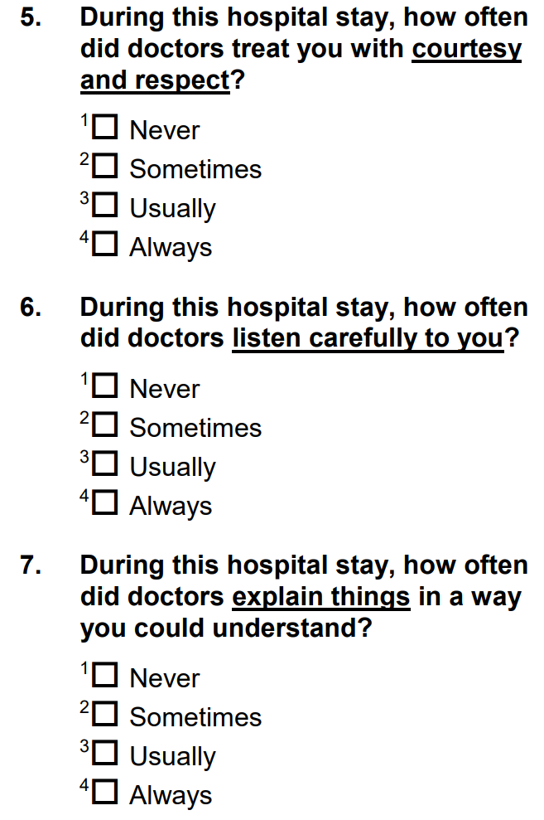
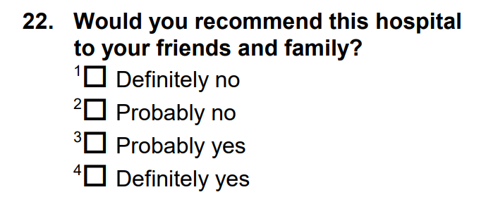
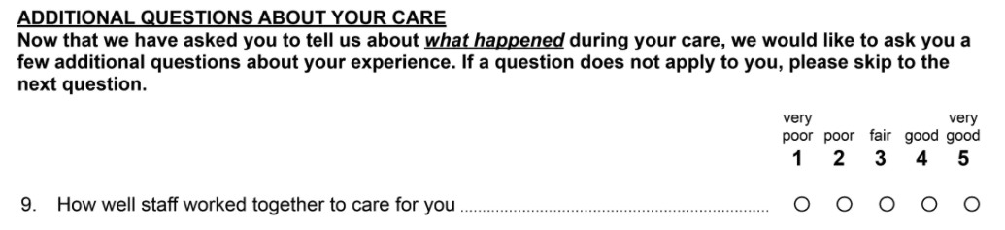

Table 1: Quantity of survey responses from studied and control hospitals.

Site | Group | Pre-Intervention  Returned Surveys (n) | Post-Intervention  Returned Surveys (n) | Total (n)
LIJVS | Study | 60 | 94 | 154
HH | Control | 458 | 540 | 998
PVH | Control | 213 | 262 | 475
Legend: LIJVS: Long Island Jewish Valley Stream, HH: Huntington Hospital, PVH: Plainview Hospital

Table 2: Demographics of study population.

 | Age Range (Years Old) | Median Age (Years Old) | Mean Age (Years Old) | Female Responses | Male Responses
Pre- Intervention | 30-95 | 61 | 60.7 | 51.7% | 48.3%
Post-Intervention | 28-90 | 67 | 65.9 | 63.4% | 36.6%

Table 3: Top box score percentile changes pre and post-intervention.

Top Box Score (%) National Percentile Rank
Question | Pre- Intervention | Post-Intervention | Pre- Intervention | Post-Intervention
Communication with Doctors* | 85.9 | 87.9 | 91 | 96
Recommend Hospital | 65 | 75.5 | 21 | 63
* Average of HCAHPS questions 5, 6 & 7

Table 4: Results for all questions evaluated.

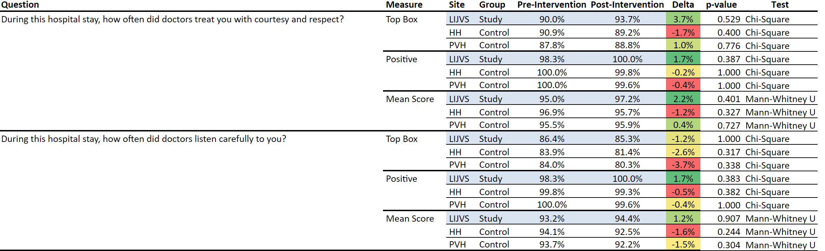
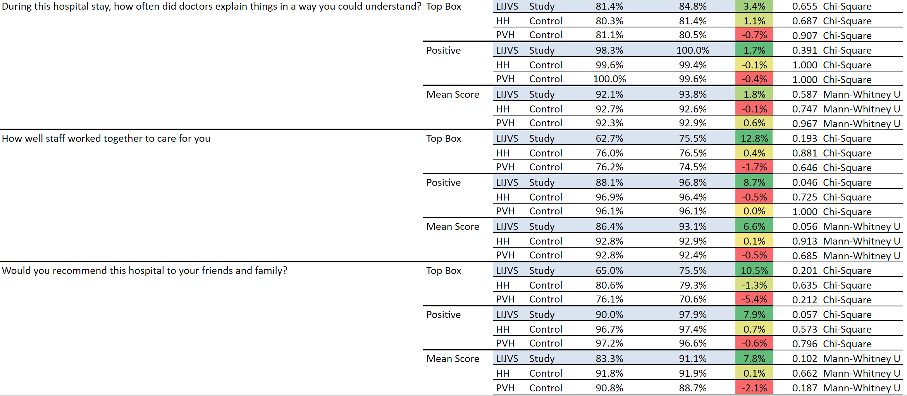

Figure 3: HCAHPS question 5 responses.
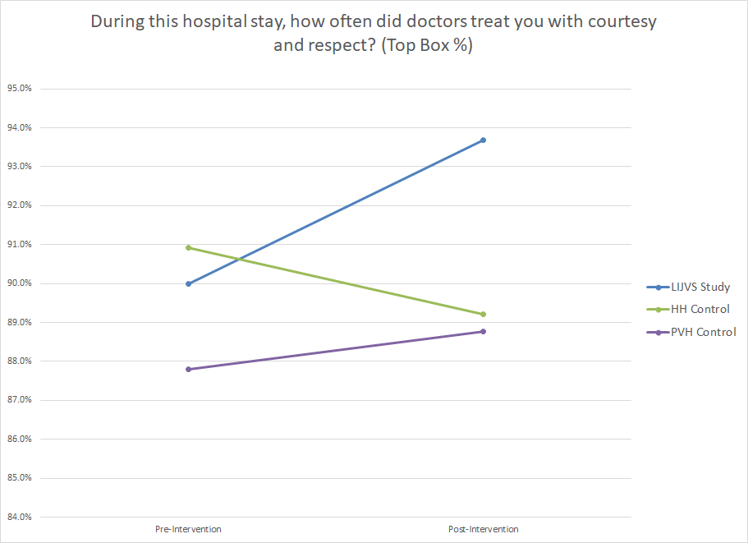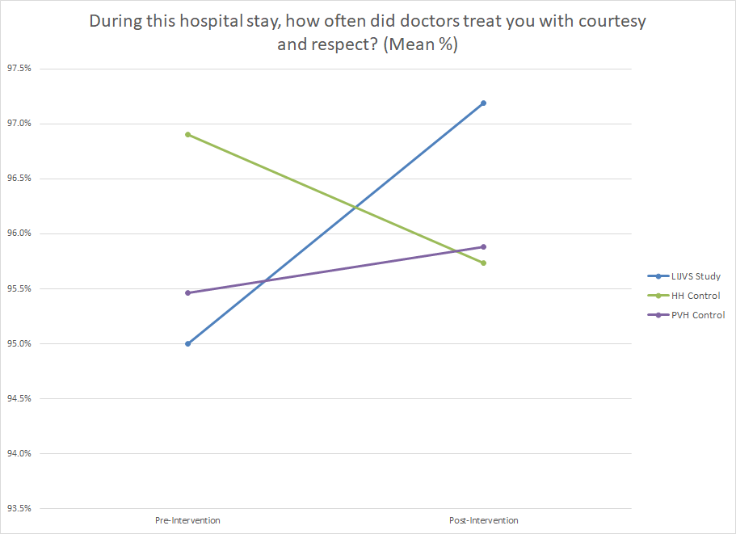

Figure 4: HCAHPS question 6 responses.
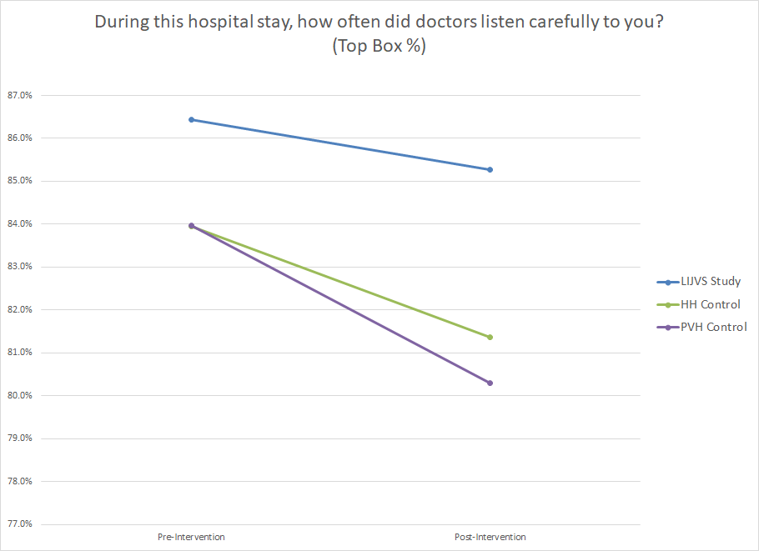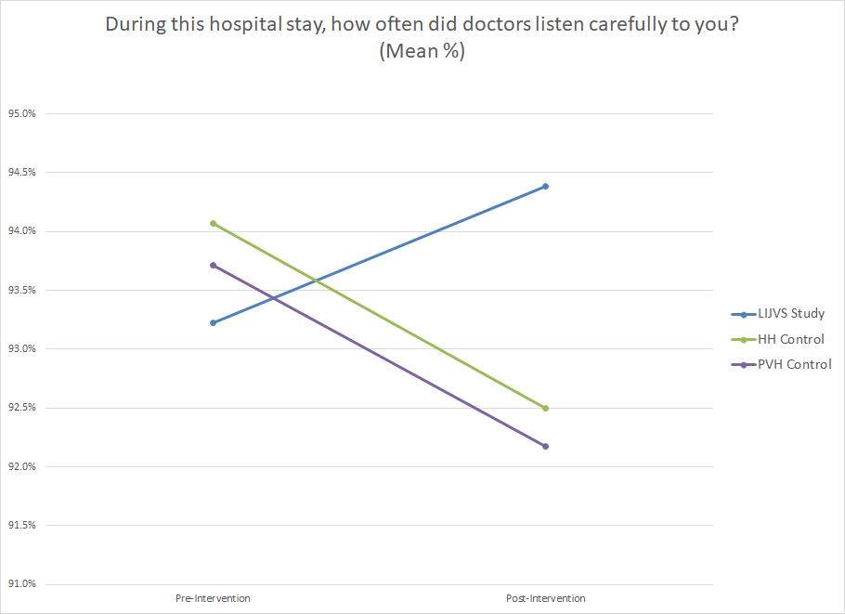

Figure 5: HCAHPS survey question 7 responses.
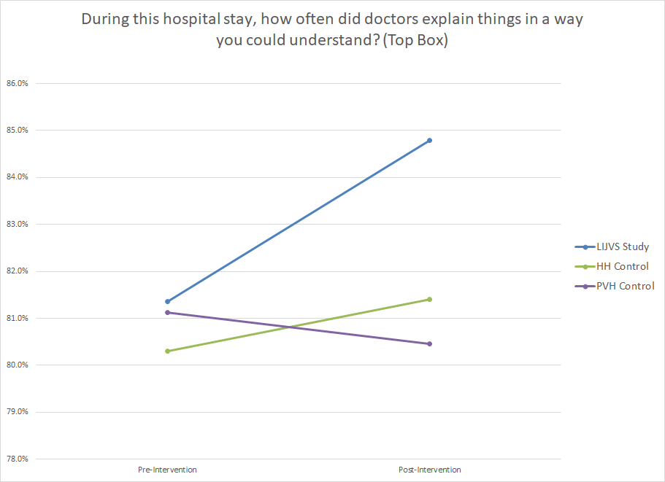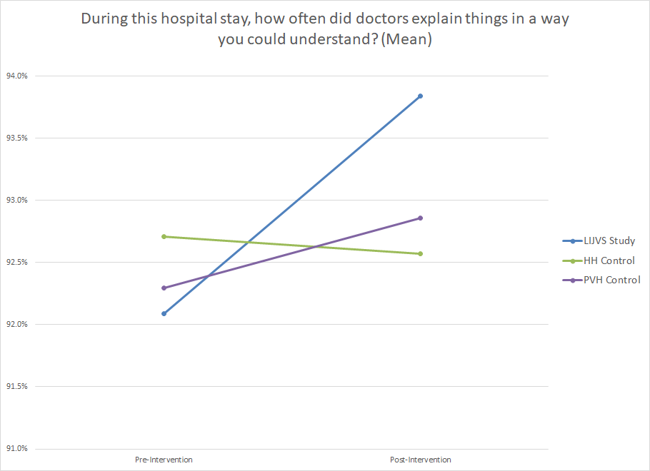

Figure 6: HCAHPS question 22 responses.
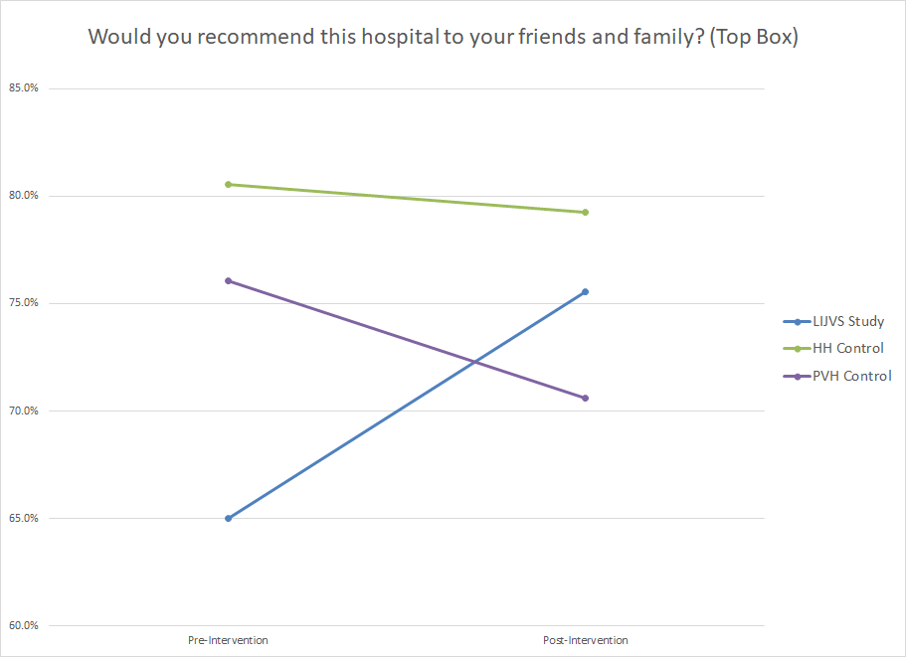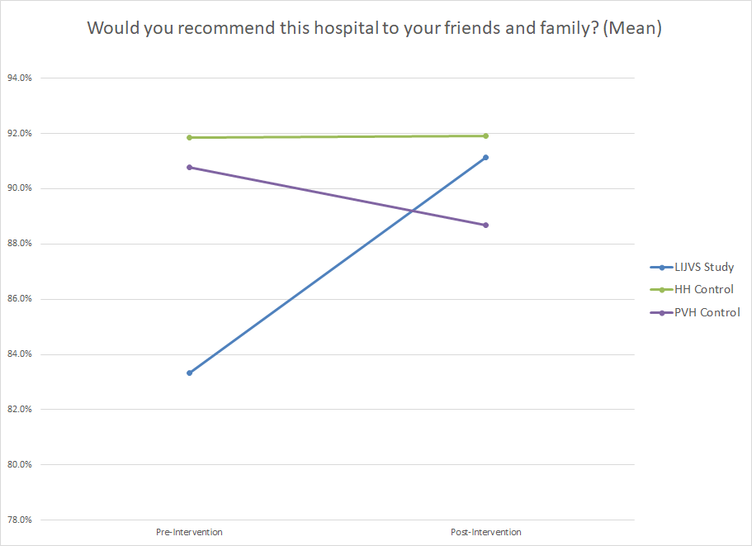

Figure 7: HCAHPS question 9 responses.
