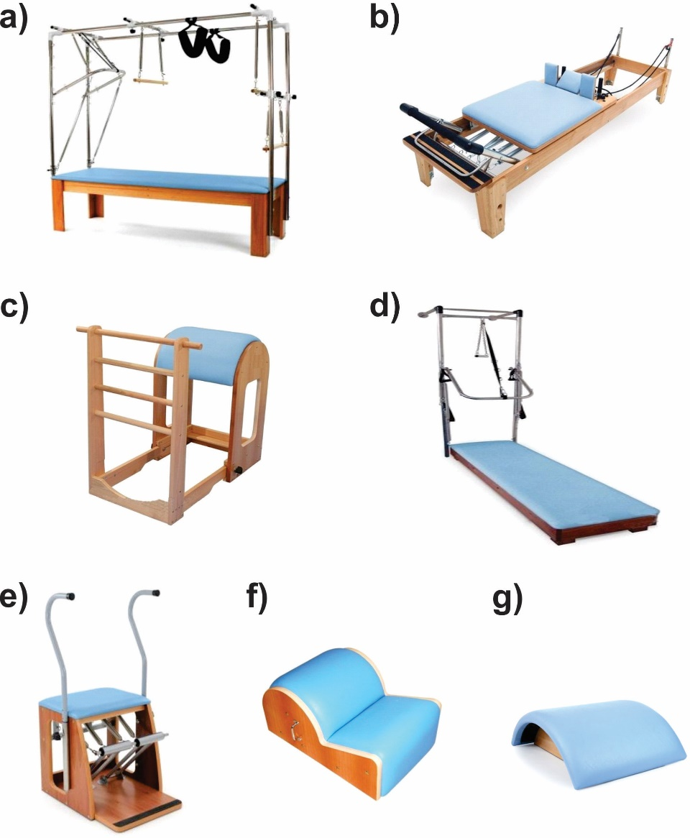
Supplementary Figure 2. Pilates - Equipment Used. a) Cadillac; b) Reformer; c) Ladder Barrel; d) Wall Unit; e) Chair; f) Spine Corrector; g) Small Barrel

