Appendix 1 – Best Practice Advisories (BPAs) and Electronic Health Record (EHR) Order Sets

BEST PRACTICE ADVISORIES (BPAs)
All BPAs fire for the designated provider upon opening of that patient’s chart in the EHR.

BPA #1 Screen for DKA
Trigger: ED point-of-care (POC) glucose >500 mg/dL
Target: ED RN
Response: “This patient’s hyperglycemia may be due to DKA. Order VBG (if not already done) and ask MD to consider DKA.”
Screenshot of BPA
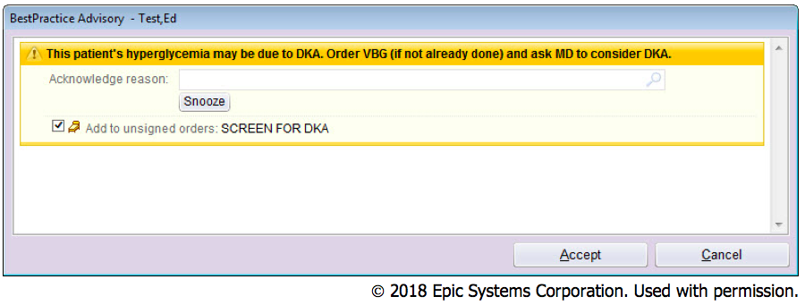
Screenshot of Nursing Order Panel
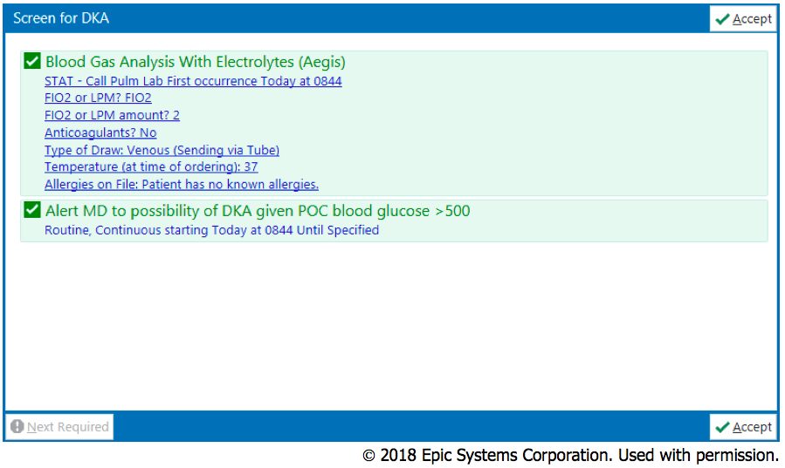

BPA #2: Diagnosis of DKA
Trigger: ED patient with 1st VBG (or ABG) glucose >250 AND bicarbonate <18 AND pH <7.3
OR
ED patient with 1st BMP (or CMP) glucose >250 AND bicarbonate <18 AND anion gap >14

Target: ED RN and ED Provider
Response to ED RN: “Patient meets diagnostic criteria for DKA based upon labs. Click to open RN DKA Panel.”
Screenshot of Nursing BPA
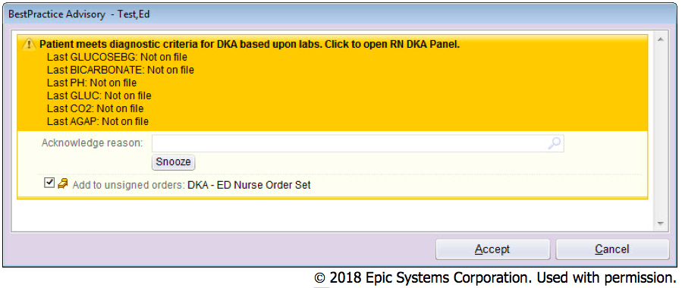

Response to ED Provider: “Patient meets diagnostic criteria for DKA based upon labs. Click to open MD DKA Panel.”

Screenshot of Provider BPA
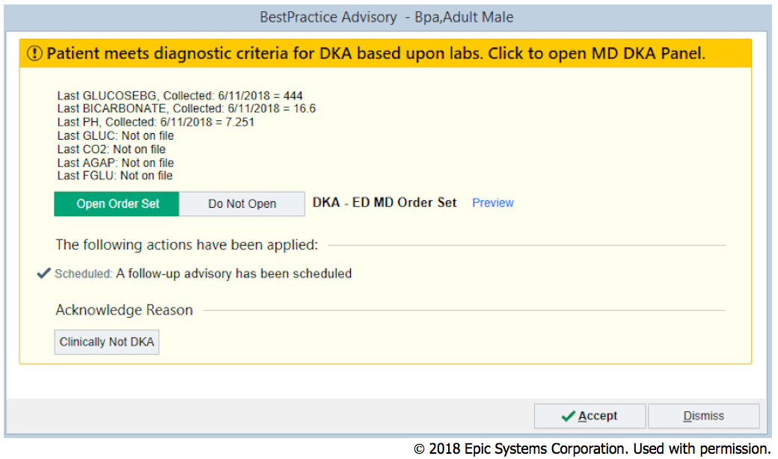

Screenshot of Provider Epic Order Set
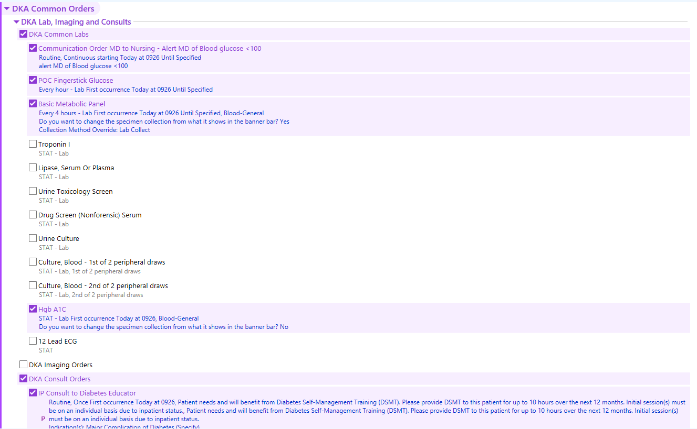
© 2018 Epic Systems Corporation. Used with permission.
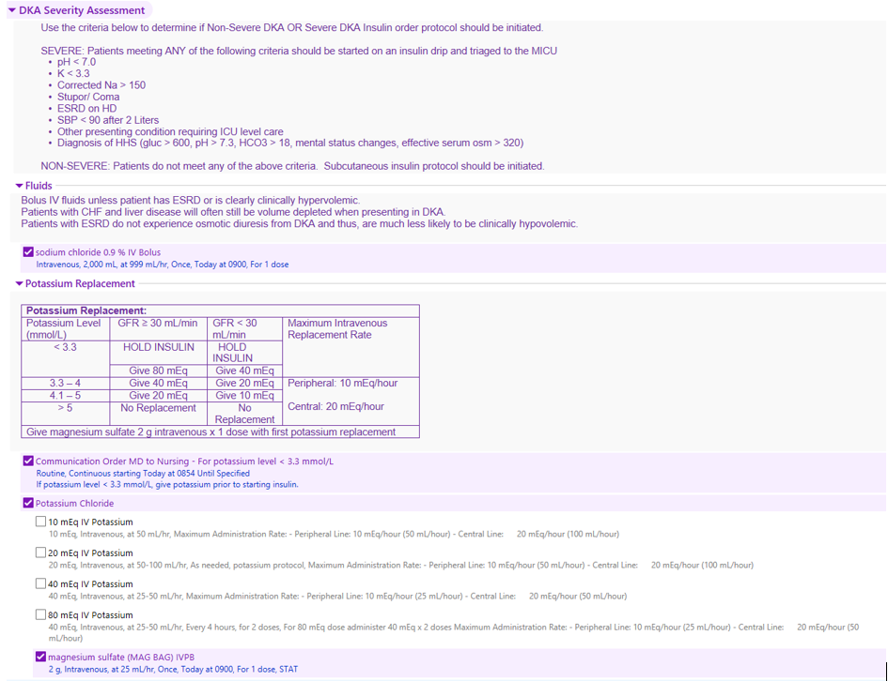
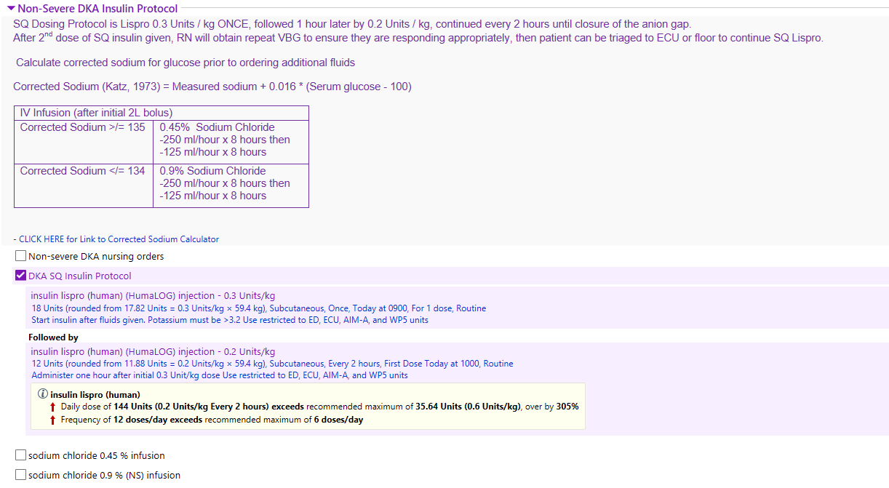
© 2018 Epic Systems Corporation. Used with permission.
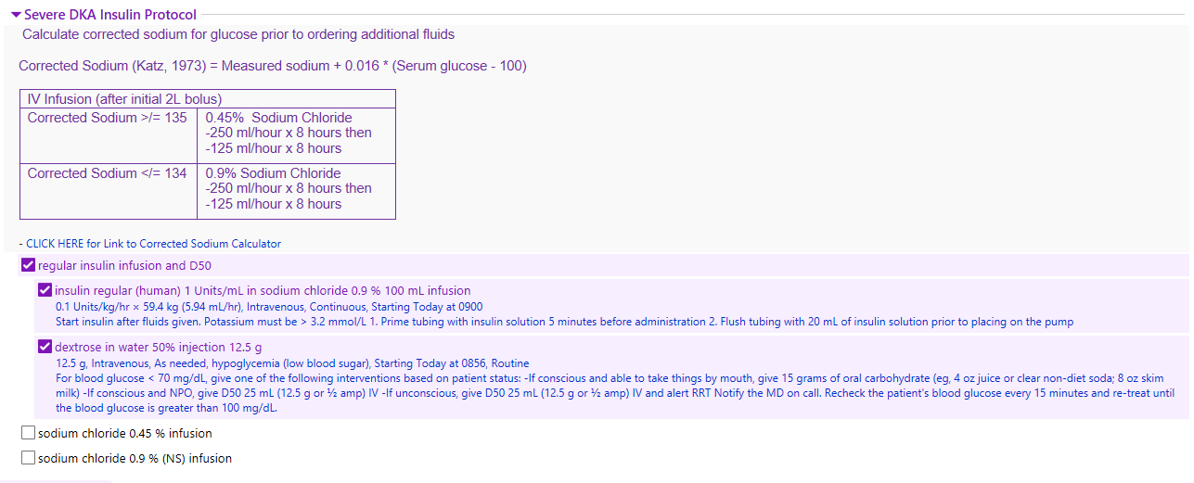
© 2018 Epic Systems Corporation. Used with permission.

BPA #3: Resolution of Hyperglycemia
Trigger: First blood glucose <250 mg/dL based upon BPA #2 firing (or DKA order set utilized)
Target: RN and MD
Response to RN: “This patient’s hyperglycemia has resolved. Alert MD via Smartweb to change IV fluids to D5 and decrease insulin dose.”
Screenshot of Nursing BPA
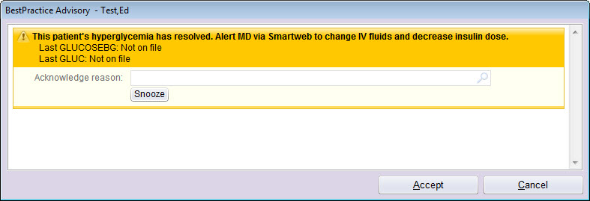
© 2018 Epic Systems Corporation. Used with permission.

Response to MD: “This patient’s hyperglycemia has resolved. Open order set to change fluids and decrease insulin dose.”
Screenshot of Provider BPA
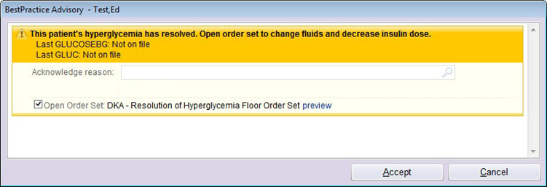
© 2018 Epic Systems Corporation. Used with permission.

Screenshot of Provider Epic Order Set
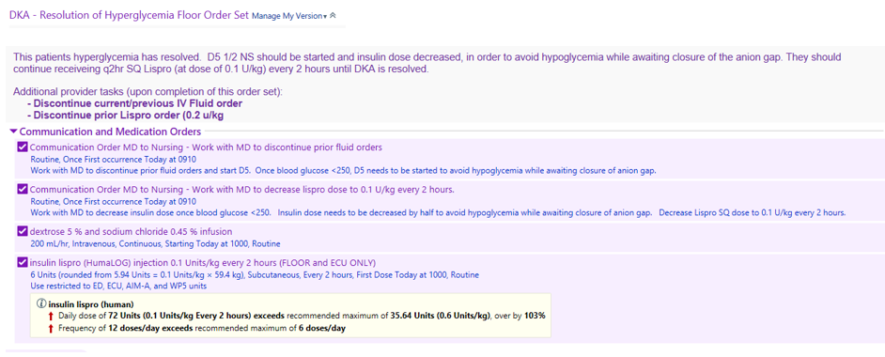
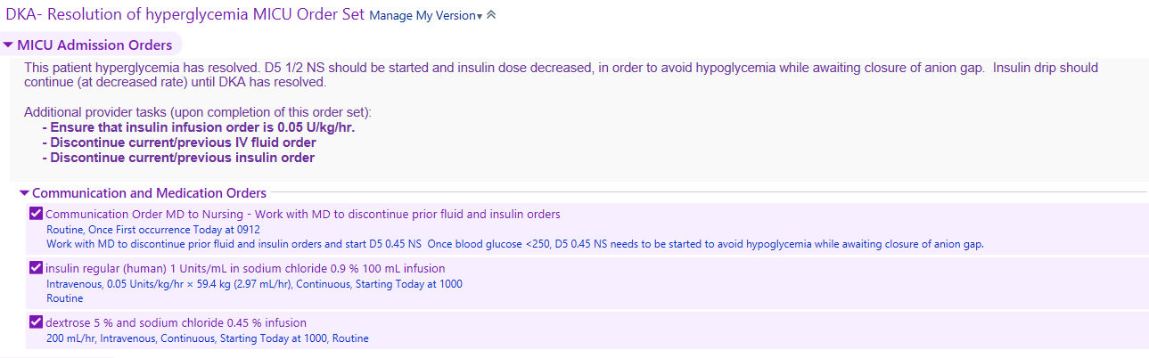
© 2018 Epic Systems Corporation. Used with permission.

BPA #4: Anion Gap Closure
Trigger: First BMP (or CMP) with anion gap <12 (in patient with BPA #2 fired or DKA order set utilized)
Target: RN and MD
Response to RN: “Patient’s DKA has resolved based on closure of anion gap. Alert MD via Smartweb to assess patient for transition to basal insulin.”
Screenshot of Nursing BPA
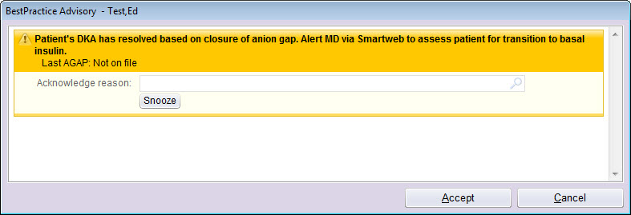
© 2018 Epic Systems Corporation. Used with permission.

Response to MD: “Patient’s DKA has resolved based on closure of anion gap. If patient meets the following criteria (able to take PO, BG<300, AG<12 and time of day 6 am -12 pm or 6 pm - 12 am), complete the following “transition to Basal Insulin’ order set.”
Screenshot of Provider BPA
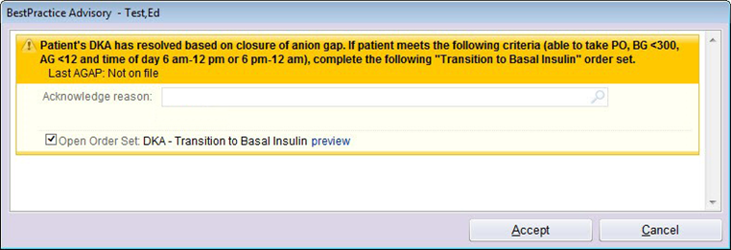
© 2018 Epic Systems Corporation. Used with permission.

Screenshot of Provider Epic Order Set
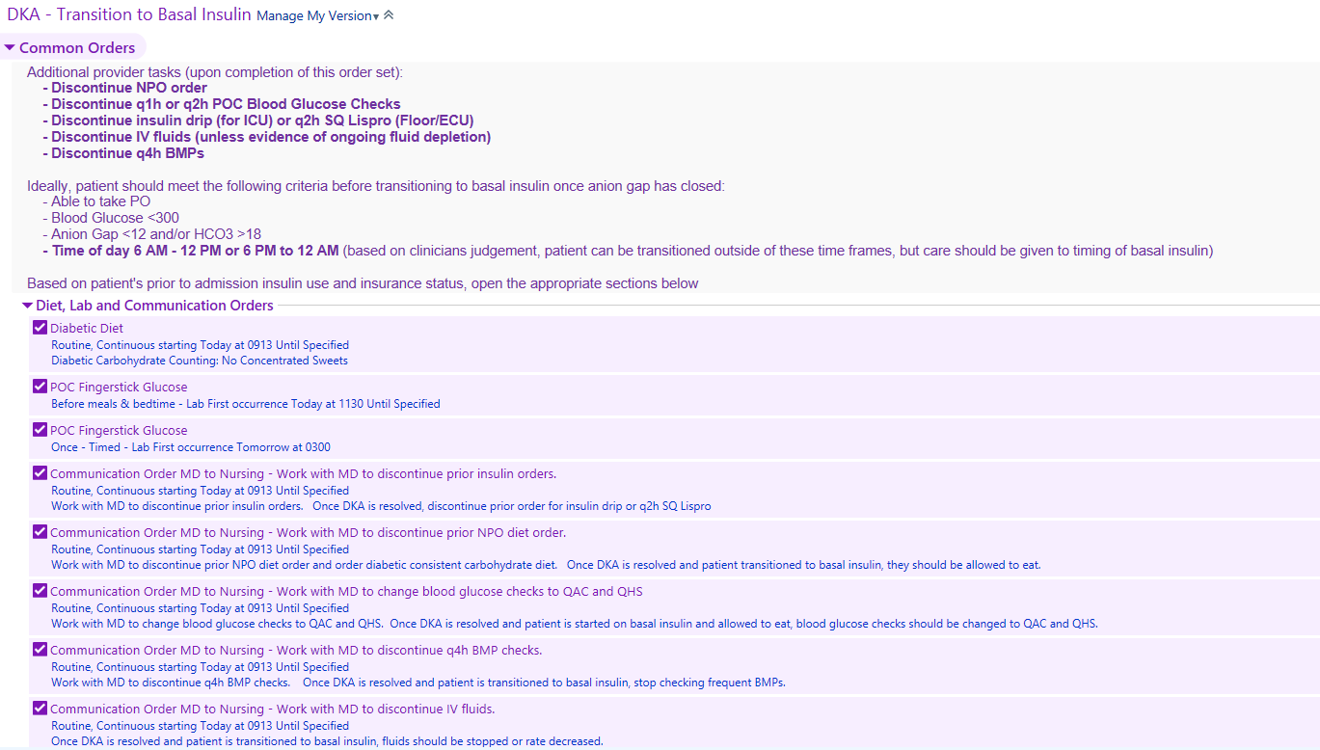
© 2018 Epic Systems Corporation. Used with permission.

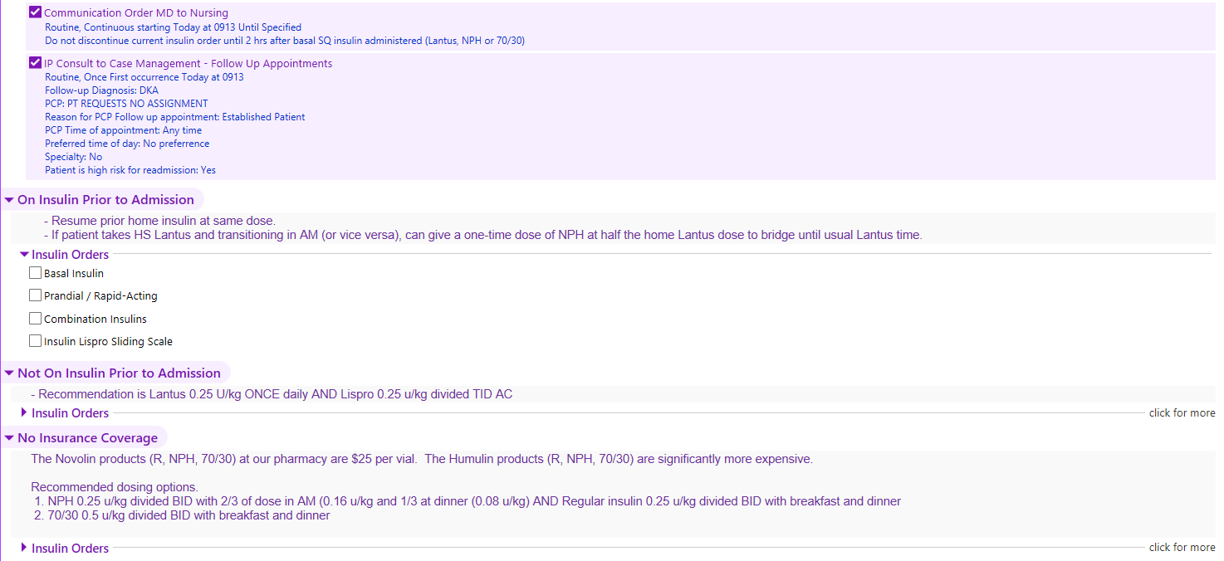
© 2018 Epic Systems Corporation. Used with permission.

