Supplemental Table 1. Reconstitution of C1-INH(SC)ª
Step | Directions | Illustration
1 | Choose a flat surface, like a table, and clean thoroughly with an alcohol swab.
2 | Wash hands thoroughly with warm soapy water.
3 | Place the C1-INH(SC) vial, the diluent vial, and the Mix2Vial on the clean, flat surface. Ensure that both vials are at room temperature. | 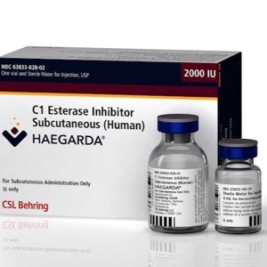
4 | Remove flip caps from the diluent vial and product vial; wipe rubber stoppers with alcohol swab and allow to dry.
5 | Peel the lid from the Mix2Vial transfer device; do not remove device from package.
6 | Place the diluent vial on a flat surface and hold the vial tightly. Grip the Mix2Vial transfer set together with the clear packaging and push the plastic spike at the blue end of the Mix2Vial transfer set firmly through the center of the stopper of the diluent vial. | 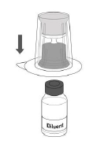
7 | Then carefully remove the clear package from the Mix2Vial transfer set without removing it or touching the exposed end. | 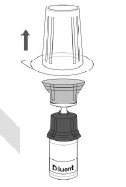
8 | With the C1-INH(SC) vial placed firmly on a flat surface, invert the diluent vial with the Mix2Vial transfer set and push the plastic spike of the transparent adapter firmly through the center of the stopper of the product vial. The diluent will automatically transfer into the C1-INH(SC) vial. | 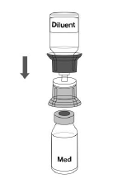
9 | With the diluent and product vial still attached to the Mix2Vial, gently swirl the product to ensure that the powder is fully dissolved. Do not shake the vial. It can take up to 10 minutes for the product to dissolve completely. | 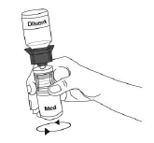
10 | With one hand, grasp the C1-INH(SC) vial and with the other hand grasp the colored diluent side of the Mix2Vial transfer set and unscrew the set into two pieces. | 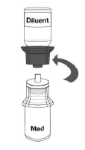
11 | Draw air into an empty, sterile, silicone-free syringe. While the product vial is upright, screw the syringe to the Mix2Vial transfer set. Inject air into the product vial. | 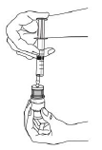
12 | While keeping the syringe plunger pressed, invert the system upside down and draw the concentrate into the syringe by pulling the plunger back slowly. | 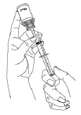
13 | Disconnect the filled syringe by unscrewing it from the Mix2Vial transfer set.
14 | Visually inspect the final solution. The reconstituted solution should be colorless, clear, and free from visible particles. It should not be used if particulate matter or discoloration is observed.
15 | The reconstituted solution should be used within 8 hours and stored at room temperature.
16 | The filled syringe should be attached to a hypodermic needle or subcutaneous infusion set and the plunger gently pushed to fill the needle or tubing.
17 | If the dose requires more than 1 vial, use a separate, unused Mix2Vial transfer set and diluent vial for each product vial.
ªdata from Murphy et al.⁵⁹
Abbreviations: C1-INH, C1 esterase inhibitor; SC, subcutaneous.

