Supplemental Table 2. Injection of C1-INH(SC)^{a,b}
Step | Directions | Illustration
1 | Gently pinch clean skin between thumb and fingers.
2 | Remove cap from needle.  - If using an SC infusion set: bend and hold wings between thumb and index finger.
3 | Whether using an SC infusion set or hypodermic syringe, the needle should be inserted under the skin at a 90° or 45° angle.  - The tip of the needle has to pass through the skin layer but not be so deep as to reach the muscle.  - Factors such as needle length and thickness of the subcutaneous layer will determine the required angle of injection. | 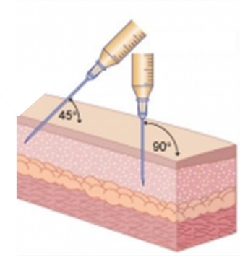  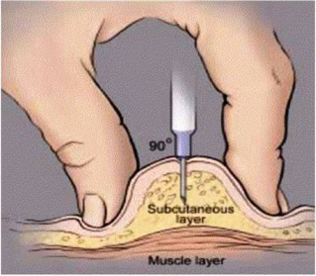
4 | If using an SC infusion set, a sterile dressing can be placed over the injection site to secure the needle. | 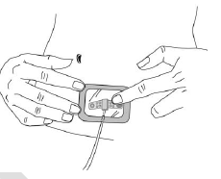
5 | The plunger should be pulled back slightly.  - If any blood is observed in the syringe/tubing, the needle and any tubing should be discarded and replaced.  - While the syringe with the product can still be used, the injection should be reattempted at a new site.
6 | The syringe plunger is slowly pushed to deliver the C1-INH(SC) dose. | 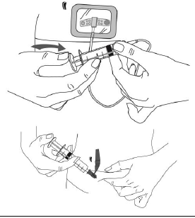
7 | Rate of injection  - Basic rule: Push slowly enough for comfort/tolerability.  - An approximate guide for injection rate is about 1 mL/min.  - Patients can slow or increase the injection rate according to their comfort level and tolerability.  - If a subcutaneous “bubble” or swelling develops, injection may be too fast or too shallow.
8 | When infusion is finished, needle is removed and discarded appropriately per local requirements.
9 | Patients should be encouraged to record the C1-INH(SC) lot number in a diary or treatment log book.
ªdata from Murphy et al.⁵⁹
^{b}The information and descriptions provided here are based on clinical trial nurses’ experience; for official instructions, please refer to the C1-INH(SC)/HAEGARDA Prescribing Information.⁴⁰
Abbreviations: C1-INH, C1 esterase inhibitor; SC, subcutaneous.

