Supplementary Data

Supplementary Table 1. Assessment of potential correlates between cytokine secretion and variables associated with the tumor cells and the CAR-T cells.
1A: Correlation between the number of CAR+ T cells and amount of IFNγ secreted
Variable 1 | Variable 2 | Pearson’s correlation
Number of CAR+ T cells (H8 construct) | IFNγ secreted upon co-culture with OVCAR-3 cells | 0.46; N.S.
Number of CAR+ T cells (2E4 construct) |  | 0.61; P=0.05
Number of CAR+ CD4+ T cells (H8 construct) |  | 0.26; N.S.
Number of CAR+ CD4+ T cells (2E4 construct) |  | 0.42; N.S.
Number of CAR+ CD8+ T cells (H8 construct) |  | 0.66; P=0.04
Number of CAR+ CD8+ T cells (2E4 construct) |  | 0.80; P=0.003

1B: Correlation between the amount of cytokine secreted and the level of 5T4 expression
Variable 1 | Variable 2 | Pearson’s correlation
IFNγ secretion (H8 construct) | 5T4 expression on Tumor cells as determined by IHC | 0.68; P=0.03
IFNγ secretion (2E4 construct) |  | 0.70; P=0.02
IL-2 secretion (H8 construct) |  | 0.65; P=0.04
IL-2 secretion (2E4 construct) |  | 0.64; P=0.03
IFNγ secretion (H8 construct) | 5T4 expression on Tumor cells as determined by flow cytometry (MFI) | 0.78; P=0.01
IFNγ secretion (2E4 construct) |  | 0.65; P=0.04
IL-2 secretion (H8 construct) |  | 0.84; P=0.005
IL-2 secretion (2E4 construct) |  | 0.77; P=0.009

A. Cell Count
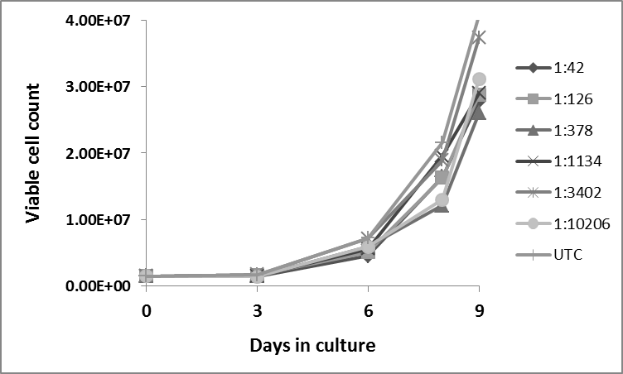
B. Percentage Transduction
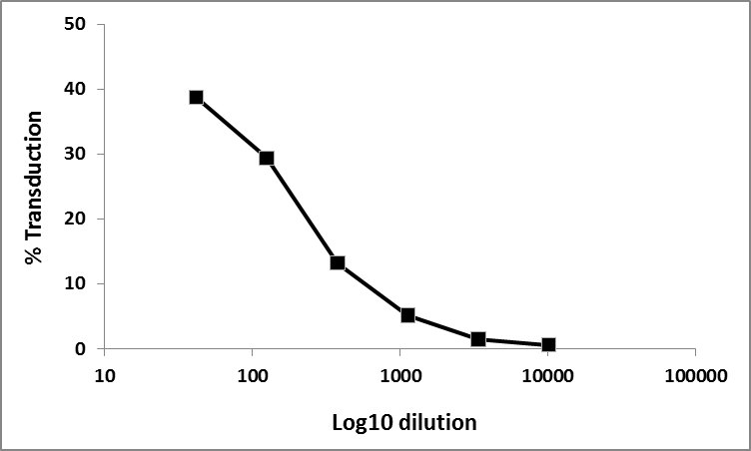
Supplementary Figure 1: Transduction of T cells and growth kinetics of transduced cells. Figure 1A shows the growth kinetics of T cells transduced with a range of dilutions of H8-CAR compared against an untransduced (UTC) control. Figure 1B shows the percentage transduction of T cells with H8-CAR over a range of viral vector dilutions.
Supplementary Figure 2: Immune infiltrates in ovarian tumor disaggregate. (A) Percentage of hematopoietic cells and tumor cells present in tumor disaggregate as determined by flow cytometry. (B) Correlation of 5T4 expression and CD3 T cell infiltration as determined by immunohistochemistry.

Supplementary Figure 3. Interleukin-2 (IL-2) production by 5T4-CAR T cells in response to immortalised ovarian cell lines expressing 5T4 and autologous tumour cells. Peripheral T cells were successfully transduced from 11 patients. T cells were transduced with the H8-CAR or 2E4-CAR or no CAR (Mock). 1x10⁵ T cells were co-cultured for 24 hours with 1x10⁵ SKOV3, OVCAR3 and primary autologous tumour cells . After 24 hours, supernatant was collected and IL-2 quantitified by ELISA. Error bars represent the mean and S.D. of triplicate results. Two-way ANOVA with Sidak’s correction; *p<0.05, **p<0.01, ***p<0.001.

Supplementary Figure 4. Kaplan-Meier survival curves of SKOV3.Luc tumors in NSG mice receiving 5T4-CAR T cell therapy. Kaplan-Meier survival curves for mice treated with H8-CAR T cells via intra-venous or intra-peritoneal routes. Log-rank (Mantel-Cox) test; *P<0.05 compared to Mock I.P and saline I.P., #P<0.05 compared to H8-CAR I.V.

Supplementary Figure 5. Dose of 5T4-CAR T cells categorised in to significant or non-significant survival advantage relative to controls. The figure summarises the efficacy experiments described herein and categorises the data in to those treatment groups in which there was a statistically significant (P<0.05) or non-significant survival advantage relative to mock transduced control groups. Dashed line represents minimum dose required to convey a significant survival advantage.

