Supplemental Digital Content 1
Chimeric antigen receptor (CAR) T-cell engineering process and CAR construct.
(a) Schematic overview of CAR T construct. (b) To produce a defined composition of CAR-expressing T cells, CD4⁺ and CD8⁺ T-cell populations were isolated from apheresis samples obtained from consenting normal donors or patients with diffuse large B-cell lymphoma. CD4-enriched and CD8-enriched populations were separately activated, transduced with a lentiviral vector encoding both the CD19-specific CAR and a truncated epidermal growth factor receptor (EGFRt, a surrogate marker for transduction), and expanded. CAR-engineered cells were cryopreserved, stored at temperatures below −130°C, and thawed prior to use. CAR-positive cells were used at a target CD4⁺:CD8⁺ ratio of ≈ 1:1. To account for any variability in transduction efficiency, numbers of EGFRt-positive cells were normalized across experiments. CD28tm, CD28 transmembrane domain; huEGFRt, human EGFRt; LTR, long terminal repeat; PBMC, peripheral blood mononuclear cell; EGFR, epidermal growth factor receptor; scFv, single-chain variable fragment.
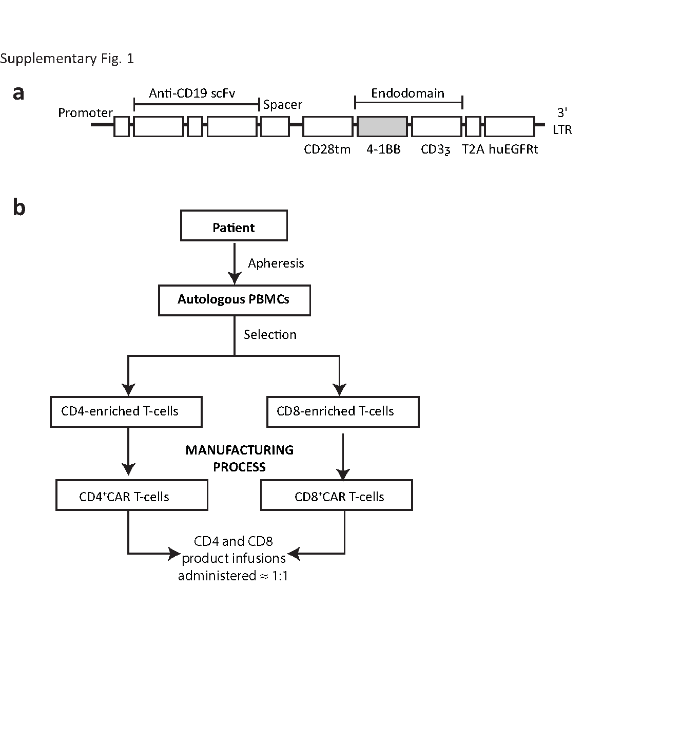

Supplemental Digital Content 2
CD19 expression and proliferation profile of Nalm-6 cells. (a) Expression level of CD19 on Nalm-6 compared with K562.CD19. (b) Growth of Nalm-6 cells measured by percentage of confluence in the presence of ibrutinib or acalabrutinib.

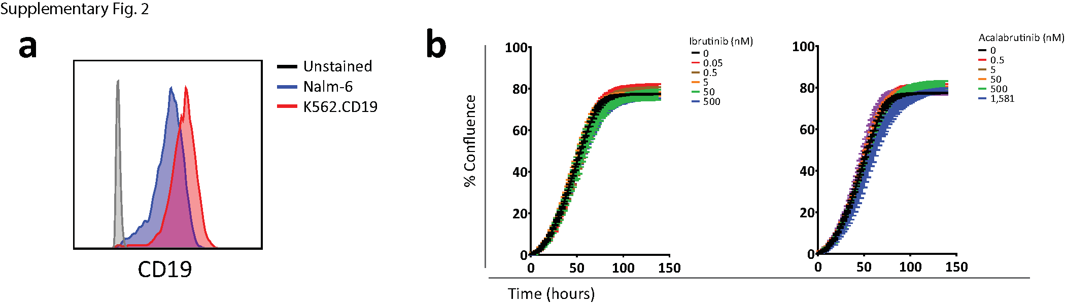

Supplemental Digital Content 3
RNA expression of kinases from serially stimulated chimeric antigen receptor (CAR) T cells (day 18). Box and whisker plot of kinase expressions of CAR T cells from 3 donors in transcripts per million (TPM). Aca, acalabrutinib; BLK, B lymphocyte kinase; BMX, bone marrow tyrosine kinase; BTK, Bruton tyrosine kinase; ctrl, control; EGFR, epidermal growth factor receptor; ERBB2, erb-b2 receptor tyrosine kinase 2; ibr, ibrutinib; ITK, interleukin 2–inducible T-cell kinase; JAK3, Janus kinase 3; TEC, Tec protein tyrosine kinase; TXK, tyrosine protein kinase TXK.

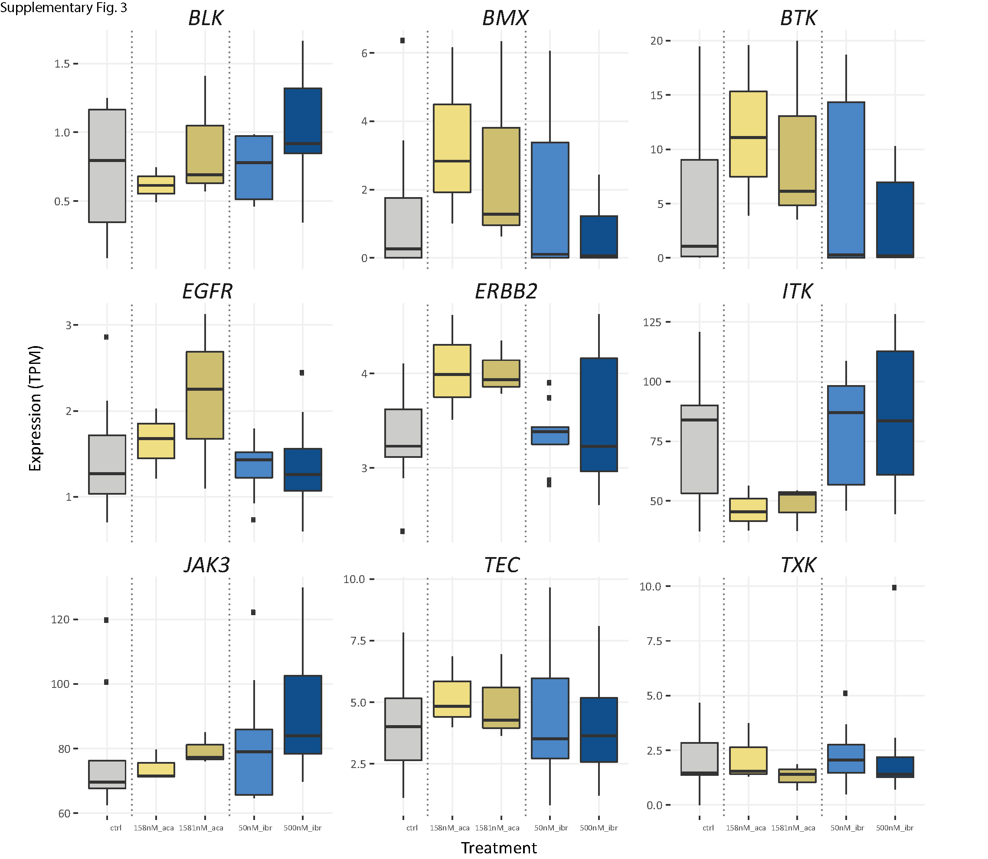

Supplemental Digital Content 4
Secreted cytokine concentrations from chimeric antigen receptor (CAR) T cells after in vitro treatment with ibrutinib or acalabrutinib. (a and b) Cytokine concentrations of interferon gamma (IFN-γ), interleukin 2 (IL-2) and tumor necrosis factor-alpha (TNF-α) 2 days after stimulation with 30 µg/mL anti-idiotypic antibody of CAR T cells treated with (a) ibrutinib or (b) acalabrutinib.
(c and d) Cytokine concentrations 2 days after stimulation with K562.CD19 of CAR T cells treated with (c) ibrutinib or (d) acalabrutinib. (e) Comparison of cytokine concentrations between short-term stimulated CAR T cells (day 2) and chronic stimulated CAR T cells (day 6) following restimulation, representative data from 1 donor. (f and g) Prior to restimulation, CAR T cells were stimulated with 30 µg anti-idiotypic antibody for 6 days with (f) ibrutinib or (g) acalabrutinib. Day 6 CAR T cells were then restimulated for 24 hours with 30 µg/mL anti-idiotypic antibody in the absence of Bruton tyrosine kinase inhibitor, and cytokine concentrations were measured. Representative data from 2 independent experiments and 3 CAR T cell donors (mean ± SEM).
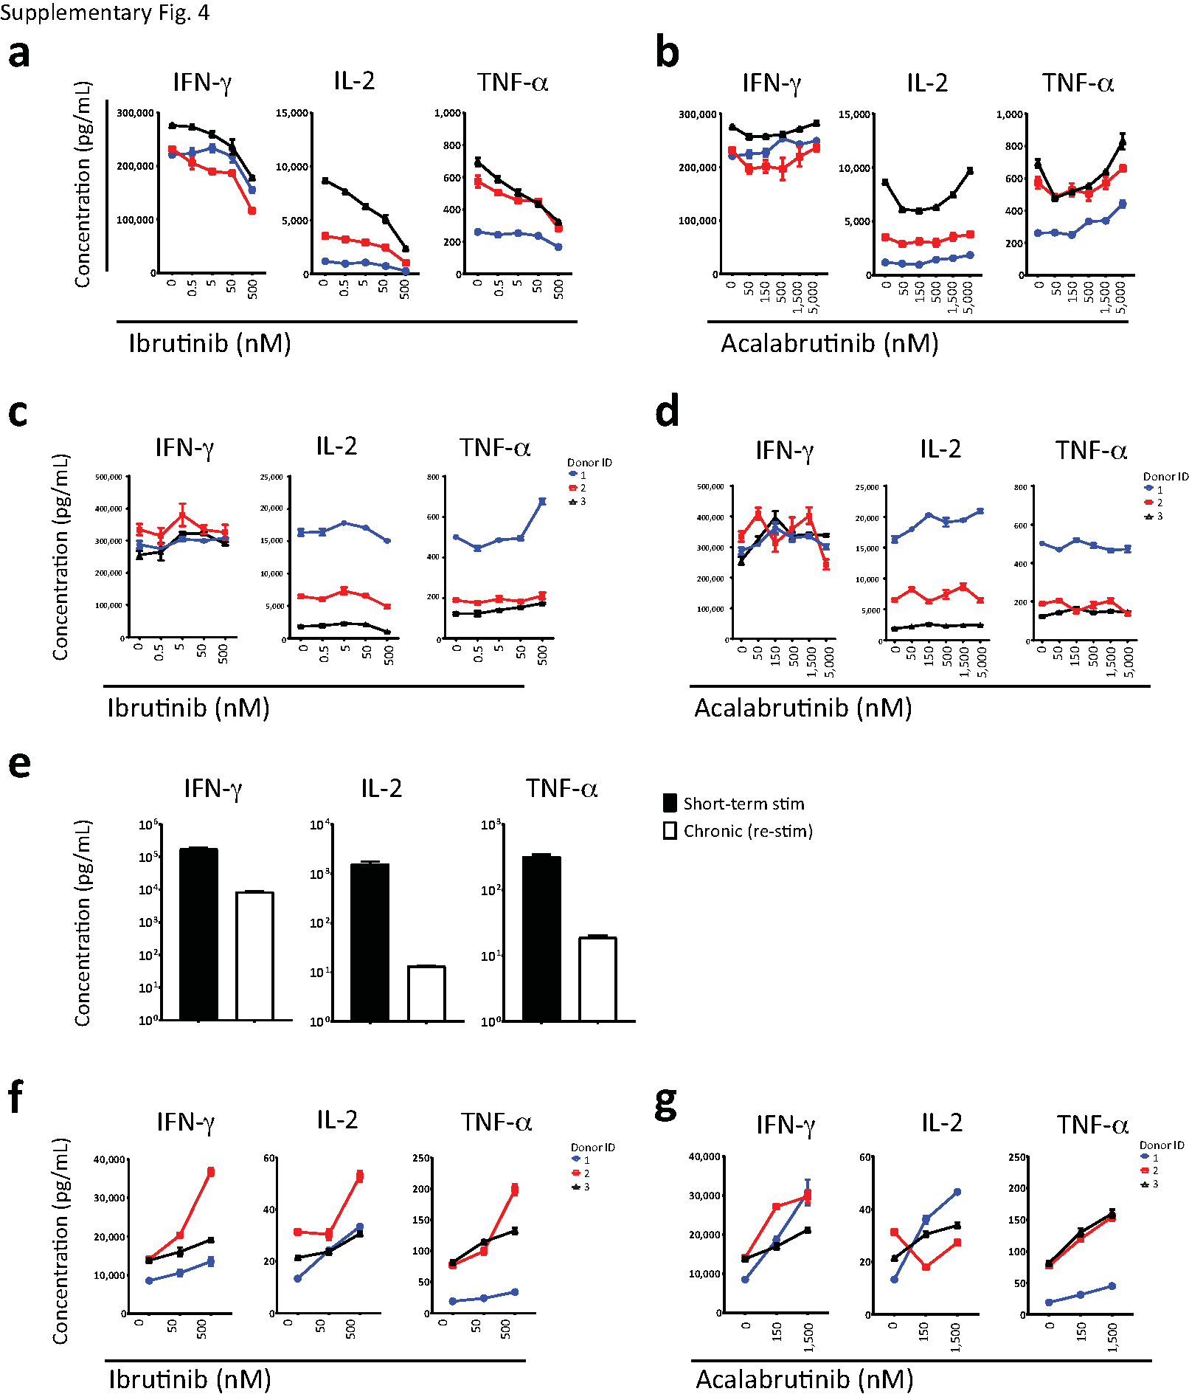

Supplemental Digital Content 5
Chimeric antigen receptor (CAR) T phenotypic marker expression in the presence of Bruton tyrosine kinase inhibitor in the 6-day anti-idiotypic antibody stimulation assay. (a) Expression of CD8, CD25, CD69, CD38, PD-1, CD107a, CD62L, CD45RO, and CCR7 on population 1 gated from multivariate T-distributed stochastic neighbor embedding (t-SNE) analysis of 3 different donors after 6 days of 30 µg/mL anti-idiotypic antibody stimulation. (b) Percentage of total cells that are in population 1 based on t-SNE analysis after 6 days of stimulation and treatment with ibrutinib or acalabrutinib. PD-1, programmed cell death 1.

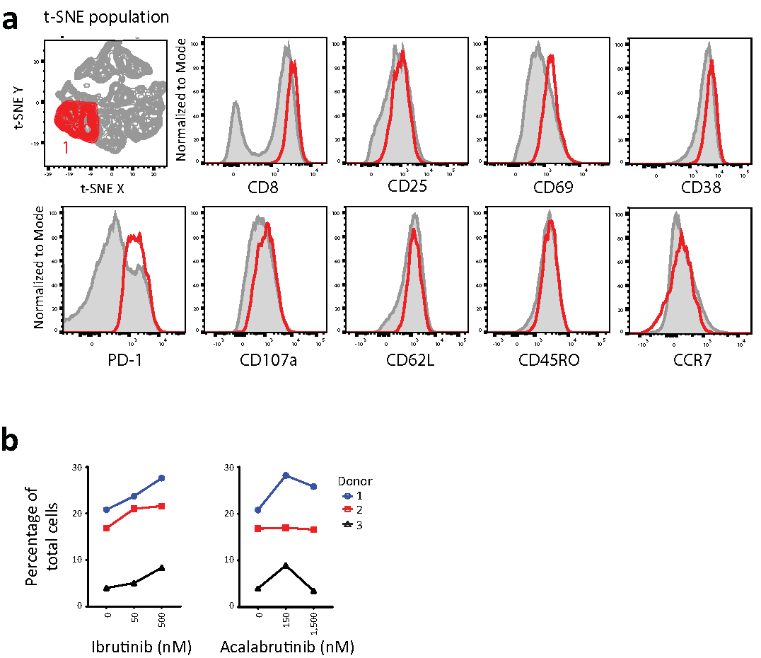

Supplemental Digital Content 6
Activation markers during initial stimulation. (a and b) Expression of CD25, CD38, CD39, and CD95 in the first 4 days after initial stimulation in the presence of (a) ibrutinib or (b) acalabrutinib. Representative result shown from cells derived from donor 2.

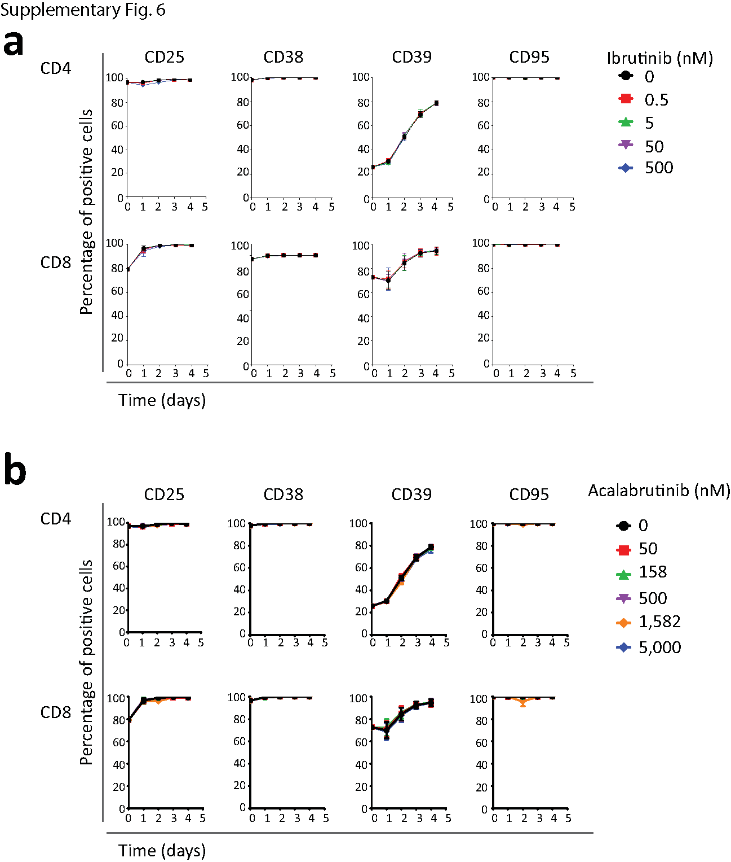

Supplemental Digital Content 7
Changes in chimeric antigen receptor (CAR) T cell memory subsets following culture in the presence of Bruton tyrosine kinase inhibitor. (a and b) Percentage of central memory T cells (TCMs; CCR7⁺CD45RA⁻) and effector memory T cells (TEMs; CCR7⁻CD45RA⁻) over 4 days after initial stimulation in the presence of (a) ibrutinib or (b) acalabrutinib. Representative result shown from donor 2.
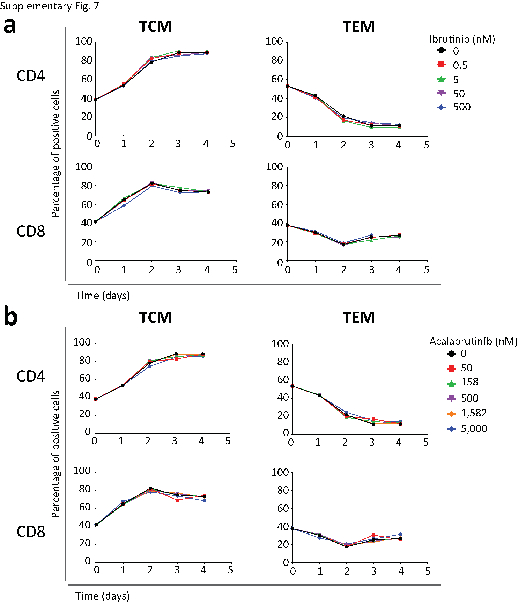

Supplemental Digital Content 8
Surface activation markers modulated in the presence of Bruton tyrosine kinase inhibitor. (a and b) Expression of CD69, CD107a, and PD-1 in the first 4 days after initial stimulation in the presence of (a) ibrutinib or (b) acalabrutinib. Data from 2 independent experiments with cells from 3 donors. Plots were analyzed by two-way analysis of variance. Statistically significant differences from control are indicated as P < 0.05 (*).

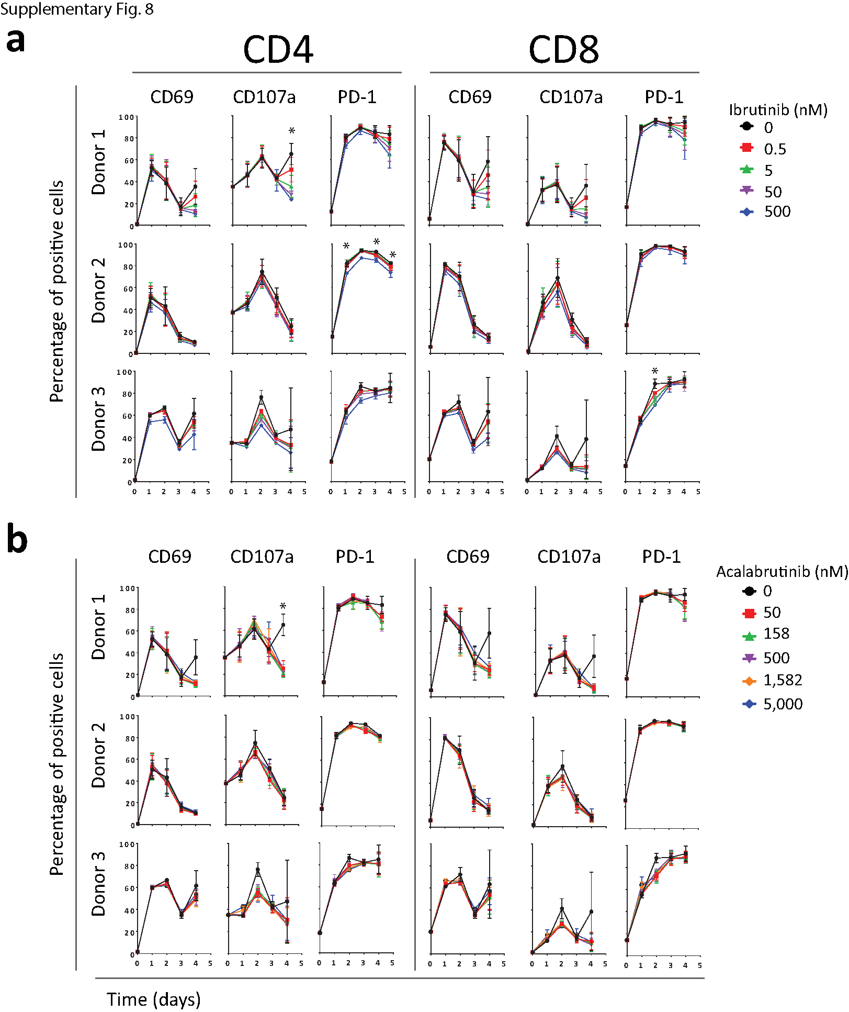

Supplemental Digital Content 9
Chimeric antigen receptor (CAR) T cell phenotypic marker expression in the presence of Bruton tyrosine kinase inhibitor in the serial stimulation assay. (a and b) Expression of CD25, CD38, CD39, CD45RO, CD62L, CD69, CD107a, and PD-1 at days 0, 11, 18, and 21 of serial stimulation in the presence of (a) ibrutinib or (b) acalabrutinib. Representative result shown from donor 2.

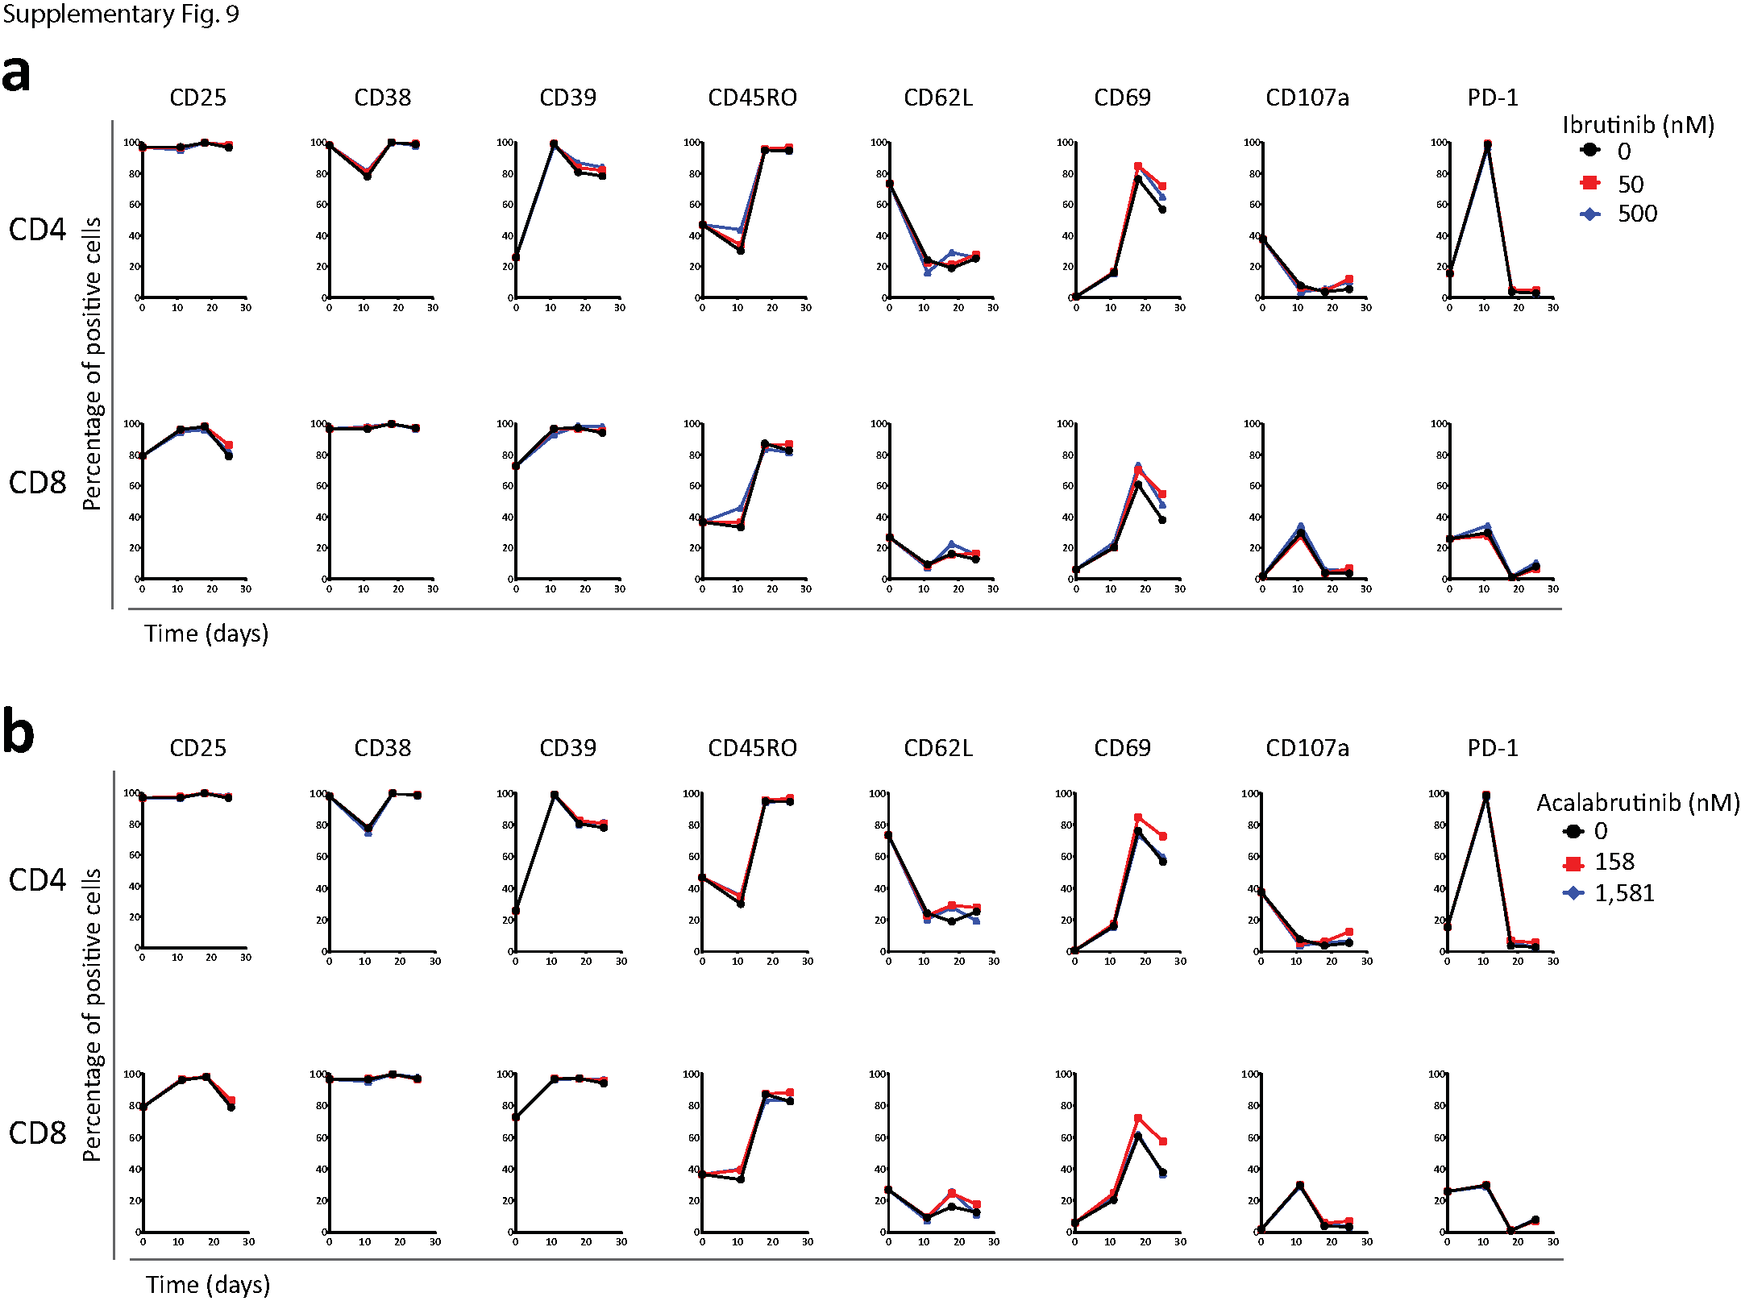

Supplemental Digital Content 10
Chimeric antigen receptor (CAR) T cells in combination with ibrutinib or acalabrutinib decreases tumor burden in mice. (a and b) Tumor growth over time as indicated by measuring average radiance by bioluminescence from mice treated with ibrutinib or acalabrutinib in drinking water and CAR T cells from (a) donor 2 and (b) donor 3. Analysis was performed with the two-way analysis of variance. Statistically significant differences are indicated as P < 0.05 (*) and
P < 0.01 (**). p/s/cm²/sr, photons per second per centimeter squared per steradian.
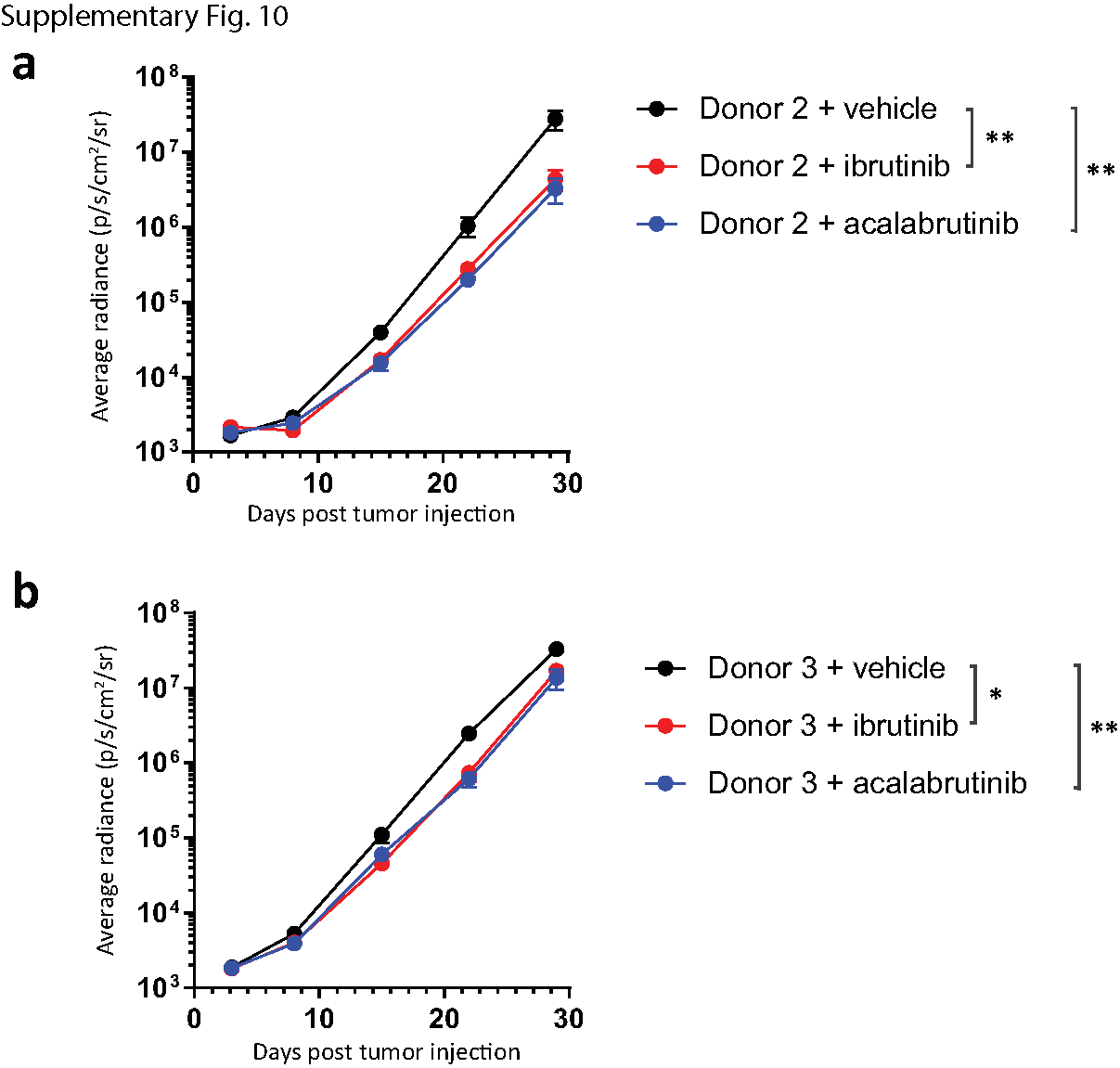
Supplemental Digital Content 11
Number of chimeric antigen receptor (CAR) T cells in mice treated with oral (PO) ibrutinib.
(a and b) CAR T cells from mice injected with donor 1 cells and treated with vehicle or PO ibrutinib were sacrificed on day 13, 19, and 26. Cells were quantified from the (a) blood or (b) tumor site (bone marrow). Analysis was performed with the one-way analysis of variance, and P values are shown.

