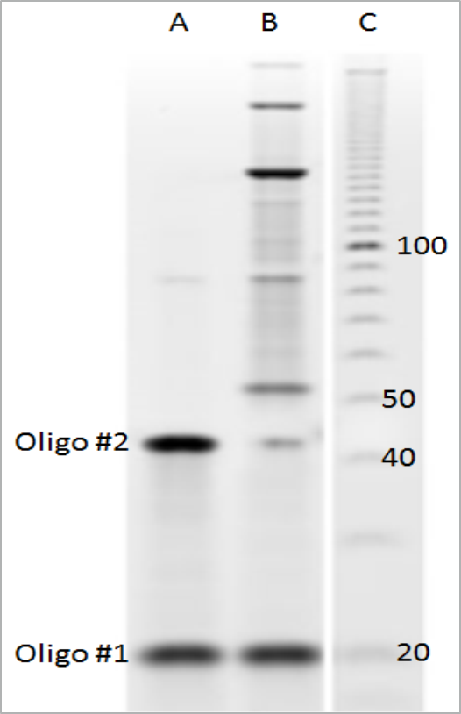

Supplementary Figure 1: Denaturing gel electrophoresis demonstrating the ligation of oligo #2. Lane C was a 10 base marker (Thermo Fisher Scientific, Waltham, MA, USA) with 20 bases, 40 bases, 50 bases and 100 bases identified. Lane A were oligo #1 and oligo #2 mixed together prior to ligation. Lane B demonstrates different products formed during the ligation: oligo #2 decreases in intensity as it forms circles, a monomeric 43 base circle was observed to migrate just above the 50 base marker, while other concatenated circles were observed to migrate as larger products on the gel. Because ssRCA produces a linear concatenated form of a circle, ligation of multimeric circles does not interfere with the downstream amplification reaction.

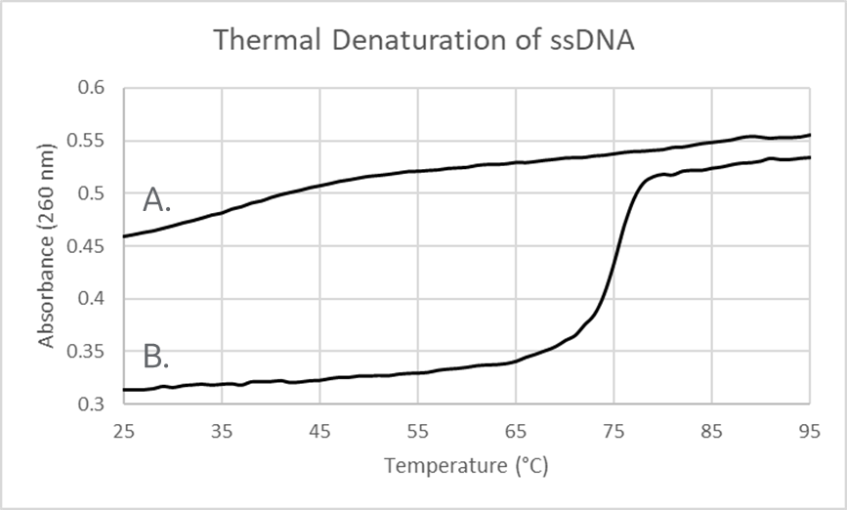

Supplementary Figure 2: Thermal denaturation curves of ssDNA. A) Profile of ssDNA alone. B) Profile when oligo #1 was simply mixed with ssDNA demonstrating a hyperchromatic shift indicative of double stranded DNA. Without the added oligo no hyperchromatic shift was observed, indicating that the ssDNA was indeed single stranded.

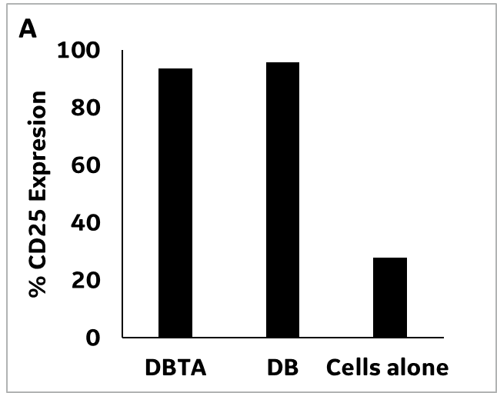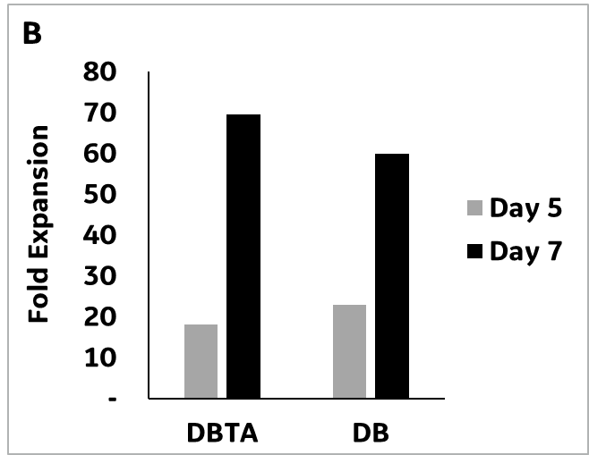
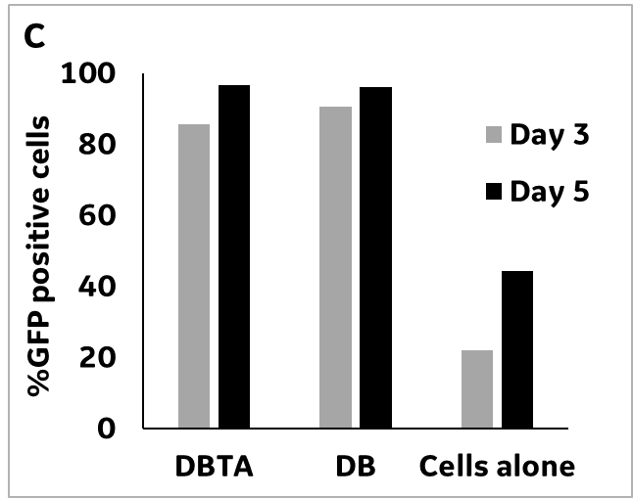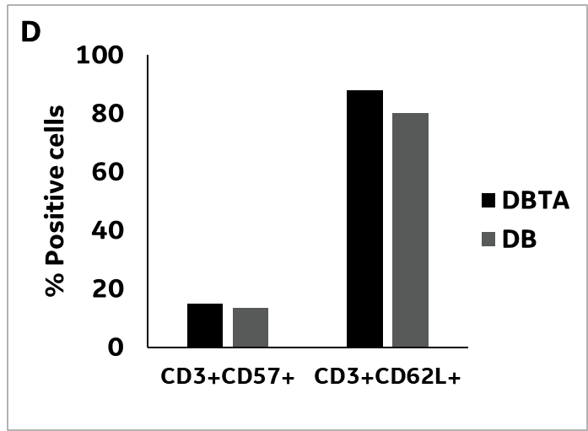
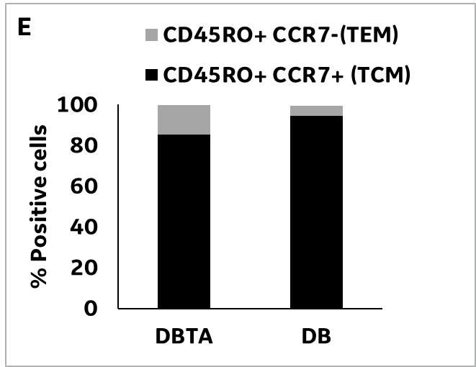
Supplementary Figure 3: Transduction of a commercial GFP vector. A: Rapid T cell activation within the first 24 hours, comparable to Dynabeads (DB). B: Fold expansions at days 5 and 7 post-activation are comparable for the DBTA and Dynabeads group. C: By day 3, the DBTA and Dynabeads groups have transduced 85% of the cells and greater than 95% are transduced by day 5. D: Expression of senescence marker CD57 and homing marker CD62L is similar across the DBTA and Dynabeads groups. E: Post expansion at day 7, the Dynabeads group has a slightly higher percentage of central memory (Tcm) T cells in comparison to the DBTA group (94.5% versus 85.3%) which could possibly be related to the higher fold expansion of the DBTA group (69.5X versus 60X). Data represents average of duplicate wells in a single experiment.

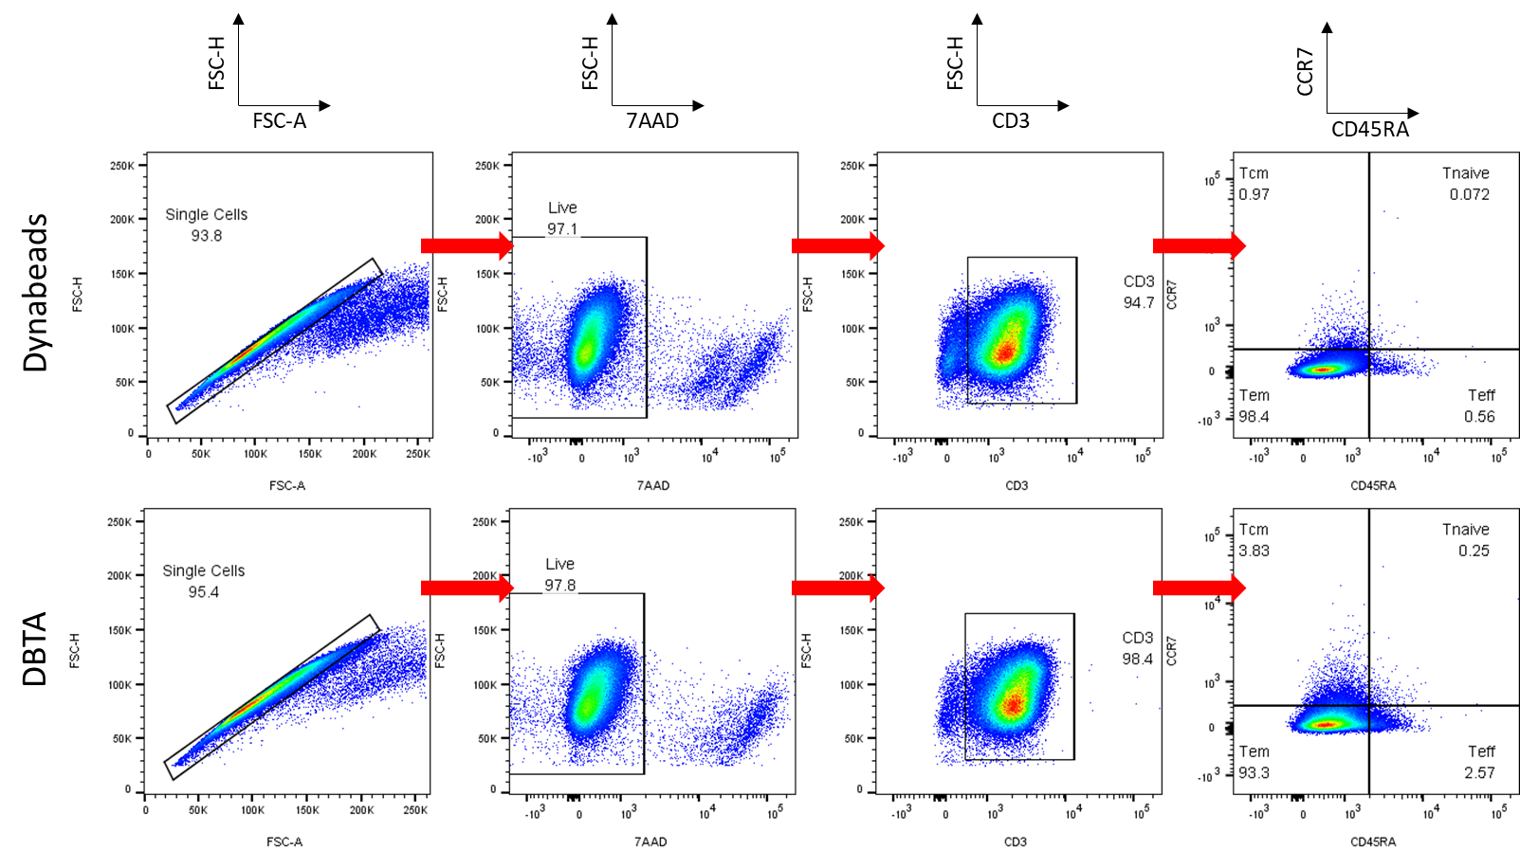
Supplementary Figure 4: Gating strategy for Fig.5F to examine T-cell subsets. Flow cytometric analysis was performed on cells stimulated with either Dynabeads (top) or GE DBTA (bottom). First, single cells were gated based off of FSC height versus area, followed by viable cell gating using 7AAD intercalating dye and CD3 –T-cell gating to achieve single viable T-cells. Next, subset discrimination was performed using CD45RA and CCR7. T central memory cells (Tcm) are CCR7+CD45RA-, T effector memory (Tem) cells are CCR7-CD45RA-, T naïve cells are CCR7+CD45RA+, and T effector (Teff) cells are CCR7-CD45RA+.

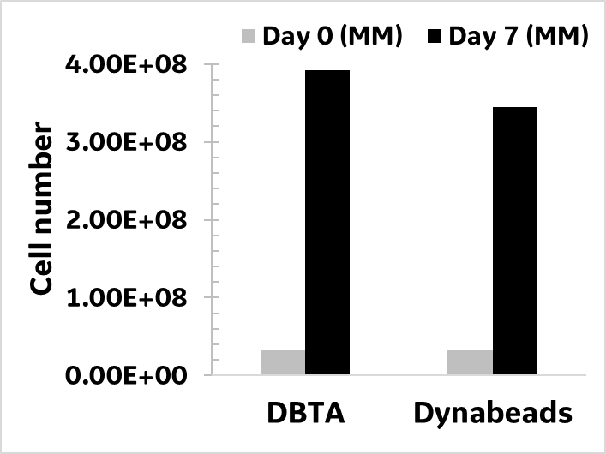

Supplementary Figure 5: Activation and expansion of T cells within a VueLife® 72C cell bag. Healthy donor T cells (32MM) were activated with DBTA or Dynabeads as per standard protocol and cultured in VueLife® 72C cell bag (Saint-Gobain, Gaithersburg, MD) under static conditions. This represents a 16X fold increase in seeding culture volume over 2mL culture in 6 well plates. Expression of CD25+ cells was greater than 90% in both the cultures (data not shown). On day 4 of culture, the bag contents were drained, washed and re-seeded into a fresh VueLife® 72C bag at a cell density of 0.5x10⁶ cell/ml. Graph represents cell numbers at harvest on day 7 from a single study.

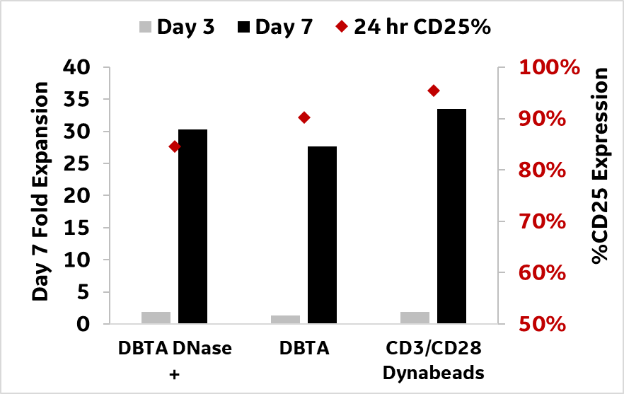

Supplementary Figure 6: Effect of transient activation on performance of the DBTA. 24 hours after T cells were activated as per standard protocol, the cells within the DBTA DNase+ group were treated with 0.3µg/mL of DNase I for 30 mins. This concentration of DNase was selected from a previous study (data not shown) where activation with the linear ssDNA component of the DBTA, pre-treated with 0.3µg/mL of DNase I for 30 mins, was comparable to the ‘cells alone’ control. Following the DNase I treatment, the cells were washed, resuspended in fresh medium and cultured as per standard protocol. Being a soluble activator, the DBTA does not require a specific washing step. However, the solubility of DBTA and its susceptibility to DNase offers a high level of flexibility in removing the activation/co-stimulation if transient activation is desired. Data from a single donor study indicates that the transient 24 hour activation has no adverse effects on the level of CD25 expression and fold expansion of the cells. Further studies are required to investigate the full effect of transient activation on phenotype and function of the expanded cells.

