Supplemental Digital Content
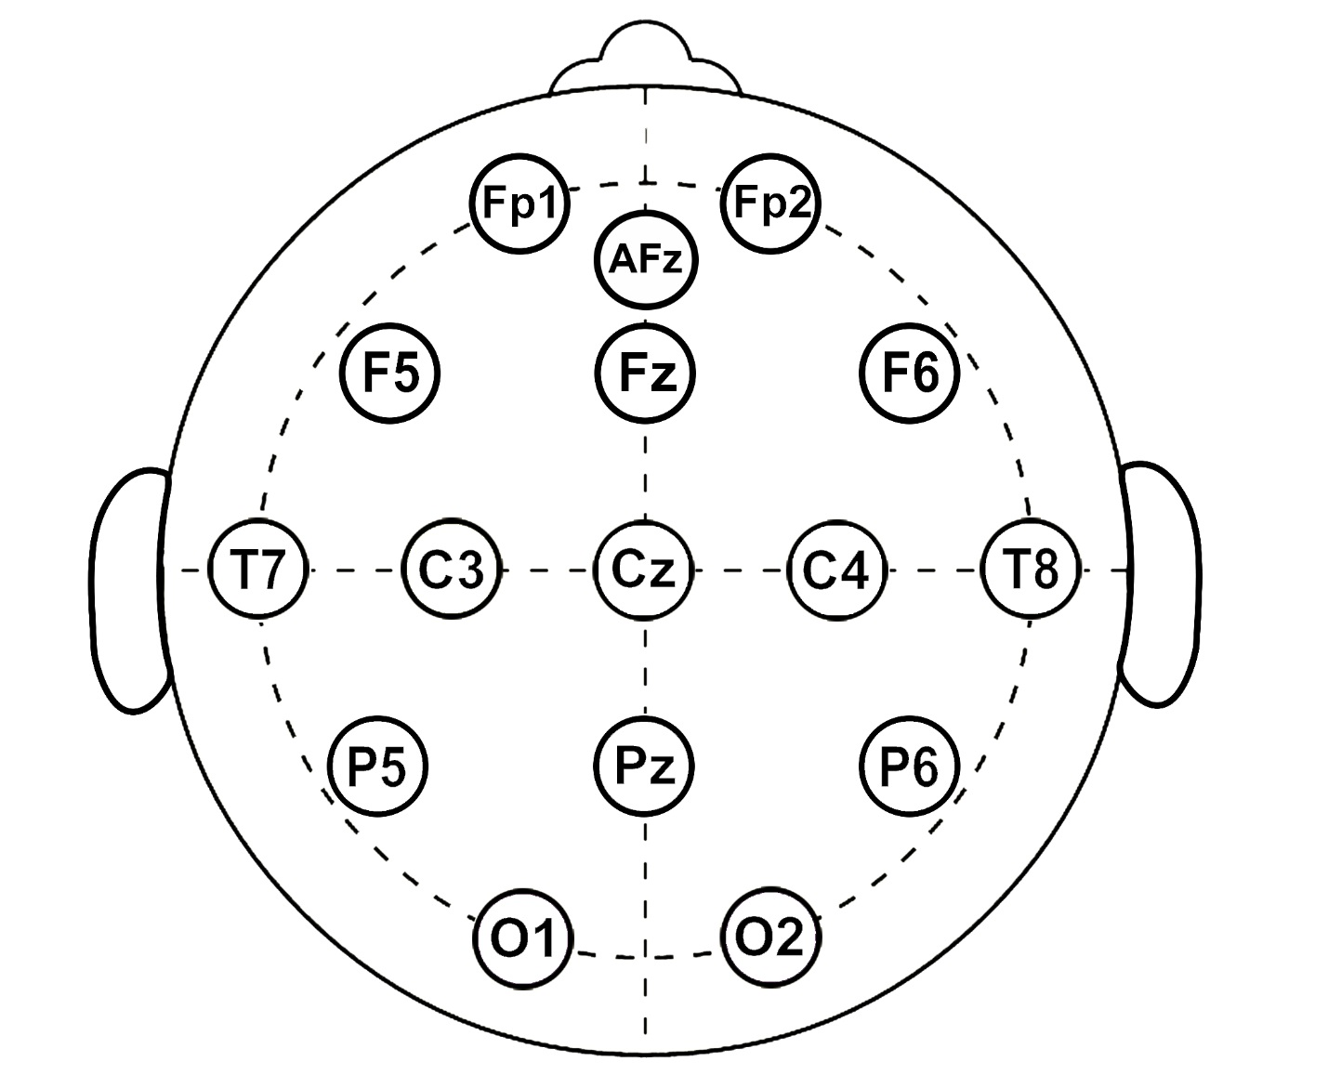

Figure: 16-Channel EEG Montage - International 10-20 System.

Electroencephalographic Data Acquisition – Supplemental Methods
EEG data were acquired using a wireless 16-channel cap (Cognionics, Inc., San Diego, CA USA) that covered the scalp (Figure). Properly sized caps were chosen by measuring head circumference, nasion to inion distance, and length between preauricular notches. The cap was then applied preoperatively, and impedances were kept below 100 kΩ per manufacturer recommendations. Data were reference-linked to the left mastoid, grounded at the right mastoid, and sampled at 500 Hz. The EEG recording device was then synchronized with the electronic medical record to timestamp critical events.

Following emergence from anesthesia, a two-minute resting state EEG epoch was recorded in eyes-closed conditions after initial PACU admission and assessment (mean 24.7 minutes [±11.6] after PACU arrival). This specific time period also helped to minimize artifact and obtain a stable neurophysiologic representation of anesthetic recovery. Data were derived from 30-60 seconds of clean neurophysiologic signaling during this time frame.

Electroencephalography Analysis – Supplemental Methods
As described in the main manuscript text, parietal alpha power and frontal-parietal connectivity were the EEG-based biomarkers chosen for analysis in this study. Parietal alpha power – both absolute and relative power characteristics – have previously demonstrated an inverse correlation with network and neurocognitive recovery following general anesthesia in human volunteers.¹ Furthermore, reduced (or absent/displaced) posterior alpha power in the eyes-closed state has correlated with various states of encephalopathy (e.g., sepsis, delirium).² Thus, a single, eyes-closed measurement of posterior alpha power upon PACU admission may inform as to the neurocognitive recovery and trajectory of surgical patients. Although no preoperative, baseline comparisons were possible for this study, analyzing both absolute and relative power (compared to other bandwidths) may provide evidence as to pathologically reduced or displaced alpha oscillatory activity. Additionally, frontal-parietal connectivity was chosen as the second EEG-based biomarker for analysis. Strength of frontal-parietal connectivity has been correlated with levels of consciousness³ and measures of cognitive function, such as fluid intelligence⁴ and coordination of cognitive control.⁵ Thus, PACU frontal-parietal connectivity strength may also correlate with neurocognitive and clinical trajectory in the immediate postoperative setting.

EEG data were cleaned and analyzed as previously described⁶ for generating spectral power results and estimating functional connectivity. In brief, raw EEG data were first exported to MATLAB (version 2017a; MathWorks, Inc., Natick, MA USA) and down-sampled to 250 Hz. For EEG data abstraction, at least one usable channel was required for each area of interest (prefrontal: Fp1, Fp2; frontal; F5, F6, Fz; parietal: P5, P6, Pz) for a given participant. Data preprocessing then occurred in a stepwise manner by visual inspection – and removal of bad channels – followed by detrending and low-pass filtering at 55 Hz. Independent component analysis was then conducted to remove cardiac artifact, eye movement, muscle movement, and other transient artifacts via extended-Infomax algorithm in EEGLAB Toolbox.^{6, 7}

Power spectrograms were then generated using the multi-taper method in Chronux analysis toolbox⁸ with window length equal to 2 seconds with 50% overlap, time-bandwidth product equal to 2, and number of tapers equal to 3. The relative power was calculated from the absolute power normalized by the total power. Spectra were presented for frontal and parietal regions by median (averaging) PACU spectral data from all available participants. Functional connectivity was then estimated with weighted phase lag index, which measures the instantaneous phases of two signals to determine whether they may be synchronized, and thus, functionally related.⁹ Effects of volume conduction and reference montage are mitigated by this strategy, as weighted phase lag index only accounts for nonzero phase lead/lag relationships. If the instantaneous phase of one signal consistently leads (or lags) that of another, the two signals are considered phase-locked, and the index is equal to 1. On the other hand, if the lead/lag relationship is random, the index will be low (and 0 if there is no phase difference between the signals). Detailed analytic and estimation methods were described previously.⁶ Briefly, weighted phase lag index values were extracted and quantified using the following steps: first, EEG signals were divided into 30-second windows with 10-second step size, then 2-second subwindows were created with 50% overlapping; second, the multitaper method⁸ was used to estimate cross-spectral density with time-bandwidth product = 2 and the number of tapers = 3; lastly, weighted phase lag index values were estimated as a function of frequency from these repetitions using a custom-written function adapted from Fieldtrip toolbox.¹⁰ To minimize potential bias, surrogate data were generated via trial-shuffling method, and weighted phase lag index was calculated and subtracted from the original value to produce the final estimation of connectivity.^{6, 11} Cortical connectivity was presented among prefrontal, frontal, and parietal regions given their involvement with consciousness and altered perioperative brain states.^{12, 13}

Supplemental References
1. Blain-Moraes S, Tarnal V, Vanini G, et al. Network efficiency and posterior alpha patterns are markers of recovery from general anesthesia: A high-density electroencephalography study in healthy volunteers. Front Hum Neurosci 2017;11: 328.
2. Palanca BJA, Wildes TS, Ju YS, et al. Electroencephalography and delirium in the postoperative period. Br J Anaesth 2017;119: 294-307.
3. Untergehrer G, Jordan D, Kochs EF, et al. Fronto-parietal connectivity is a non-static phenomenon with characteristic changes during unconsciousness. PLoS One 2014;9: e87498.
4. Cole MW, Ito T, Braver TS. Lateral prefrontal cortex contributes to fluid intelligence through multinetwork connectivity. Brain Connect 2015;5: 497-504.
5. Cole MW, Reynolds JR, Power JD, et al. Multi-task connectivity reveals flexible hubs for adaptive task control. Nat Neurosci 2013;16: 1348-55.
6. Vlisides PE, Li D, Zierau M, et al. Dynamic cortical connectivity during general anesthesia in surgical patients. Anesthesiology 2019;130: 885-897.
7. Delorme A, Makeig S. Eeglab: An open source toolbox for analysis of single-trial eeg dynamics including independent component analysis. J Neurosci Methods 2004;134: 9-21.
8. Mitra P, Bokil H. Observed brain dynamics. Oxford University Press; 2007.
9. Vinck M, Oostenveld R, van Wingerden M, et al. An improved index of phase-synchronization for electrophysiological data in the presence of volume-conduction, noise and sample-size bias. Neuroimage 2011;55: 1548-65.
10. Oostenveld R, Fries P, Maris E, et al. Fieldtrip: Open source software for advanced analysis of meg, eeg, and invasive electrophysiological data. Comput Intell Neurosci 2011;2011: 156869.
11. Papana A, Kugiumtzis D, Larsson PG. Reducing the bias of causality measures. Phys Rev E Stat Nonlin Soft Matter Phys 2011;83: 036207.
12. Flores FJ, Hartnack KE, Fath AB, et al. Thalamocortical synchronization during induction and emergence from propofol-induced unconsciousness. Proc Natl Acad Sci U S A 2017;114: E6660-e6668.
13. Lee U, Ku S, Noh G, et al. Disruption of frontal-parietal communication by ketamine, propofol, and sevoflurane. Anesthesiology 2013;118: 1264-75.

