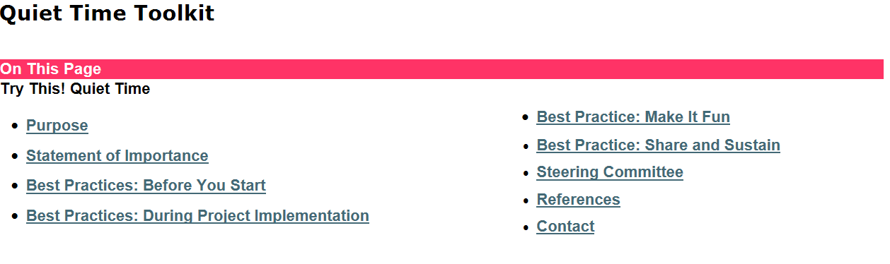
The toolkit is a webpage embedded in the UNC Hospitals intranet and includes strategies endorsed by the Quiet Time Steering Committee for implementing and testing a designated Quiet Time on individual units. This toolkit covers evidence-based recommendations and guidance on how to use available tools to implement and sustain best practices. Each section links to resources (tools, templates and tip sheets) that units can readily access during implementation of QT. The toolkit is available to employees of UNC Hospitals as a result of this quality improvement project.
For more information, contact the author: Christine.hedges@unchealth.unc.edu

