Figure. Average Richards-Campbell Sleep Questionnaire (RCSQ) and Quiet Scores Pre- and Postintervention
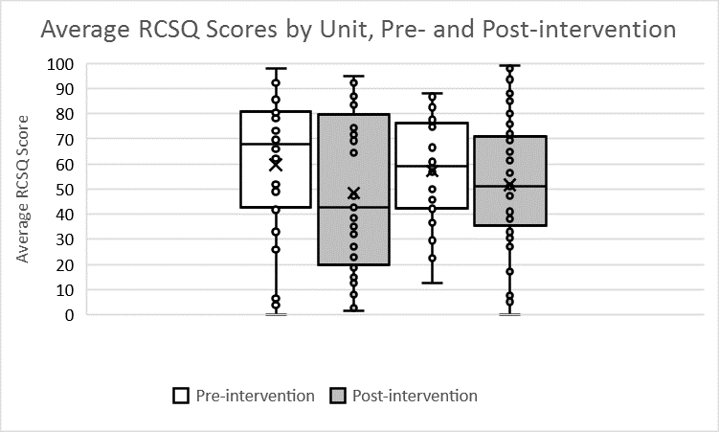  Unit 2  Unit 1 | 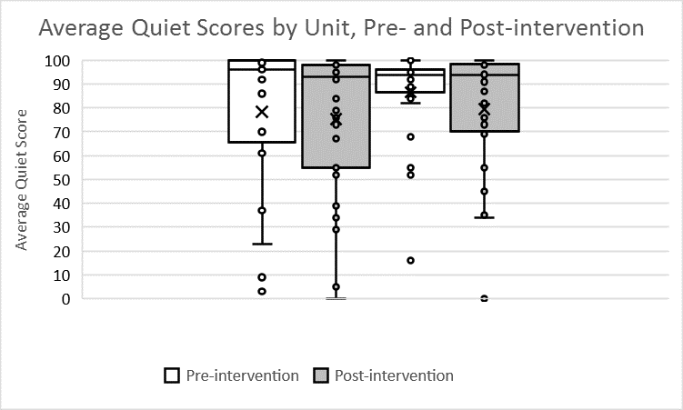  Unit 1  Unit 2
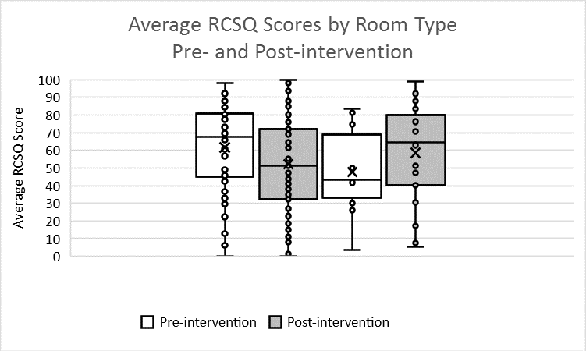  Shared  Private | 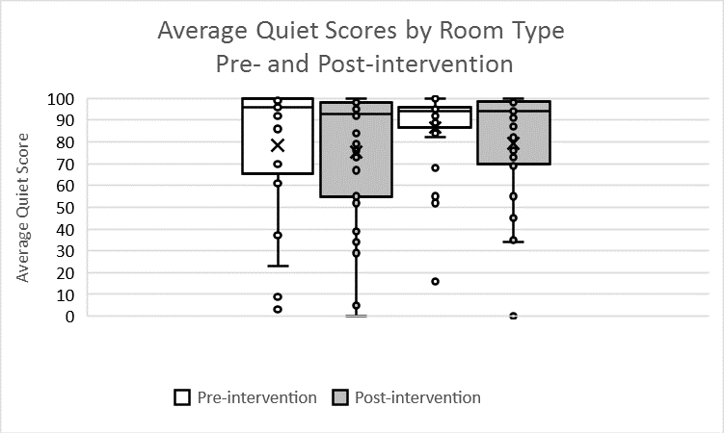  Shared  Private

Box & whisker plot key: The box represents the interquartile range (IQR), with quartiles 2 and 3 separated by the median. X represents the mean. Whiskers extend 1.5 X IQR. Circles represent discrete measurement points; those beyond the whiskers are considered outliers.

