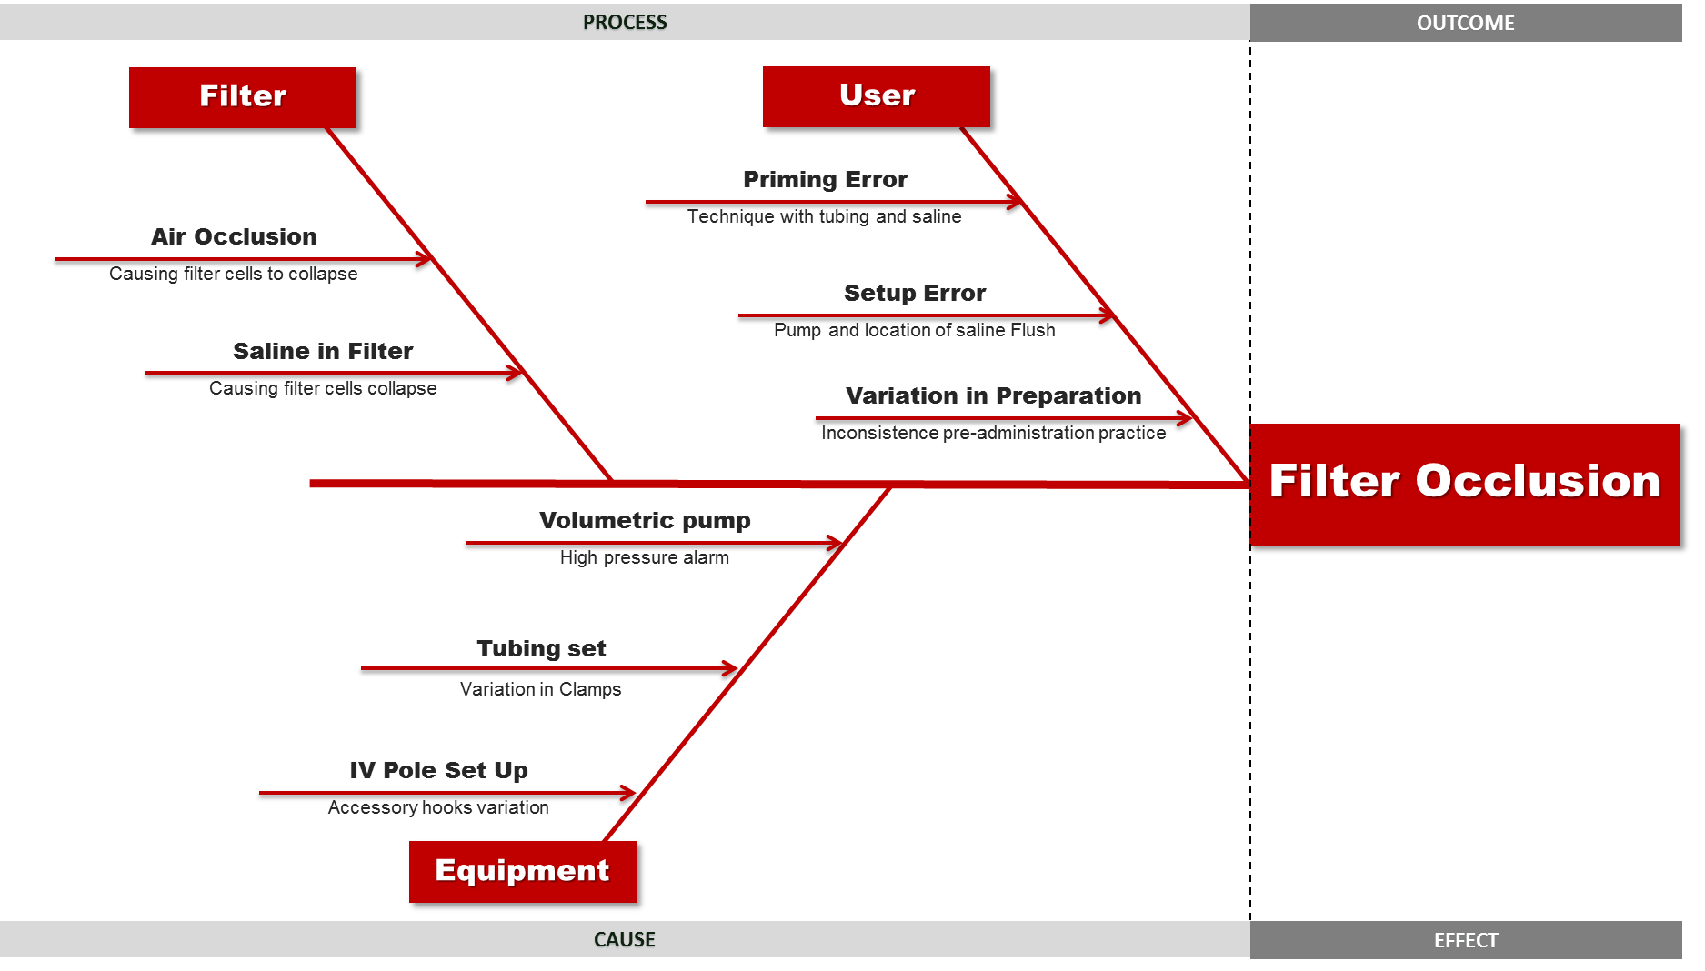
© The University of Texas MD Anderson Cancer Center, February 28, 2021. Reprinted by permission from The University of Texas MD Anderson Cancer Center.

