Supplemental Digital Content Figure. Clinical Case Management Discharge Readmission Risk Pathway for Patients with Diabetes

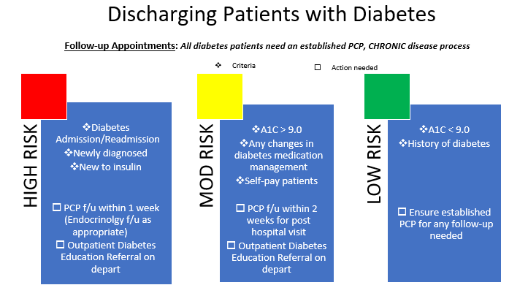
PCP=Primary Care Provider

