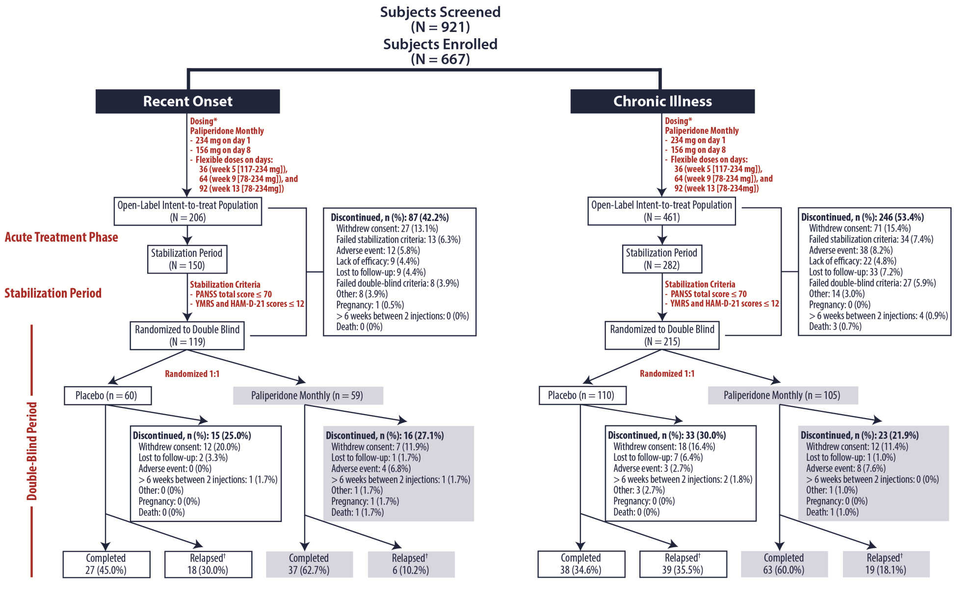

Supplemental Figure 1. Study Design and Subject Disposition
The primary study consisted of: 1) a 7-day screening phase; 2) a 13-week, open-label, flexible-dose, acute treatment phase; 3) a 12-week, open-label, fixed-dose, stabilization phase; and 4) a 15-month, double-blind, placebo-controlled relapse-prevention period. Subject disposition is shown by duration of psychiatric illness. Subject’s illness duration was categorized as recent onset (defined as ≤5 years since first psychiatric diagnosis) or chronic illness (>5 years since first psychiatric diagnosis).
†Relapse was defined as first occurrence of any one of the following: 1) Psychiatric hospitalization; 2) Intervention to avert imminent hospitalization; 3) Clinically significant self-injury, suicidal or homicidal ideation, or violent behaviors; 4) Worsening of 1 or more of the following PANSS items (score ≥6 after randomization if the score was ≤4 at randomization): P1, P2, P3, P4, P6, P7, G8, or G14; or 5) Worsening in any of the following at 2 consecutive visits within 7 days: a) ≥25% increase in PANSS total score if the score at randomization was >45; b) ≥10-point increase in PANSS total score if the score at randomization was ≤45; c) Worsening of any 1 or more of the following PANSS items to ≥5 if the score was ≤3 at randomization: P1, P2, P3, P4, P6, P7, G8, or G14; or d) Increase in CGI-S-SCA ≥2 points if the score at randomization was 1 to 3 or an increase ≥1 point if the score at randomization was ≥4.

