Figure 1: Scatterplots for mean pupillometer and ICP values

NPI values and ICP
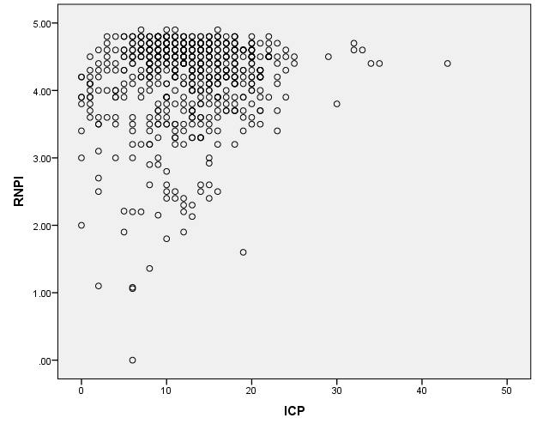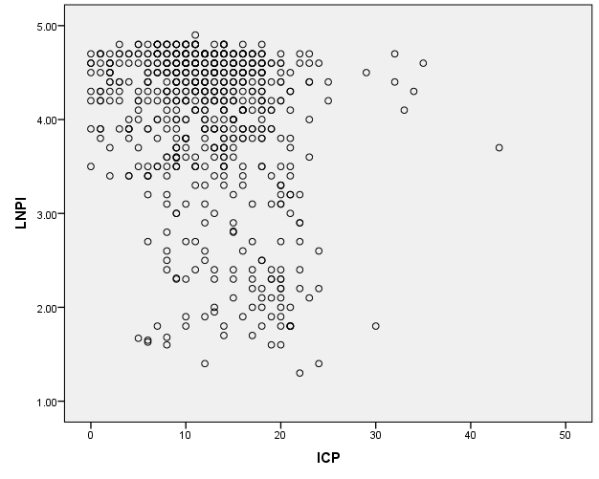
Figure 1a: Distribution of right eye NPi and Figure 1b: Distribution of left eye NPi and
ICP. ICP.

CV Values and ICP
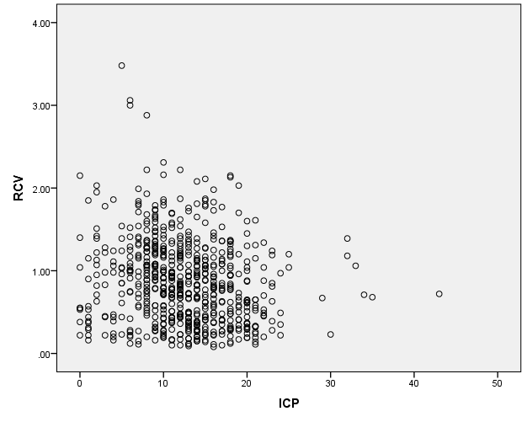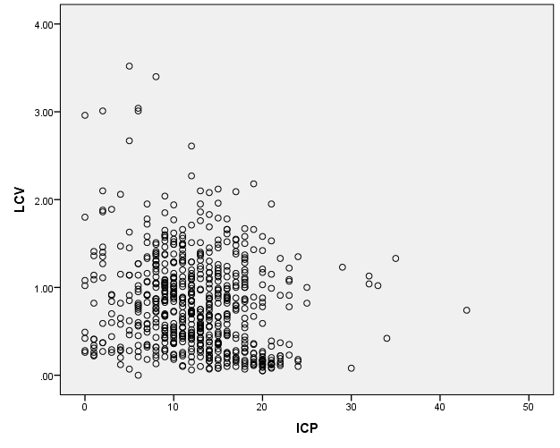
Figure 1c: Distribution of right eye constriction Figure 1d: Distribution of left eye constriction
velocities and ICP. velocities and ICP.

