Supplemental Information
Table S1. Opioid classes investigated and frequency of prescriptions for CTR.
Opioid Class | N (%)
Aspirin/caffeine/dihydrocodeine bitartrate | 0 (0%)
Buprenorphine HCL | 2 (0%)
Buprenorphine HCL/naloxon | 2 (0%)
Butorphanol tartrate | 0 (0%)
Codeine phosphate | 0 (0%)
Codeine sulfate | 2 (0%)
Codeine/acetaminophen | 366 (6.4%)
Fentanyl | 9 (0.2%)
Fentanyl citrate oral transmucosal | 0 (0%)
Hydrocodone bitartrate | 0 (0%)
Hydrocodone/acetaminophen | 3966 (69.2%)
Hydrocodone/ibuprofen | 11 (0.2%)
Hydromorphone HCL | 16 (0.3%)
Levorphanol tartrate | 0 (0%)
Meperidine HCL | 27 (0.5%)
Methadone HCL | 1 (0%)
Morphine sulfate | 2 (0%)
Morphine sulfate ER | 4 (0.1%)
Nalbuphine HCL | 0 (0%)
Oxycodone HCL | 74 (1.3%)
Oxycodone/acetaminophen | 1142 (19.9%)
Oxycodone/aspirin | 0 (0%)
Oxycodone/ibuprofen | 0 (0%)
Oxymorphone hydrochloride | 2 (0%)
Pentazocine/naloxon HCL | 14 (0.2%)
Tapentadol | 0 (0%)
Tramadol HCL | 84 (1.5%)
Tramadol hydrochloride AC | 5 (0.1%)

Table S2. Prevalence of risk factors prior to CTR (90 days prior to CTR procedure) and during the release time frame (seven days before/after CTR procedure)
Category | All, n = 7,840 | Not Prescribed Opioid for CTR, n = 2,353 | Prescribed Opioid for CTR, n = 5,487 | p.value¹
Depression diagnosis prior to CTR |  |  |  | 0.059
No | 6,479 (82.6%) | 1,974 (83.9%) | 4,505 (82.1%)
Yes | 1,361 (17.4%) | 379 (16.1%) | 982 (17.9%)
Drug abuse diagnosis prior to CTR |  |  |  | 1
No | 7,809 (99.6%) | 2,344 (99.6%) | 5,465 (99.6%)
Yes | 31 (0.4%) | 9 (0.4%) | 22 (0.4%)
Alcohol abuse diagnosis prior to CTR |  |  |  | 0.897
No | 7,814 (99.7%) | 2,346 (99.7%) | 5,468 (99.7%)
Yes | 26 (0.3%) | 7 (0.3%) | 19 (0.3%)
Psychosis diagnosis prior to CTR |  |  |  | 1
No | 7,830 (99.9%) | 2,350 (99.9%) | 5,480 (99.9%)
Yes | 10 (0.1%) | 3 (0.1%) | 7 (0.1%)
Depression diagnosis during release time frame |  |  |  | 0.497
No | 7,336 (93.6%) | 2,209 (93.9%) | 5,127 (93.4%)
Yes | 504 (6.4%) | 144 (6.1%) | 360 (6.6%)
Drug abuse diagnosis during release time frame |  |  |  | 1
No | 7,826 (99.8%) | 2,349 (99.8%) | 5,477 (99.8%)
Yes | 14 (0.2%) | 4 (0.2%) | 10 (0.2%)
Alcohol abuse diagnosis during release time frame |  |  |  | 0.789
No | 7,834 (99.9%) | 2,352 (100%) | 5,482 (99.9%)
Yes | 6 (0.1%) | 1 (0%) | 5 (0.1%)
Psychosis diagnosis during release time frame |  |  |  | NA
No | 7,840 (100%) | 2,353 (100%) | 5,487 (100%)
Benzodiazapine prescription during release time frame |  |  |  | 0.388
No | 7,800 (99.5%) | 2,338 (99.4%) | 5,462 (99.5%)
Yes | 40 (0.5%) | 15 (0.6%) | 25 (0.5%)
¹ p-value from chi-squared test

Table S3. Frequency of predictor being selected in bootstrap multiple regression backwards selection techniques
 | Variable Type | Selection Frequency in Duration Model (%) | Selection Frequency in Cost Model (%)
Age (years) | Numeric | 78 | 26
Alcohol abuse diagnosis during disability time frame | Bernoulli | 10 | 9
Anemia diagnosis during disability time frame | Bernoulli | 36 | 95
Arrhythmia diagnosis during disability time frame | Bernoulli | 20 | 8
Blood loss diagnosis during disability time frame | Bernoulli | 5 | 43
Congestive heart failure diagnosis during disability time frame | Bernoulli | 30 | 54
Coagulopathy diagnosis during disability time frame | Bernoulli | 14 | 17
Depression diagnosis during disability time frame | Bernoulli | 4 | 34
Diabetes, uncomplicated diagnosis during disability time frame | Bernoulli | 72 | 5
Diabetes, complicated diagnosis during disability time frame | Bernoulli | 13 | 10
Drug abuse diagnosis during disability time frame | Bernoulli | 12 | 36
Fluid and electrolyte disorder diagnosis during disability time frame | Bernoulli | 9 | 23
HIV/AIDS diagnosis during disability time frame | Bernoulli | 39 | 3
Hypertension, uncomplicated diagnosis during disability time frame | Bernoulli | 18 | 13
Hypothyroidism diagnosis during disability time frame | Bernoulli | 36 | 3
Liver disease diagnosis during disability time frame | Bernoulli | 33 | 20
Lymphoma diagnosis during disability time frame | Bernoulli | 0 | 0
Other neurological disorders diagnosis during disability time frame | Bernoulli | 11 | 56
Obesity diagnosis during disability time frame | Bernoulli | 6 | 12
Paralysis diagnosis during disability time frame | Bernoulli | 0 | 0
Pulmonary circulation disorders diagnosis during disability time frame | Bernoulli | 31 | 23
Psychoses diagnosis during disability time frame | Bernoulli | 1 | 0
Peptic ulcer disease excluding bleeding diagnosis during disability time frame | Bernoulli | 0 | 1
Pulmonary disease, chronic diagnosis during disability time frame | Bernoulli | 23 | 62
Peripheral vascular disorders diagnosis during disability time frame | Bernoulli | 11 | 1
Renal failure diagnosis during disability time frame | Bernoulli | 10 | 31
Rheumatoid arthritis/ collagen vascular diseases diagnosis during disability time frame | Bernoulli | 25 | 13
Solid tumor without metastasis diagnosis during disability time frame | Bernoulli | 0 | 0
Valvular disease diagnosis during disability time frame | Bernoulli | 20 | 17
Weight loss diagnosis during disability time frame | Bernoulli | 1 | 14
Comorbidity index during disability time frame | Numeric | 40 | 30
Case works in construction industry | Bernoulli | 0 | 0
*Opioid prescribed according to Guidelines | Bernoulli | 74 | 99
Case had inpatient stay during disability time frame | Bernouli | 36 | 97
Number of unique ICDs during disability time frame | Numeric | 100 | 100
Number of unique CPTS during disability time frame | Numeric | 100 | 100
Case works in finance insurance real estate industry | Bernoulli | 31 | 78
Sex (male or female) | Categorical | 87 | 10
Case works in manufacturing durable goods industry | Bernoulli | 99 | 89
Case works in manufacturing nondurable goods industry | Bernoulli | 99 | 65
Median household income in geographic area | Numeric (scaled) | 50 | 100
Number of CTR procedures | Numeric | 100 | 100
Case works in oil gas, extraction, mining industry | Bernoulli | 26 | 1
Percent of individuals in geographical area with a college education | Numeric | 95 | 14
Population density in geographical area | Numeric | 42 | 35
Case has POS health plan | Bernoulli | 0 | 0
Case has PPO health plan | Bernoulli | 6 | 95
Case had a previous disability leave | Bernoulli | 77 | 15
Case had a previous disability leave for CT | Bernoulli | 18 | 8
Case works in retail trade industry | Bernoulli | 70 | 20
Case is a salaried worker | Bernoulli | 100 | 51
Case works in services industry | Bernoulli | 91 | 14
Case works in transportation, communications, utilities industry | Bernoulli | 55 | 89
Case is a union worker | Bernoulli | 100 | 29
* Exposure of interest

Table S4. Kaplan-Meier estimations of the difference in disability duration and medical costs by whether the opioid-naïve case was prescribed an opioid according or contrary to ACOEM’s recommendations. Removing cases prescribed any opioids later than the day after the CTR procedure
 |  | Disability Duration (Days) |  |  |  |  |  | Medical Costs ($)
 | N | 5th %ile | 25th %ile | Median | Mean | 75th %ile | 95th %ile | 5th %ile | 25th %ile | Median | Mean | 75th %ile | 95th %ile
Opioid According to Guidelines | 1,369 | 13 | 25 | 40 | 47 | 55 | 99 | 1,677 | 2,850 | 4,057 | 5,279 | 6,053 | 11,370
Opioid Contrary to Guidelines | 1,443 | 14 | 27 | 41 | 50 | 59 | 112 | 1,800 | 2,971 | 4,496 | 6,005 | 6,938 | 14,717

Table S5. Lognormal survival regression model results quantifying the impact of prescribing opioids contrary to ACOEM’s guidelines on disability duration and medical costs. Removing cases prescribed any opioids later than the day after the CTR procedure (n = 2,812).
 | Disability Duration Model (Days) |  |  | Medical Cost Model ($)
Variable | β | Standard error | p-value | β | Standard error | p-value
Intercept | 3.118 | 0.133 | <0.001 | 7.641 | 0.048 | <0.001
Opioid prescribed contrary to Guidelines | - | - | - | 0.088 | 0.021 | <0.001
Sex (male = 1, females = 0) | -0.063 | 0.024 | 0.008 | - | - | -
Previous disability program utilization | 0.059 | 0.022 | 0.008 | - | - | -
Number of unique diagnoses during disability | 0.019 | 0.004 | <0.001 | 0.028 | 0.004 | <0.001
Number of unique procedures during disability | 0.019 | 0.002 | <0.001 | 0.016 | 0.002 | <0.001
Number of CTR procedures | 0.524 | 0.034 | <0.001 | 0.518 | 0.033 | <0.001
Comorbidities during disability:¹
Diabetes mellitus | -0.096 | 0.039 | 0.014 | - | - | -
Pulmonary disease | - | - | - | -0.121 | 0.054 | 0.025
Case industry:
Manufacturing Durable Goods | 0.09 | 0.027 | 0.001 | -0.18 | 0.035 | <0.001
Manufacturing Nondurable Goods | 0.126 | 0.033 | <0.001 | -0.112 | 0.04 | 0.005
Services | 0.084 | 0.044 | 0.056 | - | - | -
Transportation Communications Utilities | - | - | - | -0.172 | 0.035 | <0.001
Finance, insurance, real estate | - | - | - | -0.146 | 0.04 | <0.001
Geographical area variables:
Median household income (scaled) | -0.025 | 0.013 | 0.047 | 0.074 | 0.011 | <0.001
Percent of college graduates | -0.518 | 0.21 | 0.014 | - | - | -
Health plans:
Preferred provider organization plan | - | - | - | -0.06 | 0.022 | 0.007
Consumer-driver health plan | -0.109 | 0.024 | <0.001 | - | - | -
Case salaried | -0.271 | 0.029 | <0.001 | 0.075 | 0.027 | 0.005
Case in union | 0.105 | 0.025 | <0.001 | - | - | -
¹ Comorbidity groupings from Quan et al. (2005).

Table S6. Comparison of demographic and medical characteristics of STD cases in our sample to non-disability cases with a CTR procedure
Category | STD Cases in Sample, n = 7,840 | Non-Disability Cases with CTR, n = 7,840 | p.value¹
Sex |  |  | <0.001
Female | 4,757 (60.7%) | 4,419 (56.4%)
Male | 3,083 (39.3%) | 3,421 (43.6%)
Age (years) |  |  | <0.001
≥18 and < 30 | 236 (3%) | 195 (2.5%)
≥30 and < 40 | 1,199 (15.3%) | 928 (11.8%)
≥40 and < 50 | 2,346 (29.9%) | 2,136 (27.2%)
≥50 and < 66 | 4,059 (51.8%) | 4,581 (58.4%)
Number of unique diagnoses during release time frame |  |  | 0.705
0 | 0 (0%) | 4 (0.1%)
1 | 2,136 (27.2%) | 2,142 (27.3%)
≥2 and < 4 | 3,256 (41.5%) | 3,285 (41.9%)
≥4 and < 22 | 2,448 (31.2%) | 2,409 (30.7%)
Number of unique procedures during release time frame |  |  | <0.001
≥1 and < 3 | 1,924 (24.5%) | 1,628 (20.8%)
≥3 and < 5 | 2,114 (27%) | 2,139 (27.3%)
≥5 and < 8 | 1,798 (22.9%) | 1,910 (24.4%)
≥8 and < 45 | 2,004 (25.6%) | 2,163 (27.6%)
Depression diagnosis prior to CTR |  |  | 0.001
No | 6,479 (82.6%) | 6,314 (80.5%)
Yes | 1,361 (17.4%) | 1,526 (19.5%)
Opioid prescribed during release time frame |  |  | <0.001
No | 2,353 (30%) | 2,633 (33.6%)
Yes | 5,487 (70%) | 5,207 (66.4%)
Opioid prescribed contrary to guidelines during release time frame |  |  | 0.162
No | 5,574 (71.1%) | 5,654 (72.1%)
Yes | 2,266 (28.9%) | 2,186 (27.9%)
¹ p-value from chi-squared test

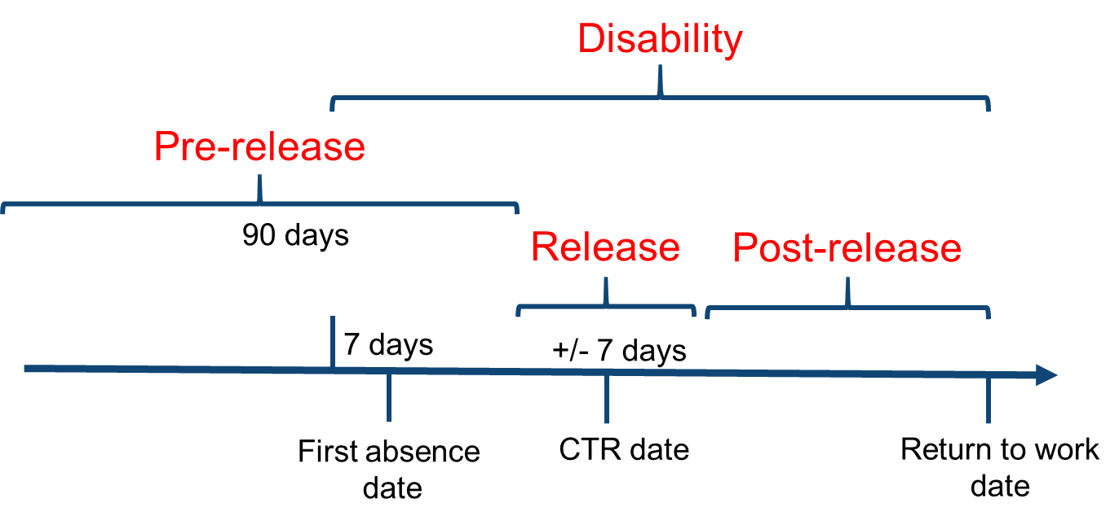
Figure S1. Time frames used in analysis

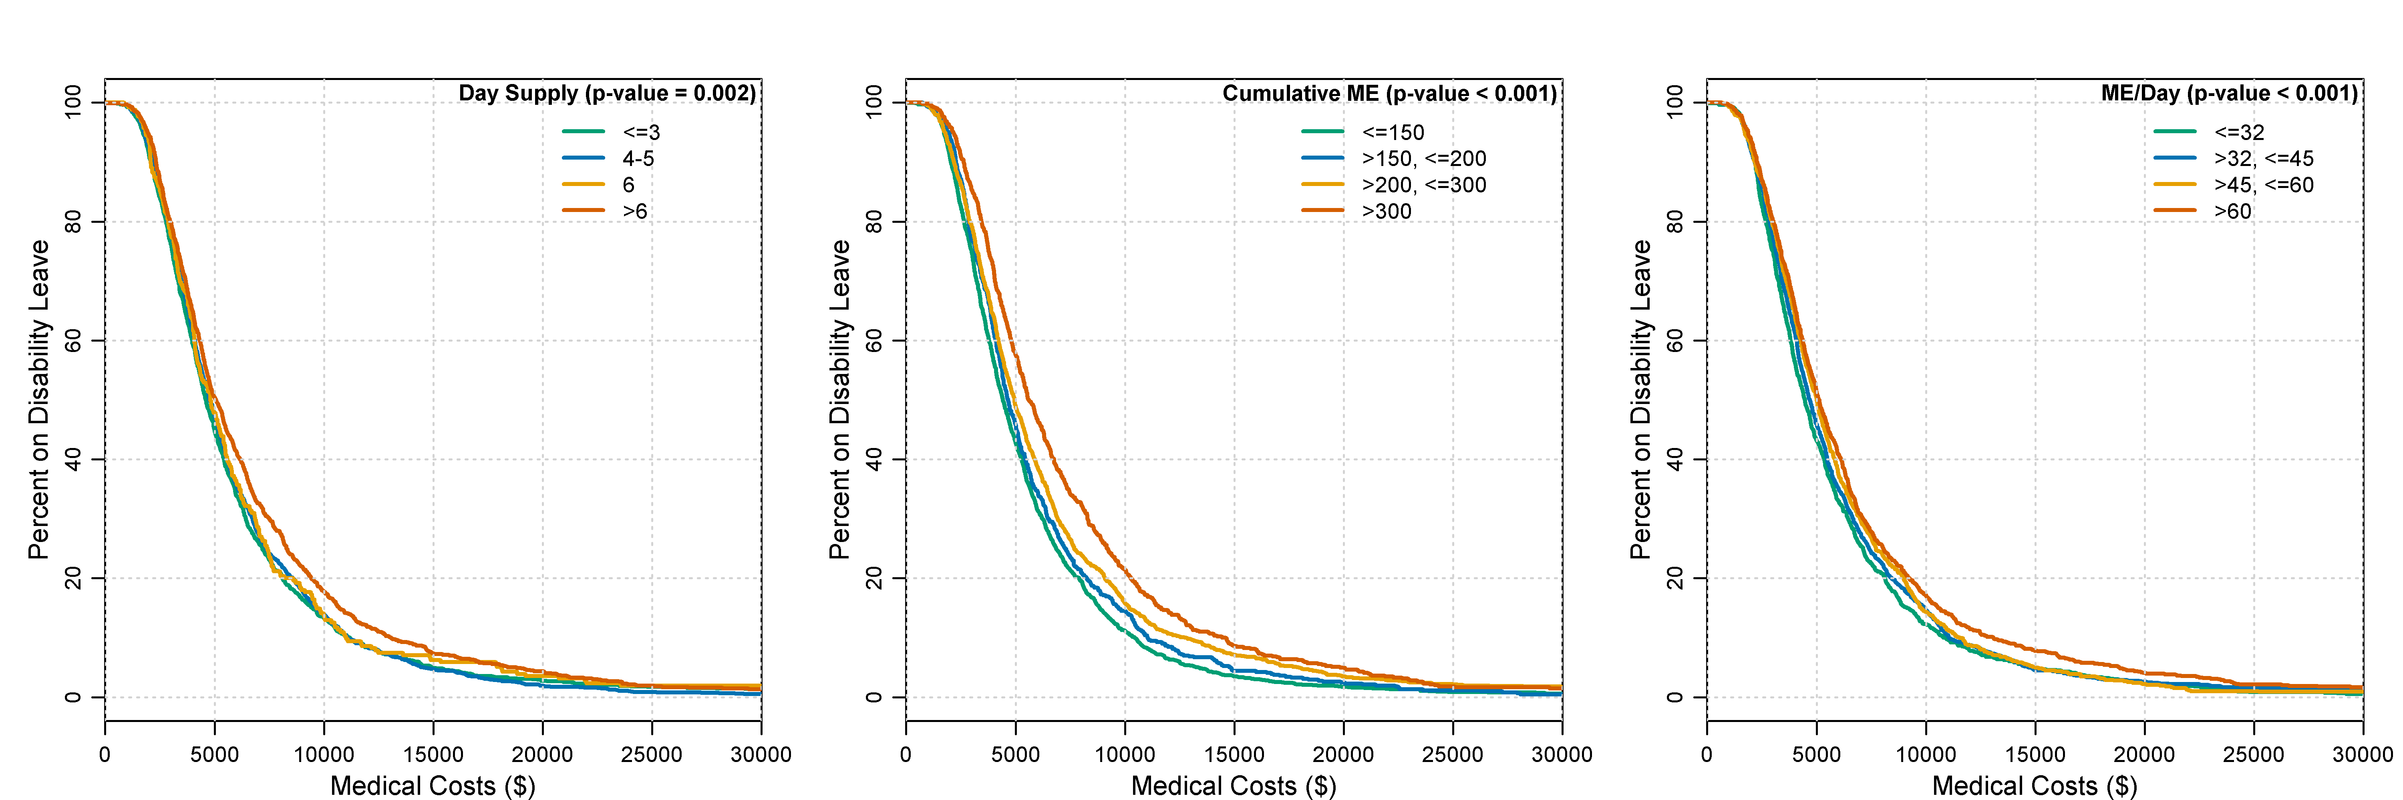
Figure S2. Kaplan-Meier curves of percent on disability and medical costs by opioid day supply, cumulative morphine equivalents (ME), and ME (mg) per day.

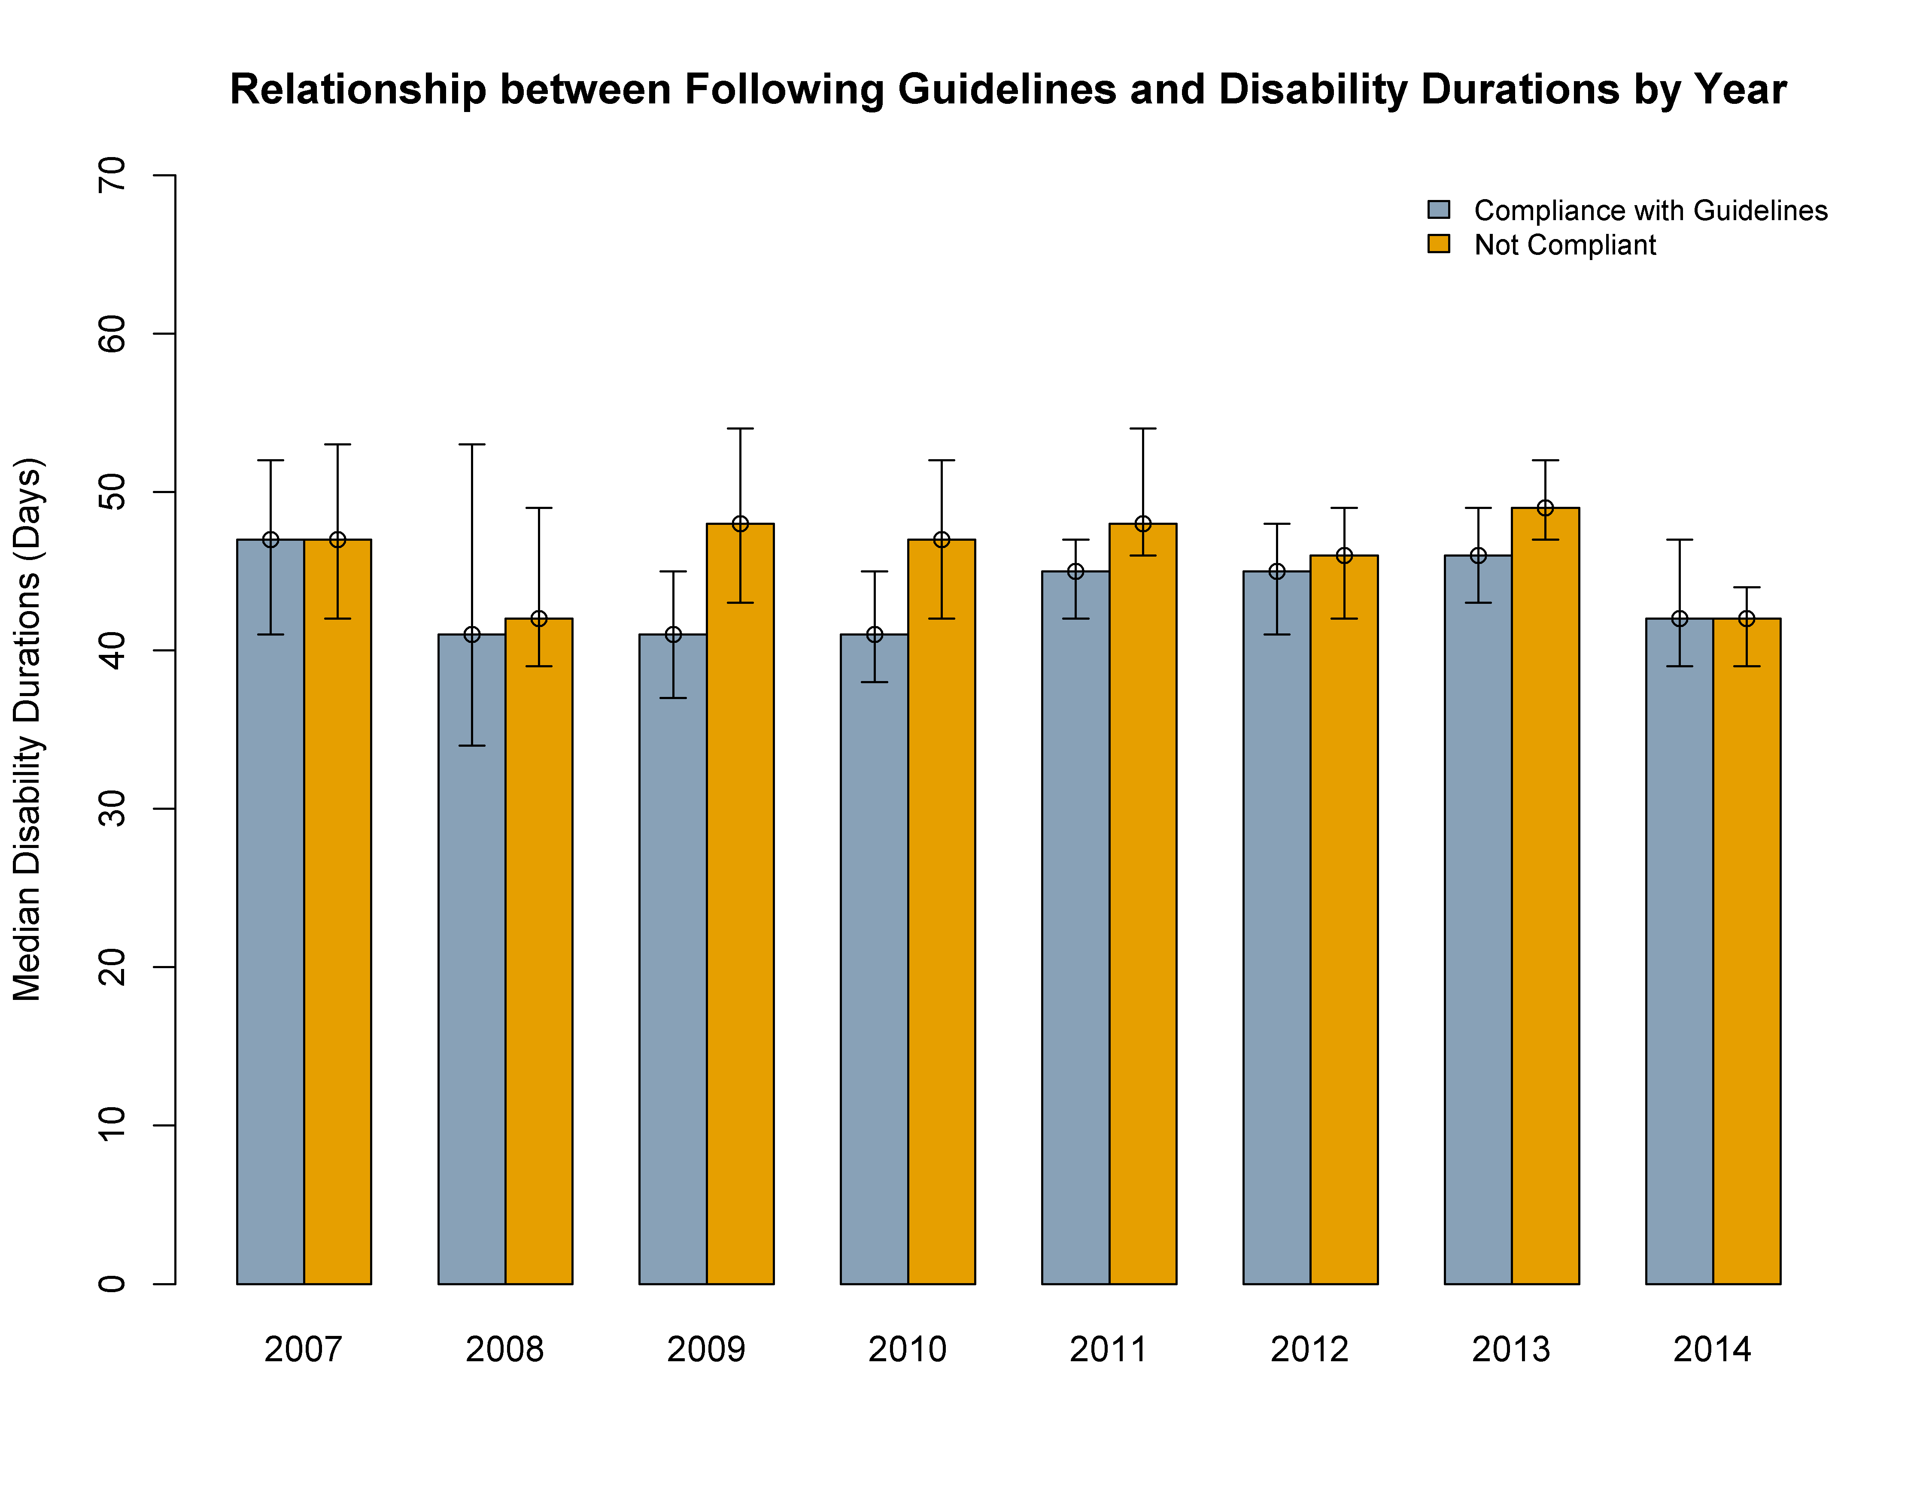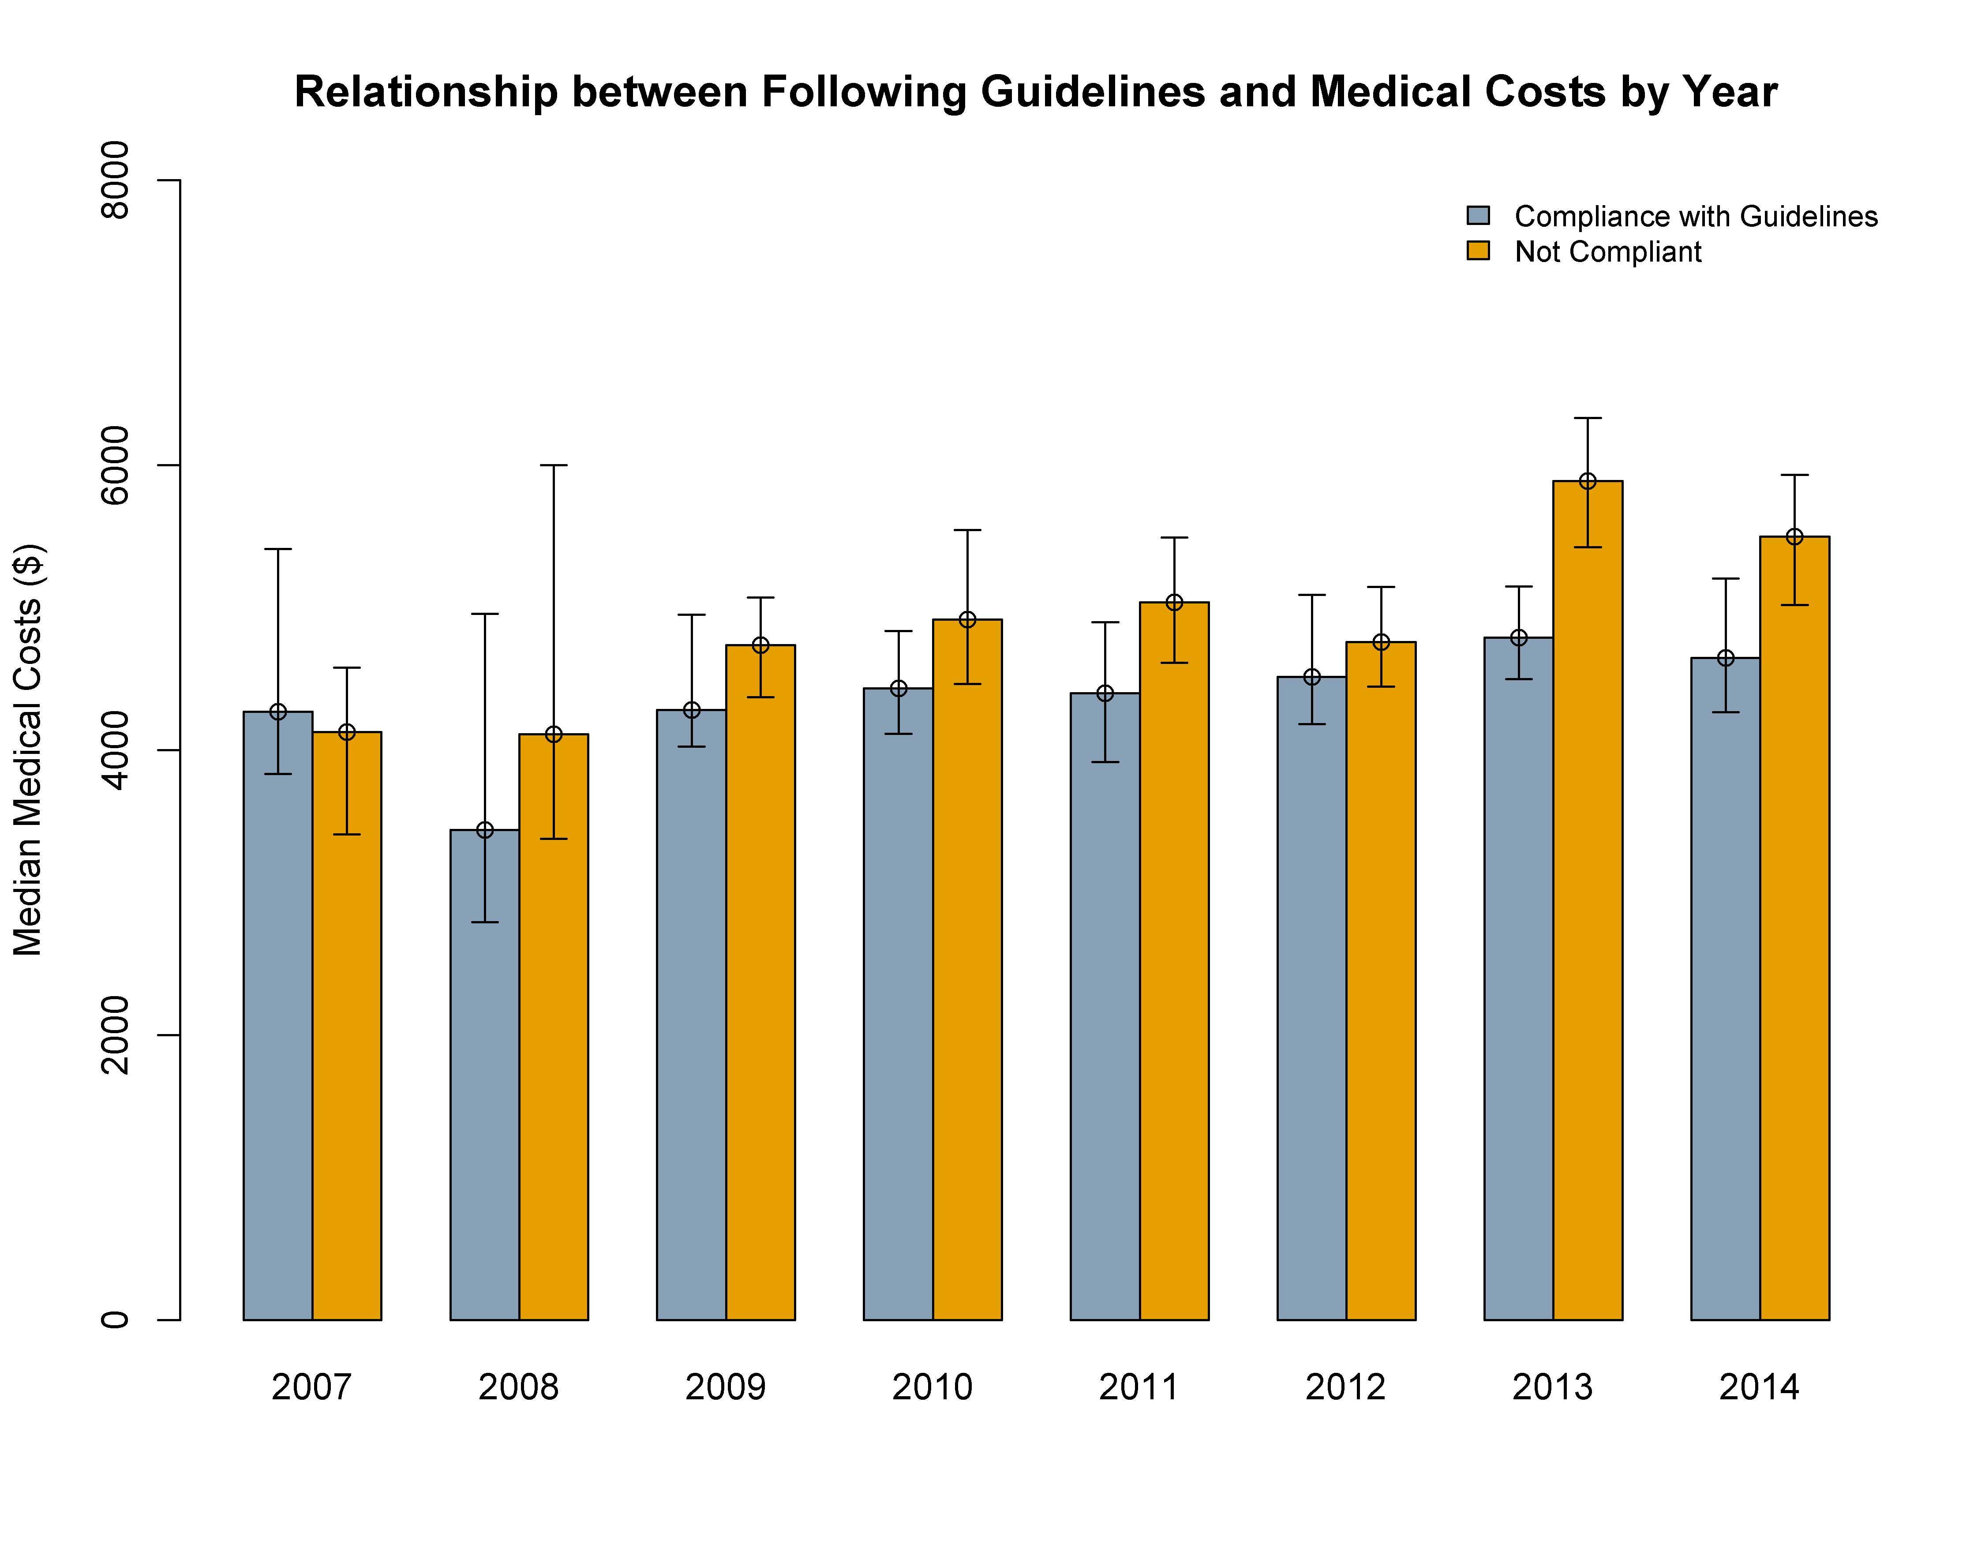
Figure S3. Yearly differences in disability durations and medical costs by whether opioid guidelines were followed. Error bars represent 95% confidence intervals of the median value from Kaplan-Meier estimations

