SDC 1. LEAN/Six Sigma Approach
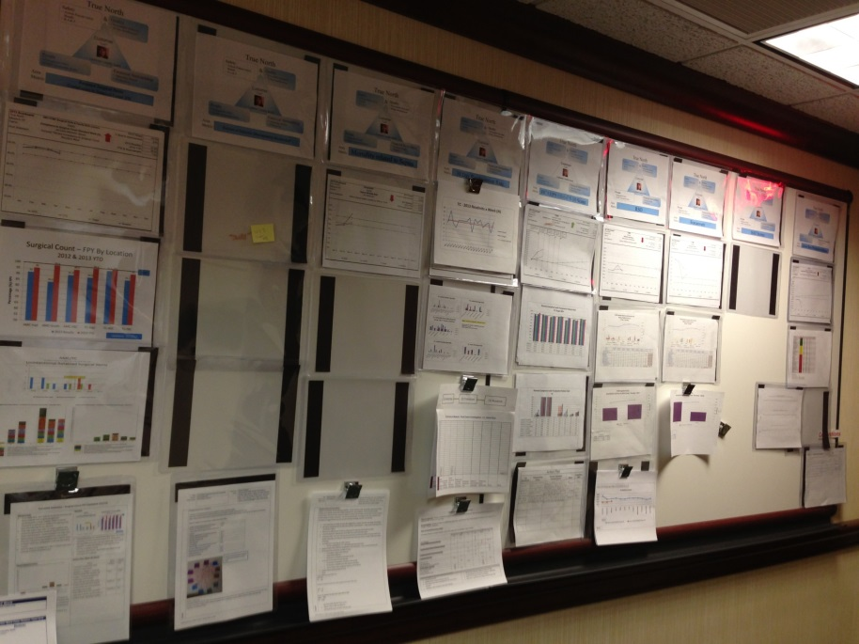
ThedaCare Improvement Center Hospital Leadership Board (printed with permission)

