SDC #1
Mapping Pain Concepts in an Electronic Flow Sheet to a Clinical Data Model

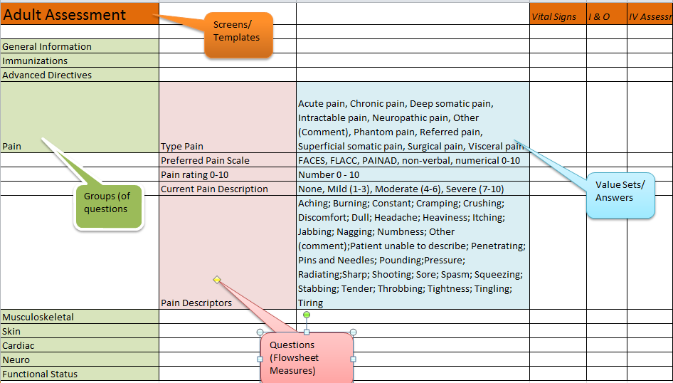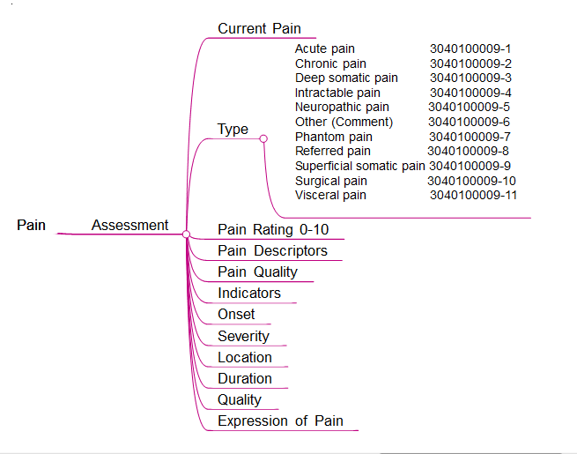

With permission from Bonnie Westra, PhD, RN, FAAN, FACMI, Associate Professor, Director, Center for Nursing Informatics, School of Nursing, The University of Minnesota, Minneapolis, MN

