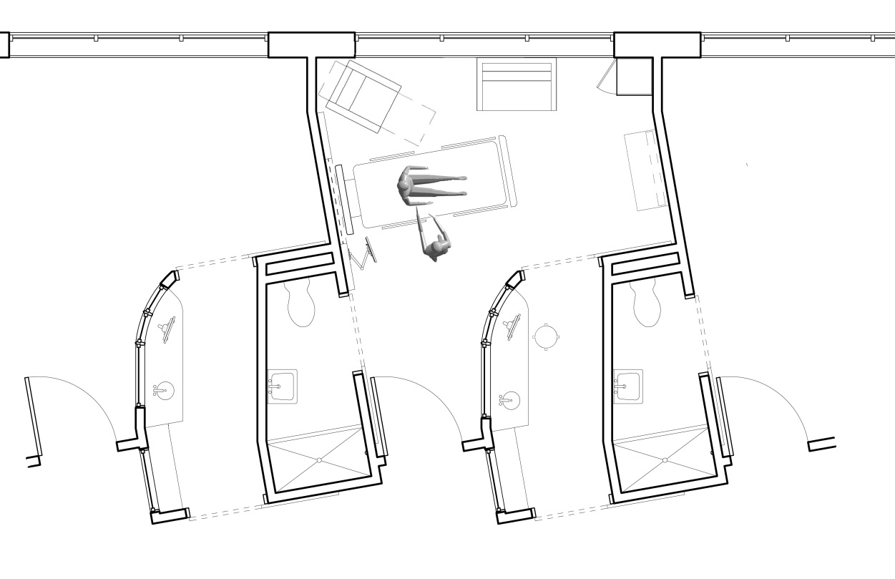
Nurse Porch

The nurses felt an appropriately outfitted patient room with porch could prevent searches for supplies and equipment and encourage the nurses to conduct more activities at or near the patient bedside. Additionally, the room could prevent distractions from the nursing station, hallway, and patient bedside during activities that require concentration such as documentation, order entry, medication preparation, and prescription entry. Image courtesy of Knoll and HOK.

