Supplemental Digital Content – No. 1
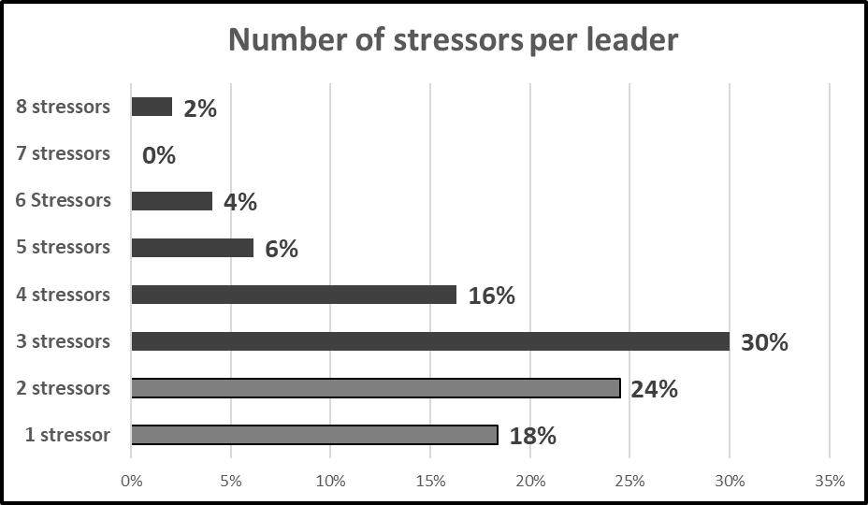
Figure 3. Showing the percentage of leader’s selecting each categorical number of stressors. A total of 58% stated having three or more contributing stressors in their life.

