Supplemental Digital Content – No. 2
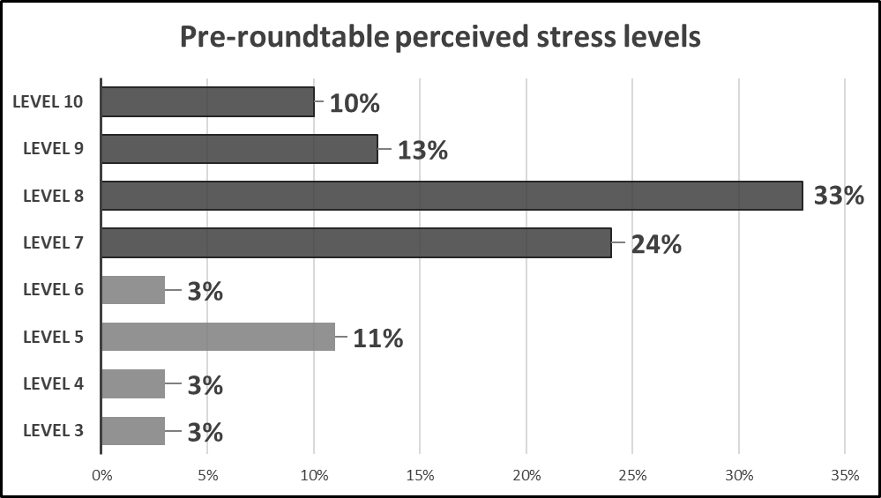
Figure 4: Shows the perceived leader stress levels prior to implementation of the roundtable meetings with 80% selecting stress levels of seven or above.

