Supplemental Digital Content – No. 3
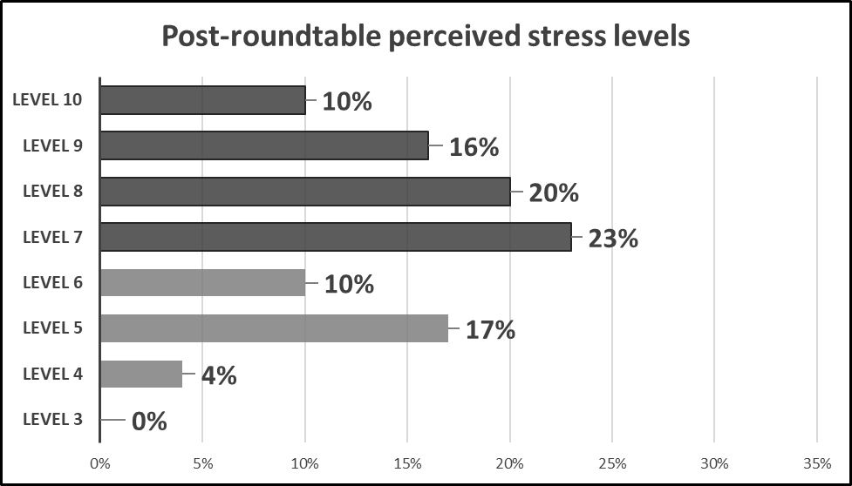
Figure 5: Showing the perceived leader stress levels after implementation of the roundtable meetings with 69% selecting stress level seven or above; an 11% decrease from pre-roundtable implementation.

