Appendix 1: Pre-event Report

The purpose of the report is to provide information regarding the participants, their motivation to learn and educational needs so that faculty can fine tune their planned content and educational techniques, particularly when the audience is heterogeneous (different countries, different levels of experience, training paths, etc.).
The information in the overall report must be viewed and interpreted by the event chairperson and faculty. Interpretation must always consider the language the questions were administered in compared with the fluent languages of the responders, the culture within the country or subspecialty, and the overall context of the educational event.

The first information in the report is general information regarding registration and faculty.
Demographics or participant profile has 6 questions:
1) When did you graduate from medical school?
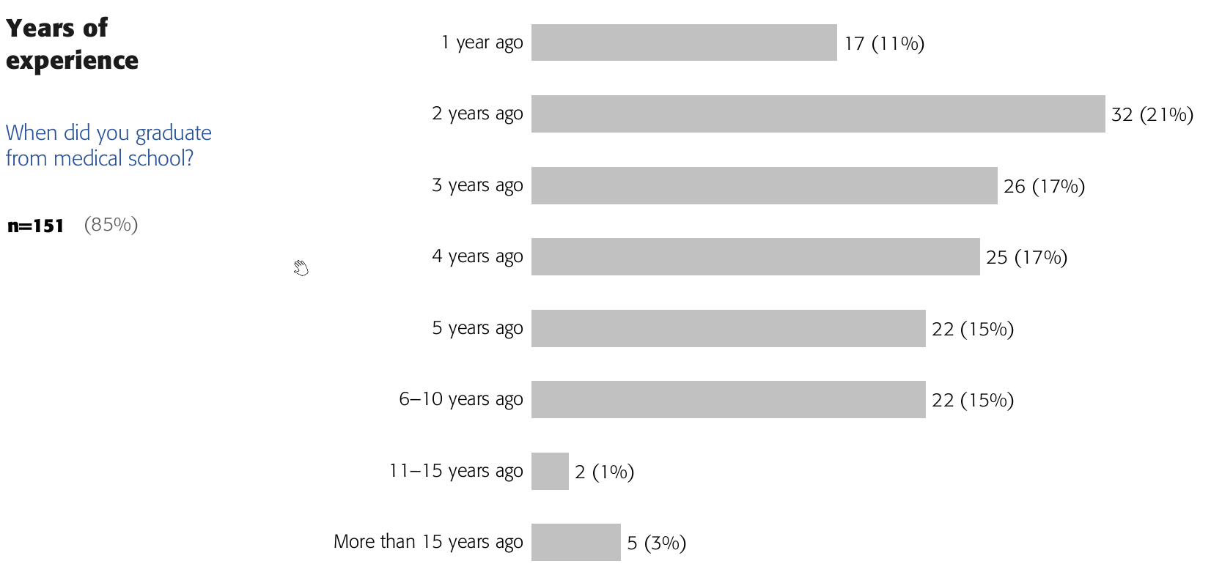
This question is used to estimate the years of experience. The answer options for events for residents (in the example) are more granular compared to the one for events for continuing professional development. This is because residency programs have different durations in many countries therefore knowing the year of residency is relevant for those events.

2) I do mostly... (> 50% of time):
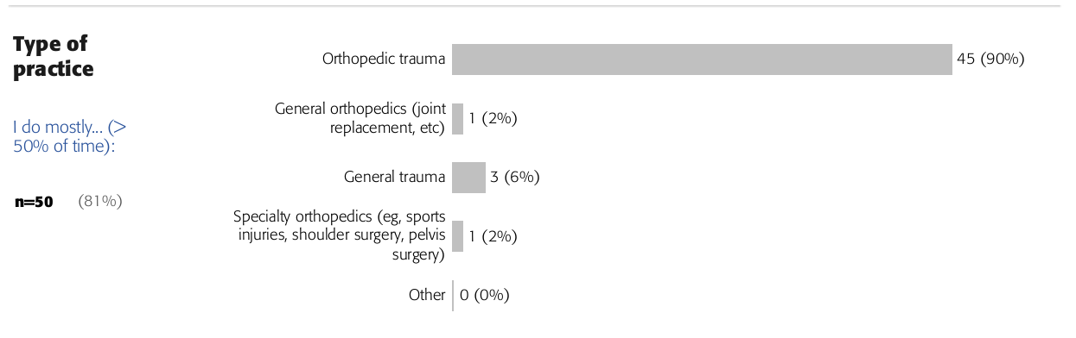
This question identifies the proportion of surgeons from different backgrounds. The answer options can be more granular with different subspecialties depending on the course needs. It can also identify non-surgeons for interdisciplinary education (eg, geriatricians in courses for the care of older adults).

3-4) How many orthopedic trauma cases do you perform as the primary surgeon on average within a month? And as the assistant surgeon?
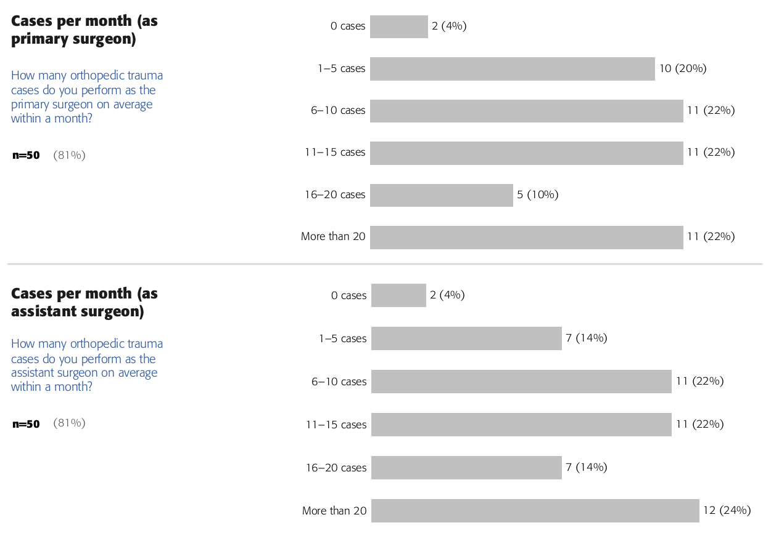This estimates expertise level and helps identify if the participants are already managing a lot of patients or are starting in this area.

5) What is your main practice location?
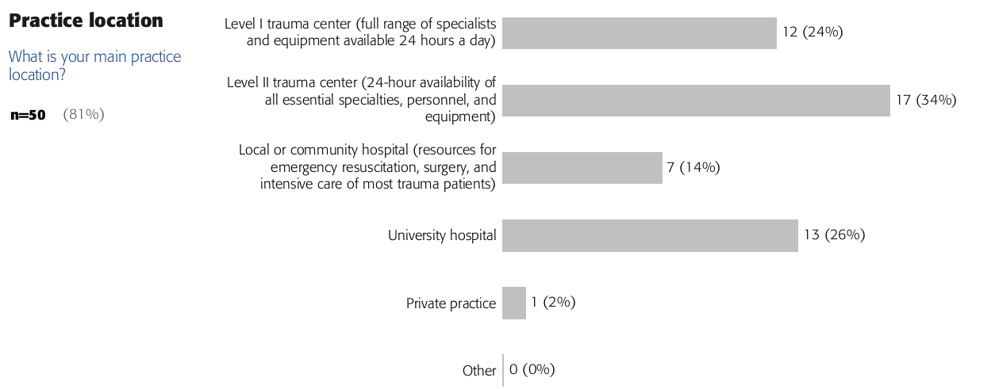This question estimates the access to systems, technology, peers, and further teaching (e.g. a surgeon in a university hospital or level I trauma center usually has access to more peers and faculty and to more equipped departments than surgeons in community hospitals). We based the answer options on World Health Organization categories and common terms used. The categories may not be optimal for some countries and may have some overlap, however, responses generally provide a comprehensive overview of the main proportions.

6) My self-assessed expertise level is...
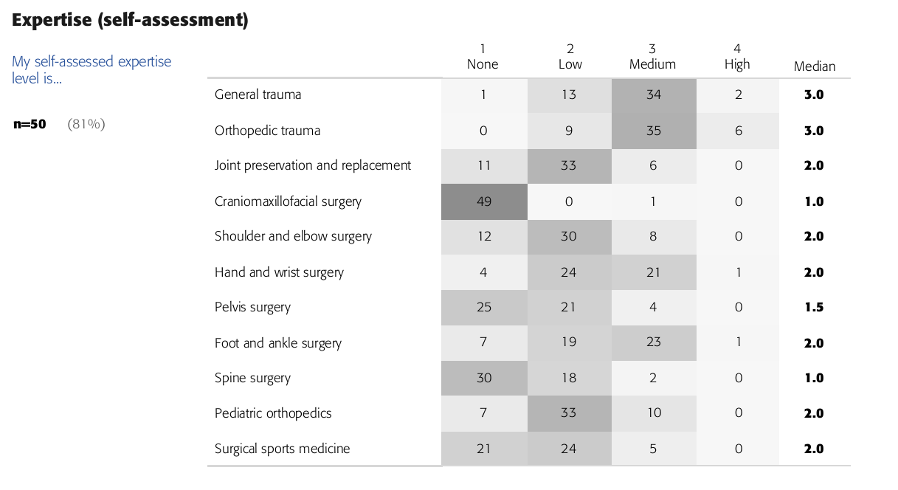
We ask participants to complete a table of self-assessed expertise on a four-point Likert scale regarding all the subspecialty topics we offer education in. The data are presented as a heat map of expertise along with median scores. This helps to see areas of strength in other specialties and to create a profile of the proportion of the audience who have High, Medium, and Low expertise in several areas.

Motivation has subjective and objective questions (generating "gap scores" and scores for optional multiple-choice questions (MCQs)):
1) What is your present and desired level of ability for the following competencies?
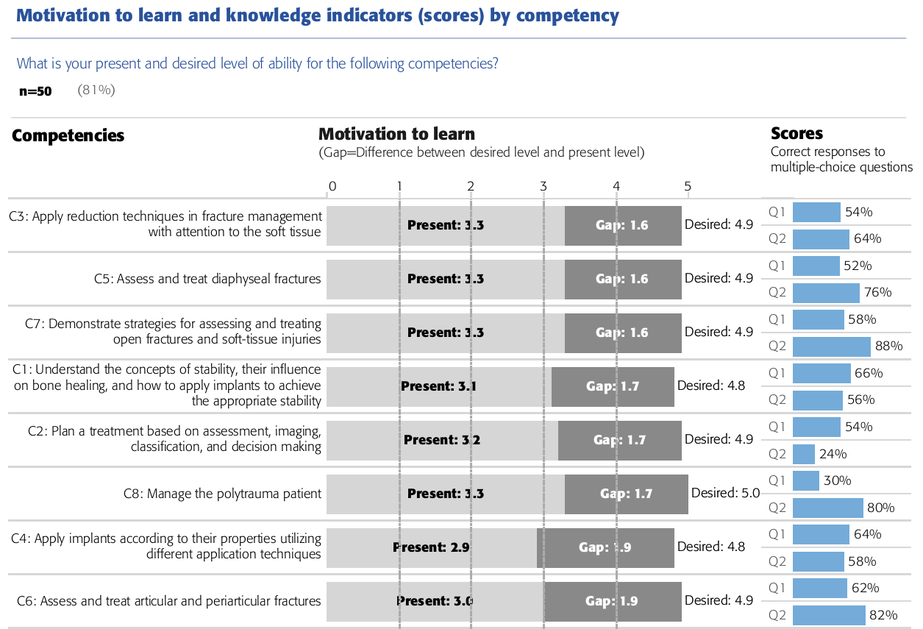
Motivation is the fundamental precondition for successful learning and is based on needs¹. For each defined event competency (or learning objective) we ask participants to rate their present and desired level of ability on a 1 to 5 Likert-scale (5 indicating the highest level). The desired level indicates the relevance of that competency for the participant (5=very relevant), while the present level indicates who capable the participants believes to be in each competency.
To estimate motivation to learn, we calculate the gap (=difference) between self-reported desired level of expertise and present level for each defined event competency (or learning objective)¹⁻³. Good motivation to learn is associated with gap scores between 1 and 2.5. Conversely large gaps promote high levels of anxiety that is likely to be associated with feelings of aversion, while small discrepancies lead to very low levels of anxiety that can be easily tolerated¹.
Our reports show the event competencies (or objectives) in ascending order with the largest gap at the bottom.

2) Multiple-choice assessment questions
In some of our curricula, the subjective gap scores are complemented by objective data from a set of two multiple-choice assessment questions for each competency. Feedback shows the correct answer and rationale and references. This approach was previously used in the Learning Assessment Toolkit² that was developed to supplement the judgment of surgical educators before and after a teaching event with real evidence. This can detect areas where the subjective and objective data suggests that participants know more or know less that they think (ie, "different combinations of perceived and actual needs") and educators can plan strategies to address each scenario (Appendix 4).

References

1. Fox R, Miner C: Motivation and the facilitation of change, learning and participation in educational programs for health professionals. J Cont Educ Health Prof 1999;19:132-141.
2. de Boer PG, Buckley R, Schmidt P, et al: Learning assessment toolkit. J Bone Joint Surg Am 92:1325-9, 2010
3. Knox A: Influences on participation in continuing education. J Cont Educ Health Prof 1990; 10:261–274.

