Appendix 2: Post-Event Report

The purpose of the Post-Event report is to evaluate the outcome of the educational event and to identify "what went well" and "what could be done differently next time". The information must be viewed and interpreted by the event chairperson who has the deepest insight into the overall running of the educational event and has the feedback from faculty debriefings. Each stakeholder group can set a benchmark for their expected percentage response for all questions. Review of data over time and comparisons with similar events helps assess "success" and to set future "targets". Our reports for standard courses for residents include an average indicator for all similar events in the region over 2 years, providing the chairperson with a tool to instantly compare the data.

Outcome-Participation represents the number of learners registered and each question shows the number of completed responses^{1,2}.
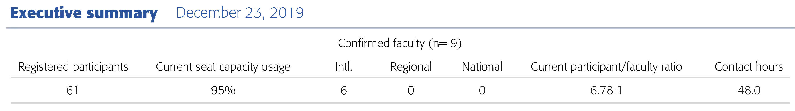

Outcome-Satisfaction
Satisfaction measures the degree to which the expectations of the learners about the educational activity were met¹. We use a set of 4 questions:
1) Would you recommend this event to your colleagues?
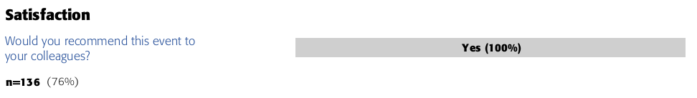
2) How useful was the content to your daily practice?
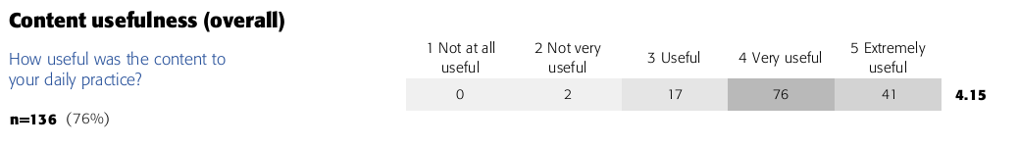
Participants rate the overall content on a 1 to 5 Likert scale (from "Not at all useful" to "Extremely useful"). Content usefulness ratings for each lecture, discussion group, and practical exercise are optional and can be requested (Appendix 3). The number of responders choosing each answer option are presented in a heat map and an average is included. Average scores above 4 are generally considered good quality for most questions, however, comparisons with results of similar events in a region and setting should be considered.

3) To what degree were the stated objectives met?
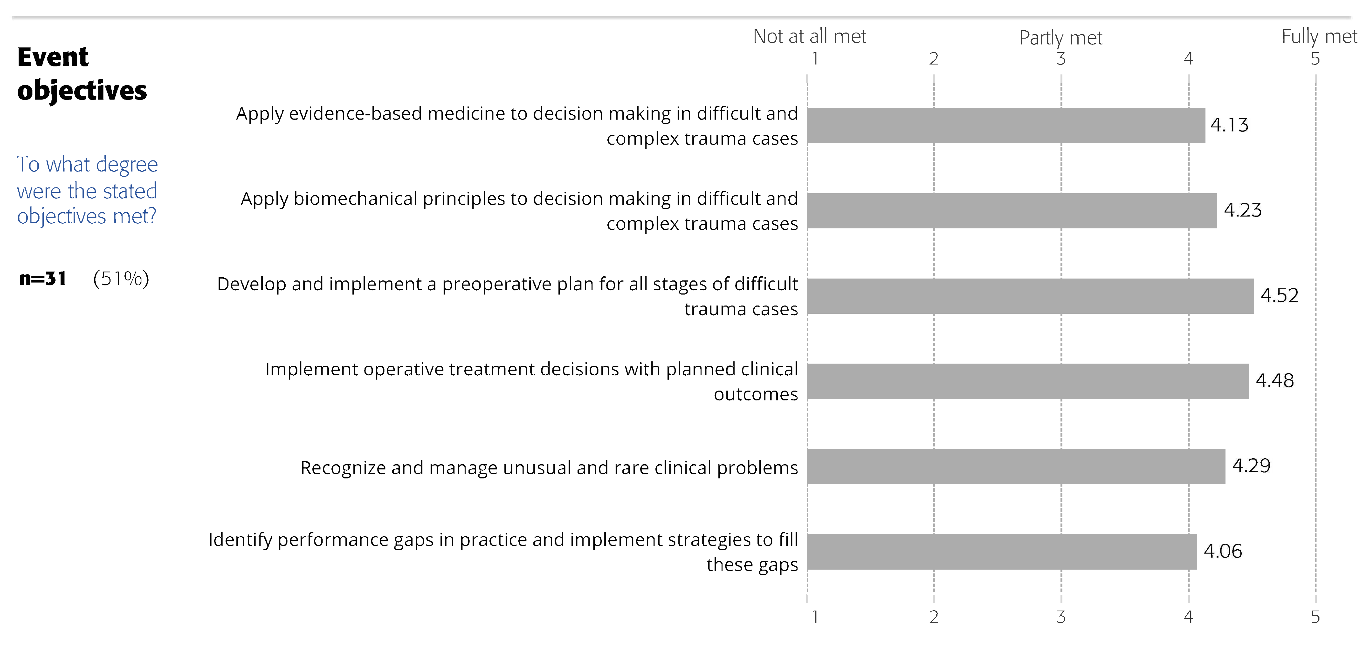
Participants rate how well each of the event learning objectives were met on a 1 to 5 Likert scale (from "Not at all" to "Fully met"). This information can be combined over a series of events with the same objectives to help identify global and local trends. Scores above 4 are generally considered good quality.

4) Do you have any suggestions for improvement regarding content and faculty?
The open field provides the opportunity for learners to make suggestions for improvement and responses can identify possible explanations for participant dissatisfaction.

Outcome-Learning, competence, and performance are the Moore’s Level 3, 4, and 5 of outcome and the ultimate goal of education. Achieving an increase in competence and performance should be the standard in today's medical education¹. This section has 3 questions and 2 sets of optional questions:
1) What was the overall impact of this educational event?
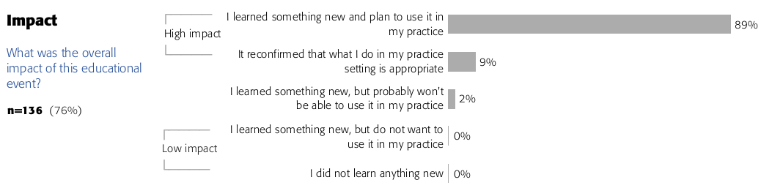
This question helps to estimate learning by asking participants to self-report knowledge gain. The first two responses are considered high impact. The other categories of response are monitored and can be investigated further by analyzing the other questions in the subsequent sections and by considering the participant profile and gaps from the Pre-Event report.

2) What is your present and desired level of ability for the following competencies?
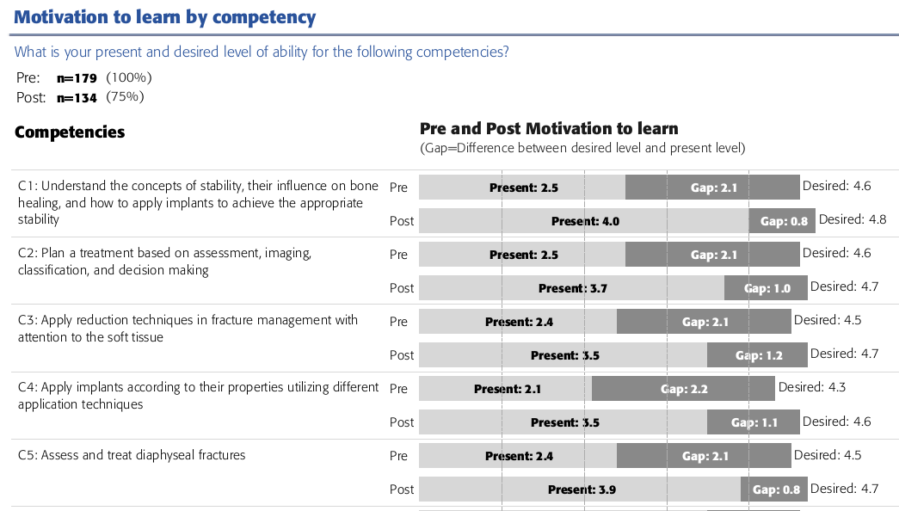
This question is identical to the pre-event question used to measure motivation to learn by competency. The averages for the pre-event responses are shown along with the averages for the post-event. The increase in the self-reported level of ability as well as the reduction in the gaps may suggest improvements in knowledge or competence³ and should be validated by objective measures. An increase in the desired level of ability is often reported after the event. The response rate must be adequate in order to make sure that most of the responders are the same for pre- and post-event reports. For a more accurate analysis data form unmatched responders can be excluded.

3) Optional Multiple-choice assessment questions
As an extended option, we offer an objective measure of learning and ability using a set of two multiple-choice questions for each competency. The questions can be identical to the one given in the pre-event or can be a new set with a matched level of difficulty. The assessment scores are included beside the gap scores per objective/competency.

4) Please describe the specific change you intend to make in your clinical practice. Please select the competency your intended change in related to (select one or more)
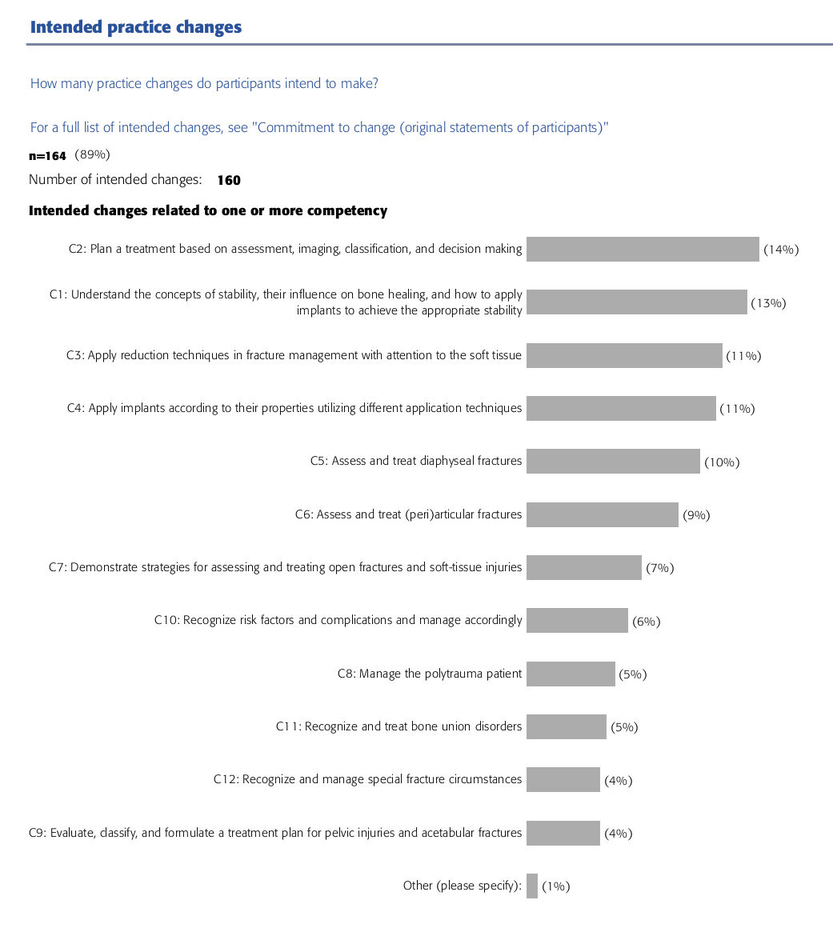
To estimate increase in competence and performance, we ask participants to describe one to three specific changes they intend to make in the clinical practice and to which competence is related to. This provides an opportunity for self-reflection which itself promotes learning⁴.
5) The intended changes identified in the question above are the subject of an optional Commitment to Change Outcome Report three months later. We ask participants to self-report the implementation status of the intended changes and barriers encountered (Appendix 3)

Faculty performance has 2 standard questions and an optional set of questions:
1) How effective were all faculty in the role they played?
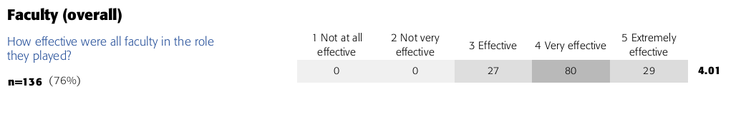
Faculty strongly influences the success of an educational activity. To measure overall faculty performance, we ask participants to score overall effectiveness on a 1 to 5 Likert scale (from "Not at all" to "Extremely"). Faculty ratings above 4 are considered good, however variations in the ratings due to regional differences should be considered. We offer the possibility to extend the standard dataset with faculty performance for each lecture, discussion, and practical exercise (Appendix 3).

2) Do you have any suggestions for improvement regarding content and faculty?
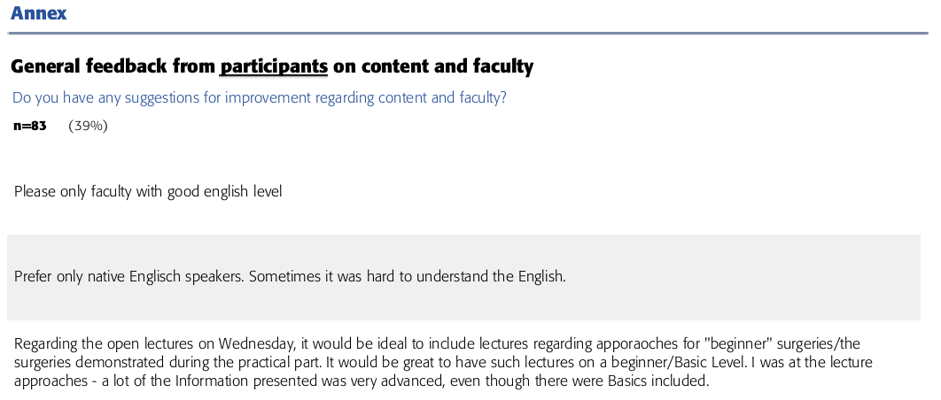
The open field provides useful suggestions for improvement and possible explanations for participants unsatisfaction.

Event key performance indicators (KPIs) include 4 questions:
1) Please rate the venue/location:
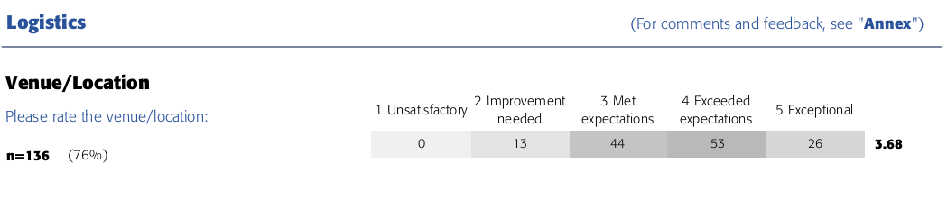
The venue/location are scored on a 1 to 5 Likert scale (from "Unsatisfactory" to "Exceptional"). A score of 3 in considered good. Participants that scored the location 1 or 2 could not recommend the course to colleagues.

2) Did you perceive this event to be commercially biased?

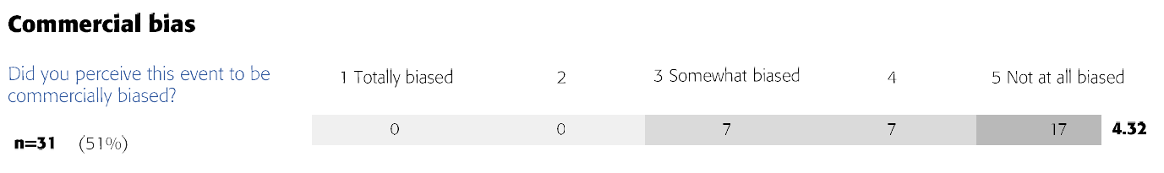

Participants rate the perceived commercial bias of the event on a 1 to 5 Likert scale (from "Totally" to "Not at all"). This parameter should be strictly monitored especially for accreditation purposes.

3) Who covered the overall cost of you participating in this event?
The cost coverage is thought to influence the commitment of participants in the educational activity however it is strictly related to regional practices. In some countries surgeons pay for their own education while in other they are mainly sponsored by hospitals or by industry through travel grants or fellowships.

4) Did you experience any obstacles in terms of logistics, communication, and venue?
This open field question provides useful suggestions for improvement and possible explanations for participants unsatisfaction.

References
1. Moore DE, Jr., Green JS, Gallis HA: Achieving desired results and improved outcomes: integrating planning and assessment throughout learning activities. J Contin Educ Health Prof 29:1-15, 2009
2. McGowan BS, Mandarakas A, McGuinness S, et al: Outcomes Standardisation Project (OSP) for Continuing Medical Education (CE/CME) Professionals: Background, Methods, and Initial Terms and Definitions. J Eur CME 9:1717187, 2020
3. Fox R, Miner C: Motivation and the facilitation of change, learning and participation in educational programs for health professionals. J Cont Educ Health Prof 1999;19:132-141.
4. National, Research, Council: How People Learn: Brain, Mind, Experience, and School: Expanded Edition. Washington, DC: The National Academies Press, 2000. .

