Appendix 3: Optional reports

Commitment to Change Outcome Report
As expanded option we offer a Commitment to Change (CTC) Outcome follow up three months after the event. We ask participants, to self-report the implementation status of the intended changes and obstacles in the implementation. This is a practical approach to facilitate and measure behavioral changes resulting from attending an educational event¹. In addition, it encourages reflection that is an essential aspect of learning². Despite the response rate is normally quite low due to the long time elapsed from the event, data from multiple events can be aggregated and analyzed to improve the curriculum³.

The first part of the report contains a summary taken from the Post-Event Report (Appendix 2).
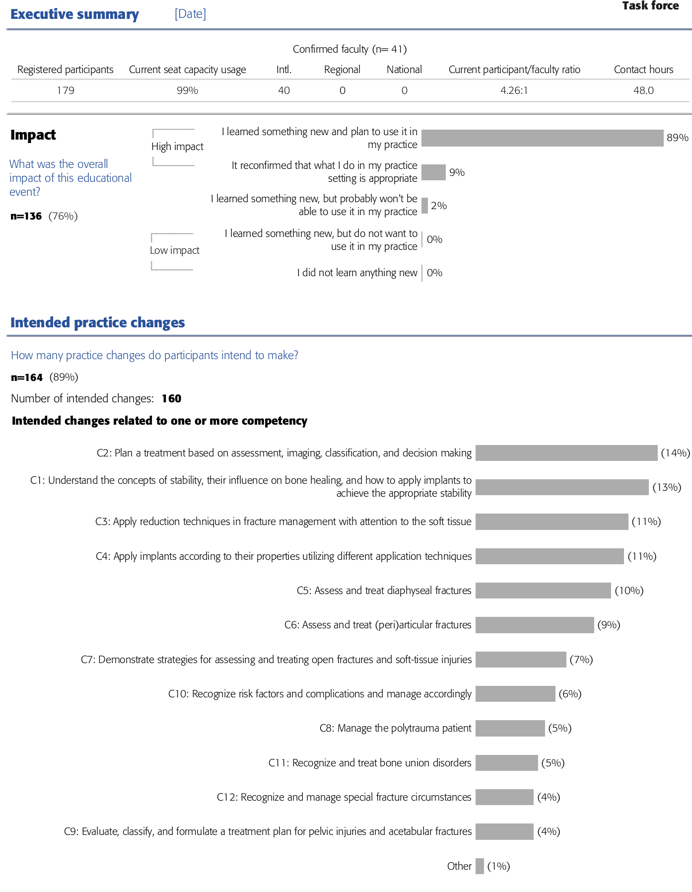
The second part includes the data coming from 2 optional questions:
- Regarding your first intended change (see "Change 1" in the survey invitation): To what extent have you implemented this change in your clinical practice?
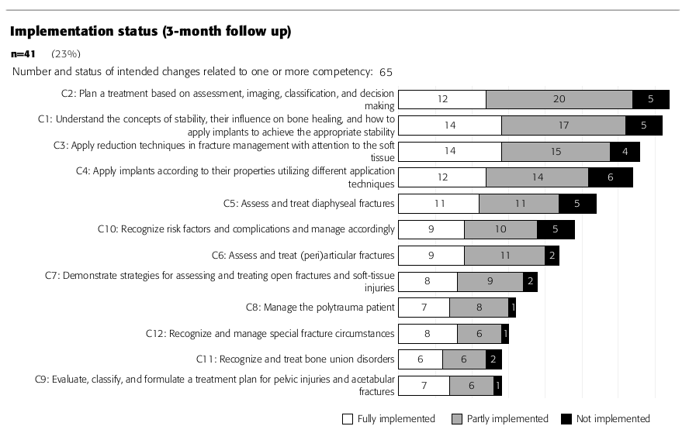

- If you have not been able to fully implement your intended change, please identify the main barrier or reason (multiple answers are possible).
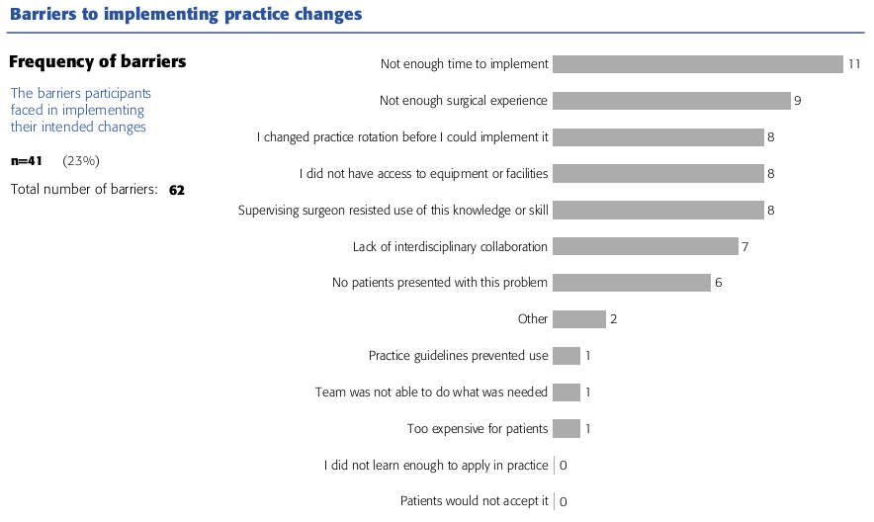

Content and Faculty Report
The purpose of the Content and Faculty Report is to show content usefulness and faculty effectiveness for each lecture, discussion, and practical exercise. This report is strictly confidential and is only submitted to the chairpersons. This report is generated only if during the event the optional dataset has been collected.
The first part of the report contains on overview while the second part has all the individual faculty and content ratings.
Part 1
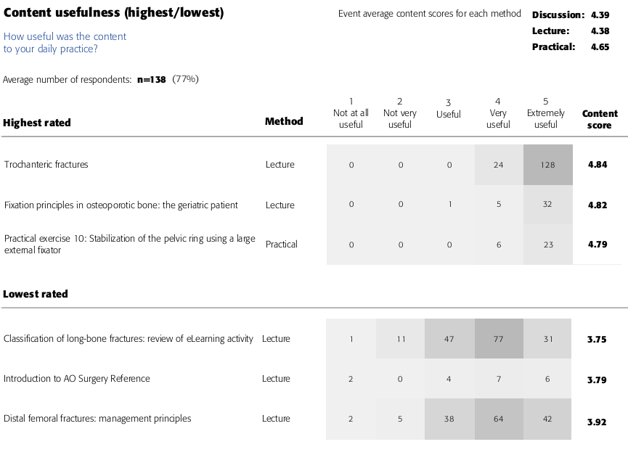
Part 2
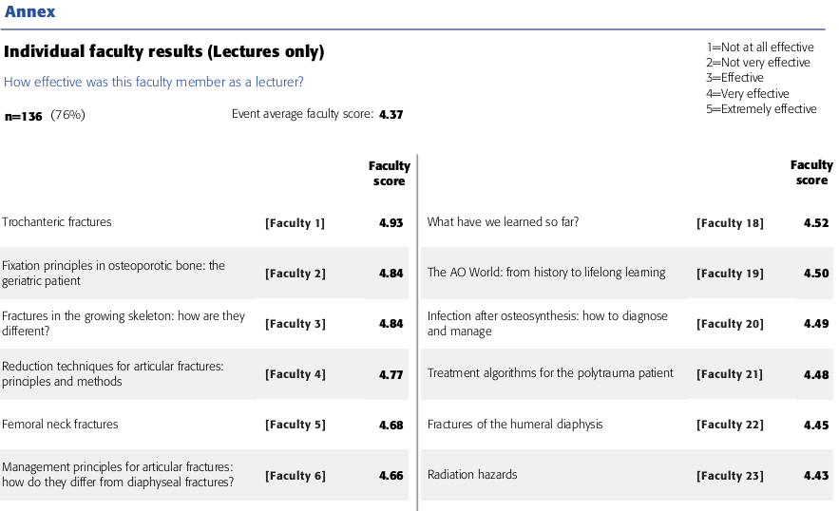
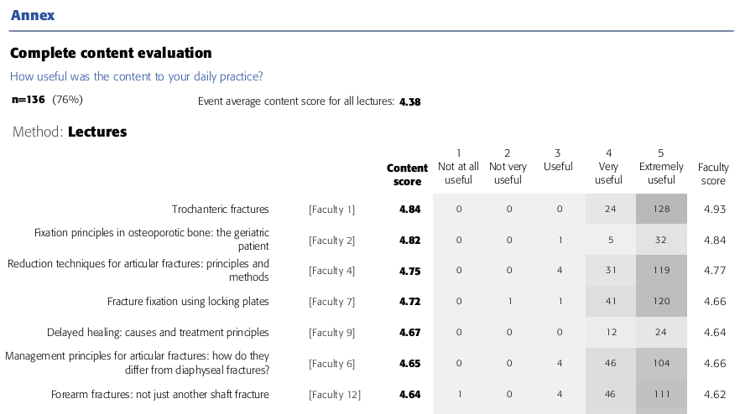

Individual Faculty Report
The purpose of the Individual Faculty Report is to provide data to faculty members about their own performance during the educational activity based on participant judgment. This is generated in combination with the Content and Faculty Report since they are based on the same questionnaire administered during the event.

Every faculty receives a confidential personalized report that includes:
1) What was the overall impact of this educational event? (Same as Post-Event Report, Appendix 2)
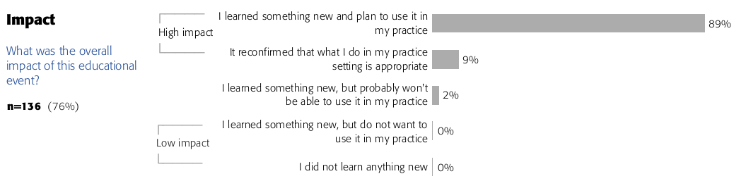
2) To what degree were the stated objectives met? (Same as Post-Event Report, Appendix 2)
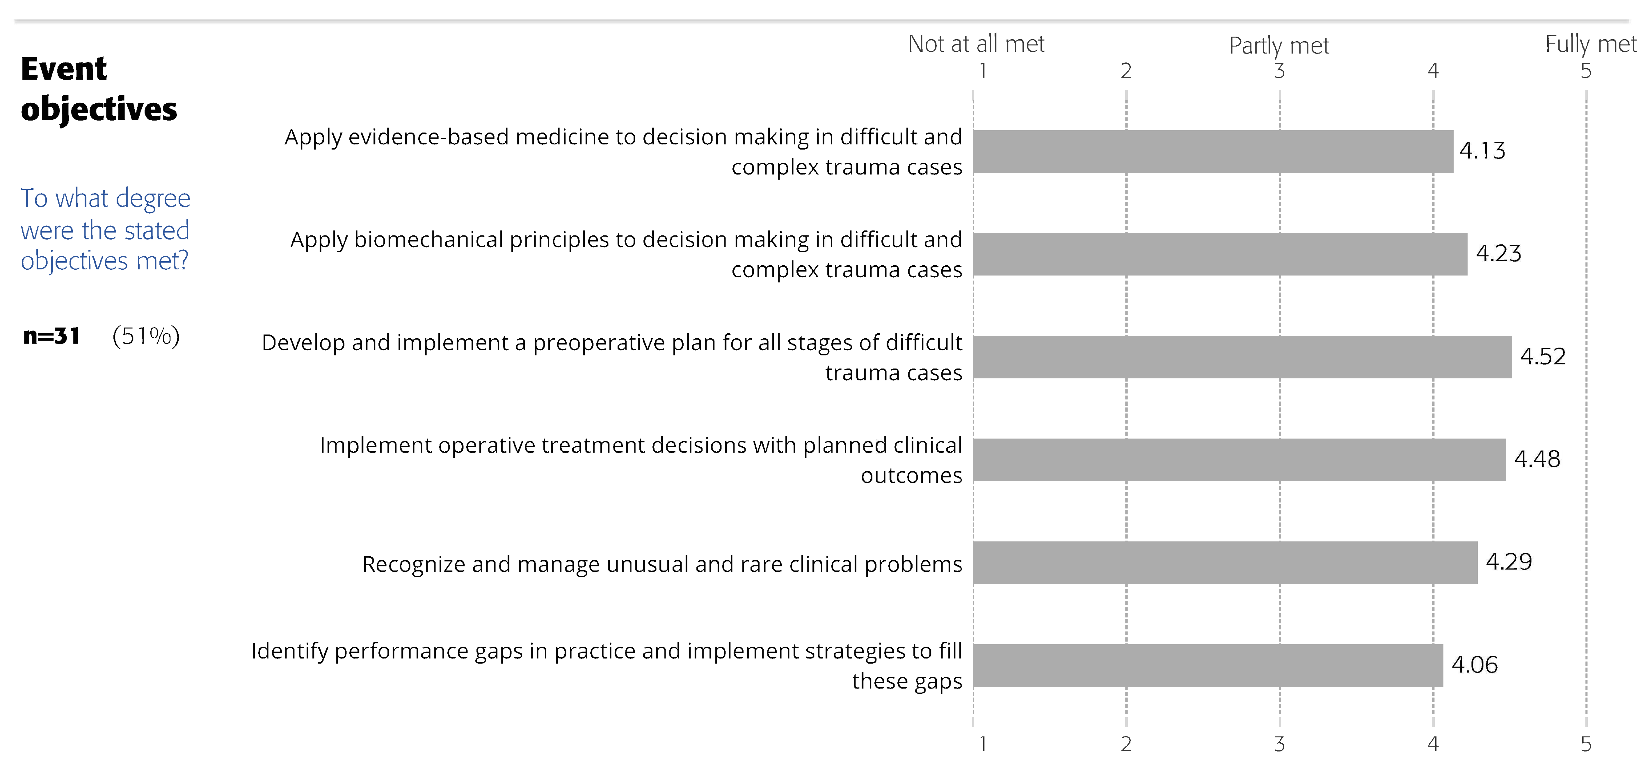
3) Average of individual performance compared to overall faculty average
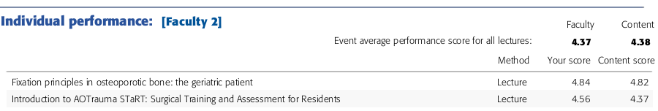
4) Single performance rating divided by lecture, discussion groups, and practical.
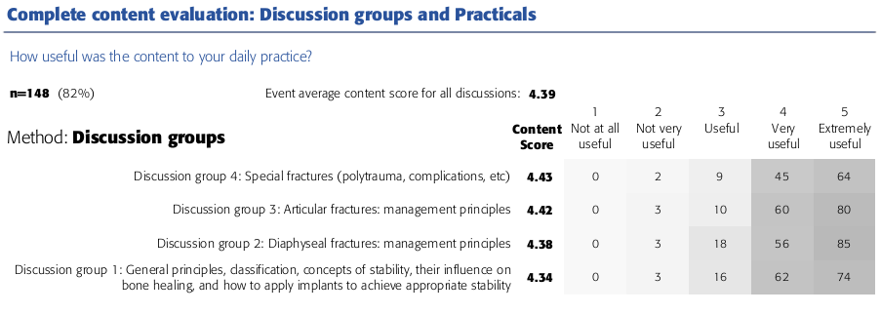

CME Report
The CME Report has been created to standardize the documents submitted to the CME accrediting authorities by the course organizers. It contains a subset of 5 questions from the Post-event Report (Appendix 2).
What was the overall impact of this educational event?
To what degree were the stated objectives met?
How useful was the content to your daily practice?
How effective were all faculty in the role they played?
Did you perceive this event to be commercially biased?

References
1. Shershneva MB, Wang MF, Lindeman GC, et al: Commitment to practice change: an evaluator's perspective. Eval Health Prof 33:256-75, 2010
2. National, Research, Council: How People Learn: Brain, Mind, Experience, and School: Expanded Edition. Washington, DC: The National Academies Press, 2000. .
3. Cunningham M, Kates S, Blauth M: Using a commitment to change tool for evaluation and planning of a global competency-based curriculum in orthogeriatrics. J Contin Educ Health Prof 34:123-30, 2014

