Appendix 4: Actions chairperson can take based on Pre-event report.

Example 1—Small gap and low level of desired ability:
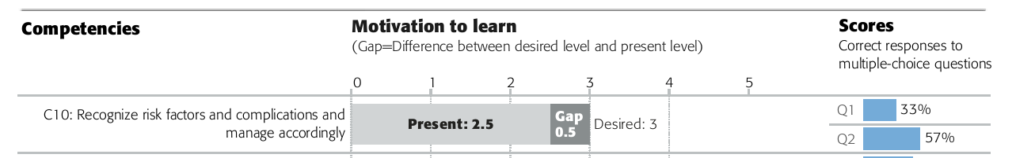
Interpretation: Participants do not perceive this topic as relevant for them (desired level is only 3 and the gap is small), so they do not have a high motivation to learn. And the scores show that they don't know much about this topic.

How can I increase their motivation to learn? E.g., by showing a case that failed because the risk factors and complications were not recognized appropriately and therefore managed badly. This can be done at the beginning of a lecture or in small group discussions. Remember to inform the faculty member who gives the lecture as early as possible. It may be necessary to reinforce this topic throughout the course (lectures, small group discussions and practical exercises).

Example 2—Small gap and high level of present ability:
Participants perceive this as a relevant topic and they think they know a lot already (present level of ability is 4). The multiple-choice assessment questions recommend that their self-assessment of their ability is appropriate. The gap is small and therefore the motivation to learn more about this topic is relatively low.

How can I increase their motivation to learn? E.g., use more complex cases in small group discussion (if topic is included) or at the beginning of the lecture on the topic.

Example 3—Low perceived level of present ability (2), high level of desired ability (5):
Participants perceive their own level of ability in this topic as very low, but the topic is very relevant to them. Therefore, the gap is very big which can lead to anxiety for some of the learners. The multiple-choice questions on the other hand, indicate that their level of knowledge is higher than they think.

How can we help learners to overcome their anxiety and to understand that they know more than they think? E.g., start with an easy case in the lecture or small group discussion, help learners with a stepwise approach, proceeding from simple to more complex information until they recognize that they know more than they thought

