Appendices

Appendix A: Awareness of the Number of People with Disabilities in Jurisdiction
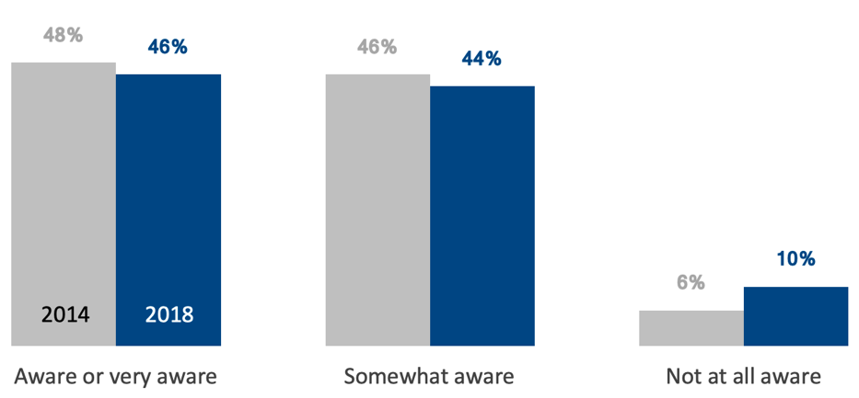

Appendix B: Knowledge about Accommodations for People with Disabilities
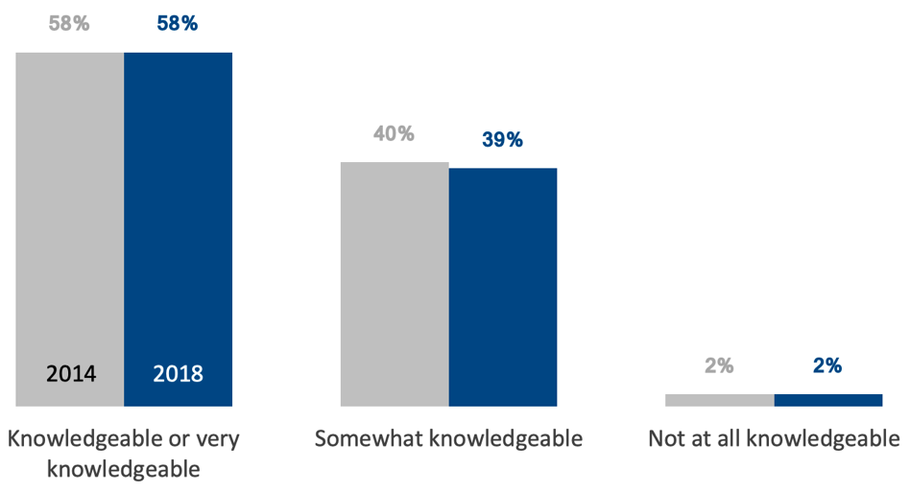

Appendix C: Awareness of the Prevalence of Chronic Conditions among People with Disabilities
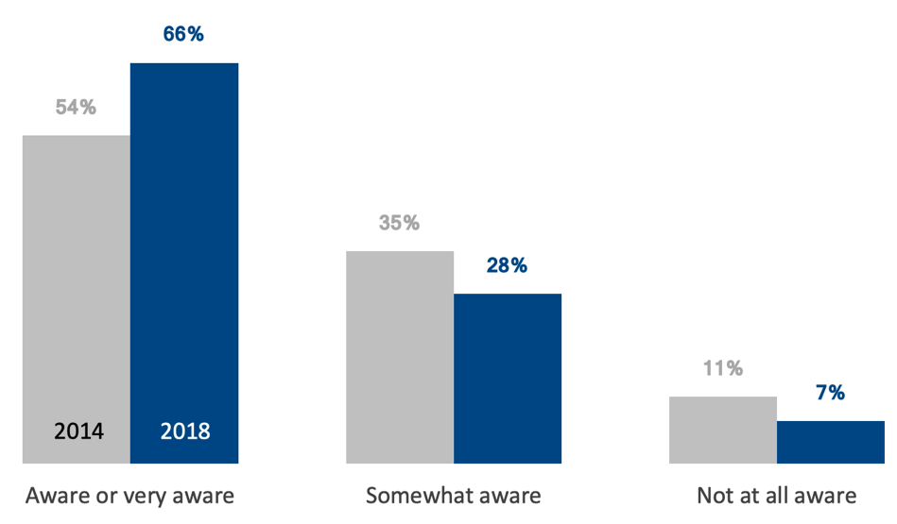

Appendix D: Jurisdictions in which People with Disabilities are Considered a Population that Experiences Health Disparities
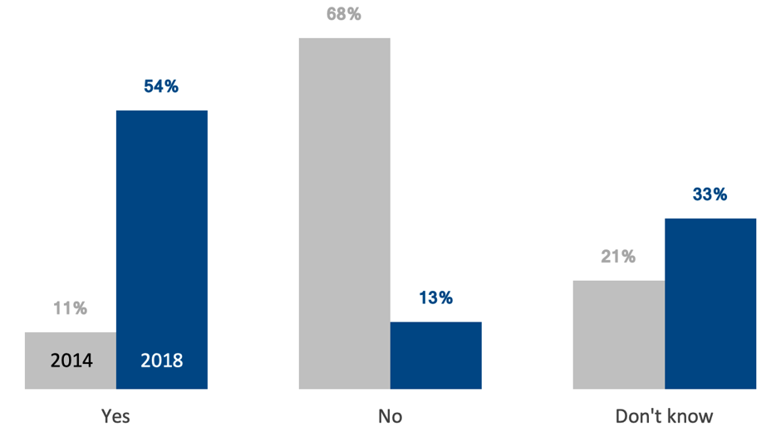

Appendix E: Data Source to Determine Awareness and Knowledge
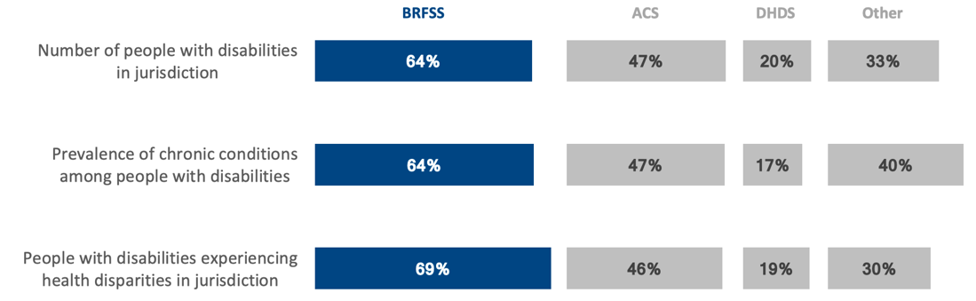

Appendix F: Activities Engaging Community Agencies that Serve People with Disabilities
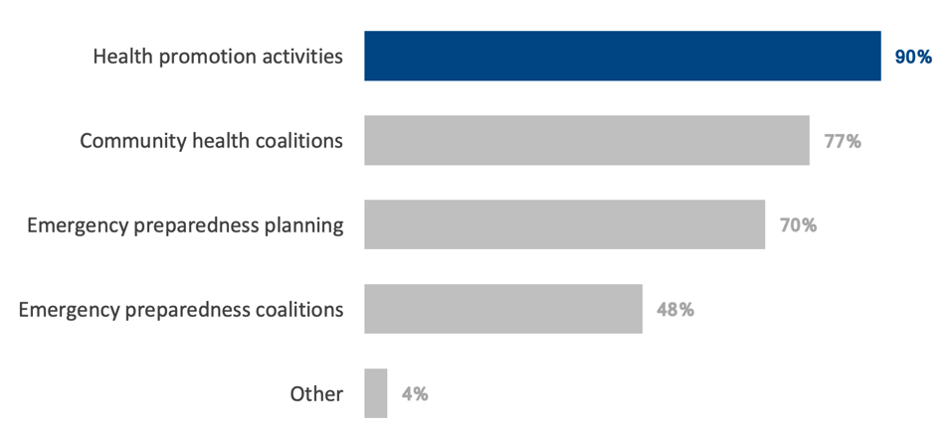

Appendix G: Opportunities to Help LHDs Develop and Implement Inclusive Programming for People with Disabilities
